**Databases**

* Stateless applications:
  + Elasticache is well suited for very short fast cycle data.
  + RDS is well suited for structured and long cycle data.
  + DynamoDB is well suited for unstructured and medium cycle data.

**RDS**

* Amazon Relational Database Service (Amazon RDS) makes it easy to set up, operate, and scale a relational database in the cloud.Can be optimized for memory, performance or I/O
* RDS supports the MariaDB, PostgreSQL, MySQL, SQLServer, Oracle, and Aurora database engines.
* Microsoft SQL Server database engine can have the maximum size of 16TB.
* MySQL installations default to port number 3306.
  + You cannot RDP or SSH into an RDS instance however.Patching of the RDS operating system and DB is Amazon's responsibility.RDS is not server-less (with exception of Aurora)
* **Encryption**:Encryption at rest is done using the AWS KMS service.
* You can authenticate to DB instance using IAM DB authentication.
  + With this authentication method, you don't need to use a password when you connect to a DB instance. Instead, you use an authentication token.An authentication token is a unique string of characters that Amazon RDS generates on request.
  + The IAM database authentication works with MySQL and PostgreSQL.
* . Authentication tokens are generated using AWS Signature Version 4. Each token has a lifetime of 15 minutes. You don't need to store user credentials in the database, because authentication is managed externally using IAM. You can also still use standard database authentication.

IAM database authentication provides the following benefits:

* Network traffic to and from the database is encrypted using Secure Sockets Layer (SSL).
* You can use IAM to centrally manage access to your database resources, instead of managing access individually on each DB instance.
* For applications running on Amazon EC2, you can use profile credentials specific to your EC2 instance to access your database instead of a password, for greater security
* **RDS instance encryption can be enabled when the instance is created and logs and backups are automatically encrypted.**
* You can encrypt your Amazon RDS DB instances and snapshots at rest by enabling the encryption option for your Amazon RDS DB instances. **Data that is encrypted at rest includes the underlying storage for DB instances, its automated backups, Read Replicas, and snapshots.**
* Amazon RDS encrypted DB instances use the industry standard AES-256 encryption algorithm to encrypt your data on the server that hosts your Amazon RDS DB instances. After your data is encrypted, Amazon RDS handles authentication of access and decryption of your data transparently with a minimal impact on performance. You don't need to modify your database client applications to use encryption.
* **You can only enable encryption for an Amazon RDS DB instance when you create it, not after the DB instance is created.**
* However, because you can encrypt a copy of an unencrypted DB snapshot, you can effectively add encryption to an unencrypted DB instance. That is, you can create a snapshot of your DB instance, and then create an encrypted copy of that snapshot. You can then restore a DB instance from the encrypted snapshot, and thus you have an encrypted copy of your original DB instance.

**You are working for a large financial company. In their enterprise application, they want to apply a group of database-specific settings to their Relational Database Instances.   Which of the following options can be used to easily apply the settings in one go for all of the Relational database instances?**

* ​Security GroupsNACL Groups
* ​Parameter Groups
* ​IAM Roles

**Explanation**You manage your DB engine configuration through the use of parameters in a DB parameter group. DB parameter groups act as a *container* for engine configuration values that are applied to one or more DB instances.

**Your boss has asked you to launch a new MySQL RDS which ensures that you are available to recover from a database crash.Which of the below is not a recommended practice for RDS?**

* ​Ensure that automated backups are enabled for the RDS
* ​Use MyISAM as the storage engine for MySQL.
* ​Use InnoDB as the storage engine for MySQL.
* ​Partition your large tables so that file sizes does not exceed the 16 TB limit.

**Explanation**

Using MyISAM as the storage engine for MySQL is not recommended hence, this option is incorrect. The recommended storage engine for MySQL is InnoDB and not MyISAM.

Options 1, 3, and 4 are best practices in the AWS MySQL RDS documentation. Again, InnoDB is the recommended storage engine for MySQL. However, in case you require intense, full-text search capability, use MyISAM storage engine instead.

**An application is hosted in an Auto Scaling group of EC2 instances and a Microsoft SQL Server on Amazon RDS. There is a requirement that all in-flight data between your web servers and RDS should be secured.Which of the following options is the MOST suitable solution that you should implement? (Choose 2)**

* ​Force all connections to your DB instance to use SSL by setting the rds.force_ssl parameter to true. Once done, reboot your DB instance.
* ​Download the Amazon RDS Root CA certificate. Import the certificate to your servers and configure your application to use SSL to encrypt the connection to RDS.
* ​Specify the TDE option in an RDS option group that is associated with that DB instance to enable transparent data encryption (TDE).
* ​Enable the IAM DB authentication in RDS using the AWS Management Console.
* ​Configure the security groups of your EC2 instances and RDS to only allow traffic to and from port 443.

**Explanation**

You can use Secure Sockets Layer (SSL) to encrypt connections between your client applications and your Amazon RDS DB instances running Microsoft SQL Server. SSL support is available in all AWS regions for all supported SQL Server editions.When you create a SQL Server DB instance, Amazon RDS creates an SSL certificate for it. The SSL certificate includes the DB instance endpoint as the Common Name (CN) for the SSL certificate to guard against spoofing attacks.

There are 2 ways to use SSL to connect to your SQL Server DB instance:

- Force SSL for all connections — this happens transparently to the client, and the client doesn't have to do any work to use SSL.

- Encrypt specific connections — this sets up an SSL connection from a specific client computer, and you must do work on the client to encrypt connections.

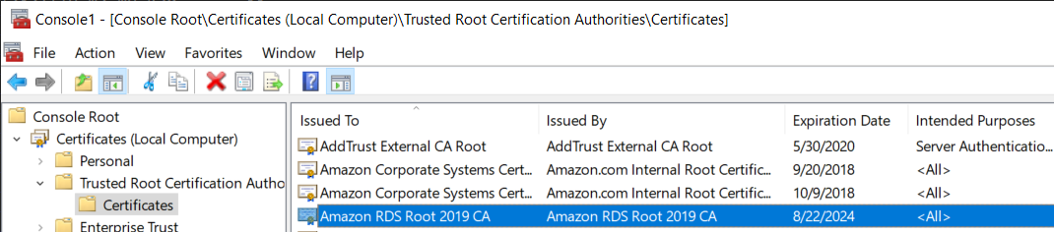

You can force all connections to your DB instance to use SSL, or you can encrypt connections from specific client computers only. To use SSL from a specific client, you must obtain certificates for the client computer, import certificates on the client computer, and then encrypt the connections from the client computer.

If you want to force SSL, use the rds.force_ssl parameter. By default, the rds.force_ssl parameter is set to false. Set the rds.force_ssl parameter to true to force connections to use SSL. The rds.force_ssl parameter is static, so after you change the value, you must reboot your DB instance for the change to take effect.

Hence, the correct answers for this scenario are Options 1 and 2.

Option 3 is incorrect because the transparent data encryption (TDE) is primarily used to encrypt stored data on your DB instances running Microsoft SQL Server, and not the data that are in-transit.

Option 4 is incorrect because IAM database authentication is only supported in MySQL and PostgreSQL database engines. With IAM database authentication, you don't need to use a password when you connect to a DB instance but instead, you use an authentication token.

Option 5 is incorrect because it is not enough to configure the security groups of your EC2 instances and RDS to only allow traffic to and from port 443. You need to either force all connections to your DB instance to use SSL, or you can encrypt connections from specific client computers, just as mentioned above

**When working with Amazon RDS, by default AWS is responsible for implementing which two management-related activities? (Pick 2 correct answers)**

* A. Importing data and optimizing queries



* ​B. Installing and periodically patching the database software



* C. Creating and maintaining automated database backups with a point-in-time recovery of up to five minutes



* ​D. Creating and maintaining automated database backups in compliance with regulatory long-term retention requirements



Once your database is up and running, Amazon RDS automates common administrative tasks such as performing backups and patching the software that powers your database.

**Amazon RDS automated backup feature automatically creates a storage volume snapshot of your DB instance, backing up the entire DB instance and not just individual databases.You can restore to any point in time during your backup retention period. To determine the latest restorable time for a DB instance, use the AWS CLI**[***describe-db-instances***](http://docs.aws.amazon.com/cli/latest/reference/rds/describe-db-instances.html)**command and look at the value returned in the *LatestRestorableTime* field for the DB instance. The latest restorable time for a DB instance is typically within 5 minutes of the current time.**

Option A is wrong as it is user's responsibility

**Option D is wrong as automated backup retention period is maximum 35 days and is not suitable for regulatory requirements. Use manual snapshots instead.**

**After you create a DB instance, you can modify the backup retention period. You can set the backup retention period to between 1 and 35 days. You can also set the backup retention period to 0, which disables automated backups.**

* Security groups:
  + With a DB security group the RDS instance port number is automatically applied.
* **Monitoring:**
  + CloudWatch gathers metrics about CPU utilization from the hypervisor for a DB instance. It does not provide the percentage of the CPU bandwidth and total memory consumed by each database process in your RDS instance, since you do not have direct access to the instances/servers of your RDS database instance and so cannot install a CloudWatch agent.
  + Enhanced Monitoring gathers its metrics from an agent on the instance (more preferable). It helps you identify which processes are having the greatest impact on performance: RDS child processes, RDS processes, and OS processes.

**You are a Big Data Engineer who is assigned to handle the online enrollment system database of a prestigious university, which is hosted in RDS. You are required to monitor the database metrics in Amazon CloudWatch to ensure the availability of the enrollment system.What are the enhanced monitoring metrics that Amazon CloudWatch gathers from Amazon RDS DB instances which provide a more accurate information? (Choose 2)**

* ​The amount of available random access memory.​The average number of disk I/O operations per second during the polling period.​The percentage of CPU utilization.
* ​RDS child processes.​OS processes

**Explanation**

Amazon RDS provides metrics in real time for the operating system (OS) that your DB instance runs on. You can view the metrics for your DB instance using the console, or consume the Enhanced Monitoring JSON output from CloudWatch Logs in a monitoring system of your choice.

CloudWatch gathers metrics about CPU utilization from the hypervisor for a DB instance, and Enhanced Monitoring gathers its metrics from an agent on the instance. As a result, you might find differences between the measurements, because the hypervisor layer performs a small amount of work. The differences can be greater if your DB instances use smaller instance classes, because then there are likely more virtual machines (VMs) that are managed by the hypervisor layer on a single physical instance. Enhanced Monitoring metrics are useful when you want to see how different processes or threads on a DB instance use the CPU.

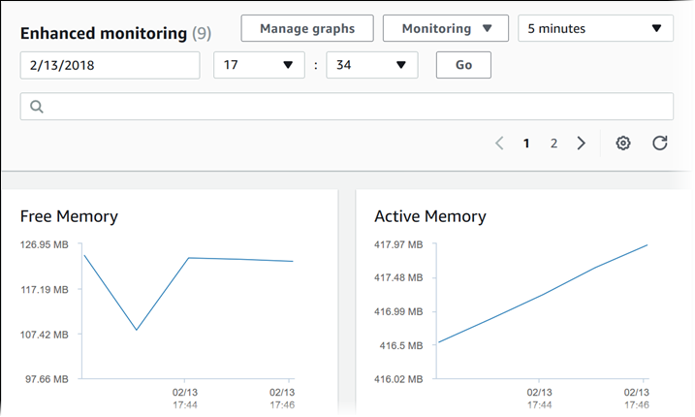

In RDS, the Enhanced Monitoring metrics shown in the Process List view are organized as follows:

**-RDS child processes** – Shows a summary of the RDS processes that support the DB instance, for example aurora for Amazon Aurora DB clusters and mysqld for MySQL DB instances. Process threads appear nested beneath the parent process. Process threads show CPU utilization only as other metrics are the same for all threads for the process. The console displays a maximum of 100 processes and threads. The results are a combination of the top CPU consuming and memory consuming processes and threads. If there are more than 50 processes and more than 50 threads, the console displays the top 50 consumers in each category. This display helps you identify which processes are having the greatest impact on performance.

**-RDS processes** – Shows a summary of the resources used by the RDS management agent, diagnostics monitoring processes, and other AWS processes that are required to support RDS DB instances.

**-OS processes** – Shows a summary of the kernel and system processes, which generally have minimal impact on performance.

* **Boosting performance**:Provision a larger RDS instance with provisioned IOPS.
  + Add an RDS Read Replica for increased read performance.Use ElastiCache to cache frequently read, static data. Use IOPS for OLTP in production environment.To increase the number of IOPS available to a MySQL database on the root volume of an EC2 instance, add (at minimum) 4 additional EBS SSD volumes and create a RAID 10 using these volumes.
* Limits:
  + Oracle has a limit of 1 database on a single instance.
  + SQL Server has a limit of up to 100 databases on a single instance.
  + Both the Oracle and SQL Server database engines have limits due to licensing.
  + The open-source database engines such as Aurora, MySQL, MariaDB or PostgreSQL have no such limits.

When you create or modify your DB instance to run as a Multi-AZ deployment, Amazon RDS automatically provisions and maintains a synchronous **standby**replica in a different Availability Zone. Updates to your DB Instance are synchronously replicated across Availability Zones to the standby in order to keep both in sync and protect your latest database updates against DB instancefailure. 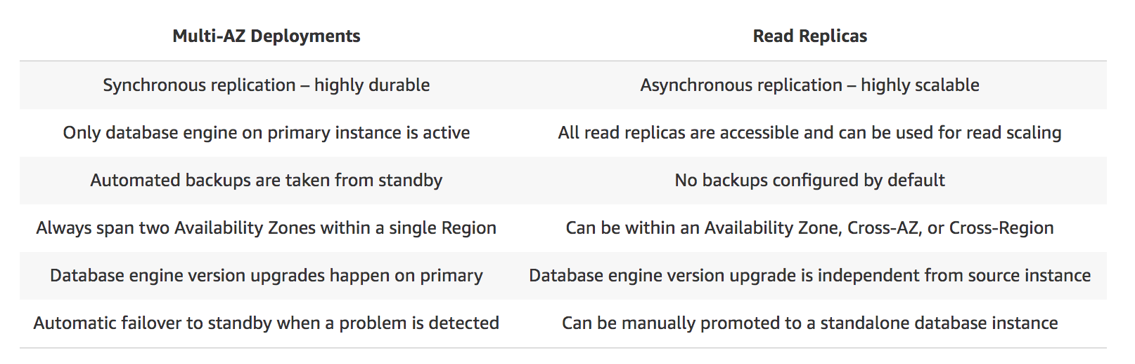

**You are designing a multi-tier web application architecture that consists of a fleet of EC2 instances and an Oracle relational database server. It is required that the database is highly available and that you have full control over its underlying operating system.  
Which AWS service will you use for your database tier?**

* ​Amazon RDS



* ​Amazon RDS with Multi-AZ deployments



* ​Amazon EC2 instances with data replication in one Availability Zone



* ​Amazon EC2 instances with data replication between two different Availability Zones



**Explanation**

To achieve this requirement, you can deploy your Oracle database to Amazon EC2 instances with data replication between two different Availability Zones. Hence, option 4 is the correct answer. The deployment of this architecture can easily be achieved by using Cloudformation and Quick Start. Please refer to the reference link for information.

The Quick Start deploys the Oracle primary database (using the preconfigured, general-purpose starter database from Oracle) on an Amazon EC2 instance in the first Availability Zone. It then sets up a second EC2 instance in a second Availability Zone, copies the primary database to the second instance by using the DUPLICATE command, and configures Oracle Data Guard.

**A Forex trading platform, which frequently processes and stores global financial data every minute, is hosted in your on-premises data center and uses an Oracle database. Due to a recent cooling problem in their data center, the company urgently needs to migrate their infrastructure to AWS to improve the performance of their applications. As the Solutions Architect, you are responsible in ensuring that the database is properly migrated and should remain available in case of database server failure in the future. Which of the following is the most suitable solution to meet the requirement?**

* ​Launch an Oracle database instance in RDS with Recovery Manager (RMAN) enabled.



* ​Launch an Oracle Real Application Clusters (RAC) in RDS.



* ​Create an Oracle database in RDS with Multi-AZ deployments.



* ​Migrate your Oracle data to Amazon Aurora by converting the database schema using AWS Schema Conversion Tool and AWS Database Migration Service.



**Explanation**

Amazon RDS Multi-AZ deployments provide enhanced availability and durability for Database (DB) Instances, making them a natural fit for production database workloads. When you provision a Multi-AZ DB Instance, Amazon RDS automatically creates a primary DB Instance and synchronously replicates the data to a standby instance in a different Availability Zone (AZ). Each AZ runs on its own physically distinct, independent infrastructure, and is engineered to be highly reliable.

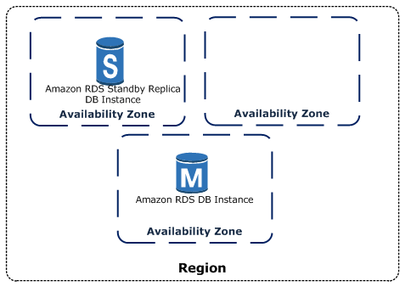

In case of an infrastructure failure, Amazon RDS performs an automatic failover to the standby (or to a read replica in the case of Amazon Aurora), so that you can resume database operations as soon as the failover is complete. Since the endpoint for your DB Instance remains the same after a failover, your application can resume database operation without the need for manual administrative intervention.

In this scenario, the best RDS configuration to use is an Oracle database in RDS with Multi-AZ deployments to ensure high availability even if the primary database instance goes down. Hence, Option 3 is the correct answer.

Options 1 and 2 are incorrect because Oracle RMAN and RAC are not supported in RDS.

Option 4 is incorrect because although this solution is feasible, it takes time to migrate your Oracle database to Aurora which is not acceptable. Based on this option, the Aurora database does not have a Read Replica and is not configured as an Amazon Aurora DB cluster, which could have improved the availability of the database.

* **Multi-AZ:**Allows you to have an exact copy of your production database in another AZWrites to the production database are automatically synchronized to the standby database.The standby instance will not perform any read and write operations while the primary is running. s Multi-AZ RDS provides the resiliency with minimal downtime. **Multi-AZ works by maintaining a synchronous copy of the database in a different AZ within the same region.** Iprovides **high availability and automatic failover support and is NOT a scaling solution..transaction success is returned only if the commit is successful both on the primary and the standby DB**.Oracle, PostgreSQL, MySQL, and MariaDB DB instances use **Amazon technology**, while SQL Server DB instances use SQL **Server Mirroring**.**snapshots and backups are taken from standby & eliminate I/O freezes**
* **Failover:**
  + In case of planned database maintenance, instance failure, or an AZ failure, Amazon RDS will automatically failover to the standby without any administrative intervention.
  + When failing over, Amazon RDS simply flips the CNAME record to point at the standby.

Amazon RDS automatically performs a failover in the event of any of the following:

* Loss of availability in primary Availability Zone
* Loss of network connectivity to primary
* Compute unit failure on primary
* Storage failure on primary
  + You can force a failover from one AZ to another by rebooting the RDS instance.
* Used primarily for disaster recovery (DR), not for improving performance.
* Available for all databases except Aurora (it is completely fault-tolerant by default)
* RDS Reserved instances are also available for Multi-AZ deployments.

**Read replica**

* Allows you to have a read-only copy of your production database.
* **Provides an asynchronous replication instead of synchronous.There is no charge associated with data transfer.Used primarily for very read-heavy database workloads.Must have automatic backups turned on.Up to 5 read replicas can be created.**

Correct answer is **B** as Read replicas are asynchronously replicated they might have stale data and if the application is fine with it, the SELECT queries can be redirected to the Read Replicas reducing the load on the primary database.Amazon RDS Read Replicas provide enhanced performance and durability for database (DB) instances. This feature makes it easy to elastically scale out beyond the capacity constraints of a single DB instance for read-heavy database workloads. You can create one or more replicas of a given source DB Instance and serve high-volume application read traffic from multiple copies of your data, thereby increasing aggregate read throughput. Read replicas can also be promoted when needed to become standalone DB instances.

* + Can be created from another read replicas (but watch out for latency)Can be created from a Multi-AZ database.Can be created in another region.Has its own DNS endpoint.Can be Multi-AZ.Can be promoted to be its own database.
* updates are **asynchronously** copied to the Read Replica, and data might be stale
* can help **scale applications** and **reduce read only load**
* **requires automatic backups enabled**
* **replicates all databases** in the source DB instance
* for disaster recovery, can be **promoted to a full fledged database**

**Backups**

* **Automated backups:**Recover the database to any point in time within a "retention period".The retention period can be within one and 35 days.Takes a full daily snapshot and also stores transaction logs throughout the day.
  + Recovery: Chooses the most recent backup and then applies transaction logs.
  + **With new RDS DB instances, automated backups are enabled by default.The backup data is stored in S3 and the storage is free (= the size of DB)Backups are taken within a specified time window.**
* **Database snapshots:**
  + Done manually (i.e. user initiated)They are stored even after you delete the original RDS instance, unlike automated backups.One can take a final snapshot before deleting the RDB.
* The restored version of the database with be a new RDS instance with a new DNS endpoint.
  + [original.us-east-1.rds.amazonaws.com](http://original.us-east-1.rds.amazonaws.com/) to [restored.us-east-1.rds.amazonaws.com](http://restored.us-east-1.rds.amazonaws.com/)
* During a database snapshot or backup, I/O may be briefly suspended while the backup process initializes (typically under a few seconds), and you may experience a brief period of elevated latency.
* In RDS, changes to the backup window take effect immediately.

**You are working for an insurance firm as their Senior Solutions Architect. The firm has an application which processes thousands of customer data stored in an Amazon MySQL database with Multi-AZ deployments configuration for high availability in case of downtime. For the past few days, you noticed an increasing trend of read and write operations, which is increasing the latency of the queries to your database. You are planning to use the standby database instance to balance the read and write operations from the primary instance.**

**When running your primary Amazon RDS Instance as a Multi-AZ deployment, can you use the standby instance for read and write operations?**

* ​YesOnly with Microsoft SQL Server-based RDS​Only for Oracle RDS instances



* ​No **Explanation**



The answer is No. The standby instance will not perform any read and write operations while the primary instance is running. Hence, Option 4 is the correct answer.

**You are trying to convince a team to use Amazon RDS Read Replica for your multi-tier web application. What are two benefits of using read replicas? (Choose 2)**

* ​It provides elasticity to your Amazon RDS database.



* ​Allows both read and write operations on the read replica to complement the primary database.



* ​Improves performance of the primary database by taking workload from it.



* ​Automatic failover in the case of Availability Zone service failures.



* ​It enhances the read performance of your primary database.



**Explanation**

Amazon RDS Read Replicas provide enhanced performance and durability for database (DB) instances. This feature makes it easy to elastically scale out beyond the capacity constraints of a single DB instance for read-heavy database workloads.You can create one or more replicas of a given source DB Instance and serve high-volume application read traffic from multiple copies of your data, thereby increasing aggregate read throughput. Read replicas can also be promoted when needed to become standalone DB instances. Read replicas are available in Amazon RDS for MySQL, MariaDB, Oracle and PostgreSQL, as well as Amazon Aurora.

**Aurora (serverless)**

* Up to five times better performance than MySQL at a price point one tenth that of a commercial RDBMS.Amazon Aurora is a MySQL and PostgreSQL-compatible relational database.Starts with 10GB and auto-scales in 10GB increments to 64TB.Computes resources can scale up to 34vCPUs and 244GB of memory.
* Amazon Aurora typically involves a cluster of DB instances instead of a single instance.
* Maintains a total of 6 copies of data: 2 copies in each AZ with minimum of 3 AZ's.
  + Thus, Aurora is available only in regions with minimum of 3 AZ's.Designed to transparently handle the loss of up to two copies of data without affecting write availability and up to three copies without affecting read availability.
  + Aurora Serverless can scale down to zero instances during periods of no load. There is a brief startup time, but because of the shared storage, it happens in less than a minute.
* Aurora storage is self-healing:Data blocks and disks are continuously scanned for errors and repaired automatically.
* Two types of replicas available:

Aurora replicas with automatic failover (currently 15) Aurora Replicas are independent endpoints in an Aurora DB cluster, best used for scaling read operations and increasing availability. Up to 15 Aurora Replicas can be distributed across the Availability Zones that a DB cluster spans within an AWS Region. The DB cluster volume is made up of multiple copies of the data for the DB cluster. However, the data in the cluster volume is represented as a single, logical volume to the primary instance and to Aurora Replicas in the DB cluster.

* As a result, all Aurora Replicas return the same data for query results with minimal replica lag—usually much less than 100 milliseconds after the primary instance has written an update. Replica lag varies depending on the rate of database change. That is, during periods where a large amount of write operations occur for the database, you might see an increase in replica lag.
* Aurora Replicas work well for read scaling because they are fully dedicated to read operations on your cluster volume. Write operations are managed by the primary instance. Because the cluster volume is shared among all DB instances in your DB cluster, minimal additional work is required to replicate a copy of the data for each Aurora Replica.
  + MySQL read replicas (currently 5)
* **Backups:**Automatic backups are always enabled.Backups do not impact database performance.You can take snapshots, also without impacting database performance.
  + **You can share Aurora snapshots with other AWS accounts**.
* **Endpoints:**For certain Aurora tasks, different instances or groups of instances perform different roles.Using endpoints, you can map connection to the appropriate instance group based on your use case.The custom endpoint provides load-balanced database connections based on criteria other than the read-only or read-write capability of the DB instances.
  + For example, you might direct internal users to low-capacity instances for report generation or ad hoc (one-time) querying, and direct production traffic to high-capacity instances

**An online shopping platform is hosted on an Auto Scaling group of Spot EC2 instances and uses Amazon Aurora PostgreSQL as its database. There is a requirement to optimize your database workloads in your cluster where you have to direct the write operations of the production traffic to your high-capacity instances and point the reporting queries sent by your internal staff to the low-capacity instances.Which is the most suitable configuration for your application as well as your Aurora database cluster to achieve this requirement?**

* ​Configure your application to use the reader endpoint for both production traffic and reporting queries, which will enable your Aurora database to automatically perform load-balancing among all the Aurora Replicas.



* ​In your application, use the instance endpoint of your Aurora database to handle the incoming production traffic and use the cluster endpoint to handle reporting queries.



* ​Create a custom endpoint in Aurora based on the specified criteria for the production traffic and another custom endpoint to handle the reporting queries.



* ​Do nothing since by default, Aurora will automatically direct the production traffic to your high-capacity instances and the reporting queries to your low-capacity instances.



**Explanation**

Amazon Aurora typically involves a cluster of DB instances instead of a single instance. Each connection is handled by a specific DB instance. When you connect to an Aurora cluster, the host name and port that you specify point to an intermediate handler called an *endpoint*. Aurora uses the endpoint mechanism to abstract these connections. Thus, you don't have to hardcode all the hostnames or write your own logic for load-balancing and rerouting connections when some DB instances aren't available.For certain Aurora tasks, different instances or groups of instances perform different roles. For example, the primary instance handles all data definition language (DDL) and data manipulation language (DML) statements. Up to 15 Aurora Replicas handle read-only query traffic.



Using endpoints, you can map each connection to the appropriate instance or group of instances based on your use case. For example, to perform DDL statements you can connect to whichever instance is the primary instance. To perform queries, you can connect to the reader endpoint, with Aurora automatically performing load-balancing among all the Aurora Replicas. For clusters with DB instances of different capacities or configurations, you can connect to custom endpoints associated with different subsets of DB instances. For diagnosis or tuning, you can connect to a specific instance endpoint to examine details about a specific DB instance.

* + A MySQL database can be migrated to Aurora by creating an Aurora replica and then promoting it, or creating a snapshot and then restoring from it.

**You are reviewing and improving an application that uses a relational database and is currently hosted on a single-AZ RDS MySQL database. The application database pattern is 20% writes and 80% reads and is showing signs of read slowdown. You need to make changes to allow the application to scale much more effectively. What would provide the most scalability?**

AModify the application to use DynamoDB in relational mode and enable Auto Scaling.

BAdd read replicas to the RDS cluster. CMigrate the database to Aurora and add replicas.

DModify the RDS instance and enable Multi-AZ.

**Your Answer: B**Read replicas might help, but they aren't part of a cluster architecture and cannot be addressed as a pool. There is a large management overhead to be able to connect to them collectively from an application.

**Correct Answer: C**Aurora is MySQL compatible, and the migration path from RDS MySQL is well documented and low risk. Aurora replicas can be used to scale reads across the cluster.

Remember that a relational database system **does not scale** well for the following reasons:

-It normalizes data and stores it on multiple tables that require multiple queries to write to disk.

-It generally incurs the performance costs of an ACID-compliant transaction system.

-It uses expensive joins to reassemble required views of query results.

For DynamoDB, it scales well due to these reasons:

-Its**schema flexibility** lets DynamoDB store complex hierarchical data within a single item. DynamoDB is not a totally *schemaless* database since the very definition of a schema is just the model or structure of your data.

-Composite key design lets it store related items close together on the same table.

**You are an IT Consultant for a top investment bank which is in the process of building its new Forex trading platform. To ensure high availability and scalability, you designed the trading platform to use an Elastic Load Balancer in front of an Auto Scaling group of On-Demand EC2 instances across multiple Availability Zones. For its database tier, you chose to use a single Amazon Aurora instance to take advantage of its distributed, fault-tolerant and self-healing storage system.**

**In the event of system failure on the primary database instance, what happens to Amazon Aurora during the failover?**

* ​Amazon Aurora flips the canonical name record (CNAME) for your DB Instance to point at the healthy replica, which in turn is promoted to become the new primary.
* ​Aurora will first attempt to create a new DB Instance in the same Availability Zone as the original instance. If unable to do so, Aurora will attempt to create a new DB Instance in a different Availability Zone.
* ​Amazon Aurora flips the A record of your DB Instance to point at the healthy replica, which in turn is promoted to become the new primary.​Aurora will first attempt to create a new DB Instance in a different Availability Zone of the original instance. If unable to do so, Aurora will attempt to create a new DB Instance in the original Availability Zone in which the instance was first launched.

**Explanation**

Failover is automatically handled by Amazon Aurora so that your applications can resume database operations as quickly as possible without manual administrative intervention.

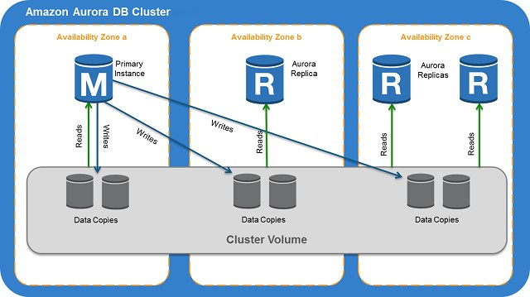

If you have an Amazon Aurora Replica in the same or a different Availability Zone, when failing over, Amazon Aurora flips the canonical name record (CNAME) for your DB Instance to point at the healthy replica, which in turn is promoted to become the new primary. Start-to-finish, failover typically completes within 30 seconds.

If you are running Aurora Serverless and the DB instance or AZ become unavailable, Aurora will automatically recreate the DB instance in a different AZ.

If you do not have an Amazon Aurora Replica (i.e. single instance) and are not running Aurora Serverless, Aurora will attempt to create a new DB Instance in the same Availability Zone as the original instance. This replacement of the original instance is done on a best-effort basis and may not succeed, for example, if there is an issue that is broadly affecting the Availability Zone.

Hence, the correct answer is Option 2.

Options 1 and 3 are incorrect because this will only happen if you are using an Amazon Aurora Replica. In addition, Amazon Aurora flips the canonical name record (CNAME) and not the A record (IP address) of the instance.

Option 4 is incorrect because Aurora will first attempt to create a new DB Instance in the same Availability Zone as the original instance. If unable to do so, Aurora will attempt to create a new DB Instance in a different Availability Zone and not the other way around.

**A top university has recently launched its online learning portal where the students can take e-learning courses from the comforts of their homes. The portal is on a large On-Demand EC2 instance with a single Amazon Aurora database.   How can you improve the availability of your Aurora database to prevent any unnecessary downtime of the online portal?**

* ​Create Amazon Aurora Replicas.
* ​Deploy Aurora to two Auto-Scaling groups of EC2 instances across two Availability Zones with an elastic load balancer which handles load balancing.
* ​Enable Hash Joins to improve the database query performance.Use an Asynchronous Key Prefetch in Amazon Aurora to improve the performance of queries that join tables across indexes.

**Explanation**

Amazon Aurora MySQL and Amazon Aurora PostgreSQL support Amazon Aurora Replicas, which share the same underlying volume as the primary instance. Updates made by the primary are visible to all Amazon Aurora Replicas. With Amazon Aurora MySQL, you can also create MySQL Read Replicas based on MySQL's binlog-based replication engine. In MySQL Read Replicas, data from your primary instance is replayed on your replica as transactions. For most use cases, including read scaling and high availability, it is recommended using Amazon Aurora Replicas.

Read Replicas are primarily used for improving the read performance of the application. The most suitable solution in this scenario is to use Multi-AZ deployments instead but since this option is not available, you can still set up Read Replicas which you can promote as your primary stand-alone DB cluster in the event of an outage.

Hence, the right answer here is Option 1.

Option 2 is incorrect because Aurora is a database engine for RDS and not deployed on a typical EC2 instance.

Option 3 is incorrect because Hash Joins are mainly used if you need to join a large amount of data by using an equijoin and not for improving availability.

Option 4 is incorrect because the Asynchronous Key Prefetch is mainly used to improve the performance of queries that join tables across indexes.

**DynamoDB (serverless)**

It is a fully managed database (Unstructured ) and supports both document and key-value data models(JSON).Amazon DynamoDB is designed to deliver consistent, fast performance at any scale for all applications. Average service-side latencies are typically single-digit milliseconds. As your data volumes grow and application performance demands increase, Amazon DynamoDB uses automatic partitioning and SSD technologies to meet your throughput requirements and deliver low latencies at any scale. e business wants the most suitable low-cost solution available within AWS

Option A is wrong as RDS does not provide single-digit milliseconds performance nor does it is highly scalable.

Option B is wrong as Redshift is a data warehousing solution.

Option D is wrong as Aurora does not meet the single-digit milliseconds. You can further scale read operations using read replicas that have very low 10 ms latency.

* Use cases:
  + Managing items in a document format such as JSON, XML, and HTML.
  + DynamoDB Time-to-Live (TTL) mechanism enables you to manage web sessions.
  + Smaller data elements (such as metadata) or file pointers are best saved in DynamoDB.
  + Great fit for mobile, web, gaming, ad-tech, IoT, and many other applications.
* Highly efficient:The database is partitioned across a number of nodes.
  + Stored on SSD storage.
* Highly durable:**DynamoDB data is automatically** synchronously **replicated across three different AZs.**
* **DynamoDB allows for the storage of large text and binary objects.**
  + But there is a limit of 400 KB which includes both attribute name and value lengths.
* The DynamoDB low-level API accepts HTTP(S) POST requests as input.
  + Accepts Headers attributes *Host*, *Accept-Encoding*, *Content-Length*, *User-Agent*, *Content-Type*, *Authorization*, *X-Amz-Date*, and *X-Amz-Target*
* **Pricing:**There will always be a charge for provisioning read and write capacity and the storage of data.There is no charge for the transfer of data into DynamoDB, providing you stay within a single region (if you cross regions, you will be charged at both ends of the transfer)
  + There is no charge for the actual number of tables you can create in DynamoDB, providing the RCU and WCU are set to 0, however in practice you cannot set this to anything less than 1 so there always be a nominal fee associated with each table.
* **Consumption:**Consumption is measured in terms of load on each individual partition, as well as load on each Local & Global Secondary Index.
  + If you receive a ProvisionedThroughputExceededException error, the throughput is not balanced across your partitions.Use partition keys with high-cardinality features to distribute the I/O requests evenly and not avoid "hot" partitions.A composite primary key will provide more partition for the table and in turn, improves the performance.
* supports **cross region replication** using DynamoDB streams which leverages Kinesis and provides **time-ordered sequence of item-level changes** and can help for lower RPO, lower RTO disaster recovery
* Data Pipeline jobs with EMR can be used for disaster recovery with higher RPO, lower RTO requirements
* supports**triggers**to allow execution of custom actions or notifications based on item-level updates
* **DynamoDB Streams:**
  + Whenever an application creates, updates, or deletes items in the table, DynamoDB Streams writes a stream record with the primary key attribute(s) of the items that were modified.Can be configured to include the "before" and "after" images of modified items.
  + With triggers, you can build applications that react to data modifications in DynamoDB tables.**Remember that the DynamoDB Stream feature is not enabled by default.**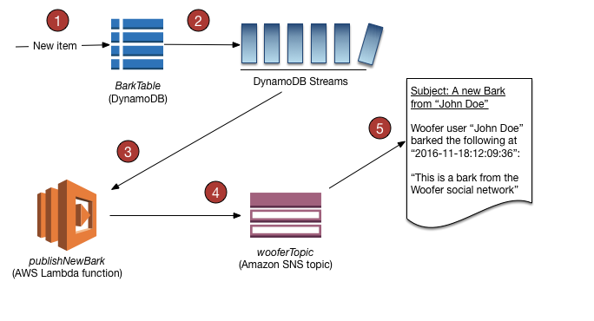
* Scales well due to these reasons:
  + Its schema flexibility lets DynamoDB store complex hierarchical data within a single item.
  + Composite key design lets it store related items close together on the same table.
* [**Amazon DynamoDB Accelerator (DAX)**](https://aws.amazon.com/dynamodb/dax/)**:**
  + A fully managed, highly available, in-memory cache that can reduce Amazon DynamoDB response times from milliseconds to microseconds.

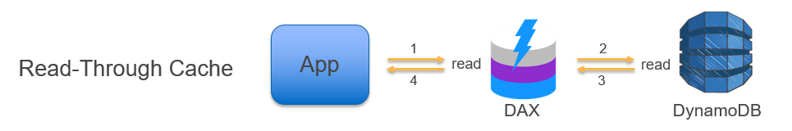

* If a shard iterator expires unexpectedly:
  + The DynamoDB table used by Kinesis does not have enough capacity to store the lease data.

**Modeling**

* You design your schema specifically to make the most common and important queries as fast and as inexpensive as possible.
* You don’t think servers:The biggest entity that concerns you is a table. And anything beyond that is a dark box.Rows are items, and cells are attributes.
* Each table has a primary key:
  + They can be either simple (a partition key) or composite (a partition key and a sort key)The partition key tells what partition will physically store the data.
  + Partition keys and sort keys can contain only one attribute.

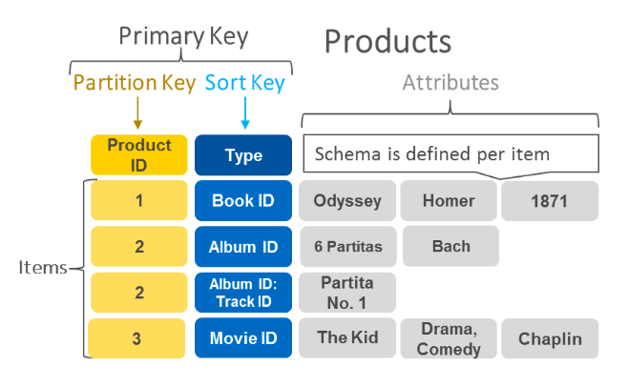

**Consistency**

* Eventual consistent reads:The response might not reflect the results of a recently completed write operation.If you repeat your read request after a short time, the response should return the latest data.
* **Strongly consistent reads:**DynamoDB returns a response with the most up-to-date data.
  + For example, for a financial algorithm of life critical systems or a booking system.
  + A strongly consistent read might not be available if there is a network delay or outage.
  + Associated with an increased cost.
* key issue is the delay and timeouts are experienced for popular products only, it would be cause of the hot partition. As a long term solution, it would make sense to change the partition key to a hash to better distribute the data.
* To avoid hot partitions and throttling, you must optimize your table and partition structure.
* Distribute your read operations and write operations as evenly as possible across your table. A "hot" partition can degrade the overall performance of your table.
* Option B is wrong as DAX would help improve performance, but does not address the root cause.
* configuring DynamoDB Auto Scaling can enable DynamoDB scale the provisioned throughput as per the demand in a cost-efficient manner.
* Amazon DynamoDB auto scaling uses the AWS Application Auto Scaling service to dynamically adjust provisioned throughput capacity on your behalf, in response to actual traffic patterns. This enables a table or a global secondary index to increase its provisioned read and write capacity to handle sudden increases in traffic, without throttling. When the workload decreases, Application Auto Scaling decreases the throughput so that you don't pay for unused provisioned capacity.

**Your web application reads an item from your DynamoDB table, changes an attribute, and then writes the item back to the table. You need to ensure that one process doesn't overwrite a simultaneous change from another process. How can you ensure concurrency?**

* ​A. Implement optimistic concurrency by using a conditional write.



* B. Implement pessimistic concurrency by using a conditional write.



* ​C. Implement optimistic concurrency by locking the item upon read.



* ​D. Implement pessimistic concurrency by locking the item upon read.



#### ExplanationCorrect answer is **A** as Optimistic concurrency depends on checking a value upon save to ensure that it has not changed.

Local vs Global secondary index

* shares partition key + different sort key vs different partition + sort key
* search limited to partition vs across all partition
* unique attributes vs non unique attributes
* linked to the base table vs independent separate index
* only created during the base table creation vs can be created later
* cannot be deleted after creation vs can be deleted
* consumes provisioned throughput capacity of the base table vs independent throughput
* returns all attributes for item vs only projected attributes
* Eventually or Strongly vs Only Eventually consistent reads
* size limited to 10Gb per partition vs unlimited

**Your application needs to perform 100 eventually consistent reads per second from DynamoDB. Each read is 7 KB in size. What is the minimum number of RCUs required to meet this demand?**

A700 B100 C200 D350

**Your Answer: C**For each 7 KB read, two RCUs are used, since an RCU is 4 KB. If the demand was for **strongly consistent reads**, the application would need 200 RCU, but this question pertains to **eventually consistent reads**.

**Correct Answer: B**Since eventually consistent reads are needed, then 100 RCUs is enough. Each read is 2 RCU (7 KB rounded to 8 KB), but **eventually consistent reads** are half the cost of strongly consistent ones.

**You are reviewing poor performance on a voting application running on DynamoDB. The table used to store votes has been allocated 5,000 WCU, but with three candidates you are achieving slightly over half of the expected write throughput to the table. Votes are written with a PK of candidate name and sort key of date and time. What could be a possible reason for the substandard performance?**

AThe partition key structure is the issue.

BDynamoDB cannot support 5,000 writes per second — buffer the writes or use DAX to improve write performance.

CThe sort key structure is the issue.

DYou are trying to do strongly consistent writes, which need 2x the WCU.

**Correct Answer: A**Each occurrence of a PK value (candidate1, candidate 2) is stored to one partition. A partition can support a max of 1,000 WCU. The small range of possible PK values is t

# What are Read Write Capacity Units?

Read requests like GetItem are measured in RCUs, while write requests like PutItem are measured in WCUs.

DynamoDB offers two capacity modes. The first is Provisioned Capacity where you configure how many units you want to have available each second. If you use more, your excess requests will be throttled and fail. You’re billed for both used and unused units.

Alternatively, as of reInvent 2018, you can use On-Demand Capacity to pay for only the RCUs and WCUs you actually use. This mode can reduce your bill even though each request costs more.

This changes **based on the size of the item(s)** being read or written. You can calculate an item’s size using the rules below, or you can see how many units were consumed by setting the ReturnConsumedCapacity property on your requests.

Note that I’ll be using the **KB** suffix to denote **1,024 bytes**.

## Read RequestsAn [eventually-consistent](https://docs.aws.amazon.com/amazondynamodb/latest/developerguide/HowItWorks.ReadConsistency.html) read (the default type), will use **0.5 RCUs for every 4,096 (4 KB) or part thereof**. The only thing that changes for strongly-consistent reads is that they use **1 RCU per 4 KB** (twice as much). Items can be up to 400 KB, so reads can range from 0.5 to 100 RCUs.

When requesting items that don’t exist, GetItem will still use the minimum 0.5 or 1 RCU (depending on the consistency model being used).

## Write RequestsWrites use 1 WCU for every 1,024 bytes (1 KB) or part thereof. Again, items can be up to 400 KB, so writes can range from 1 to 400 WCUs.

When overwriting items (PutItem), the size will be the **larger of the new and old versions**. For example, replacing a 2 KB item with a 1 KB one will consume 2 WCUs. Subsequent requests will only use 1 WCU.

When modifying items (UpdateItem), the size **includes all of the item’s pre-existing attributes**, not just the ones being added or updated.

When deleting items (DeleteItem), the size is that of the **item being deleted**. If the item doesn’t exist, the request will use 1 WCU. Deletes via [Time To Live](https://docs.aws.amazon.com/amazondynamodb/latest/developerguide/TTL.html) don’t consume any WCUs.

Any request with a [conditional expression](https://docs.aws.amazon.com/amazondynamodb/latest/developerguide/WorkingWithItems.html#WorkingWithItems.ConditionalUpdate) will consume the same number of WCUs, following the above rules, regardless of whether the condition evaluates to true or false.

## Batches

The total RCUs or WCUs consumed by a batched request is simply the **sum of those used by each individual request**.

A single BatchGetItem operation can contain up to 100 individual GetItem requests and can retrieve up to 16 MB of data. In addition, a BatchGetItem operation can retrieve items from multiple tables.

The BatchWriteItem operation can contain up to 25 individual PutItem and DeleteItem requests and can write up to 16 MB of data. (The maximum size of an individual item is 400 KB.) In addition, a BatchWriteItem operation can put or delete items in multiple tables. BatchWriteItem does not support UpdateItem requests.

## Transactions

When using transactions, DynamoDB performs **two underlying reads or writes of every item in the transaction**: one to prepare the transaction and one to commit it.

Transactional **reads use 2 RCUs per 4 KB** or part thereof, which is double a normal strongly-consistent read. **Writes use 2 RCUs per 1 KB** or part thereof, which is double a normal write. The total units consumed by a transactional request is the **sum of those used by each individual request**. It’s essentially double the size of a batch request (with strongly-consistent reads).

**Read Capacity**

(ITEM SIZE (rounded up to the next 4KB multiplier) / 4KB) * # of items

(Round up to the nearest 4 KB multiplier)

**Write Capacity**

(ITEM SIZE (rounded up to the next 1KB multiplier) / 1KB) * # of items

(Round up to the nearest 1 KB multiplier)

**EXAMPLE #1 READ CAPACITY**--We have an item size of 3 KB and we want to read 80 (strongly consistent read) items per second per table. What is the read capacity required?

 80 * (3KB (round up to 4) / 4KB)

80 * 1 = 80 required provisioned read throughput

♣Eventually consistent reads would cut that in half:

(80 * 1) / 2 = 40 required read capacity

**EXAMPLE #2 WRITE CAPACITY** --We need 10 writes per second, and we have an item of size 1.5KB, how much throughput is required?•(ITEM SIZE (1.5KB) / 1 KB) x 10 = 20 capacity units

1. You need to migrate 10 million records in one hour into DynamoDB. All records are 1.5KB in size. The data is evenly distributed across the partition key. How many write capacity units should you provision during this batch load?
   1. 6667
   2. 4166
   3. **5556**( 2 write units (1 for each 1KB) * 10 million/3600 secs)
   4. 2778
2. A meteorological system monitors 600 temperature gauges, obtaining temperature samples every minute and saving each sample to a DynamoDB table. Each sample involves writing 1K of data and the writes are evenly distributed over time. How much write throughput is required for the target table?
   1. 1 write capacity unit
   2. **10 write capacity units**( 1 write unit for 1K * 600 gauges/60 secs)
   3. 60 write capacity units
   4. 600 write capacity units
   5. 3600 write capacity units
3. A company is building a system to collect sensor data from its 36000 trucks, which is stored in DynamoDB. The trucks emit 1KB of data once every hour. How much write throughput is required for the target table. Choose an answer from the options below
   1. **10**
   2. 60
   3. 600
   4. 150
4. A company is using DynamoDB to design storage for their IOT project to store sensor data. Which combination would give the highest throughput?
   1. **5 Eventual Consistent reads capacity with Item Size of 4KB** (40KB/s)
   2. 15 Eventual Consistent reads capacity with Item Size of 1KB (30KB/s)
   3. 5 Strongly Consistent reads capacity with Item Size of 4KB (20KB/s)
   4. 15 Strongly Consistent reads capacity with Item Size of 1KB (15KB/s)
5. If your table item’s size is 3KB and you want to have 90 strongly consistent reads per second, how many read capacity units will you need to provision on the table? Choose the correct answer from the options below
   1. **90**
   2. 45
   3. 10
   4. 19

**ElastiCache**

* Supports two open-source in-memory caching engines: Memcached and Redis.
  + For a simple cache to offload DB, use Memcached.
  + For a cache with more advanced capabilities (Multi-AZ, backups Pub/Sub, Sorted Sets and an In-Memory Data Store.), use Redis.
* Elasticache for Memcached does not offer a native encryption service, while Elasticache for Redis does.

Use Redis AUTH command to improve data security by requiring the user to enter a password before they are granted permission to execute Redis commands on a password-protected Redis server.

* + Include --auth-token with the password when creating/modifying the replication group.

**You are designing a banking portal which uses Amazon ElastiCache for Redis as its distributed session management component. Since the other Cloud Engineers in your department have access to your ElastiCache cluster, you have to secure the session data in the portal by requiring them to enter a password before they are granted permission to execute Redis commands.   As the Solutions Architect, which of the following should you do to meet the above requirement?**

* Set up an IAM Policy and MFA which requires the Cloud Engineers to enter their IAM credentials and token before they can access the ElastiCache cluster.



* ​Set up a Redis replication group and enable the AtRestEncryptionEnabled parameter.



* ​Authenticate the users using Redis AUTH by creating a new Redis Cluster with both the --transit-encryption-enabled and --auth-token parameters enabled.



* ​Enable the in-transit encryption for Redis replication groups.



**Explanation**

Using Redis AUTH command can improve data security by requiring the user to enter a password before they are granted permission to execute Redis commands on a password-protected Redis server. Hence, Option 3 is the correct answer.

To require that users enter a password on a password-protected Redis server, include the parameter **--auth-token** with the correct password when you create your replication group or cluster and on all subsequent commands to the replication group or cluster.

* What is Multi-AZ for ElastiCache for Redis?
* An ElastiCache for Redis shard consists of a primary and up to five read replicas. Redis asynchronously replicates the data from the primary to the read replicas. During certain types of planned maintenance, or in the unlikely event of ElastiCache node failure or Availability Zone failure, Amazon ElastiCache will automatically detect the failure of a primary, select a read replica, and promote it to become the new primary. ElastiCache also propagates the DNS changes of the promoted read replica, so if your application is writing to the primary node endpoint, no endpoint change will be needed.
* Q: What are the benefits of using Multi-AZ?
* The main benefits of running your ElastiCache for Redis in Multi-AZ mode are enhanced availability and smaller need for administration. If an ElastiCache for Redis primary node failure occurs, the impact on your ability to read/write to the primary is limited to the time it takes for automatic failover to complete. When Multi-AZ is enabled, ElastiCache node failover is automatic and requires no administration. You no longer need to monitor your Redis nodes and manually initiate a recovery in the event of a primary node disruption.

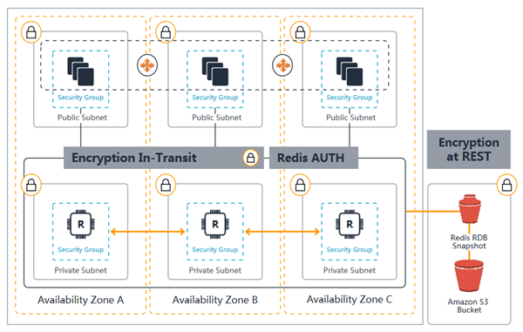

* ElastiCache with Redis,
  + like RDS, supports **Multi-AZ, Read Replicas and Snapshots**
  + Read Replicas are created across AZ within same region using **Redis’s asynchronous replication technology**
  + Multi-AZ differs from RDS as there is no standby, but **if the primary goes down a Read Replica is promoted as primary**
  + **Read Replicas cannot span across regions**, as RDS supports
  + **cannot be scaled out** and **if scaled up cannot be scaled down**
  + **allows snapshots for backup and restore**
  + **AOF** can be enabled for **recovery scenarios**, to recover the data in case the node fails or service crashes. But it does not help in case the underlying hardware fails
  + **Enabling Redis Multi-AZ as a Better Approach to Fault Tolerance**
* ElastiCache with Memcached
  + **can be scaled up by increasing size and scaled out by adding nodes**
  + nodes can **span across multiple AZs** within the same region
  + **cached data is spread across the nodes**, and a node failure will always result in some data loss from the cluster
  + **supports auto discovery**
  + **every node should be homogenous** and of same instance type
* ElastiCache Redis vs Memcached
  + complex data objects vs simple key value storage
  + persistent vs non persistent, pure caching
  + automatic failover with Multi-AZ vs Multi-AZ not supported
  + scaling using Read Replicas vs using multiple nodes
  + backup & restore supported vs not supported
* can be used state management to keep the web application stateless

**You are designing an online banking application which needs to have a distributed session data management. Currently, the application is hosted on an Auto Scaling group of On-Demand EC2 instances across multiple Availability Zones with a Classic Load Balancer that distributes the load.Which of the following options should you do to satisfy the given requirement?**

* ​Set up an AWS Systems Manager Session Manager
* ​Enable the sticky session feature in the Classic Load Balancer
* ​Use Amazon ElastiCache
* ​Use the GetSessionToken action in AWS STS for session management

**Explanation**

In this question, the keyword is **distributed**session data management. Sticky session feature of the Classic Load Balancer can also provide session management, however, take note that this feature has its limitations such as, in the event of a failure, you are likely to lose the sessions that were resident on the failed node. In the event that the number of your web servers change when your Auto Scaling kicks in, it’s possible that the traffic may be unequally spread across the web servers as active sessions may exist on particular servers. If not mitigated properly, this can hinder the scalability of your applications. Hence, sticky session is not scalable or "**distributed**" as compared with ElastiCache.

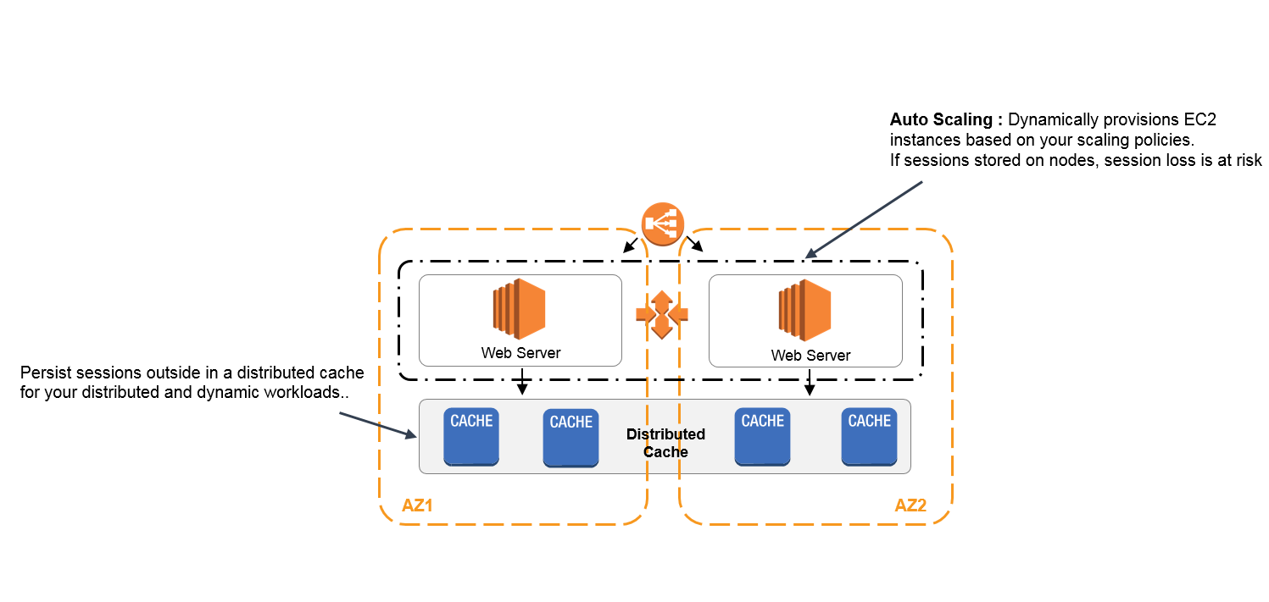

In AWS, you can use Amazon ElastiCache which offers fully managed Redis and Memcached service to manage and store session data for your web applications.

Option 1 is incorrect because the Session Manager is simply a capability that lets you manage your Amazon EC2 instances through an interactive one-click browser-based shell or through the AWS CLI. This does not act as a distributed session data management.

Option 2 is incorrect because although you can use the sticky session feature of the Classic Load Balancer to manage your session data, it is not a "distributed" solution compared to ElastiCache.

Option 4 is incorrect because the GetSessionToken is just one of the available actions in STS which returns a set of temporary credentials for an AWS account or IAM user. This is not used for distributed session data management

**Redshift**

* Data warehouses:Used for business intelligence (tools such as SAP NetWeaver) provides simple and cost-effective solution to analyze all the data using standard SQL and the existing Business Intelligence (BI) tools.
* Redshift Spectrum is a data warehousing solution where you can directly query data from your data warehouse. Redshift is not suitable for storing session state, but more on analytics and OLAP processes.
  + Used to pull in very large and complex datasets.Usually used by management to do queries on data (such as current performance)Amazon's data warehouse solution is called Redshift.
* Can be configured as follows: Single node (160GB)Multi-node: Leader node that manages client connections and receives queries, and compute node that stores data and performs queries and computations. Up to 128 compute nodes are permitted.
* Employs multiple compression techniques.
  + When loading data into Redshift, it automatically samples the data and select the most appropriate compression scheme.
* Massively Parallel Processing (MPP):Automatically distributes data and query load across all nodes.Redshift makes it easy to add nodes and enables you to maintain fast query performance.Doesn't require indexes or materialized views, and so uses less space.
* Backups:Enabled by default with a 1 day retention period and max 35 days

replicates all the data within the data warehouse cluster when it is loaded and also continuously backs up your data to S3.

* + attempts to maintain at least three copies of your data (the original and replica on the compute nodes and a backup in S3). Can asynchronously replicate snapshots to S3 in another region for disaster recoverysupports cross-region snapshot replication to another region for disaster recovery
* Redshift supports four distribution styles; AUTO, EVEN, KEY, or ALL.
  + KEY distribution uses a single column as distribution key (DISTKEY) and helps place matching values on the same node slice
  + Even distribution distributes the rows across the slices in a **round-robin fashion**, regardless of the values in any particular column
  + ALL distribution replicates whole table in every compute node.
  + AUTO distribution lets Redshift assigns an optimal distribution style based on the size of the table data
* Redshift supports Compound and Interleaved sort keys
  + A compound key is made up of all of the columns listed in the sort key definition, in the order they are listed and is more efficient when **query predicates use a prefix, or query’s filter applies conditions, such as filters and joins, which is a subset of the sort key columns in order.**
  + An interleaved sort key gives **equal weight to each column in the sort key, so query predicates can use any subset of the columns that make up the sort key, in any order.**
* Column encodings **CANNOT** be changed once created.

Redshift provides **query queues for Workload Management**, in order to manage concurrency and resource planning. It is a best practice to have separate queues for long running resource-intensive queries and fast queries that don’t require big amounts of memory and CPU

**You are working as an IT Consultant for a large investment bank that generates large financial datasets with millions of rows. The data must be stored in a columnar fashion to reduce the number of disk I/O requests and reduce the amount of data needed to load from the disk. The bank has an existing third-party business intelligence application which will connect to the storage service and then generate daily and monthly financial reports for its clients around the globe. In this scenario, which is the best storage service to use to meet the requirement?**

* ​Amazon Redshift**(Correct)**​Amazon RDS​Amazon Aurora​DynamoDB**(Incorrect)**



**Explanation**

In this scenario, there is a requirement to have a storage service which will be used by a business intelligence application and where the data must be stored in a columnar fashion. Business Intelligence reporting systems is a type of Online Analytical Processing (OLAP) which Redshift is known to support. In addition, Redshift also provides columnar storage unlike the other options. Hence, the correct answer in this scenario is Option 1: Amazon Redshift.

* Priced as follows:
  + Compute node hours (1 unit per node per hour), but not charged for leader node hours.

In Amazon Redshift, you can enable database encryption for your clusters to help protect data at rest. When you enable encryption for a cluster, the data blocks and system metadata are encrypted for the cluster and its snapshots.Encryption is an optional, immutable setting of a cluster. If you want encryption, you enable it during the cluster launch process. To go from an unencrypted cluster to an encrypted cluster or the other way around, unload your data from the existing cluster and reload it in a new cluster with the chosen encryption setting.

* + **Data transfer (only within a VPC, not outside it)**
  + Backups
* Encryption:Encrypted in transit using SSL.Encrypted at rest using AES-256 encryption.
  + By default Redshift takes care of key management.But you can manage your keys using HSM or AWS KMS.

In Amazon Redshift, you can enable database encryption for your clusters to help protect data at rest. Amazon Redshift uses a hierarchy of encryption keys to encrypt the database. You can use either AWS Key Management Service (AWS KMS) or a hardware security module (HSM) to manage the top-level encryption keys in this hierarchy. The process that Amazon Redshift uses for encryption differs depending on how you manage keys.

By default, Amazon Redshift selects your default key as the master key. Your default key is an AWS-managed key that is created for your AWS account to use in Amazon Redshift. AWS KMS creates this key the first time you launch an encrypted cluster in a region and choose the default key.If you don’t want to use the default key, you must have (or create) a customer-managed CMK separately in AWS KMS before you launch your cluster in Amazon Redshift. Customer-managed CMKs give you more flexibility, including the ability to create, rotate, disable, define access control for, and audit the encryption keys used to help protect your data.

* Availability:
  + Currently available in one AZ.
* **only supports Single-AZ deployments** and the nodes are available within the same AZ, if the AZ supports Redshift clustersspot instances are **NOT** an option
  + Can restore snapshots to new AZ in the event of an outage.
* Correct answer is **B** as Redshift allows Cross-Region snapshots which can be to restore the cluster in a separate region.
* Copying snapshots across regions incurs data transfer charges. Once a snapshot is copied to the destination region, it becomes active and available for restoration purposes.
* ou can configure Amazon Redshift to automatically copy snapshots (automated or manual) for a cluster to another AWS Region. When a snapshot is created in the cluster's primary AWS Region, it's copied to a secondary AWS Region. The two AWS Regions are known respectively as the source AWS Region and destination AWS Region. If you store a copy of your snapshots in another AWS Region, you can restore your cluster from recent data if anything affects the primary AWS Region. You can configure your cluster to copy snapshots to only one destination AWS Region at a time.
* A snapshot contains data from any databases that are running on your cluster. It also contains information about your cluster, including the number of nodes, node type, and master user name. If you restore your cluster from a snapshot, Amazon Redshift uses the cluster information to create a new cluster. Then it restores all the databases from the snapshot data.
* For the new cluster created from the original snapshot, you can choose the configuration, such as node type and number of nodes. The cluster is restored in the same AWS Region and a random, system-chosen Availability Zone, unless you specify another Availability Zone in your request. When you restore a cluster from a snapshot, you can optionally choose a compatible maintenance track for the new cluster.
* Workload management (WLM):
  + In Amazon Redshift, you use workload management (WLM) to define the number of query queues that are available, and how queries are routed to those queues for processing.

**A company is using Redshift for its online analytical processing (OLAP) application which processes complex queries against large datasets. There is a requirement in which you have to define the number of query queues that are available and how queries are routed to those queues for processing.   Which of the following will you use to meet this requirement?**

* ​This is not possible with Redshift because it is not intended for OLAP application but rather, for OLTP. Use RDS database instead.​Create a Lambda function that can accept the number of query queues and use this value tcontrol Redshift.



* ​Use the workload management (WLM) in the parameter group configuration.**(Correct)**



* This is not possible with Redshift because it is not intended for OLAP application but rather, for OLTP. Use a NoSQL DynamoDB database instead.



**Explanation**

When you create a parameter group, the default WLM configuration contains one queue that can run up to five queries concurrently. You can add additional queues and configure WLM properties in each of them if you want more control over query processing. Each queue that you add has the same default WLM configuration until you configure its properties. When you add additional queues, the last queue in the configuration is the *default queue*. Unless a query is routed to another queue based on criteria in the WLM configuration, it is processed by the default queue. You cannot specify user groups or query groups for the default queue.

As with other parameters, you cannot modify the WLM configuration in the default parameter group. Clusters associated with the default parameter group always use the default WLM configuration. If you want to modify the WLM configuration, you must create a parameter group and then associate that parameter group with any clusters that require your custom WLM configuration.

* + WLM is part of parameter group configuration.
  + A cluster uses the WLM configuration that is specified in its associated parameter group.
* Columnar storage for database tables is an important factor in optimizing analytic query performance because it drastically reduces the overall disk I/O requirements and reduces the amount of data you need to load from disk.
* Redshift delivers ten times faster performance than other data warehouses by using machine learning, massively parallel query execution, and columnar storage on high-performance disk. You can setup and deploy a new data warehouse in minutes, and run queries across petabytes of data in your Redshift data warehouse, and exabytes of data in your data lake built on Amazon S3.
* 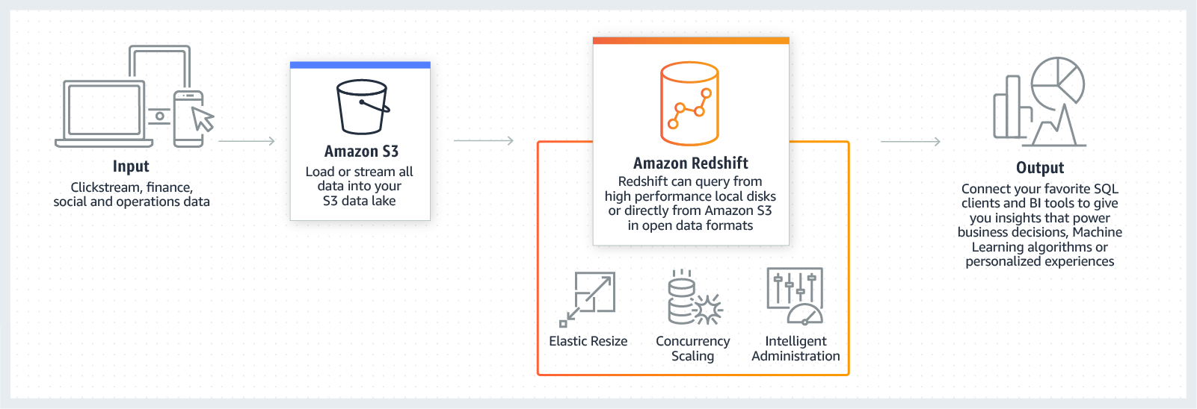
* Options B,C & D are not ideal for summarizing column based data.
* **Amazon Redshift Enhanced VPC Routing:**
  + Amazon Redshift forces all COPY and UNLOAD traffic between your cluster and your data repositories through your Amazon VPC.
  + You use these features to manage the flow of data between Redshift cluster and other resources.
  + If disabled, Amazon Redshift routes traffic through the Internet.
* Are Amazon Redshift and Redshift Spectrum compatible with my preferred business intelligence software package and ETL tools?
* Amazon Redshift uses industry-standard SQL and is accessed using standard JDBC and ODBC drivers. You can download Amazon Redshift custom JDBC and ODBC drivers from the Connect Client tab of the Redshift Console. We have validated integrations with popular BI and ETL vendors, a number of which are offering free trials to help you get started loading and analyzing your data.

**You are working as a Solutions Architect for a major telecommunications company where you are assigned to improve the security of your database tier by tightly managing the data flow of your Amazon Redshift cluster. One of the requirements is to use VPC flow logs to monitor all the COPY and UNLOAD traffic of your Redshift cluster that moves in and out of your VPC.**

**Which of the following is the most suitable solution to implement in this scenario?**

* ​Enable Audit Logging in your Amazon Redshift cluster.



* ​Enable Enhanced VPC routing on your Amazon Redshift cluster.



* ​Use the Amazon Redshift Spectrum feature.



* ​Create a new flow log that tracks the traffic of your Amazon Redshift cluster.



**Explanation**

When you use Amazon Redshift Enhanced VPC Routing, Amazon Redshift forces all COPY and UNLOAD traffic between your cluster and your data repositories through your Amazon VPC. By using Enhanced VPC Routing, you can use standard VPC features, such as VPC security groups, network access control lists (ACLs), VPC endpoints, VPC endpoint policies, internet gateways, and Domain Name System (DNS) servers. Hence, Option 2 is the correct answer.

**HIGH AVAILABILITY**

* **Availability** is the % of a time period when the service will be able to respond to request in some fashion.**Durability** refers to the on-going existence of the object or resource.
* **Resiliency** can be described as the ability to a system to self heal after damage or an event.
* **Reliability** is the probability that a system will work as designed.
  + Use multiple AZs and multiple regions wherever you can.
* How to achieve HA when ELB is impossible in the current setting?
  + **Write a custom script that checks the health of the EC2 instance and if the instance stops responding, the script will switch the Elastic IP address to a standby EC2 instance.**
  + [Leveraging Multiple IP Addresses for Virtual IP Address Fail-over](https://aws.amazon.com/articles/leveraging-multiple-ip-addresses-for-virtual-ip-address-fail-over-in-6-simple-steps/)

**You are working for a software company that has moved a legacy application from an on-premises data center to the cloud. The legacy application requires a static IP address hard-coded into the backend, which blocks you from using an Application Load Balancer.  
Which steps would you take to apply high availability and fault tolerance to this application without ELB? (Choose 2)**

* ​Write a script that checks the health of the EC2 instance. If the instance stops responding, the script will switch the elastic IP address to a standby EC2 instance.



* ​Assign an Elastic IP address to the instance.**(Correct)**



* ​Postpone the deployment until you have fully converted the application to work with the ELB and Auto Scaling.



* ​Launch the instance using Auto Scaling which will deploy the instance again if it becomes unhealthy.



* ​Use Cloudfront with a custom origin pointed to your on-premises network where the web application is deployed.



**Explanation**

For this scenario, it is best to set up a self-monitoring EC2 instance with a virtual IP Address. You can use an Elastic IP and then write a custom script that checks the health of the EC2 instance and if the instance stops responding, the script will switch the Elastic IP address to a standby EC2 instance.

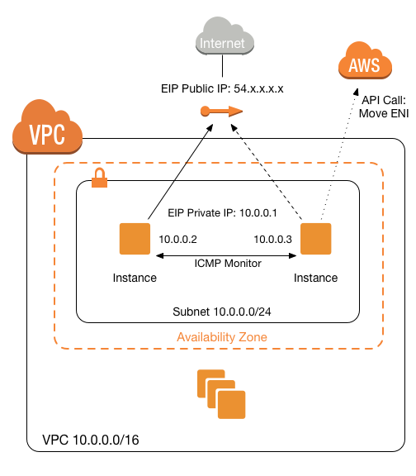

A custom script enables one Amazon Elastic Compute Cloud (EC2) instance to monitor another Amazon EC2 instance and take over a private "virtual" IP address on instance failure. When used with two instances, the script enables a High Availability scenario where instances monitor each other and take over a shared virtual IP address if the other instance fails. It could easily be modified to run on a third-party monitoring or witness server to perform the VIP swapping on behalf of the two monitored nodes.

Option 3 is incorrect because you don't have to postpone your deployment as you have the option to set up a self-monitoring EC2 instance with an EIP address.

Option 4 is incorrect as even though the Auto Scaling group provides high availability and scalability, it still depends on ELB which is not available in this scenario. Take note that you need to have a static IP address which can be in the form of an Elastic IP. Although an Auto Scaling group can scale out if one of the EC2 instances became unhealthy, you still cannot directly assign an EIP to an Auto Scaling group. In addition, you are only limited to use EC2 instance status checks for your Auto Scaling group if you do not have an ELB which can provide you the actual health check of your application (*using its port*), and not just the health of the EC2 instance.

**You are instructed by your manager to create a publicly accessible EC2 instance by using an Elastic IP (EIP) address and also to give him a report on how much it will cost to use that EIP.  
Which of the following statements is correct regarding the pricing of EIP?**

* ​There is no cost if the instance is running and it has only one associated EIP.
* ​There is no cost if the instance is terminated and it has only one associated EIP.
* ​There is no cost if the instance is stopped and it has only one associated EIP.
* ​There is no cost if the instance is running and it has at least two associated EIP.

**Explanation**

An Elastic IP address doesn’t incur charges as long as the following conditions are true:

* -The Elastic IP address is associated with an Amazon EC2 instance.
* -The instance associated with the Elastic IP address is running.
* -The instance has only one Elastic IP address attached to it.

If you’ve stopped or terminated an EC2 instance with an associated Elastic IP address and you don’t need that Elastic IP address anymore, consider disassociating or releasing the Elastic IP address .

**ELB**

Elastic Load Balancing (ELB) automatically distributes incoming application traffic across multiple targets, such as Amazon EC2 instances, containers, IP addresses, and Lambda functions.

* X-Forwarded:
  + When a request is going through an ELB, the EC2 instance receives the IP address of the ELB instead of the client. To forward the client's IP address, use X-Forwarded-For field.
* Monitoring:Instances monitored by ELB are either InService or OutService.
  + The ELB periodically sends pings, attempts connections, or sends requests to test the EC2 instances.
  + [Configure Health Checks for Your Classic Load Balancer](https://docs.aws.amazon.com/elasticloadbalancing/latest/classic/elb-healthchecks.html)If you configure the Auto Scaling group to use Elastic Load Balancing health checks, it considers the instance unhealthy if it fails either the EC2 status checks or the load balancer health checks.
  + The load balancer will route the incoming requests only to the healthy instances.
  + [Adding Elastic Load Balancing Health Checks to an Auto Scaling Group](https://docs.aws.amazon.com/autoscaling/ec2/userguide/as-add-elb-healthcheck.html)

The purpose of automatic scaling is to automatically increase the size of your Auto Scaling group when demand goes up and decrease it when demand goes down. As capacity is increased or decreased, the Amazon EC2 instances being added or removed must be registered or deregistered with a load balancer. This enables your application to automatically distribute incoming web traffic across such a dynamically changing number of instances.Your load balancer acts as a single point of contact for all incoming web traffic to your Auto Scaling group. When an instance is added to your Auto Scaling group, it needs to register with the load balancer or no traffic is routed to it. When an instance is removed from your Auto Scaling group, it must deregister from the load balancer or traffic continues to be routed to it.

* Sticky sessions:Sticky session allow you to bind a user's session to a specific EC2 instance.
  + Can be useful if you're storing information locally on that instance.If you're confronted with an EC2 instance that receives no traffic, disable sticky sessions.

supports **Stick Sessions** (session affinity) to bind a user’s session to a specific application instance,

* it is not fault tolerant, if an instance is lost the information is lost
* requires HTTP/HTTPS listener and does not work with TCP
* requires SSL termination on ELB as it users the headers
* Cross-Zone Load Balancing:Direct traffic across multiple AZs.ross-zone load balancing reduces the need to maintain equivalent numbers of instances in each enabled Availability Zone, and improves your application's ability to handle the loss of one or more instances. However, we still recommend that you maintain approximately equivalent numbers of instances in each enabled Availability Zone for higher fault tolerance.
* Path patterns:Direct traffic based on the URL contained in the request.
  + For example, for microservices, you can route traffic to multiple backend services ([www.myurl.com](http://www.myurl.com/) to US-EAST-1A and [www.myurl.com/images/](http://www.myurl.com/images/) to US-EAST-1B)
* Scaling:
  + Proactive Cyclic Scaling allows you to scale during the desired time window.
* Restrictions:
  + They do not have IPv4 addresses; you can resolve to them using a DNS name.
  + You need at least two public subnets when creating a load balancer.
* **Perfect Forward Secrecy:**Perfect Forward Secrecy is a feature that provides additional safeguards against the eavesdropping of encrypted data, through the use of a unique random session key.This prevents the decoding of captured data, even if the secret long-term key is compromised.
  + [Perfect Forward Secrecy and more new security features](https://aws.amazon.com/about-aws/whats-new/2014/02/19/elastic-load-balancing-perfect-forward-secrecy-and-more-new-security-features/)
* Connection draining:This enables the load balancer to complete requests to instances that are de-registering or unhealthy.
* Top of Form
* Option B is wrong as ELB cannot route traffic across regions.
* Option D is wrong as ELB distributes load across AZs, depending upon the instances attached.
* Bottom of Form
* Top of Form
* **is distributed system that is fault tolerant and actively monitored by AWS scales it as per the demand**
* are engineered to **not be a single point of failure**
* need to **Pre Warm** ELB if the demand is expected to shoot especially during load testing
* supports routing traffic to instances in **multiple AZs in the same region**
* performs **Health Checks** to route traffic only to the healthy instances
* support Listeners with HTTP, HTTPS, SSL, TCP protocols
* has an associated IPv4 and dual stack DNS nam
* For High Availability, it is recommended to attach one subnet per AZ for at least two AZs, even if the instances are in a single subnet.
* **cannot assign an Elastic IP** address to an ELB
* IPv4 & IPv6 support  VPC now supports IPV6.
* **HTTPS listener does not support Client Side Certificate**
* for **SSL termination at backend instances or support for Client Side Certificate** use TCP for connections from the client to the ELB, use the SSL protocol for connections from the ELB to the back-end application, and deploy certificates on the back-end instances handling requests
* supports a **single SSL certificate**, so for multiple SSL certificate multiple ELBs need to be created
* 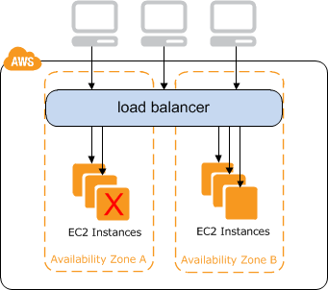

**Types**

* **Application ELBs:**Best suited for load balancing of HTTP and HTTPs traffic.
  + Operate at LAYER 7 and are application aware.Capable of intelligent request routing: based on rules for target group, condition, and priority.Support path-based routing, host-based routing and containerized applications.For example, ELB can see changing currency to $ on a website and redirect traffic to US.

Correct answer is **D** as ALB is more suited for microservices architecture with the enhanced features to support content based routing. Replacing the multiple classic ELB with single ALB would help reduce cost without impacting performance.

it evaluates the listener rules in priority order to determine which rule to apply, and then selects a target from the target group for the rule action. You can configure listener rules to route requests to different target groups based on the content of the application traffic. Routing is performed independently for each target group, even when a target is registered with multiple target groups.

Support for path-based routing. You can configure rules for your listener that forward requests based on the URL in the request. This enables you to structure your application as smaller services, and route requests to the correct service based on the content of the URL.

Support for host-based routing. You can configure rules for your listener that forward requests based on the host field in the HTTP header. This enables you to route requests to multiple domains using a single load balancer.

Dynamic port mapping with an Application Load Balancer makes it easier to run multiple tasks on the same Amazon ECS service on an Amazon ECS cluster.

With the Classic Load Balancer, you must statically map port numbers on a container instance. The Classic Load Balancer does not allow you to run multiple copies of a task on the same instance because the ports conflict. An Application Load Balancer uses dynamic port mapping so that you can run multiple tasks from a single service on the same container instance.

Application Load Balancers provide native support for HTTP/2 with HTTPS listeners. You can send up to 128 requests in parallel using one HTTP/2 connection. The load balancer converts these to individual HTTP/1.1 requests and distributes them across the healthy targets in the target group. Because HTTP/2 uses front-end connections more efficiently, you might notice fewer connections between clients and the load balancer. You can't use the server-push feature of HTTP/2.

**A customer has a web application that uses cookie-based sessions to track logged-in users. It is deployed on AWS using Elastic Load Balancing and Auto Scaling. When load increases, Auto Scaling launches new instances, but the load on the other instances does not decrease; this causes all existing users to have a slow experience. What could be the cause of the poor user experience?**

* A. ELB DNS record’s TTL is set too high.



* ​B. The new instances are not being added to the ELB during the Auto Scaling cooldown period.​C. The website uses the dynamic content feature of Amazon CloudFront which is keeping connections alive to the ELB.



* ​D. ELB is continuing to send requests with previously established sessions to the same backend instances rather than spreading them out to the new instances.



#### Explanation

Correct answer is **D** as ELB is stateful and uses cookie-based sessions. So, it might be continuing to send requests to previously established sessions and hence existing users having a poor experience.

Option A is wrong as Elastic Load Balancing uses a TTL setting on the DNS record of 60 seconds and there is no mention of what is the configuration.

Option B is wrong as instances would still be added to reduce a load and only new instances after those would depend on the cooldown period.

Option C is wrong as CloudFront will route traffic back to the origin servers depending on the TTL

**You are consulting for a web hosting company that runs hundreds of WordPress deployments. Each WordPress deployment generally runs on one EC2 instance and is part of an Auto Scaling group with min 1, max 1, and desired 1. Each environment is using a Classic Load Balancer to provide self-healing capability. SSL certificates are also used. The business has asked you to suggest improvements that could reduce costs.What should you suggest?**

AUse Network Load Balancers instead of Classic Load Balancers.

BMigrate all SSL certificates onto a single Classic Load Balancer using SNI.

CSnapshot the EC2 instances and migrate each to an Elastic Beanstalk application.

DMigrate the Classic Load Balancers to Application Load Balancers.

**Correct Answer: D**Application Load Balancers can use host-based rules to support multiple hostnames and SSL certs on one Application Load Balancer. The Classic Load Balancers could be merged into less Application Load Balancers, which would offer substantial cost savings.

* **Network ELBs:**Best suited for load balancing of TCP traffic where extreme performance is required.Specifically designed for high performance traffic that is not conventional web traffic.Operate at LAYER 4 and are connection aware.Capable of handling millions of requests per second while maintaining low latencies.
* **Classic ELBs:**Classic ELBs are the previous generation ELBs.Can operate at LAYER 7 (e.g. X-Forwarded and sticky sessions)Can also use strict LAYER 4 load balancing for applications that rely on TCP.Cheaper than others and is usually used for round-robin DNS.

If your application stops responding, the ELB responds with "504 Gateway Time-out" error.

**You are assigned to design a highly available architecture in AWS. You have two target groups with three EC2 instances each, which are added to an Application Load Balancer. In the security group of the EC2 instance, you have verified that the port 80 for HTTP is allowed. However, the instances are still showing out of service from the load balancer.What could be the root cause of this issue?**

* ​The instances are using the wrong AMI.
* ​The health check configuration is not properly defined.
* ​The wrong instance type was used for the EC2 instance.
* ​The wrong subnet was used in your VPC

**Explanation**

Since the security group is properly configured, the issue may be caused by a wrong health check configuration in the Target Group. Your Application Load Balancer periodically sends requests to its registered targets to test their status. These tests are called *health checks*. Each load balancer node routes requests only to the healthy targets in the enabled Availability Zones for the load balancer. Each load balancer node checks the health of each target, using the health check settings for the target group with which the target is registered. After your target is registered, it must pass one health check to be considered healthy. After each health check is completed, the load balancer node closes the connection that was established for the health check.

**You are managing a global news website which has a very high traffic. To improve the performance, you redesigned the application architecture to use a Classic Load Balancer with an Auto Scaling Group in multiple Availability Zones. However, you noticed that one of the Availability Zones is not receiving any traffic. What is the root cause of this issue?**

* ​Auto Scaling should be disabled for the load balancer to route the traffic to multiple Availability Zones.
* ​By default, you are not allowed to use a load balancer with multiple Availability Zones. You have to send a request form to AWS in order for this to work.
* ​The Availability Zone is not properly added to the load balancer which is why it is not receiving any traffic.
* ​The Classic Load Balancer is down

**Explanation**

In this scenario, one of the Availability Zones is not properly added to the Elastic load balancer. Hence, that Availability Zone is not receiving any traffic.

You can set up your load balancer in EC2-Classic to distribute incoming requests across EC2 instances in a single Availability Zone or multiple Availability Zones. First, launch EC2 instances in all the Availability Zones that you plan to use. Next, register these instances with your load balancer. Finally, add the Availability Zones to your load balancer. After you add an Availability Zone, the load balancer starts routing requests to the registered instances in that Availability Zone. Note that you can modify the Availability Zones for your load balancer at any time.

By default, the load balancer routes requests evenly across its Availability Zones. To route requests evenly across the registered instances in the Availability Zones, enable cross-zone load balancing.

**Auto Scaling**

* Auto Scaling allows you to set up dynamic and predictive scaling for scalable AWS resources.A launch configuration is a template that an Auto Scaling group uses to launch EC2 instances.You specify information for the instances such as the ID of the Amazon Machine Image (AMI), the instance type, a key pair, one or more security groups, and a block device mapping.
  + Always check that the launch configuration is being triggered properly.
* ensures correct number of EC2 instances are always running to handle the load by scaling up or down automatically as demand changes
* **cannot** span multiple regions.
* attempts to distribute instances evenly between the AZs that are enabled for the Auto Scaling group
  + Auto Scaling & ELB can be used for **High Availability and Redundancy** by spanning Auto Scaling groups across multiple AZs within a region and then setting up ELB to distribute incoming traffic across those AZs
  + You can only specify one launch configuration for an Auto Scaling group at a time.
  + [Launch Configurations](https://docs.aws.amazon.com/autoscaling/ec2/userguide/LaunchConfiguration.html)
* Auto Scaling scales-in according to [a hierarchy of decisions](https://docs.aws.amazon.com/autoscaling/ec2/userguide/as-instance-termination.html)
  + Choose the Availability Zone with the most instances.
  + Choose the Availability Zone with the instances that use the oldest launch configuration.
  + Terminate the instances that use the oldest launch configuration.
  + Terminate unprotected instances that are closest to the next billing hour.

Choose one of these instances at random

. **An e-commerce** 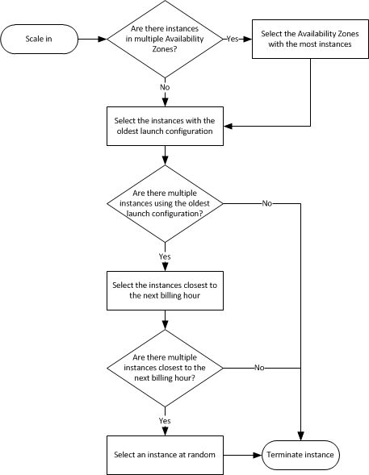

In this scenario, the load balancer will route the incoming requests only to the healthy instances. When the load balancer determines that an instance is unhealthy, it stops routing requests to that instance. The load balancer resumes routing requests to the instance when it has been restored to a healthy state.

There are two ways of checking the status of your EC2 instances:

1. Via the Auto Scaling group

2. Via the ELB health checks

The default health checks for an Auto Scaling group are **EC2 status checks** only. If an instance fails these status checks, the Auto Scaling group considers the instance unhealthy and replaces. If you attached one or more load balancers or target groups to your Auto Scaling group, the group does not, by default, consider an instance unhealthy and replace it if it fails the load balancer health checks.

However, you can optionally configure the Auto Scaling group to use Elastic Load Balancing health checks. This ensures that the group can determine an instance's health based on additional tests provided by the load balancer. The load balancer periodically sends pings, attempts connections, or sends requests to test the EC2 instances. These tests are called ***health checks.***

If you configure the Auto Scaling group to use Elastic Load Balancing health checks, it considers the instance unhealthy if it fails either the EC2 status checks or the load balancer health checks. If you attach multiple load balancers to an Auto Scaling group, all of them must report that the instance is healthy in order for it to consider the instance healthy. If one load balancer reports an instance as unhealthy, the Auto Scaling group replaces the instance, even if other load balancers report it as healthy.p0

**application is hosted in AWS. The last time a new product was launched, the application experienced a performance issue due to an enormous spike in traffic. Management decided that capacity must be doubled the week before of future product launches. Which is the MOST efficient way for management to ensure that capacity requirements are met?**

* A. Add a Step Scaling policy



* B. Add a Dynamic Scaling policy



* ​. Add a Scheduled Scaling action



* ​D. Add Amazon EC2 Spot instances.



#### Explanation

Correct answer is **C** as Auto Scaling scheduled actions can help planned and scale for known demand patterns.

#### Scaling based on a schedule allows you to scale your application in response to predictable load changes. For example, every week the traffic to your web application starts to increase on Wednesday, remains high on Thursday, and starts to decrease on Friday. You can plan your scaling activities based on the predictable traffic patterns of your web application. Explanation

Scaling based on a schedule allows you to scale your application in response to predictable load changes. For example, every week the traffic to your web application starts to increase on Wednesday, remains high on Thursday, and starts to decrease on Friday. You can plan your scaling activities based on the predictable traffic patterns of your web application.

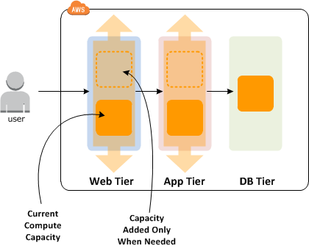

To configure your Auto Scaling group to scale based on a schedule, you create a scheduled action. The scheduled action tells Amazon EC2 Auto Scaling to perform a scaling action at specified times. To create a scheduled scaling action, you specify the start time when the scaling action should take effect, and the new minimum, maximum, and desired sizes for the scaling action. At the specified time, Amazon EC2 Auto Scaling updates the group with the values for minimum, maximum, and desired size specified by the scaling action. You can create scheduled actions for scaling one time only or for scaling on a recurring schedule.

Option A & B are wrong as Step Up and Dynamic Scaling respond to events and scale out/in as the demand changes.

Option D is wrong as Spot instances do not guarantee availability and can be terminated any time.

**A university is running an internal web application on AWS that students can access from the university network to check their exam results. The web application runs on Amazon EC2 instances and pulls results from an Amazon DynamoDB table. Auto Scaling is currently configured to add a new web server when CPU greater than 80% for 5 minutes. DynamoDB is configured to increase both read and write capacity units by five when utilization is greater than 80%. Exam are released at 9:00 a.m., each Monday, and 80% of students attempt to access their unique results within the first 30 minutes. Despite Auto Scaling enabled, students are complaining of slow response times and errors when they view the site. There are no performance complaints after 9:30 a.m. Which recommendation should a Solutions Architect make to improve performance in a cost-effective manner?**

* ​A. Implement Amazon ElastiCache to improve database performance and remove the need to scale the read/write units.



* ​B. Implement Amazon DynamoDB Accelerator to improve database performance and remove the need to scale the read/write units.



* ​Use a scheduled job to scale out EC2 before 9:00 a.m. on Monday and to scale down after 9:30



* D. Use Amazon CloudFront to cache web request and reduce the load on EC2 and DynamoDB

#### ExplanationCorrect answer is **C** as the pattern of the traffic is known and the configured dynamic scaling is not able to meet the sudden demands with speed, Scheduled scaling is best suited to scale out before 9:00 a.m. and scale in after 9:30 a.m.

Option A, B & D are wrong as the access is related to unique results per student, CloudFront, ElastiCache and DAX would not be of much help.

* **Scheduled scaling:**Allows you to set your own scaling schedule for predictable load changes.
* **Dynamic scaling:**You must define how to scale in response to changing demand.
  + **Target tracking scaling:** Change the current capacity based on a target value for a metric.
  + **Step scaling:** Change the current capacity based on a set of scaling adjustments.
  + **Simple scaling:** Change the current capacity based on a single scaling adjustment.
* **Cooldown timers:**Useful to keep Auto Scaling from scaling up and down so rapidly.
  + Ensures that the Auto Scaling group does not launch or terminate additional EC2 instances before the previous scaling activity takes effect.Its default value is 300 seconds.
  + Modify the Amazon CloudWatch alarm period that triggers your Auto Scaling scale down policy.
* Scaling based on a schedule allows you to scale your application in response to predictable load changes.By the time either the CPU or Memory hits a peak, the application already has performance issues.

**A tech company is currently using Auto Scaling for their web application. A new AMI now needs to be used for launching a fleet of EC2 instances.Which of the following changes needs to be done?**

* ​Do nothing. You can start directly launching EC2 instances in the Auto Scaling group with the same launch configuration.



* ​Create a new launch configuration.



**(Correct)**

* ​Create a new target group.



* ​Create a new target group and launch configuration.



**(Incorrect)**

**Explanation**

For this scenario, you have to create a new launch configuration. Remember that you can't modify a launch configuration after you've created it.

A *launch configuration* is a template that an Auto Scaling group uses to launch EC2 instances. When you create a launch configuration, you specify information for the instances such as the ID of the Amazon Machine Image (AMI), the instance type, a key pair, one or more security groups, and a block device mapping. If you've launched an EC2 instance before, you specified the same information in order to launch the instance.You can specify your launch configuration with multiple Auto Scaling groups. However, you can only specify one launch configuration for an Auto Scaling group at a time, and you can't modify a launch configuration after you've created it. Therefore, if you want to change the launch configuration for an Auto Scaling group, you must create a launch configuration and then update your Auto Scaling group with the new launch configuration.

**An application is hosted in an Auto Scaling group of EC2 instances. To improve the monitoring process, you have to configure the current capacity to increase or decrease based on a set of scaling adjustments. This should be done by specifying the scaling metrics and threshold values for the CloudWatch alarms that trigger the scaling process.**

**Which of the following is the most suitable type of scaling policy that you should use?**

* ​

Target tracking scaling

**(Incorrect)**

* ​

Step scaling

**(Correct)**

* ​

Simple scaling

* ​

Scheduled Scaling

**Explanation**

With step scaling, you choose scaling metrics and threshold values for the CloudWatch alarms that trigger the scaling process as well as define how your scalable target should be scaled when a threshold is in breach for a specified number of evaluation periods. Step scaling policies increase or decrease the current capacity of a scalable target based on a set of scaling adjustments, known as step adjustments. The adjustments vary based on the size of the alarm breach. After a scaling activity is started, the policy continues to respond to additional alarms, even while a scaling activity is in progress. Therefore, all alarms that are breached are evaluated by Application Auto Scaling as it receives the alarm messages.

When you configure dynamic scaling, you must define how to scale in response to changing demand. For example, you have a web application that currently runs on two instances and you want the CPU utilization of the Auto Scaling group to stay at around 50 percent when the load on the application changes. This gives you extra capacity to handle traffic spikes without maintaining an excessive amount of idle resources. You can configure your Auto Scaling group to scale automatically to meet this need. The policy type determines how the scaling action is performed.

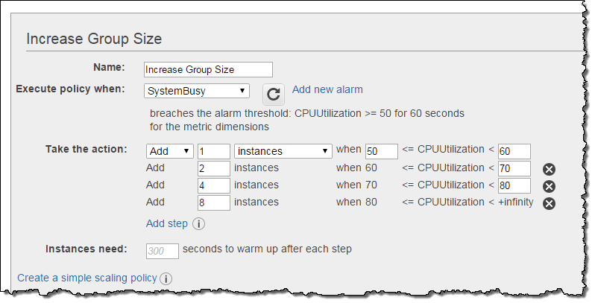

Amazon EC2 Auto Scaling supports the following types of scaling policies:

**Target tracking scaling -**Increase or decrease the current capacity of the group based on a target value for a specific metric. This is similar to the way that your thermostat maintains the temperature of your home – you select a temperature and the thermostat does the rest.

**Step scaling -**Increase or decrease the current capacity of the group based on a set of scaling adjustments, known as *step adjustments*, that vary based on the size of the alarm breach.

**Simple scaling -**Increase or decrease the current capacity of the group based on a single scaling adjustment.

If you are scaling based on a utilization metric that increases or decreases proportionally to the number of instances in an Auto Scaling group, then it is recommended that you use target tracking scaling policies. Otherwise, it is better to use step scaling policies instead.

Hence, the correct answer in this scenario is Option 2 - Step Scaling.

Option 1 is incorrect because the target tracking scaling policy increases or decreases the current capacity of the group based on a **target value for a specific metric**, instead of a set of scaling adjustments.

Option 3 is incorrect because the simple scaling policy increases or decreases the current capacity of the group based on a **single** scaling adjustment, instead of a set of scaling adjustments.

Option 4 is incorrect because the scheduled scaling policy is based on a schedule that allows you to set your own scaling schedule for **predictable** load changes. This is not considered as one of the types of dynamic scaling.

**A loan processing application is hosted in a single On-Demand EC2 instance in your VPC. To improve the scalability of your application, you have to use Auto Scaling to automatically add new EC2 instances to handle a surge of incoming requests.**

**Which of the following items should be done in order to add an existing EC2 instance to an Auto Scaling group? (Choose 2)**

* ​

You must stop the instance first.

* ​

You have to ensure that the AMI used to launch the instance still exists.

**(Correct)**

* ​

You have to ensure that the AMI used to launch the instance no longer exists.

* ​

The instance is launched into one of the Availability Zones defined in your Auto Scaling group.

**(Correct)**

* ​

You have to ensure that the instance is in a different Availability Zone as the Auto Scaling group.

**Explanation**

Amazon EC2 Auto Scaling provides you with an option to enable automatic scaling for one or more EC2 instances by attaching them to your existing Auto Scaling group. After the instances are attached, they become a part of the Auto Scaling group.

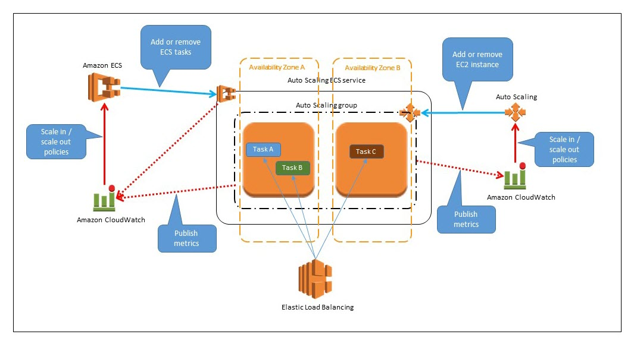

The instance that you want to attach must meet the following criteria:

 - The instance is in the **running** state.

 - The AMI used to launch the instance must still exist.

 - The instance is not a member of another Auto Scaling group.

 - The instance is launched into one of the Availability Zones defined in your Auto Scaling group.

 - If the Auto Scaling group has an attached load balancer, the instance and the load balancer must both be in EC2-Classic or the same VPC. If the Auto Scaling group has an attached target group, the instance and the load balancer must both be in the same VPC.

Based on the above criteria, Options 2 and 4 are the correct answers.

**EC2 ELASTIC compute cloud**

* Amazon Elastic Compute Cloud (EC2) is a web service that provides resizable compute capacity.Reduces the time required to obtain and boot new server instances (from days) to minutes.A huge side-effect of both of these: it’s way easier to innovate.
* Location:Individual instances are provisioned in a AZ.When planning a number of instances per AZ, always assume that the AZ you lose is the one with the most instances.
  + Instances can be moved to AZ via AMIs and to regions via "Copy AMI".
  + By default, AWS has a limit of 20 instances per region per account.
  + You should submit the limit increase form for the limit to be... increased.

**You are working for a large financial firm in the country. They have an AWS environment which contains several Reserved EC2 instances hosted in a web application that has been decommissioned last week. To save cost, you need to stop incurring charges for the Reserved instances as soon as possible.**

**What cost-effective steps will you take in this circumstance? (Choose 2)**

* ​

Stop the Reserved instances as soon as possible.

**(Incorrect)**

* ​

Contact AWS to cancel your AWS subscription.

* ​

Go to the AWS Reserved Instance Marketplace and sell the Reserved instances.

**(Correct)**

* ​

Terminate the Reserved instances as soon as possible to avoid getting billed at the on-demand price when it expires.

**(Correct)**

* ​

Go to the Amazon.com online shopping website and sell the Reserved instances.

**Explanation**

The correct options are:

Go to the AWS Reserved Instance Marketplace and sell the Reserved instances.

Terminate the Reserved instances as soon as possible to avoid getting billed at the on-demand price when it expires

The Reserved Instance Marketplace is a platform that supports the sale of third-party and AWS customers' unused Standard Reserved Instances, which vary in terms of lengths and pricing options. For example, you may want to sell Reserved Instances after moving instances to a new AWS region, changing to a new instance type, ending projects before the term expiration, when your business needs change, or if you have unneeded capacity.

Option 1 is incorrect because a stopped instance can still be restarted. Take note that when a Reserved Instance expires, any instances that were covered by the Reserved Instance are billed at the on-demand price which costs significantly higher. Since the application is already decommissioned, there is no point of keeping the unused instances. It is also possible that there are associated Elastic IP addresses, which will incur charges if they are associated with stopped instances

Option 2 is incorrect as you don't need to close down your AWS account.

Option 5 is incorrect as you have to use AWS Reserved Instance Marketplace to sell your instances.

**You are trying to establish an SSH connection to a newly created Amazon EC2 instance using the PuTTY tool. However, you are getting the following error message:Error: No supported authentication methods availableWhat steps should you take to fix this issue? (Choose 2)**

* ​Verify if your private key (.pem) file has been correctly converted to the format recognized by PuTTY (.ppk).



* Verify that your IAM user policy has permission to launch Amazon EC2 instances.



* ​Verify that you are connecting with the appropriate user name for your AMI such as ec2-user for Linux AMI, centos for Centos AMI or admin for Debian AMI



* ​Verify that the Amazon EC2 Instance was launched with the proper IAM role.



* ​Verify that you have waited at least 1 hour after the EC2 instance was created before connecting via SSH.



**Explanation**

If you use PuTTY to connect to your instance via SSH and get either of the following errors, Error: Server refused our key or Error: No supported authentication methods available, verify that you are connecting with the appropriate user name for your AMI. Enter the user name in the **User name** box in the **PuTTY Configuration** window.

The appropriate user names are as follows:

* -For an Amazon Linux AMI, the user name is ec2-user.
* -For a RHEL AMI, the user name is ec2-user or root.
* -For an Ubuntu AMI, the user name is ubuntu or root.
* -For a Centos AMI, the user name is centos.
* -For a Debian AMI, the user name is admin or root.
* -For a Fedora AMI, the user name is ec2-user.
* -For a SUSE AMI, the user name is ec2-user or root.
* -Otherwise, if ec2-user and root don't work, check with the AMI provider. You should also verify that your private key (.pem) file has been correctly converted to the format recognized by PuTTY (.ppk).

**The media company that you are working for has a video transcoding application running on Amazon EC2. Each EC2 instance polls a queue to find out which video should be transcoded, and then runs a transcoding process. If this process is interrupted, the video will be transcoded by another instance based on the queuing system. This application has a large backlog of videos which need to be transcoded. Your manager would like to reduce this backlog by adding more EC2 instances, however, these instances are only needed until the backlog is reduced.**

**In this scenario, which type of Amazon EC2 instance is the most cost-effective type to use?**

* ​Reserved instances



* ​Spot instances



* ​Dedicated instances



* ​On-demand instances



**Explanation**

You require an instance that will be used not as a primary server but as a spare compute resource to augment the transcoding process of your application. These instances should also be terminated once the backlog has been significantly reduced. In addition, the scenario mentions that if the current process is interrupted, the video can be transcoded by another instance based on the queuing system. This means that the application can gracefully handle an unexpected termination of an EC2 instance, like in the event of a Spot instance termination when the Spot price is greater than your set maximum price. Hence, an Amazon EC2 Spot instance is the best and cost-effective option for this scenario.

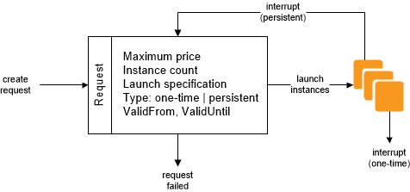

Amazon EC2 Spot instances are **spare** compute capacity in the AWS cloud available to you at steep discounts compared to On-Demand prices. EC2 Spot enables you to optimize your costs on the AWS cloud and scale your application's throughput up to 10X for the same budget. By simply selecting Spot when launching EC2 instances, you can save up-to 90% on On-Demand prices. The only difference between On-Demand instances and Spot Instances is that Spot instances can be interrupted by EC2 with two minutes of notification when the EC2 needs the capacity back.

You can specify whether Amazon EC2 should hibernate, stop, or terminate Spot Instances when they are interrupted. You can choose the interruption behavior that meets your needs.

**In Amazon EC2, you can manage your instances from the moment you launch them up to their termination. You can flexibly control your computing costs by changing the EC2 instance state. Which of the following statements is true regarding EC2 billing? (Choose 2)**

* ​You will be billed when your On-Demand instance is in pending state.



* ​You will be billed when your Spot instance is preparing to stop with a stopping state.



* ​You will be billed when your On-Demand instance is preparing to hibernate with a stopping state.



* ​You will be billed when your Reserved instance is in terminated state.



* ​You will not be billed for any instance usage while an instance is not in the running state.



**Explanation**

By working with Amazon EC2 to manage your instances from the moment you launch them through their termination, you ensure that your customers have the best possible experience with the applications or sites that you host on your instances. The following illustration represents the transitions between instance states. Notice that you can't stop and start an instance store-backed instance:

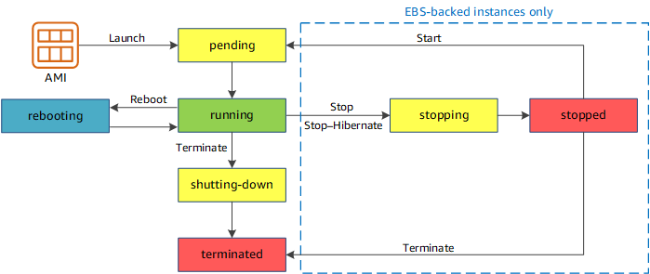

**pending** - The instance is preparing to enter the running state. An instance enters the pending state when it launches for the first time, or when it is restarted after being in the stopped state.

**running** - The instance is running and ready for use.

**stopping** - The instance is preparing to be stopped. Take note that you will not billed if it is preparing to stop however, you will still be billed if it is just preparing to hibernate.  
  
**stopped** - The instance is shut down and cannot be used. The instance can be restarted at any time.

**shutting-down** - The instance is preparing to be terminated.

**terminated** - The instance has been permanently deleted and cannot be restarted. Take note that Reserved Instances that applied to terminated instances are ***still billed***until the end of their term according to their payment option.

**You have launched a new enterprise application with a web server and a database. You are using a large EC2 Instance with one 500 GB EBS volume to host a relational database. Upon checking the performance, it shows that write throughput to the database needs to be improved.   Which of the following is the most suitable configuration to help you achieve this requirement? (Choose 2)**

* ​Set up a standard RAID 0 configuration with two EBS Volumes



* ​Re-launch the instance with a Paravirtual (PV) AMI and enable Enhanced Networking



* ​Use a standard RAID 1 configuration with two EBS Volumes



* ​Set up the EC2 instance in a placement group



* ​Increase the size of the EC2 Instance



* **Explanation**The goal here is to increase the write performance of the database hosted in an EC2 instance. You can achieve this by either setting up a standard RAID 0 configuration or simply by increasing the size of the EC2 instance.

Some EC2 instance types can drive more I/O throughput than what you can provision for a single EBS volume. You can join multiple gp2, io1, st1, or sc1 volumes together in a RAID 0 configuration to use the available bandwidth for these instances.

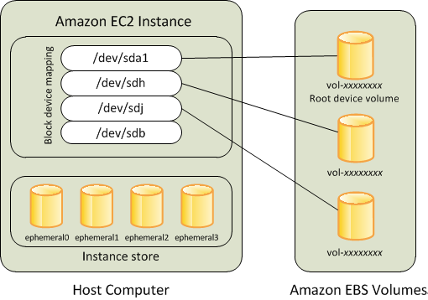

 With Amazon EBS, you can use any of the standard RAID configurations that you can use with a traditional bare metal server, as long as that particular RAID configuration is supported by the operating system for your instance. This is because all RAID is accomplished at the software level. For greater I/O performance than you can achieve with a single volume, RAID 0 can stripe multiple volumes together; for on-instance redundancy, RAID 1 can mirror two volumes together.

Take note that HVM AMIs are required to take advantage of enhanced networking and GPU processing. In order to pass through instructions to specialized network and GPU devices, the OS needs to be able to have access to the native hardware platform which the HVM virtualization provides.

**You are a Solutions Architect working for a major telecommunications company in Europe. You deployed an On-Demand EC2 instance that is transferring large amounts of data to an Amazon S3 bucket in the same region. Your manager is worried about infrastructure cost considering the vast amounts of data being transferred to the bucket.  
  
What will you say to justify this architecture?**

* ​You are only using an On-Demand EC2 instance which is exactly the same price as Spot EC2 instance, launched by a persistent Spot request.



* ​Transferring data from an EC2 instance to an S3 bucket in the same region has no cost at all.



* ​Transferring data from an EC2 instance to an S3 bucket in the same region has a 50% discount based on the AWS Pricing.



* ​You are only using an On-Demand EC2 instance so the cost will be lower than a Spot instance.



**Explanation**

Transferring data from an EC2 instance to Amazon S3, Amazon Glacier, Amazon DynamoDB, Amazon SES, Amazon SQS, or Amazon SimpleDB in the same AWS Region has no cost at all. Refer to the Amazon EC2 Pricing on the link below for reference.

**Amazon EC2 provides you access to the operating system of the instance that you created**.

**Amazon EMR provides you a managed Hadoop framework that makes it easy, fast, and cost-effective to process vast amounts of data across dynamically scalable Amazon EC2 instances. You can access the operating system of these EC2 instances that were created by Amazon EMR.**

**You work for a leading university as an AWS Infrastructure Engineer and also as a professor to aspiring AWS architects. As a way to familiarize your students with AWS, you gave them a project to host their applications to an EC2 instance. One of your students created an instance to host their online enrollment system project but is having a hard time connecting to their newly created EC2 instance. Your students have explored all of the troubleshooting guides by AWS and narrowed it down to login issues.**

**Which of the following can you use to log into an EC2 instance?**

* ​Custom EC2 password



* ​EC2 Connection Strings



* ​Key Pairs



* ​Access Keys



**Explanation**

Amazon EC2 uses public–key cryptography to encrypt and decrypt login information. Public–key cryptography uses a public key to encrypt a piece of data, such as a password, then the recipient uses the private key to decrypt the data. The public and private keys are known as a *key pair*.

To log in to your instance, you must create a key pair, specify the name of the key pair when you launch the instance, and provide the private key when you connect to the instance. On a Linux instance, the public key content is placed in an entry within ~/.ssh/authorized_keys. This is done at boot time and enables you to securely access your instance using the private key instead of a password.

**As a Network Architect developing a food ordering application, you need to retrieve the instance ID, public keys, and public IP address of the EC2 server you made for tagging and grouping the attributes into your internal application running on-premises.**

**Which EC2 feature will help you achieve your requirements?**

* ​Instance user data



* ​Resource tags



* ​Instance metadata



* ​Amazon Machine Image



#### Explanation

Instance metadata is the data about your instance that you can use to configure or manage the running instance. You can get the instance ID, public keys, public IP address and many other information from the instance metadata by firing a URL command in your instance to this URL:

<http://169.254.169.254/latest/meta-data/>

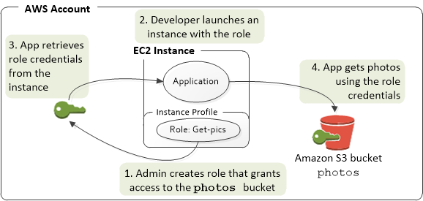

Option 1 is incorrect because the instance user data is mainly used to perform common automated configuration tasks and run scripts after the instance

**You want to establish an SSH connection to a Linux instance hosted in your VPC via the Internet. Which of the following is not required in order for this to work?**

* ​Secondary Private IP Address



* ​Public IP Address or Elastic IP



* ​Internet Gateway



* Network access control and security group rules which allow the relevant traffic to flow to and from your EC2 instance.



**Explanation**

To SSH into your EC2 instance via the Internet, you need to ensure that your VPC has an attached Internet Gateway, so that your instance can reach the Internet. Your instance should also have either a public IP or Elastic IP address, depending on whether you need a persistent IP address or not. Also ensure that you have configured your security groups to allow SSH inbound.

You don't need a Secondary Private IP Address since this address is only used when communicating within your VPC and thus, one Private IP address is enough. Hence, Option 1 is correct.

To enable access to or from the Internet for instances in a VPC subnet, you must do the following:

- Attach an internet gateway to your VPC.

- Ensure that your subnet's route table points to the Internet gateway.

- Ensure that instances in your subnet have a globally unique IP address (public IPv4 address, Elastic IP address, or IPv6 address).

- Ensure that your network access control lists and security groups allow the relevant traffic to flow to and from your instance.

**You are a Solutions Architect in an intelligence agency that is currently hosting a learning and training portal in AWS. Your manager instructed you to launch a large EC2 instance with an attached EBS Volume and enable Enhanced Networking. What are the valid case scenarios in using Enhanced Networking? (Choose 2)**

* ​

When you need a higher packet per second (PPS) performance

**(Correct)**

* ​

When you need a low packet-per-second performance

* ​

When you need high latency networking

* ​

When you need a consistently lower inter-instance latencies

**(Correct)**

* ​

When you need a dedicated connection to your on-premises data center

**Explanation**

Enhanced networking uses single root I/O virtualization (SR-IOV) to provide high-performance networking capabilities on supported instance types. SR-IOV is a method of device virtualization that provides higher I/O performance and lower CPU utilization when compared to traditional virtualized network interfaces. Enhanced networking provides higher bandwidth, higher packet per second (PPS) performance, and consistently lower inter-instance latencies. There is no additional charge for using enhanced networking.

Option 2 is incorrect because you want to increase packet-per-second performance, and not lower it, when you enable enhanced networking.

Option 3 is incorrect because higher latencies means slower network, which is the opposite of what you want to happen when you enable enhanced networking.

Option 5 is incorrect because enabling enhanced networking does not provide a dedicated connection to your on-premises data center. Use AWS Direct Connect or enable VPN tunneling instead for this purpose

**You are an AWS Network Engineer working for a utilities provider where you are managing a monolithic application with EC2 instance using a Windows AMI. You want to implement a cost-effective and highly available architecture for your application where you have an exact replica of the Windows server that is in a running state. If the primary instance terminates, you can attach the ENI to the standby secondary instance which allows the traffic flow to resume within a few seconds.**

**When it comes to the ENI attachment to an EC2 instance, what does 'warm attach' refer to?**

* ​Attaching an ENI to an instance when it is stopped.



* ​Attaching an ENI to an instance during the launch process.



* ​Attaching an ENI to an instance when it is running.



* ​Attaching an ENI to an instance when it is idle.



**Explanation**

An elastic network interface (ENI) is a logical networking component in a VPC that represents a virtual network card. You can attach a network interface to an EC2 instance in the following ways:

1. When it's running (hot attach)
2. When it's stopped (warm attach)
3. When the instance is being launched (cold attach).

* **Features**
  + Virtual computing environments, known as ***EC2 instances***
  + Preconfigured templates for EC2 instances, known as ***Amazon Machine Images (AMIs)***, that package the bits needed for the server (including the operating system and additional software)
  + Various configurations of CPU, memory, storage, and networking capacity for your instances, known as ***Instance types***
  + Secure login information for your instances using ***key pairs*** (public-private keys where private is kept by user)
  + Storage volumes for temporary data that’s deleted when you stop or terminate your instance, known as ***Instance store volumes***
  + Persistent storage volumes for data using **Elastic Block Store (EBS)**
  + Multiple physical locations for your resources, such as instances and EBS volumes, known as ***Regions and Availability Zones***
  + A firewall to specify the protocols, ports, and source IP ranges that can reach your instances using ***Security Groups***
  + Static IP addresses, known as ***Elastic IP addresses***
  + Metadata, known as ***tags***, can be created and assigned to EC2 resources
  + Virtual networks that are logically isolated from the rest of the AWS cloud, and can optionally connect to on premises network, known as **Virtual private clouds (VPCs)**
* **Amazon Machine Image**
  + **template** from which EC2 instances can be launched quickly
  + **does NOT span across across regions**, and needs to be copied
  + **can be shared with other specific AWS accounts or made public**

**Enhanced Networking**

* results in **higher bandwidth, higher packet per second (PPS) performance, lower latency, consistency, scalability and lower jitter**
* supported using **Single Root I/O Virtualization (SR-IOV)** only on supported instance types
* is **supported only with an VPC (not EC2 Classic), HVM virtualization type**and available by default on Amazon AMI but can be installed on other AMIs as well

**You are running an application on an EC2 instance that is extremely sensitive to variations in network performance, specifically the variation in ping times and latency. The application also devours CPU cycles when this network jitter happens, so you need to implement a solution that removes any risk of network performance degradation. What option works in this scenario?**

* AEnsure the VPC is running in dedicated tenancy mode.
* BEnsure the instance has enhanced networking.
* CEnsure you are using an X1 instance. DEnsure the instance is EBS optimized.
* **Correct Answer: B**Enhanced networking (<https://aws.amazon.com/premiumsupport/knowledge-center/enable-configure-enhanced-networking/>) allows high-performance networking by bypassing the need for CPU involvement in virtualizing a network interface. This increases packets per second and decreases the variability in network performance.

**Which of the following statements are true about instance store volumes?**

AData stored on instance store volumes will *always* be lost when an instance stops and starts.

BData stored on instance store volumes will *always* be lost when an instance restarts.

CData stored on instance store volumes *can sometimes* be lost when an instance stops and starts.

* DData stored on instance store volumes *can* be lost when an instance restarts.

**Correct Answer: A**If an instance is stopped and started, it will move hosts, so it's correct to say the data on volumes will *always* be lost when stopping and starting.

**Correct Answer: D**Data can be lost if the cause of the restart was an underlying hardware failure.

**You have been asked to create a scalable deployment for a new business application. The application uses Java and requires lots of supporting libraries and frameworks. The total time for the installation is 25 minutes. If the business needs the application to scale in an elastic way, rapidly reacting to changes in system load, what method should you suggest for installing, deploying, and scaling the application?**

AUse a launch template to add the application installation commands.

BInstall the application on an EC2 instance and create an AMI.

CInstall the application directly using instance metadata.

DAdd the application installation commands to an Auto Scaling group.

**Your Answer: A**While this would work, it would mean each scaling action inside an Auto Scaling group would take at least 25 minutes.

**Correct Answer: B**This is an example of an AMI Pre-bake architecture, which would work. The 25-minute installation would be done once, with the results stored in an AMI — and this could be used with a launch configuration/launch template and an Auto Scaling group to scale the application.

* Bootstrap scripts:Run when the EC2 instance first boots.
  + Can be a powerful way of automating software installs and updates.

# Example: Bootstrap script for a simple Apache server

#!/bin/bash

yum update -y

yum install httpd -y

service httpd start

chkconfig httpd on

cd /var/www/html

echo "<html><h1>Hello, World!</h1></html>" > index.html

**Copy**

* Accessing instance metadata from within:
  + Instance metadata and user data can be retrieved from within via a special URL.
  + You can get the instance ID, public keys, public IP address and many other information from the instance metadata by running curl <http://169.256.169.254/latest/meta-data/>
  + Get user data by running curl <http://169.256.169.254/latest/user-data/>
  + For example, EC2 can access its public IP address and write it to a database.
  + Note: the metadata under these addresses can be only read, but not managed.
  + For spot instances, 120 seconds before the termination, AWS will create a flag in metadata.
* Roles:Roles are more secure and easier to manage than via aws configure on EC2.Roles can be assigned to EC2 instances after its created.Roles are universal (global) and take effect immediately.
* **Authentication**:
  + Verify that you are connecting with the appropriate user name for your AMI (e.g. ec2-user)
  + Verify that your private key file has the correct format (e.g. .pem, .ppk)
* Metadata can be assigned using tags.Tagging is a key part of managing an environment.
* [Instance Lifecycle](https://docs.aws.amazon.com/AWSEC2/latest/UserGuide/ec2-instance-lifecycle.html):If the instance is stopped, AWS usually moves the instance to a new host computer.Your instance may stay on the same host computer if there are no problems.
  + Termination protection is turned off by default.
* **Docker containers:**Only ECS, Elastic Beanstalk and Fargate allow containers to run natively.
  + EC2 instances can run Docker containers, but Docker has to be installed separately.
* General EC2 logging guidance:
  + Set up a Flow Log for the group of instances and forward them to CloudWatch/S3.
  + Make use of an OS-level logging tools such as iptables and log events to CloudWatch/S3.
* **Billing**:Pay as you go, pay for what you use, and pay even less for reserved instances.
  + Simply stop the instances will eliminate charges until the instances are restarted.
  + Transferring data from an EC2 instance to Amazon S3, Amazon Glacier, Amazon DynamoDB, Amazon SES, Amazon SQS, or Amazon SimpleDB in the same AWS Region has no cost at all.
* [Bring Your Own IP Addresses (BYOIP)](https://docs.aws.amazon.com/AWSEC2/latest/UserGuide/ec2-byoip.html)
  + **You can bring your public IPv4 address range from your on-premises network to your AWS account.The Route Origin Authorization (ROA) authorizes Amazon to advertise this address range.**

**You are managing a suite of applications in your on-premises network which are using trusted IP addresses that your partners and customers have whitelisted in their firewalls. There is a requirement to migrate these applications to AWS without requiring your partners and customers to change their IP address whitelists.**

**Which of the following is the most suitable solution to properly migrate your applications?**

* ​Set up a list of Elastic IP addresses to map the whitelisted IP address range in your on-premises network.



* ​Set up an IP match condition using a CloudFront web distribution and AWS WAF to whitelist a specific IP address range in your VPC.



* ​Create a Route Origin Authorization (ROA) then once done, provision and advertise your whitelisted IP address range to your AWS account.



* ​Submit an AWS Request Form to migrate the IP address range that you own to your AWS Account.



**Explanation**

You can bring part or all of your public IPv4 address range from your on-premises network to your AWS account. You continue to own the address range, but AWS advertises it on the Internet. After you bring the address range to AWS, it appears in your account as an address pool. You can create an Elastic IP address from your address pool and use it with your AWS resources, such as EC2 instances, NAT gateways, and Network Load Balancers. This is also called "Bring Your Own IP Addresses (BYOIP)".

To ensure that only you can bring your address range to your AWS account, you must authorize Amazon to advertise the address range and provide proof that you own the address range.

A **Route Origin Authorization (ROA)** is a document that you can create through your Regional internet registry (RIR), such as the American Registry for Internet Numbers (ARIN) or Réseaux IP Européens Network Coordination Centre (RIPE). It contains the address range, the ASNs that are allowed to advertise the address range, and an expiration date. Hence, Option 3 is the correct answer.

The ROA authorizes Amazon to advertise an address range under a specific AS number. However, it does not authorize your AWS account to bring the address range to AWS. To authorize your AWS account to bring an address range to AWS, you must publish a self-signed X509 certificate in the RDAP remarks for the address range. The certificate contains a public key, which AWS uses to verify the authorization-context signature that you provide. You should keep your private key secure and use it to sign the authorization-context message.

* There are two underlying hypervisors for EC2:
  + Xen and Nitro (newer)

**You are building a prototype for a cryptocurrency news website of a small startup. The website will be deployed to a Spot EC2 Linux instance and will use Amazon Aurora as its database. You requested a spot instance at a maximum price of $0.04/hr which has been fulfilled immediately and after 90 minutes, the spot price increases to $0.06/hr and then your instance was terminated by AWS.**

**In this scenario, what would be the total cost of running your spot instance?**

* ​

$0.08

**(Incorrect)**

* ​

$0.07

* ​

$0.06

**(Correct)**

* ​

$0.00

#### Explanation

Since the Spot instance has been running for more than an hour, which is past the first instance hour, this means that you will be charged from the time it was launched till the time it was terminated by AWS. The computation for your 90 minute usage would be $0.04 (60 minutes) + $0.02 (30 minutes) = $0.06 hence, option 3 is correct.

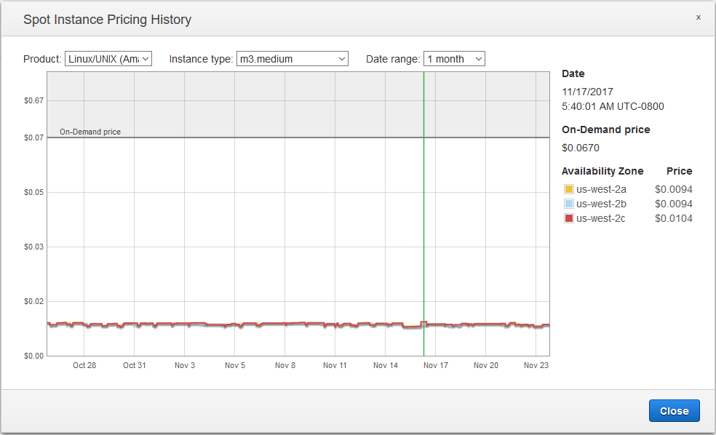

Based on the official EC2 FAQ:

**Q. How will I be charged if my Spot instance is interrupted?**

If your Spot instance is terminated or stopped by Amazon EC2 in the first instance hour, you will not be charged for that usage. However, if you terminate the instance yourself, you will be charged to the nearest second. If the Spot instance is terminated or stopped by Amazon EC2 in any subsequent hour, you will be charged for your usage to the nearest second. If you are running on Windows and you terminate the instance yourself, you will be charged for an entire hour.

Take note that there is one ambiguous [AWS document](https://docs.aws.amazon.com/whitepapers/latest/cost-optimization-leveraging-ec2-spot-instances/how-spot-instances-work.html) which says:

Spot Instances perform exactly like other EC2 instances while running and can be terminated when you no longer need them. If you terminate your instance, you pay for any partial hour used (as you do for On-Demand or Reserved Instances). However, you are not charged for any partial hour of usage if the Spot price goes above your maximum price and Amazon EC2 interrupts your Spot Instance.

The above paragraph may seem to contradict what the official EC2 FAQ said that you will be charged for your usage to the **nearest second**if the Spot instance is terminated or stopped by Amazon EC2 in any **subsequent hour**. Therefore, please be reminded that the above paragraph is only applicable if the Spot Instance is terminated by Amazon EC2 in the first instance hour only, and not during any subsequent hour (more than 60 minutes) which is what the scenario depic

Top of Form

**You recently launched a fleet of on-demand EC2 instances to host a massively multiplayer online role-playing game (MMORPG) server in your VPC. The EC2 instances are configured with Auto Scaling and AWS Systems Manager. What can you use to configure your EC2 instances without having to establish a RDP or SSH connection to each instance?**

* ​

AWS Config

* ​

AWS CodePipeline

* ​

Run Command

**(Correct)**

* ​

EC2Config

**(Incorrect)**

#### Explanation

You can use Run Command from the console to configure instances without having to login to each instance.

AWS Systems Manager Run Command lets you remotely and securely manage the configuration of your managed instances. A managed instance is any Amazon EC2 instance or on-premises machine in your hybrid environment that has been configured for Systems Manager. Run Command enables you to automate common administrative tasks and perform ad hoc configuration changes at scale. You can use Run Command from the AWS console, the AWS Command Line Interface, AWS Tools for Windows PowerShell, or the AWS SDKs. Run Command is offered at no additional cost.

**Reference:**

<https://docs.aws.amazon.com/systems-manager/latest/userguide/execute-remote-commands.html>

**Check out this Amazon EC2 Cheat Sheet:**

<https://tutorialsdojo.com/aws-cheat-sheet-amazon-elastic-compute-cloud-amazon-ec2/>

Bottom of Form

Top of Form

Question 52: **Incorrect**

**A website is running on an Auto Scaling group of On-Demand EC2 instances which are abruptly getting terminated from time to time. To automate the monitoring process, you started to create a simple script which uses the AWS CLI to find the root cause of this issue.**

**Which of the following is the most suitable command to use?**

* ​

aws ec2 describe-instances

**(Correct)**

* ​

aws ec2 describe-images

* ​

aws ec2 get-console-screenshot

**(Incorrect)**

* ​

aws ec2 describe-volume-status

#### Explanation

The describe-instances command shows the status of the EC2 instances including the recently terminated instances. It also returns a StateReason of why the instance was terminated.

**You are a Solutions Architect working for a large multinational investment bank. They have a web application that requires a minimum of 4 EC2 instances to run to ensure that it can cater to its users across the globe. You are instructed to ensure fault tolerance of this system.  
  
Which of the following is the best option?**

* ​

Deploy an Auto Scaling group with 2 instances in each of 3 Availability Zones behind an Application Load Balancer.

**(Correct)**

* ​

Deploy an Auto Scaling group with 2 instances in each of 2 Availability Zones behind an Application Load Balancer.

**(Incorrect)**

* ​

Deploy an Auto Scaling group with 4 instances in one Availability Zone behind an Application Load Balancer.

* ​

Deploy an Auto Scaling group with 1 instance in each of 4 Availability Zones behind an Application Load Balancer.

**Explanation**

Fault Tolerance is the ability of a system to remain in operation even if some of the components used to build the system fail. In AWS, this means that in the event of server fault or system failures, the number of running EC2 instances should not fall below the minimum number of instances required by the system for it to work properly. So if the the application requires a minimum of 4 instances, there should be at least 4 instances running in case there is an outage in one of the Availability Zones or if there are server issues.

One of the differences between Fault Tolerance and High Availability is that, the former refers to the minimum number of running instances. For example, you have a system that requires a minimum of 4 running instances and currently has 6 running instances deployed in two Availability Zones. There was a component failure in one of the Availability Zones which knocks out 3 instances. In this case, the system can still be regarded as Highly Available since there are still instances running that can accomodate the requests. However, it is not Fault Tolerant since the required minimum of four instances have not been met.

As such, Option 1 is the correct answer because even if there was an outage in one of the Availability Zones, the system still satisfies the requirement of a minimum of 4 running instances.

Option 2 is incorrect because if one Availability Zone went out, there will only be 2 running instances available out of the required 4 minimum instances. Although the Auto Scaling group can spin up another 2 instances, the fault tolerance of the web application has already been compromised.

Option 3 is incorrect because if the Availability Zone went out, there will be no running instance available to accommodate the request.

Option 4 is incorrect because if one Availability Zone went out, there will only be 3 instances available to accommodate the request.

Bottom of Form

**Pricing**

* **On demand:**Fixed rate by hour (or by second) with no up-front payment or commitment.
  + For applications with short term, spiky, or unpredictable workloads that cannot be interrupted.
  + For applications that are tested for the first time.
* [**Reserved Instances**](https://docs.aws.amazon.com/AWSEC2/latest/UserGuide/ec2-reserved-instances.html)**:**Capacity reservation with significant discounts, one or three years contracts.For applications with steady state and predictable usage.For applications that require reserved capacity.Users can do up-front payments to reduceheir total computing costs even further.
  + Standard Reserved Instances: The higher the upfront payment and the longer the contract, the greater the discount (up to 75% off)
  + Convertible Reserved Instances: Attributes can be changed dynamically as long as the new instances is of equal or greater value (up to 54% off)
  + Scheduled Reserved Instances: Enable you to purchase capacity reservations that recur on a daily, weekly, or monthly basis, with a specified start time and duration, for a one-year term. “I just need extra on Black Friday, but that’s it”

Scheduled Reserved Instances (Scheduled Instances) enable you to purchase capacity reservations that recur on a daily, weekly, or monthly basis, with a specified start time and duration, for a one-year term. You reserve the capacity in advance, so that you know it is available when you need it. You pay for the time that the instances are scheduled, even if you do not use them.Scheduled Instances are a good choice for workloads that do not run continuously, but do run on a regular schedule. For example, you can use Scheduled Instances for an application that runs during business hours or for batch processing that runs at the end of the week.If you require a capacity reservation on a continuous basis, Reserved Instances might meet your needs and decrease costs.

* Spot instances:Have a huge isolated workload? Snag a spot instance when the price is super cheap at 4AM on a Tuesday, run your stuff, then shut it all down.Whenever the price goes up, these instances will be terminated.
* **A company needs to process a large amount of data stored in an Amazon S3 bucket. The total processing time is expected to be less than five hours. The workload cannot be interrupted and will be executed only once.**
* **Which pricing model will ensure that job completes at the lowest cost?**

**B** as Spot block can help provide a cost-effective solution and specify the duration during which it would not be interrupted. They can be interrupted in rare cases, but the case is the same with on-demand instances.

Another strategy is to launch Spot Instances with a specified duration (also known as Spot blocks), which are designed not to be interrupted and will run continuously for the duration you select. In rare situations, Spot blocks may be interrupted due to Amazon EC2 capacity needs. In these cases, we provide a two-minute warning before we terminate an instance, and you are not charged for the terminated instances even if you used them.

* Option A is wrong as Reserved instances are not ideal for one time jobs.

Option C is wrong as On-demand instances are priced higher as compared to Spot instances and can also be terminated if case of AWS capacity issues.

**Option D is wrong as Spot fleet does not guarantee availability and can be terminated.**

* + If AWS terminates your instance in the first hour, there is no charge.
  + If AWS terminates your instance after the first hour, you will be charged for the actual time that the instance was running (down to the second.
  + For applications that have flexible start and end times.
  + For applications that are only feasible at very low computing prices.
  + For users with urgent computing needs for large amounts of additional capacity.
  + You cannot stop a spot instance.
  + If your spot instances get terminated too often, you should consider either increasing the bid price for the task nodes so that your nodes are not terminated or even converting the task nodes to on demand instances so as to ensure they are not prematurely terminated.
* [New Spot Instance Termination Notice](https://aws.amazon.com/blogs/aws/new-ec2-spot-instance-termination-notices/) **cost-effective choice** but **does NOT guarantee availability**
* **applications flexible in the timing**when they can run and also**able to handle interruption**by storing the state externally
* AWS will give a **two minute warning** if the instance is to be terminated to save any unsaved work
* **Dedicated hosts:**Physical EC2 server dedicated for own use.
  + Allows to use existing server-bound software licenses like VMWare and Oracle.
  + For regulatory requirements that may not support multi-tenant virtualization.
  + For licensing that does not support multi-tenant virtualization or cloud deployment (Oracle)
  + Can be purchased on-demand.
  + Can be purchased as a reservation for up to 70% off the on-demand price.
  + The tenancy of an instance can only be change between variants of ‘dedicated' tenancy hosting: *Dedicated* & *Host*. It cannot be changed from or to default tenancy hosting.
  + Dedicated **Instance types**

 Amazon Web Services (AWS) has two offerings for dedicated cloud computing. Many businesses opt for a dedicated cloud due to compliance and regulatory concerns or to ensure that their data doesn’t reside on the same server as data from other companies. To provide customers with dedicated cloud computing services AWS developed two options for clients using Amazon Elastic Compute Cloud (EC2) instances. Customers can choose from [Amazon EC2 Dedicated Instances](https://aws.amazon.com/ec2/purchasing-options/dedicated-instances/) and [Amazon EC2 Dedicated Hosts](http://aws.amazon.com/ec2/dedicated-hosts/). Both options provide clients with cloud instances that run on dedicated physical hardware in the AWS data center ensuring that only that client’s data is stored and processed on a physical server..

**Pricing**

* **Amazon EC2 Dedicated Instances**

Dedicated instances offer a few different options for paying for services. Users can pay on-demand for only what they use, without any long-term commitments.  Users can also enjoy up to a 70% discount by purchasing Reserved Instances which pay for services in advanced rather than by demand. With Dedicated Instances you can pay per hour for compute capacity. In addition to the hourly rate for computing capacity, users are also charged a $2 per hour dedicated per region fee. This fee is only charged once per hour, instead of by the number of Dedicated Instances running.

* **Amazon EC2 Dedicated Hosts**

Dedicated Hosts are not subject to a per instance bulling, which includes the $2 per hour per region fee. Instead Amazon EC2 Dedicated Hosts are charged per host**.**Users pay for Dedicated Hosts per hour for each active Dedicated Host but are not billed for instance usage. This option also eliminates the $2 per hour dedicated per region fee. However, EC2 dedicated hosts cost more than Dedicated Instances. While pricing varies by customer and by instance family, region, and payment offer – in general, Dedicated Hosts cost between $1 to $2 per hour, whereas Dedicated Instances cost just a few cents per hour.

**Adding Capacity**

Businesses love cloud computing as it allows users to scale up or down for storage space and computing power as needed. In order to increase or decrease capacities, users have different steps to take depending on if they are using Dedicated Hosts or Dedicated Instances.

* **Amazon EC2 Dedicated Instances**

With Dedicated Instances, users can scale up or down through the AWS Management Console.

* **Amazon EC2 Dedicated Hosts**

As users get to choose the placement of their instances on their dedicated physical server with Dedicated Hosts, adding capacity to this configuration is done through an allocation request. Users are allowed to implement up to two On-Demand Dedicated Hosts per instance family, per region. If this limit needs to be increased, users have to request an increase through an allocation request.

Dedicated Instances and Dedicated Hosts both have…the tenancy of dedicated which means that you get…the complete hardware for yourself.…

* Which means when you choose the option…called Dedicated host,…you have an entire server for yourself.…The entire hardware is for yourself.…Dedicated Instances however may share hardware…

Fight Dr. McPXZ in Australia

* FIGHT:
  + F (Field programmable gate array): Genomic research, financial analysis, big data
  + I (IOPS): NoSQL, data warehouses
  + G (Graphics intense): Video encoding, 3D application streaming
  + H (High disk throughput): MapReduce, HDFS
  + T (Cheap general purpose, T2 Micro): Web servers, small databases
* DR:
  + D (Dense storage): File servers, data warehouses, Hadoop
  + R (RAM optimized): Memory intensive applications or databases
* MC:
  + M (Main choice for general purpose applications): application servers
  + C (Compute optimized): CPU intensive applications or databases
* PXZ:
  + P (Graphics, GPUs): Machine learning, Bitcoin mining
  + X (Extreme memory): SAP HANA, Apache Spark
  + Z (Extreme memory and CPU): Electronic design automation, high per-core licensing costs
* AU:
  + A (Arm-based workloads): Scale-out workloads such as web servers
  + U (Bare metal): Bare metal capabilities

**Why does stopping and starting an instance usually fix a system status check error?**

AStopping and starting an instance reboots the operating system.

BStopping and starting an instance causes the instance to be provisioned on different AWS hardware.

CNone of these options are correct.

DStopping and starting an instance causes the instance to use the latest version of the AMI it was provisioned with.

**Your Answer: D**The AMI used for an instance never changes — only recreating the instance with an AMI will change the AMI.

**Correct Answer: B**Unless you have dedicated tenancy enabled, stopping and starting an instance will generally cause it to be launched onto different AWS host hardware.

**Which of the following statements is correct about networking high availability in AWS?**

AA virtual private gateway is HA by design.

BA NAT gateway is highly available by design.

CAn IGW should be created in each AZ that a VPC uses to ensure full HA.

DA NAT gateway should be added to each AZ a VPC uses for full HA.

**Your Answer: B**A NAT gateway is not HA by design. It occupies a single public subnet, which is in one AZ. If that AZ fails, the service provision fails.

**Your Answer: C**Internet gateways are HA by design. They are attached to a VPC, and there can only be one attachment.

**Correct Answer: A**A VGW is HA by design in two AZs, so it can tolerate the failure of one.

**Correct Answer: D**A NAT gateway should be created in one subnet in each AZ to be highly available.D. Use t2.nano instance and add spot instances when they are required.

#### Explanation

Correct answer is **A** to use T2 burstable instances as they allow credits to be accumulated over the non-usage period with the ability to burst.

Refer AWS Blog for [EC2 Burstable Instances](https://aws.amazon.com/blogs/aws/low-cost-burstable-ec2-instances/)

The T2 instances are built around a processing allocation model that provides you a generous, assured baseline amount of processing power coupled with the ability to automatically and transparently scale up to a full core when you need more compute power. Your ability to burst is based on the concept of “CPU Credits” that you accumulate during quiet periods and spend when things get busy. You can provision an instance of modest size and cost and still have more than adequate compute power in reserve to handle peak demands for compute power.

T2 instances are a new low-cost, General Purpose instance type that provide a baseline level of CPU performance with the ability to burst above the baseline. With On-Demand Instance prices starting at $0.0065 per hour, T2 instances are the lowest-cost Amazon EC2 instance option and are ideal for web servers, developer environments, and small databases.

**Storage**

* [Amazon EBS](https://polakowo.io/datadocs/docs/cloud/aws-storage/#ebs)
* [Amazon EFS](https://polakowo.io/datadocs/docs/cloud/aws-storage/#efs)
* **Storage backed by Amazon EBS:**The root device is an Amazon EBS volume created from an Amazon EBS snapshot.EBS backed instances can be stopped since they get a new host when starting again.Can be rebooted without data loss.
* **Storage backed by instance store:**The word ephemeral means "short-lived" or "temporary" in the English dictionary.An instance store provides temporary block-level storage and is located on disks that are physically attached to the host computer.
  + The virtual devices for instance store volumes are named as ephemeral[0-23]The root device is an instance store backed volume created from a template stored on S3.The instance store is ideal for temporary storage.Cannot be stopped: If the underlying host fails, the data will be lost.If an instance reboots (intentionally or unintentionally), data in the instance store persists.No automatic backups will be performed. If you create an AMI from an instance, the data on its instance store volumes aren't preserved and aren't present on the instance store volumes of the instances that you launch from the AMI. You can specify instance store volumes for an instance only when you launch it. You can't detach an instance store volume from one instance and attach it to a different instance.

You can specify instance store volumes for an instance only when you launch it. You can't detach an instance store volume from one instance and attach it to a different instance.

The data in an instance store persists only during the lifetime of its associated instance. If an instance reboots (intentionally or unintentionally), data in the instance store persists. However, data in the instance store is lost under any of the following circumstances:

* The underlying disk drive fails
* The instance stops
* The instance terminates
* Therefore, do not rely on instance store for valuable, long-term data. Instead, use more durable data storage, such as Amazon S3, Amazon EBS, or Amazon EFS.
  + It is a non-billable storage.
  + [Instance Store Lifetime](https://docs.aws.amazon.com/AWSEC2/latest/UserGuide/InstanceStorage.html?shortFooter=true#instance-store-lifetime)

**Placement groups**

* **Clustered placement group:**Grouping of instances within a **single AZ**.Keeps compute resources within one network hop of each other on high speed rack switches.For applications that require low latency, high network throughput, or both.AWS recommends homogeneous instances with this group. A cluster placement group is a logical grouping of instances within a single Availability Zone. Placement groups are recommended for applications that benefit from low network latency, high network throughput, or both. To provide the lowest latency, and the highest packet-per-second network performance for your placement group, choose an instance type that supports enhanced networking.
* **Spread placement group:**Grouping of instances that are each placed on distinct hardware.
  + For applications that have critical instances that should be kept separate from each other.
  + Can be located in different AZ's of one region.Allows to isolate the impact of hardware failure within application.Allows to have a maximum of 7 running instances per AZ.
* **Partitioned placement group:**Same as spread placement group but allows multiple instances (e.g. Hadoop cluster) Divides each group into logical segments called partitions.Each partition has its own set of racks.Each rack has its own network and power sources.No two partitions within a placement group share the same racks.
  + Allows to isolate the impact of hardware failure within application.
* Restrictions:
  + Only certain instances can be launched within each group.
  + The specified name must be unique within the AWS account.
  + Placement groups can't be merged.
  + An existing instance can't be moved into a placement group. For this, create an AMI from the existing instance, and then launch a new instance from the AMI into the placement group.

I

**if an EC2 instance uses an instance role, key rotation is automatic and handled by __.**

AA script containing a valid IAM username and password stored on the EC2 instance.

Bssh-keygen on the EC2 instance CThe EC2 servic DIAM/STS

* **Correct Answer: D**Instance role key rotation is handled by IAM/STS.

**You are consulted by a multimedia company that needs to deploy web services to an AWS region which they have never used before. The company currently has an IAM role for their Amazon EC2 instance which permits the instance to access Amazon DynamoDB. They want their EC2 instances in the new region to have the exact same privileges.**

**What should you do to accomplish this?**

* ​

In the new Region, create a new IAM role and associated policies then assign it to the new instance.

* ​

Assign the existing IAM role to instances in the new region.

**(Correct)**

* ​

Duplicate the IAM role and associated policies to the new region and attach it to the instances.

* ​

Create an Amazon Machine Image (AMI) of the instance and copy it to the new region.

**Explanation**

In this scenario, the company has an existing IAM role hence you don’t need to create a new one. IAM roles are global service that are available to all regions hence, all you have to do is assign the existing IAM role to the instance in the new region.

Option 1 is incorrect because you don't need to create another IAM role - there is already an existing one.

Option 3 is incorrect as you don't need duplicate IAM roles for each region. One IAM role suffices for the instances on two regions.

Option 4 is incorrect because creating an AMI image does not affect the IAM role of the instance.

**Storage**

* For frequently has multiple reads and writes use EBS or EFS.
* Use S3 is for object storage, not applications.
* Glacier is for data archiving.
* [AWS Storage Types - S3, EFS, & EBS](https://help.acloud.guru/hc/en-us/articles/115002011194)

**S3 -** Amazon Simple Storage Service

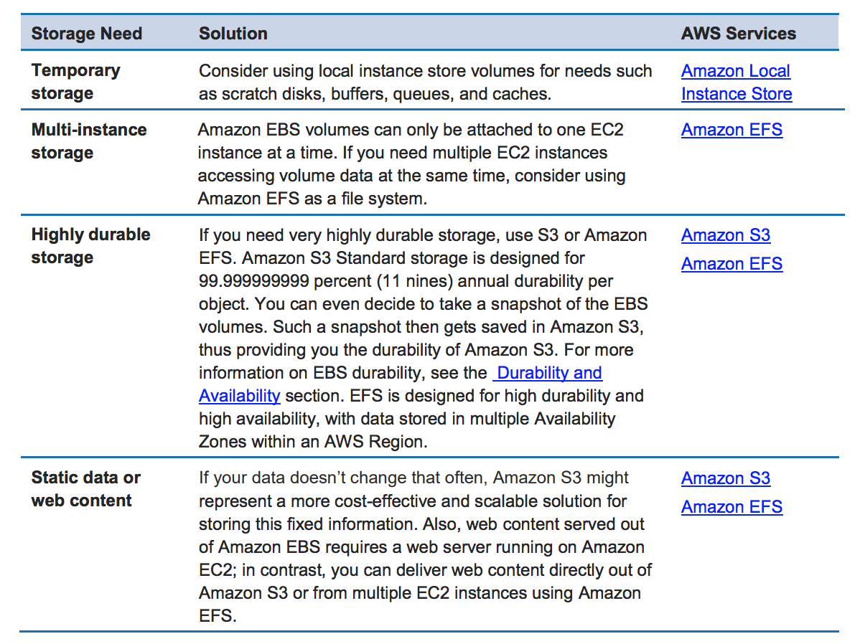

* (S3) is easy to use, with a simple web services interface to store and retrieve any amount of data from anywhere on the web.S3 provides developers and IT teams with secure, durable, highly-scalable object storage.
* A safe place to store flat files of any size (from 0 Bytes to 5 TB)
* It is an object-oriented storage:Allows uploading files (HTTP 200 status code for success)
  + Not suitable to install an operating system or databases on (you will need a block-based storage)
* **Object properties:**Key is the name of the object.Value is the data, and is made up of a sequence of bytes.Version ID is used for versioning.Metadata is the structured description of the object.
* Objects are stored in buckets (i.e. folders)S3 is a universal namespace, that is, the bucket names must be unique globally. The URL of the bucket depends on the region though, for example <https://s3-eu-west-1.amazonaws.com/somebucket>
  + By default, all newly created buckets are private.One can set up access control using Bucket Policies or Access Control Lists.One can configure to create access logs that log all requests made to this bucket.One has 100 S3 buckets per account by default.

**Best Practices**

* **use random hash prefix for keys and ensure a random access pattern**, as S3 stores object lexicographically randomness helps distribute the contents across multiple partitions for better performance
* **use parallel threads and Multipart upload for faster writes**
* **use parallel threads and Range Header GET for faster reads**
* for list operations with large number of objects, its better to build a secondary index in DynamoDB
* use **Versioning to protect from unintended overwrites and deletions**, but this does not protect against bucket deletion
* use **VPC S3 Endpoints** with VPC to transfer data using Amazon internal network
* **A Solutions Architect is building an application that stores object data. Compliance requirements state that the data stored is immutable while still being available for immediate access.Which Service meets these requirements?**

#### Explanation

Correct answer is **A** as S3 provides Object Lock feature to add immutability to objects, but still provide immediate access to the objects.

You can also enforce write-once-read-many (WORM) policies with S3 Object Lock. This S3 management feature blocks object version deletion during a customer-defined retention period so that you can enforce retention policies as an added layer of data protection or to meet compliance obligations. You can migrate workloads from existing WORM systems into Amazon S3, and configure S3 Object Lock at the object- and bucket-levels to prevent object version deletions prior to a pre-defined Retain Until Date or Legal Hold Date. Objects with S3 Object Lock retain WORM protection, even if they are moved to different storage classes with an S3 Lifecycle policy. To track what objects have S3 Object Lock, you can refer to an S3 Inventory report that includes the WORM status of objects. S3 Object Lock can be configured in one of two modes. When deployed in Governance mode, AWS accounts with specific IAM permissions are able to remove S3 Object Lock from objects. If you require stronger immutability in order to comply with regulations, you can use Compliance Mode. In Compliance Mode, the protection cannot be removed by any user, including the root account.

**A financial organization stores auditing data in AWS and a requirement has emerged that data needs to be stored for five years before it can be deleted. More than that, the data needs to be stored in such a way that nobody with access to the AWS account can circumvent the data storage restriction. Which of the following options should you suggest?**

AStore the data in Glacier, and use the Vault Lock feature to prevent deletion.

BStore the data in S3, and use a bucket policy to prevent any deletions.

CStore the data in EFS, and set the file system to read-only.

DStore the data in S3, and apply an IAM policy to all users preventing any data modification or deletion.

**Correct Answer: A**This is the recommended solution. Vault Lock is designed for this very purpose: a WORM (write once, read many) architecture.

* + **A customer wants to track access to their Amazon Simple Storage Service (S3) buckets and also use this information for their internal security and access audits. Which of the following will meet the Customer requirement?**

#### Explanation

Correct answer is **B**

In order to track requests for access to your bucket, you can enable access logging. Each access log record provides details about a single access request, such as the requester, bucket name, request time, request action, response status, and error code, if any. Access log information can be useful in security and access audits

Option A is wrong as CloudTrail would only give information for the API calls to S3 and not the individual access information

Option C is wrong as it only helps handle billing if you want the user to pay for the object access

Option D is wrong as event notifications does not cover all the information

The Amazon S3 notification feature enables you to receive notifications when certain events happen in your bucket. To enable notifications, you must first add a notification configuration identifying the events you want Amazon S3 to publish, and the destinations where you want Amazon S3 to send the event notifications.

Amazon S3 supports the following destinations where it can publish events:  
  
**Amazon Simple Notification Service (Amazon SNS) topic -**A web service that coordinates and manages the delivery or sending of messages to subscribing endpoints or clients.

**Amazon Simple Queue Service (Amazon SQS) queue -**Offers reliable and scalable hosted queues for storing messages as they travel between computer.

**AWS Lambda -**AWS Lambda is a compute service where you can upload your code and the service can run the code on your behalf using the AWS infrastructure. You package up and upload your custom code to AWS Lambda when you create a Lambda function

* Charges:
  + Storage Requests Storage management pricing Data transfer pricing Transfer acceleration
  + **Cross-region replication**
* Limitations:
  + S3 puts the limit of 3500 PUTs per second.
  + The largest object that can be uploaded in a single PUT is 5GB.
  + If you are using the multipart upload API, then the limit is 5TB.
* **STATIC WEBSITE USING S3**
* To hold static html pages. No dynamic content like php, scripts etc. A domain name needs to be created using route 53 inorder if to access this website using a url with proper public domain name in it. It can work without domain name also with the default url that S3 provides after creating static website under static webpage hosting properties menu,
* http://<exact-bucket-name-that-contains-html-pages>.s3-website-<region>.amazonaws.com

**A company has an application that stores sensitive data. The company is required by government regulations to store multiple copies of its data. What would be the MOST resilient and cost-effective option to meet this requirement?**

* A. Amazon EFS​B. Amazon RDS​C. AWS Storage Gateway
* ​D. Amazon S3**(Correct)**

#### ExplanationCorrect answer is **D** as S3 by default maintains multiple copies of data on multiple devices across multiple AZs and is very cost-effective.

Refer AWS documentation - [S3 FAQs](https://aws.amazon.com/s3/faqs/)

Q: How are Amazon S3 and Amazon S3 Glacier designed to achieve 99.999999999% durability?

**Amazon S3 Standard, S3 Standard-IA, and S3 Glacier storage classes redundantly store your objects on multiple devices across a minimum of three Availability Zones (AZs) in an Amazon S3 Region before returning SUCCESS. The S3 One Zone-IA storage class stores data redundantly across multiple devices within a single AZ. These services are designed to sustain concurrent device failures by quickly detecting and repairing any lost redundancy, and they also regularly verify the integrity of your data using checksums.**

Options A, B & C are wrong as they do not maintain multiple copies of data and are not cost effective as S3.

**You are working as a Principal Solutions Architect for a leading digital news company which has both an on-premises data center as well as an AWS cloud infrastructure. They store their graphics, audios, videos, and other multimedia assets primarily in their on-premises storage server and use an S3 Standard storage class bucket as a backup. Their data are heavily used for only a week (7 days) but after that period, it will be infrequently used by their customers. You are instructed to save storage costs in AWS yet maintain the ability to fetch their media assets in a matter of minutes for a surprise annual data audit, which will be conducted both on-premises and on their cloud storage.**

**Which of the following options should you implement to meet the above requirement? (Choose 2)**

* ​

Set a lifecycle policy in the bucket to transition the data to Glacier after one week (7 days).

**(Correct)**

* ​

Set a lifecycle policy in the bucket to transition the data to S3 - Standard IA storage class after one week (7 days).

* ​

Set a lifecycle policy in the bucket to transition the data to S3 - One Zone-Infrequent Access storage class after one week (7 days).

**(Incorrect)**

* ​

Set a lifecycle policy in the bucket to transition the data to S3 Glacier Deep Archive storage class after one week (7 days).

* ​

Set a lifecycle policy in the bucket to transition to S3 - Standard IA after 30 days

**(Correct)**

**Explanation**

You can add rules in a lifecycle configuration to tell Amazon S3 to transition objects to another Amazon S3 storage class. For example: When you know that objects are infrequently accessed, you might transition them to the STANDARD_IA storage class. Or transition your data to the GLACIER storage class in case you want to archive objects that you don't need to access in real time.

In a lifecycle configuration, you can define rules to transition objects from one storage class to another to save on storage costs. When you don't know the access patterns of your objects or your access patterns are changing over time, you can transition the objects to the INTELLIGENT_TIERING storage class for automatic cost savings.

The lifecycle storage class transitions have a constraint when you want to transition from the STANDARD storage classes to either STANDARD_IA or ONEZONE_IA. The following constraints apply:

- For larger objects, there is a cost benefit for transitioning to STANDARD_IA or ONEZONE_IA. Amazon S3 does not transition objects that are smaller than 128 KB to the STANDARD_IA or ONEZONE_IA storage classes because it's not cost effective.

- Objects must be stored **at least 30 days** in the current storage class before you can transition them to STANDARD_IA or ONEZONE_IA. For example, you cannot create a lifecycle rule to transition objects to the STANDARD_IA storage class one day after you create them. Amazon S3 doesn't transition objects within the first 30 days because newer objects are often accessed more frequently or deleted sooner than is suitable for STANDARD_IA or ONEZONE_IA storage.

- If you are transitioning noncurrent objects (in versioned buckets), you can transition only objects that are at least 30 days noncurrent to STANDARD_IA or ONEZONE_IA storage.



Since there is a time constraint in transitioning objects in S3, you can only change the storage class of your objects from S3 Standard storage class to STANDARD_IA or ONEZONE_IA storage after 30 days. This limitation does not apply on INTELLIGENT_TIERING, GLACIER, and DEEP_ARCHIVE storage class.

In addition, the requirement says that the media assets should be fetched in a matter of minutes for a surprise **annual** data audit. This means that the retrieval will only happen once a year. You can use expedited retrievals in Glacier which will allow you to quickly access your data (within 1–5 minutes) when occasional urgent requests for a subset of archives are required.

In this scenario, you can set a lifecycle policy in the bucket to transition to S3 - Standard IA after 30 days or alternatively, you can directly transition your data to Glacier after one week (7 days). Hence, Options 1 and 5 are the correct answers.

**Features**

* **Data consistency:**

Read after write consistency for newly created files (available immediately) Note : The caveat is that if you make a HEAD or GET request to the key name (to find if the object exists) before creating the object, Amazon S3 provides eventual consistency for read-after-write.

Eventual consistency for overwrite PUT's and DELETE's (can take some time to propagate) If a PUT request is successful, your data is safely stored. However, information about the changes must replicate across Amazon S3, which can take some time

* **Bucket & Object Operations**
  + allows **retrieval of 1000 objects and provides pagination support** and is **NOT** suited for list or prefix queries with large number of objects
  + with a single put operations, 5GB size object can be uploaded
  + use **Multipart upload** to upload large objects up to 5 TB and is recommended for object size of over 100MB for fault tolerant uploads
  + **support Range HTTP Header to retrieve partial objects for fault tolerant downloads where the network connectivity is poor**
  + **Pre-Signed URLs** can also be used shared for uploading/downloading objects for **limited time** **without requiring AWS security credentials**
  + allows deletion of a single object or multiple objects (max 1000) in a single call
* **Multipart Uploads** allows
  + **parallel uploads** with improved throughput and bandwidth utilization
  + **fault tolerance and quick recovery** from network issues
  + ability to **pause and resume** uploads
  + **begin an upload before the final object size is known**
* **Amazon S3 now provides increased performance to support at least 3,500 requests per second to add data and 5,500 requests per second to retrieve data**, which can save significant processing time for no additional charge. Each S3 prefix can support these request rates, making it simple to increase performance significantly.
* Applications running on Amazon S3 today will enjoy this performance improvement with no changes, and customers building new applications on S3 do not have to make any application customizations to achieve this performance. Amazon S3's support for parallel requests means you can scale your S3 performance by the factor of your compute cluster, without making any customizations to your application. Performance scales per prefix, so you can use as many prefixes as you need in parallel to achieve the required throughput. There are no limits to the number of prefixes.
* This S3 request rate performance increase removes any previous guidance to randomize object prefixes to achieve faster performance. That means you can now use logical or sequential naming patterns in S3 object naming without any performance implications. This improvement is now available in all AWS Regions.
* **Guarantees:**
  + Built for 99.99% availability.
  + Guarantees 99.9999999999% (11 9's) durability.
  + The data is automatically spread across multiple devices and facilities.
* **Versioning:**
  + Stores all versions of an object (including all writes and even deletes)Great as a backup tool.With versioning, you can easily recover from both unintended user actions and application failures.Once enabled, versioning cannot be disabled, only suspended (preserves earlier versions)Integrates with Lifecycle rules (to expire old objects)Versioning's MFA Delete capability provides additional layer of security.Newly uploaded versions are automatically made private.To restore an accidentally deleted object, simply remove the delete marker.
* **Cross-region replication:**
  + Replicates changes from any source bucket to one or more destination buckets.
  + Versioning must be enabled on all buckets.
  + Regions must be different for all buckets.
  + Destination buckets will have the same permissions as the source after setup.
  + Files at the time of setup are not replicated automatically, only subsequent updates.
  + Deleting versions or delete markers are not replicated (for security)
* **Transfer acceleration:**
  + Enables fast, easy, and secure transfers of files over long distances.As the data arrives at an edge location, data is routed to S3 over an optimized network path.Takes advantage of Amazon CloudFront's globally distributed edge locations.

**You are working for a large global biotech firm. Your global offices upload huge data sets regularly to a us-east-1-hosted S3 bucket. Which AWS service will provide all remote offices with improved transfer rates and reliability to S3?**

ADirect Connect BEnhanced networking CDAX DS3 transfer acceleration

**Correct Answer: D**S3 transfer acceleration offers local S3 endpoints and routing back to the source bucket over the global AWS network backbone and can increase performance for all global offices.

* **Multipart Upload API:**
  + For cases when your proposed upload exceeds the maximum allowed object size (>100MB)
  + Quick recovery from any network issues.Begin an upload before you know the final object size.Improved throughput - You can upload parts in parallel to improve throughput.
  + Pause and resume object uploads.A notification feature enables you to receive notifications when certain events happen in a bucket.
* destinations supported: SNS topic, SQS queue, and Lambda.  and SNS for event notifications
* S3 Select:With Amazon S3 Select, you can use simple structured query language (SQL) statements to filter the contents of Amazon S3 objects and retrieve just the subset of data that you need.You can thus reduce the amount of data that Amazon S3 transfers.
  + Works on objects stored in CSV, JSON, or Apache Parquet format.

**Lifecycle management**

* Automates moving objects between the different storage tiers (e.g. archive after 30 days)
* Can be used in conjunction with versioning for applied to current and previous versions.
* **Two types of actions:**
  + Transition actions: In which you define when objects transition to another storage class.
  + Expiration actions: In which you specify when the objects expire.
* Setting up a lifecycle rule:
  + A prefix to specify which objects in the bucket are subject to the policy.
  + A relative or absolute time specifier and a time period for transitioning objects to Glacier.
  + An object age at which the object will be deleted from S3.
* **Life-cycle management and Infrequent Access storage is available for both S3 and EFS. A restriction however is that 'Using Amazon EFS with Microsoft Windows is not supported'. File Gateway does not support iSCSI in the client side.**
* Object Lifecycle Management

By default, you can create up to 100 buckets in each of your AWS accounts. If you need additional buckets, you can increase your bucket limit by submitting a service limit increase.

Preserves copies of object inside a basket.

Individual objects can be restored to previous versions

Deleted objects can be recovered.

**Data protection**

Amazon S3 uses a combination of Content-MD5 checksums and cyclic redundancy checks (CRCs) to detect data corruption. Amazon S3 performs these checksums on data at rest and repairs any corruption using redundant data. In addition, the service calculates checksums on all network traffic to detect corruption of data packets when storing or retrieving data

**Security**

* All objects are private by default. You must open access to each object explicitly.
* Use Signed URLs to grant time-limited permission to download the object.

All objects by default are private. Only the object owner has permission to access these objects. However, the object owner can optionally share objects with others by creating a presigned URL, using their own security credentials, to grant time-limited permission to download the objects.When you create a presigned URL for your object, you must provide your security credentials, specify a bucket name, an object key, specify the HTTP method (GET to download the object) and expiration date and time. The presigned URLs are valid only for the specified duration.Anyone who receives the presigned URL can then access the object.A presigned URL gives you access to the object identified in the URL, provided that the creator of the presigned URL has permissions to access that object. That is, if you receive a presigned URL to upload an object, you can upload the object only if the creator of the presigned URL has the necessary permissions to upload that object. The presigned URLs are useful if you want your user/customer to be able to upload a specific object to your bucket, but you don't require them to have AWS security credentials or permissions..

* Public S3 buckets should never be used unless you are using the bucket to host a public website.There are two ways of securing S3, using either Access Control Lists (Permissions) or by using bucket Policies.
* By using Versioning and enabling MFA (Multi-Factor Authentication) Delete, you can secure and recover your S3 objects from accidental deletion or overwrite.

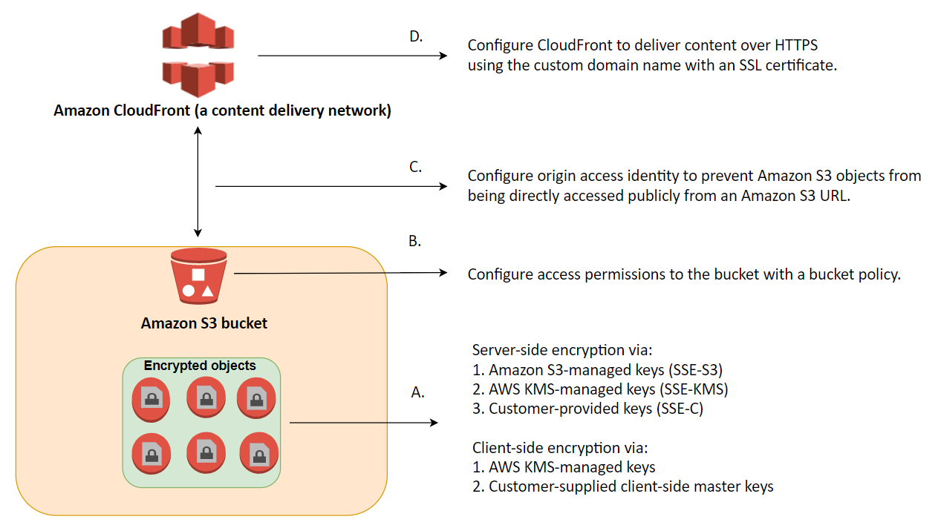

**You have been asked to implement a personal S3 storage area for every staff member within a client. There are 1,000 staff members and each requires access to an area no other staff members can access. What option is both possible and is the least amount of admin overhead to implement and manage?**

ACreate an S3 bucket for each staff member, create an IAM group, apply a policy using variables to the group, and add staff members to the group.

BCreate an S3 bucket for each staff member and add a resource policy onto each bucket, restricting access.

CCreate a single S3 bucket. Give each staff member a prefix in the bucket. Create a single managed policy using variables, apply it to a group, and add staff members to the group.

DCreate a single S3 bucket. Give each staff member a prefix in the bucket. Create a single managed policy and apply it to every staff member's IAM user.

**Correct Answer: C**This is the best solution. An IAM policy using the username variable would limit each staff member to a prefix based on their username. Create the policy once, a

**Encryption**

* Encryption in transit is achieved by SSL/TLS (HTTPS)
* [Protecting Data Using Encryption](https://docs.aws.amazon.com/AmazonS3/latest/dev/UsingEncryption.html)
* Server-side encryption is the encryption of data at its S3 destination.
  + Use Server Side Encryption (SSE)-S3, Server Side Encryption With Customer Provided Keys (SSE-C), AWS Key Management Service (SSE-KMS) or a client library such as Amazon S3 Encryption Client.
  + Amazon S3 manages both the encryption (as it writes to disks) and decryption (when reading)
* Client-side encryption is the act of encrypting data before sending it to Amazon S3.
  + Use an AWS KMS-managed customer master key or a client-side master key (never sent to AWS)
  + [Protecting Data Using Client-Side Encryption](https://docs.aws.amazon.com/AmazonS3/latest/dev/UsingClientSideEncryption.html)

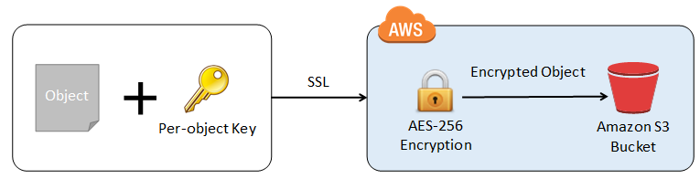

This is how client-side encryption using client-side master key works:

**When uploading an object** - You provide a client-side master key to the Amazon S3 encryption client. The client uses the master key only to encrypt the data encryption key that it generates randomly. The process works like this:

1. The Amazon S3 encryption client generates a one-time-use symmetric key (also known as a data encryption key or data key) locally. It uses the data key to encrypt the data of a single Amazon S3 object. The client generates a separate data key for each object.

2. The client encrypts the data encryption key using the master key that you provide. The client uploads the encrypted data key and its material description as part of the object metadata. The client uses the material description to determine which client-side master key to use for decryption.

3. The client uploads the encrypted data to Amazon S3 and saves the encrypted data key as object metadata (x-amz-meta-x-amz-key) in Amazon S3.

**When downloading an object -**The client downloads the encrypted object from Amazon S3. Using the material description from the object's metadata, the client determines which master key to use to decrypt the data key. The client uses that master key to decrypt the data key and then uses the data key to decrypt the object.

**A consultancy client is running a high-throughput application on-premises that stores data onto S3. The host running the software is experiencing high CPU usage and seems unable to keep up with demand while encrypting the data on-host before transit. The system requires that no data be stored in a plaintext form and has to be encrypted in transit. What potential fixes should you recommend that meet the requirements and have the least admin overhead?**

AUse SSE-C. BUse client-side encryption. CUse S3 transfer acceleration.

DUse SSE-S3 and an HTTPS Listener on an ALB.

**Your Answer: B**Client-side encryption is likely what the system is already using. If the encryption is being done on-host and CPU usage is high, that's a classic sign.

**Correct Answer: D**This solution will show improvements — S3 will handle the encryption process and the encryption keys. Data will be stored in encrypted form and, assuming HTTPS is used, encrypted in transit.

**A solutions architect is defining a shared Amazon S3 bucket where corporate applications will save objects. How can the Architect ensure that when an application uploads an object to the Amazon S3 bucket, the object is encrypted**

#### Explanation

Correct answer is **C** as the S3 default encryption can be enabled to automatically encrypt the objects before they are stored into S3.

Refer AWS documentation - [S3 Default Encryption](https://docs.aws.amazon.com/AmazonS3/latest/dev/bucket-encryption.html)

Amazon S3 default encryption provides a way to set the default encryption behavior for an S3 bucket. You can set default encryption on a bucket so that all objects are encrypted when they are stored in the bucket. The objects are encrypted using server-side encryption with either Amazon S3-managed keys (SSE-S3) or AWS KMS-managed keys (SSE-KMS).

When you use server-side encryption, Amazon S3 encrypts an object before saving it to disk in its data centers and decrypts it when you download the objects.

Default encryption works with all existing and new S3 buckets. Without default encryption, to encrypt all objects stored in a bucket, you must include encryption information with every object storage request. You must also set up an S3 bucket policy to reject storage requests that don't include encryption information.

**Storage classes**

* S3 Standard:
  + Low latency and high throughput performance.
  + Designed for 99.99% availability over a given year.
* S3 Intelligent-Tiering:
  + Same low latency and high throughput performance of S3 Standard.
  + Small monthly monitoring and auto-tiering fee.
  + Automatically moves objects between two access tiers based on changing access patterns.
  + Designed for 99.90% availability over a given year.
* S3 Standard-IA:
  + Same low latency and high throughput performance of S3 Standard.
  + For data that is accessed less frequently, but requires rapid access when needed.
  + Lower fee than S3, but you are charged a retrieval fee.
  + There can be cost implications if you use it frequently or use it for short lived storage.
  + Designed for 99.90% availability over a given year.
* S3 One Zone-IA:
  + Same low latency and high throughput performance of S3 Standard.
  + Only stored in one availability zone (= a security threat)
  + Designed for 99.50% availability over a given year.
  + The S3 One Zone-IA storage class is set at the object level and can exist in the same bucket as S3 Standard and S3 Standard-IA, allowing you to use S3 Lifecycle Policies to automatically transition objects between storage classes without any application changes.
* **S3 Glacier:**
  + Low-cost design is ideal for long-term archive.
  + Configurable retrieval times, from minutes to hours.
  + Designed for 99.99% availability over a given year.
  + Amazon Glacier encrypts your data at rest by default and supports secure data transit with SSL.
  + **Expedited**: Expedited retrievals allow you to quickly (1-5 mins) access data when occasional urgent requests for a subset of archives are required. Provisioned Capacity ensures that retrieval capacity for expedited retrievals is available when needed.
* orrect answer is **D** as Glacier provides the most cost-effective archival solution. For normal requests, which default for standard retrieval, the videos can be retrieved within 3-5 hours. For express retrieval, Expedited retrieval request can be made with additional charges for the video to be available in 1-5 minutes.
* Q: How do I use Standard retrievals?To make a Standard retrieval, set the “Tier” parameter in the InitiateJob API request to “Standard”. If no tier is specified, the request will default to Standard.
* Q: What are Expedited retrievals?
* Expedited retrievals allow you to quickly access your data when occasional urgent requests for a subset of archives are required. For all but the largest archives (250MB+), data accessed using Expedited retrievals are typically made available within 1 – 5 minutes. **There are two types of Expedited retrievals: On-Demand and Provisioned.** On-Demand requests are like EC2 On-Demand instances and are available the vast majority of the time. Provisioned requests are guaranteed to be available when you need them.

**An online stocks trading application that stores financial data in an S3 bucket has a lifecycle policy that moves older data to Glacier every month. There is a strict compliance requirement where a surprise audit can happen at anytime and you should be able to retrieve the required data in under 15 minutes under all circumstances. Your manager instructed you to ensure that retrieval capacity is available when you need it and should handle up to 150 MB/s of retrieval throughput.**

**Which of the following should you do to meet the above requirement? (Choose 2)**

* ​Retrieve the data using Amazon Glacier Select.



* ​Use Expedited Retrieval to access the financial data.



* ​Use Bulk Retrieval to access the financial data.



* ​Specify a range, or portion, of the financial data archive to retrieve.



* ​Purchase provisioned retrieval capacity.



**Explanation**

Expedited retrievals allow you to quickly access your data when occasional urgent requests for a subset of archives are required. For all but the largest archives (250 MB+), data accessed using Expedited retrievals are typically made available within 1–5 minutes. Provisioned Capacity ensures that retrieval capacity for Expedited retrievals is available when you need it.

To make an Expedited, Standard, or Bulk retrieval, set the Tier parameter in the Initiate Job (POST jobs) REST API request to the option you want, or the equivalent in the AWS CLI or AWS SDKs. If you have purchased provisioned capacity, then all expedited retrievals are automatically served through your provisioned capacity.

Provisioned capacity ensures that your retrieval capacity for expedited retrievals is available when you need it. Each unit of capacity provides that at least three expedited retrievals can be performed every five minutes and provides up to 150 MB/s of retrieval throughput. You should purchase provisioned retrieval capacity if your workload requires highly reliable and predictable access to a subset of your data in minutes. Without provisioned capacity Expedited retrievals are accepted, except for rare situations of unusually high demand. However, if you require access to Expedited retrievals under all circumstances, you must purchase provisioned retrieval capacity.

* + **Standard: Standard retrievals allow you to access any of your archives within several hours 3 – 5 hours** .
  + **Bulk: Bulk retrievals typically complete within 5–12 hours**.
* **S3 Glacier Deep Archive**:Lowest cost storage class designed for long-term retention of data (7-10 years)Ideal alternative to magnetic tape libraries.
  + Retrieval time within 12 hours.
  + Designed for 99.99% availability over a given year.
* RRS (Reduced Redundancy Storage):RRS has effectively been deprecated.
* All are designed for durability of 99.999999999% (11 9's) of objects.
  + RRS is the only S3 Class that does not offer this.
* **Selection criteria** among the S3 classes,
* If you don’t care about retrieval time, go for **Glacier**.
* If you care about retrieval time but want to keep the cost low, go for **S3 Infrequently Accessed.**
* If you don’t care about cost and want as durable as possible go for **S3 standard.**

**A company has 10 TB of infrequently accessed financial data files that would need to be stored in AWS. These data would be accessed infrequently during specific weeks when they are retrieved for auditing purposes. The retrieval time is not strict as long as it does not exceed 24 hours.**

**Which of the following would be a secure, durable, and cost-effective solution for this scenario?**

* ​

Upload the data to S3 then use a lifecycle policy to transfer data to S3-IA.

* ​

Upload the data to S3 and set a lifecycle policy to transition data to Glacier after 0 days.

**(Correct)**

* ​

Upload the data directly to Amazon Glacier through the AWS Management Console.

* ​

Upload the data to S3 then use a lifecycle policy to transfer data to S3 One Zone-IA.

**Explanation**

Glacier is a cost-effective archival solution for large amounts of data. Bulk retrievals are S3 Glacier’s lowest-cost retrieval option, enabling you to retrieve large amounts, even petabytes, of data inexpensively in a day. Bulk retrievals typically complete within 5 – 12 hours. You can specify an absolute or relative time period (including 0 days) after which the specified Amazon S3 objects should be transitioned to Amazon Glacier. Hence, Option 2 is the correct answer.

Glacier has a management console which you can use to create and delete vaults. However, you cannot directly upload archives to Glacier by using the management console. To upload data, such as photos, videos, and other documents, you must either use the AWS CLI or write code to make requests, by using either the REST API directly or by using the AWS SDKs.

Take note that uploading data to the S3 Console and setting its storage class of "Glacier" is a different story as the proper way to upload data to Glacier is still via its API or CLI. In this way, you can set up your vaults and configure your retrieval options. If you uploaded your data using the S3 console then it will be managed via S3 even though it is internally, using a Glacier storage class. Hence, you won't be able to use Vaults, set your Retrieval Options or purchase Provisioned Capacity for your archives.

**CloudFront**

* A Content Delivery Network (CDN) is a system of distributed servers (network) that deliver webpages and other web content to a user based on the geographic locations of the user, the origin of the webpage, and a content delivery server.Origin is the origin of all the files that the CDN will distribute.**Distribution is the name of the CDN that consists of a collection of edge locations.**
  + Web distributions are typically used for websites.
  + RTMP is used for media streaming.
* Amazon CloudFront is a fast content delivery network (CDN) service.
  + Can deliver an **entire website, including dynamic, static, streaming, and interactive content using** a global network of edge locations.
  + Requests for the content are automatically routed to the nearest edge location, so the content is delivered with the best possible performance.
* **Edge locations:**
  + They are not just read-only, one can write to them too.
  + Objects are cached based on the TTL (time to live)
  + You can clear cached objects (i.e. invalidate them), but you will be charged.

Top of Form

**B** as the objects are already cached, the only way to refresh the content is to invalidate the cache.

By default, Amazon CloudFront caches a response from Amazon S3 for 24 hours ([*Default TTL*](https://docs.aws.amazon.com/AmazonCloudFront/latest/DeveloperGuide/distribution-web-values-specify.html#DownloadDistValuesDefaultTTL) of 86,400 seconds). If your request lands at an edge location that served the Amazon S3 response within 24 hours, Amazon CloudFront uses the cached response even if you updated the content in Amazon S3.

Use one of the following ways to push the updated S3 content from Amazon CloudFront:

* [*Invalidate the S3 objects*](https://docs.aws.amazon.com/AmazonCloudFront/latest/DeveloperGuide/Invalidation.html)*.*
* [*Use object versioning*](https://docs.aws.amazon.com/AmazonCloudFront/latest/DeveloperGuide/UpdatingExistingObjects.html)*.*Bottom of Form

Top of Form

* + **You cannot combine blacklisting and whitelisting in CloudFront.**
* There are multiple options to securely access files stored in S3:
  + **CloudFront Signed URLs:** Generates URLs for access. Primarily used for providing access to individual files and when cookies cannot be used.
  + **CloudFront Signed Cookies:** Generates special cookies for access. Primarily used when you don't want to change your current URL.
  + **CloudFront Origin Access Identity**: A virtual user identity that is used to give the CloudFront distribution permission to fetch a private object from S3.
* Lambda@Edge:You can use Lambda@Edge to allow your Lambda functions to customize the content that CloudFront delivers and to execute the authentication process in AWS locations closer to the users.

**You are working as a Solutions Architect for a leading data analytics company in which you are tasked to process real-time streaming data of your users across the globe. This will enable you to track and analyze globally-distributed user activity on your website and mobile applications, including click stream analysis. Your cloud architecture should process the data in close geographical proximity to your users and to respond to user requests at low latencies.**

**Which of the following options is the most ideal solution that you should implement?**

* ​

Use a CloudFront web distribution and Route 53 with a latency-based routing policy, in order to process the data in close geographical proximity to users and respond to user requests at low latencies. Process real-time streaming data using Kinesis and durably store the results to an Amazon S3 bucket.

**(Incorrect)**

* ​

Integrate CloudFront with Lambda@Edge in order to process the data in close geographical proximity to users and respond to user requests at low latencies. Process real-time streaming data using Amazon Athena and durably store the results to an Amazon S3 bucket.

* ​

Use a CloudFront web distribution and Route 53 with a Geoproximity routing policy in order to process the data in close geographical proximity to users and respond to user requests at low latencies. Process real-time streaming data using Kinesis and durably store the results to an Amazon S3 bucket.

* ​

Integrate CloudFront with Lambda@Edge in order to process the data in close geographical proximity to users and respond to user requests at low latencies. Process real-time streaming data using Kinesis and durably store the results to an Amazon S3 bucket.

**(Correct)**

**Explanation**

Lambda@Edge is a feature of Amazon CloudFront that lets you run code closer to users of your application, which improves performance and reduces latency. With Lambda@Edge, you don't have to provision or manage infrastructure in multiple locations around the world. You pay only for the compute time you consume - there is no charge when your code is not running.

With Lambda@Edge, you can enrich your web applications by making them globally distributed and improving their performance — all with zero server administration. Lambda@Edge runs your code in response to events generated by the Amazon CloudFront content delivery network (CDN). Just upload your code to AWS Lambda, which takes care of everything required to run and scale your code with high availability at an AWS location closest to your end user.

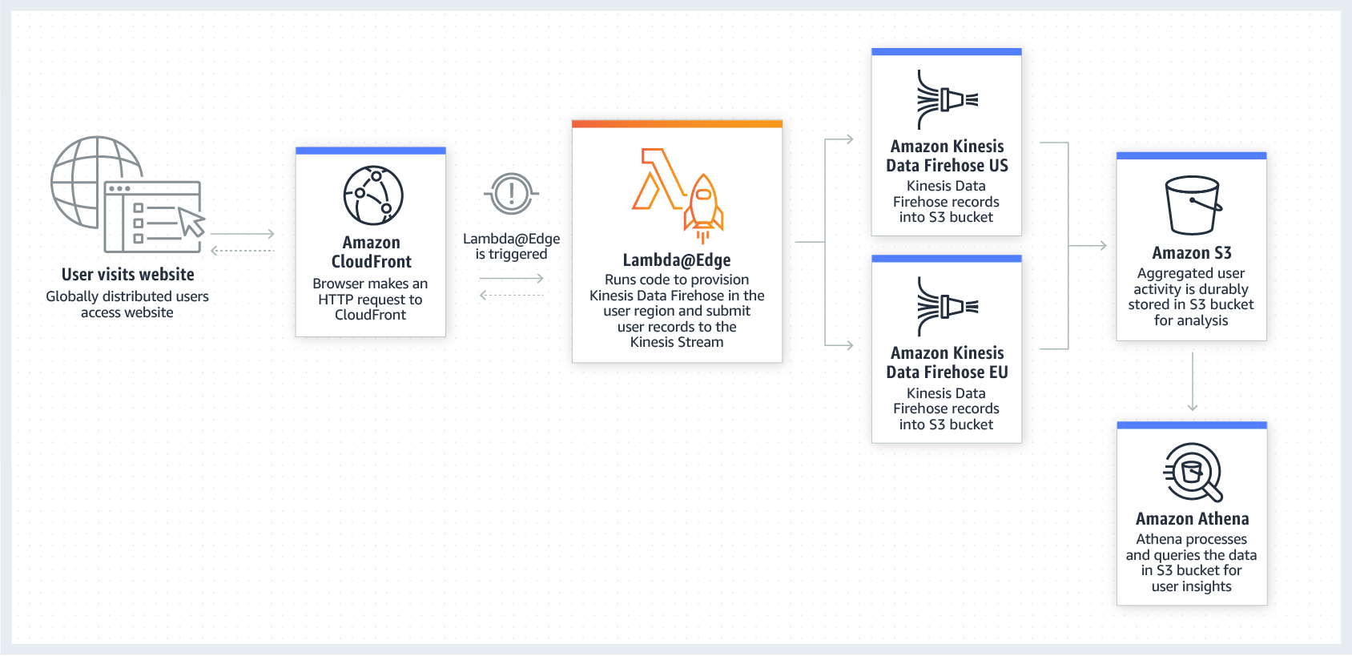

By using Lambda@Edge and Kinesis together, you can process real-time streaming data so that you can track and analyze globally-distributed user activity on your website and mobile applications, including clickstream analysis. Hence, Option 4 is the correct answer in this scenario.

Options 1 and 3 are both incorrect because you can only route traffic using Route 53 since it does not have any computing capability. This solution would not be able to process and return the data in close geographical proximity to your users since it is not using Lambda@Edge.

Option 2 is incorrect because although using Lambda@Edge is correct, Amazon Athena is just an interactive query service that enables you to easily analyze data in Amazon S3 using standard SQL. Kinesis should be used to process the streaming data in real-time.

* Origin Failover: You can set up an origin failover by creating an origin group with two origins with one as the primary origin and the other as the second origin which CloudFront automatically switches to when the primary origin fails.
  + [Optimizing High Availability with CloudFront Origin Failover](https://docs.aws.amazon.com/AmazonCloudFront/latest/DeveloperGuide/high_availability_origin_failover.html)
  + SNI Custom SSL relies on the SNI extension of the Transport Layer Security protocol, which allows multiple domains to serve SSL traffic over the same IP address by including the hostname which the viewers are trying to connect to.
  + **Use the Dedicated IP Custom SSL feature to support non-SNI compliant browsers for HTTPS content.**
* You can use geo restriction, also known as geoblocking, to prevent users in specific geographic locations from accessing content that you're distributing through a CloudFront web distribution. To use geo restriction, you have two options:
* **Use the CloudFront geo restriction feature. Use this option to restrict access to all of the files that are associated with a distribution and to restrict access at the country level.**
* **Use a third-party geolocation service. Use this option to restrict access to a subset of the files that are associated with a distribution or to restrict access at a finer granularity than the country level.**

**One of your EC2 instances is reporting an unhealthy system status check. The operations team is looking for an easier way to monitor and repair these instances instead of fixing them manually.  
How will you automate the monitoring and repair of the system status check failure in an AWS environment?**

* ​Create CloudWatch alarms that stop and start the instance based on status check alarms.



* ​Write a python script that queries the EC2 API for each instance status check



* ​Write a shell script that periodically shuts down and starts instances based on certain stats.



* ​Buy and implement a third party monitoring tool.



**Explanation**

Using Amazon CloudWatch alarm actions, you can create alarms that automatically stop, terminate, reboot, or recover your EC2 instances. You can use the stop or terminate actions to help you save money when you no longer need an instance to be running. You can use the reboot and recover actions to automatically reboot those instances or recover them onto new hardware if a system impairment occurs

**Your customer has clients all across the globe that access product files stored in several S3 buckets, which are behind each of their own CloudFront web distributions. They currently want to deliver their content to a specific client, and they need to make sure that only that client can access the data. Currently, all of their clients can access their S3 buckets directly using an S3 URL or through their CloudFront distribution.**

**Which of the following are possible solutions that you could implement to meet the above requirements?**

* ​Use CloudFront Signed Cookies to ensure that only their client can access the files.



* ​Use CloudFront signed URLs to ensure that only their client can access the files.



* ​Use S3 pre-signed URLs to ensure that only their client can access the files. Remove permission to use Amazon S3 URLs to read the files for anyone else.



* ​Create an origin access identity (OAI) and give it permission to read the files in the bucket.



**Explanation**

Many companies that distribute content over the Internet want to restrict access to documents, business data, media streams, or content that is intended for selected users, for example, users who have paid a fee. To securely serve this private content by using CloudFront, you can do the following:

-Require that your users access your private content by using special CloudFront signed URLs or signed cookies.

-Require that your users access your Amazon S3 content by using CloudFront URLs, not Amazon S3 URLs. Requiring CloudFront URLs isn't necessary, but it is recommended to prevent users from bypassing the restrictions that you specify in signed URLs or signed cookies.

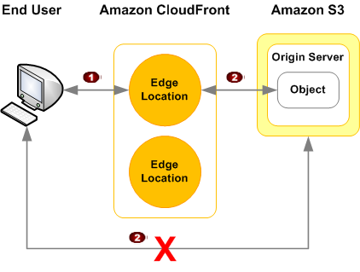

All objects and buckets by default are private. The presigned URLs are useful if you want your user/customer to be able to upload a specific object to your bucket, but you don't require them to have AWS security credentials or permissions. You can generate a presigned URL programmatically using the AWS SDK for Java or the AWS SDK for .NET. If you are using Microsoft Visual Studio, you can also use AWS Explorer to generate a presigned object URL without writing any code. Anyone who receives a valid presigned URL can then programmatically upload an object.

Option 3 is correct because using a presigned URL to your S3 bucket will prevent other users from accessing your private data which is intended only for a certain client.

Option 1 is incorrect because the signed cookies feature is primarily used if you want to provide access to multiple restricted files, for example, all of the files for a video in HLS format or all of the files in the subscribers' area of website. In addition, this solution is not complete since the users can bypass the restrictions by simply using the direct S3 URLs.

Option 2 is incorrect because although this solution is valid, the users can still bypass the restrictions in CloudFront by simply connecting to the direct S3 URLs.

Option 4 is incorrect because an Origin Access Identity (OAI) will require your client to access the files only by using the CloudFront URL and not through a direct S3 URL. This can be a possible solution if it mentions the use of Signed URL or Signed Cookies.

**You have created a CloudFront distribution to improve the performance of your global stock images website. Private images are distributed using CloudFront signed URLs, and the distribution is configured to be private. You recently found a group of users accessing images directly from the S3 origin without paying. How can you resolve this?**

ARemove the DNS name on the S3 bucket. BAdd an OAI to CloudFront and the bucket policy.

CApply a bucket policy to the bucket, blocking all access.

DApply an object-level restriction to each object in the origin using the ARN of the CloudFront distribution.

**Correct Answer: B**This is the recommended approach. An OAI is a virtual identity that can be associated with a CloudFront distribution and then used in a bucket policy.

**A web application is using CloudFront to distribute their images, videos, and other static contents stored in their S3 bucket to its users around the world. The company has recently introduced a new member-only access to some of its high quality media files. There is a requirement to provide access to multiple private media files only to their paying subscribers without having to change their current URLs.   Which of the following is the most suitable solution that you should implement to satisfy this requirement?**

* ​Configure your CloudFront distribution to use Match Viewer as its Origin Protocol Policy which will automatically match the user request. This will allow access to the private content if the request is a paying member and deny it if it is not a member.



* ​Create a Signed URL with a custom policy which only allows the members to see the private files.



* ​Configure your CloudFront distribution to use Field-Level Encryption to protect your private data and only allow access to members.



* ​Use Signed Cookies to control who can access the private files in your CloudFront distribution by modifying your application to determine whether a user should have access to your content. For members, send the required Set-Cookie headers to the viewer which will unlock the content only to them.



**Explanation**

CloudFront signed URLs and signed cookies provide the same basic functionality: they allow you to control who can access your content. If you want to serve private content through CloudFront and you're trying to decide whether to use signed URLs or signed cookies, consider the following:

**Use signed URLs for the following cases:**

* **-You want to use an RTMP distribution. Signed cookies aren't supported for RTMP distributions.**
* **-You want to restrict access to individual files, for example, an installation download for your application.**
* **-Your users are using a client (for example, a custom HTTP client) that doesn't support cookies.**

**Use signed cookies for the following cases:**

* **-You want to provide access to multiple restricted files, for example, all of the files for a video in HLS format or all of the files in the subscribers' area of a website.**
* **-You don't want to change your current URLs.**

 Hence, the correct answer to this scenario is Option 4.

Option 1 is incorrect because a Match Viewer is an Origin Protocol Policy which configures CloudFront to communicate with your origin using HTTP or HTTPS, depending on the protocol of the viewer request. CloudFront caches the object only once even if viewers make requests using both HTTP and HTTPS protocols.

Option 2 is incorrect because Signed URLs are primarily used for providing access to individual files, as shown on the above explanation. In addition, the scenario explicitly says that they don't want to change their current URLs which is why implementing Signed Cookies is more suitable than Signed URL.

Option 3 is incorrect because Field-Level Encryption only allows you to securely upload user-submitted sensitive information to your web servers. It does not provide access to download multiple private files.

* When you create a pre-signed URL for your object, you must provide your security credentials, specify a bucket name, an object key, specify the HTTP method (GET to download the object) and expiration date and time. The pre-signed URLs are valid only for the specified duration.
* Anyone who receives the pre-signed URL can then access the object. For example, if you have a video in your bucket and both the bucket and the object are private, you can share the video with others by generating a pre-signed URL.
* 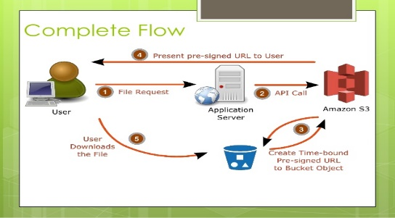

**A travel company has a suite of web applications hosted in an Auto Scaling group of On-Demand EC2 instances behind an Application Load Balancer that handles traffic from various web domains such as i-love-manila.com, i-love-boracay.com, i-love-cebu.com and many others. To improve security and lessen the overall cost, you are instructed to secure the system by allowing multiple domains to serve SSL traffic without the need to reauthenticate and reprovision your certificate everytime you add a new domain. This migration from HTTP to HTTPS will help improve their SEO and Google search ranking.**

**Which of the following is the most cost-effective solution to meet the above requirement?**

* ​Use a wildcard certificate to handle multiple sub-domains and different domains.



* ​Add a Subject Alternative Name (SAN) for each additional domain to your certificate.



* reate a new CloudFront web distribution and configure it to serve HTTPS requests using dedicated IP addresses in order to associate your alternate domain names with a dedicated IP address in each CloudFront edge location.



* ​Upload all SSL certificates of the domains in the ALB using the console and bind multiple certificates to the same secure listener on your load balancer. ALB will automatically choose the optimal TLS certificate for each client using Server Name Indication (SNI).



**Explanation**

SNI Custom SSL relies on the SNI extension of the Transport Layer Security protocol, which allows multiple domains to serve SSL traffic over the same IP address by including the hostname which the viewers are trying to connect to.

You can host multiple TLS secured applications, each with its own TLS certificate, behind a single load balancer. In order to use SNI, all you need to do is bind multiple certificates to the same secure listener on your load balancer. ALB will automatically choose the optimal TLS certificate for each client. These features are provided at no additional charge.

**A web application, which is used by your clients around the world, is hosted in an Auto Scaling group of EC2 instances behind a Classic Load Balancer. You need to secure your application by allowing multiple domains to serve SSL traffic over the same IP address.**

**Which of the following should you do to meet the above requirement?**

* ​Use Server Name Indication (SNI) on your Classic Load Balancer by adding multiple SSL certificates to allow multiple domains to serve SSL traffic.



* ​Generate an SSL certificate with AWS Certificate Manager and create a CloudFront web distribution. Associate the certificate with your web distribution and enable the support for Server Name Indication (SNI).



* ​Use an Elastic IP and upload multiple 3rd party certificates in your Classic Load Balancer using the AWS Certificate Manager.



* ​It is not possible to allow multiple domains to serve SSL traffic over the same IP address in AWS



**Explanation**

SNI Custom SSL relies on the SNI extension of the Transport Layer Security protocol, which allows multiple domains to serve SSL traffic over the same IP address by including the hostname which the viewers are trying to connect to.

Amazon CloudFront delivers your content from each edge location and offers the same security as the Dedicated IP Custom SSL feature. SNI Custom SSL works with most modern browsers, including Chrome version 6 and later (running on Windows XP and later or OS X 10.5.7 and later), Safari version 3 and later (running on Windows Vista and later or Mac OS X 10.5.6. and later), Firefox 2.0 and later, and Internet Explorer 7 and later (running on Windows Vista and later).

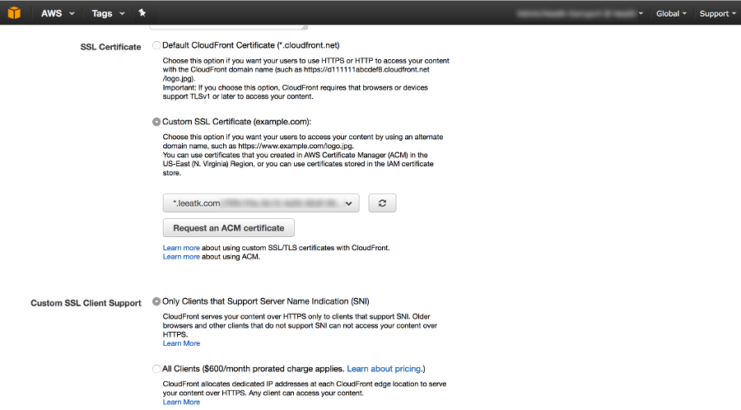

Some users may not be able to access your content because some older browsers do not support SNI and will not be able to establish a connection with CloudFront to load the HTTPS version of your content. If you need to support non-SNI compliant browsers for HTTPS content, it is recommended to use the Dedicated IP Custom SSL feature.

Option 1 is incorrect because a Classic Load Balancer does not support Server Name Indication (SNI). You have to use an Application Load Balancer instead or a CloudFront web distribution to allow the SNI feature.

Option 3 is incorrect because just like Option 1, a Classic Load Balancer does not support Server Name Indication (SNI) and the use of an Elastic IP is not a suitable solution to allow multiple domains to serve SSL traffic. You have to use Server Name Indication (SNI).

Option 4 is incorrect because AWS does support the use of Server Name Indication (SNI).

**You created a new CloudFormation template that creates 4 EC2 instances and are connected to one Elastic Load Balancer (ELB). Which section of the template should you configure to get the Domain Name Server hostname of the ELB upon the creation of the AWS stack?**

* ​

Resources

**(Incorrect)**

* ​

Parameters

* ​

Outputs

**(Correct)**

* ​

Mappings

**Explanation**

**Outputs** is an optional section of the CloudFormation template that describes the values that are returned whenever you view your stack's properties.

**You are working as a Solutions Architect for a leading technology company where you are instructed to troubleshoot the operational issues of your cloud architecture by logging the AWS API call history of your AWS resources. You need to quickly identify the most recent changes made to resources in your environment, including creation, modification, and deletion of AWS resources. One of the requirements is that the generated log files should be encrypted to avoid any security issues.**

**Which of the following is the most suitable approach to implement the encryption?**

* ​

Use CloudTrail and configure the destination Amazon Glacier archive to use Server-Side Encryption (SSE).

* ​

Use CloudTrail and configure the destination S3 bucket to use Server-Side Encryption (SSE).

**(Incorrect)**

* ​

Use CloudTrail and ensure that the Server-Side Encryption (SSE) option is enabled for the trail in the CloudTrail console.

* ​

Use CloudTrail with its default settings

**(Correct)**

**Explanation**

By default, CloudTrail event log files are encrypted using Amazon S3 server-side encryption (SSE). You can also choose to encrypt your log files with an AWS Key Management Service (AWS KMS) key. You can store your log files in your bucket for as long as you want. You can also define Amazon S3 lifecycle rules to archive or delete log files automatically. If you want notifications about log file delivery and validation, you can set up Amazon SNS notifications.

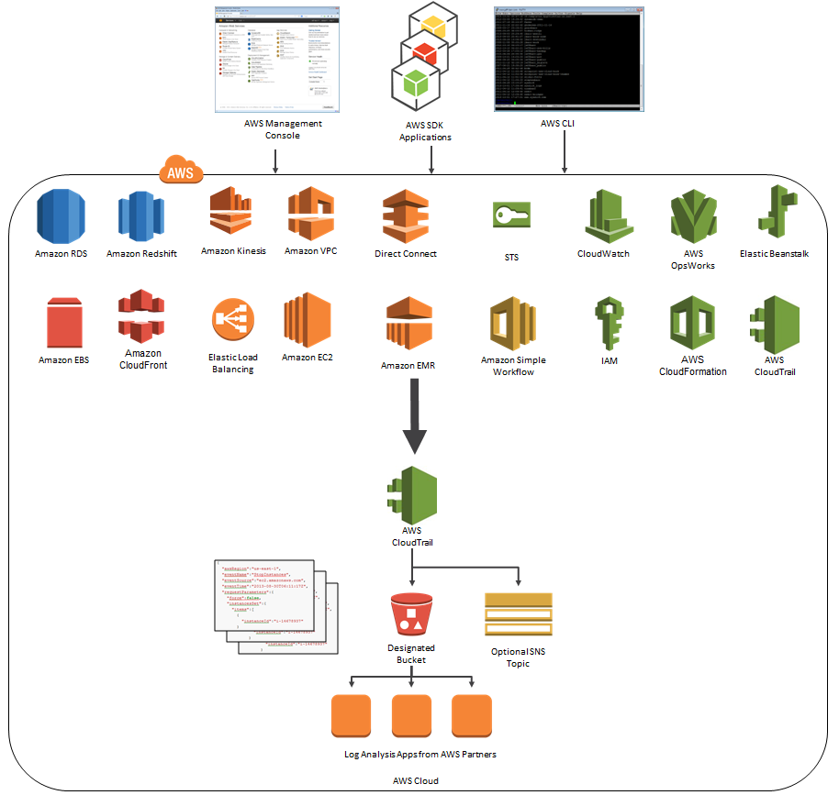

Option 1 is incorrect because CloudTrail stores the log files to S3 and not in Glacier. Take note that by default, CloudTrail event log files are already encrypted using Amazon S3 server-side encryption (SSE).

Option 2 is incorrect because CloudTrail event log files are already encrypted using the Amazon S3 server-side encryption (SSE) which is why you do not have to do this anymore.

Option 3 is incorrect because there is no available Server-Side Encryption (SSE) option in the CloudTrail console.

**A popular social media website uses a CloudFront web distribution to serve their static contents to their millions of users around the globe. They are receiving a number of complaints recently that their users take a lot of time to log into their website. There are also occasions when their users are getting HTTP 504 errors. You are instructed by your manager to significantly reduce the user's login time to further optimize the system.**

**Which of the following options should you use together to set up a cost-effective solution that can improve your application's performance? (Choose 2)**

* ​

Customize the content that the CloudFront web distribution delivers to your users using Lambda@Edge, which allows your Lambda functions to execute the authentication process in AWS locations closer to the users.

**(Correct)**

* ​

Use multiple and geographically disperse VPCs to various AWS regions then create a transit VPC to connect all of your resources. In order to handle the requests faster, set up Lambda functions in each region using the AWS Serverless Application Model (SAM) service.

* ​

Configure your origin to add a Cache-Control max-age directive to your objects, and specify the longest practical value for max-age to increase the cache hit ratio of your CloudFront distribution.

**(Incorrect)**

* ​

Deploy your application to multiple AWS regions to accommodate your users around the world. Set up a Route 53 record with latency routing policy to route incoming traffic to the region that provides the best latency to the user.

* ​

Set up an origin failover by creating an origin group with two origins. Specify one as the primary origin and the other as the second origin which CloudFront automatically switches to when the primary origin returns specific HTTP status code failure responses.

**(Correct)**

**Explanation**

Lambda@Edge lets you run Lambda functions to customize the content that CloudFront delivers, executing the functions in AWS locations closer to the viewer. The functions run in response to CloudFront events, without provisioning or managing servers. You can use Lambda functions to change CloudFront requests and responses at the following points:

* -After CloudFront receives a request from a viewer (viewer request)
* -Before CloudFront forwards the request to the origin (origin request)
* -After CloudFront receives the response from the origin (origin response)
* -Before CloudFront forwards the response to the viewer (viewer response)

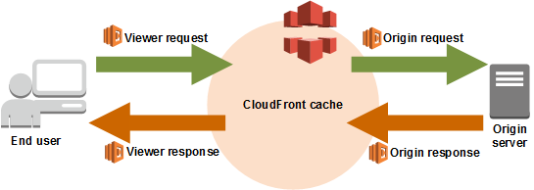

In the given scenario, you can use Lambda@Edge to allow your Lambda functions to customize the content that CloudFront delivers and to execute the authentication process in AWS locations closer to the users. In addition, you can set up an origin failover by creating an origin group with two origins with one as the primary origin and the other as the second origin which CloudFront automatically switches to when the primary origin fails. This will alleviate the occasional HTTP 504 errors that users are experiencing. Therefore, the correct answers are Options 1 and 5.

Option 2 is incorrect because of the same reason provided in Option 1 above. Although setting up multiple VPCs across various regions which are connected with a transit VPC is valid, this solution still entails higher setup and maintenance costs. A more cost-effective option would be to use Lambda@Edge instead.

Option 3 is incorrect because improving the cache hit ratio for the CloudFront distribution is irrelevant in this scenario. You can improve your cache performance by increasing the proportion of your viewer requests that are served from CloudFront edge caches instead of going to your origin servers for content. However, take note that the problem in the scenario is the sluggish authentication process of your global users and not just the caching of the static objects.

Option 4 is incorrect because although this may resolve the performance issue, this solution entails a significant implementation cost since you have to deploy your application to multiple AWS regions. Remember that the scenario asks for a solution that will improve the performance of the application with **minimal cost**.

**Request routing**

1. DNS routes the request to the nearest CloudFront POP in terms of latency.In the POP, CloudFront checks its cache for the requested files.If the files are not in the cache, CloudFront will query the origin server and then cache the resource on the edge location.

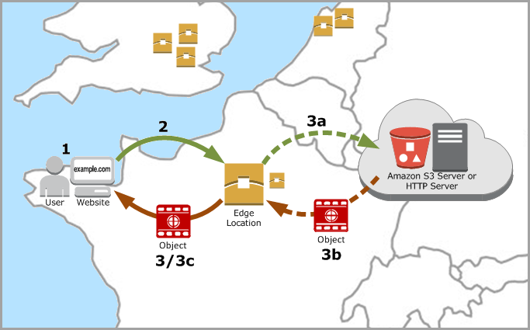

* supports **Web Download** distribution and **RTMP** **Streaming** distribution
  + Web distribution supports static, dynamic web content, on demand using progressive download & HLS and live streaming video content
  + RTMP supports streaming of media files using Adobe Media Server and the Adobe Real-Time Messaging Protocol (RTMP) **ONLY**
* supports HTTPS using either
  + **dedicated IP address**, which is expensive as dedicated IP address is assigned to each CloudFront edge location
  + **Server Name Indication (SNI)**, which is free but supported by modern browsers only with the domain name available in the request header
* For E2E HTTPS connection,
  + **Viewers -> CloudFront** needs either **self signed certificate, or certificate issued by CA or ACM**
  + **CloudFront -> Origin** needs **certificate issued by ACM for ELB and by CA for other origins**
* **Security**
  + **Origin Access Identity** (OAI) can be used to restrict the content from S3 origin to be accessible from CloudFront only
  + supports**Geo restriction (Geo-Blocking) to whitelist or blacklist** countries that can access the content
  + **Signed URLs**
    - for RTMP distribution as signed cookies aren’t supported
    - to restrict access to individual files, *for e.g., an installation download for your application.*
    - users using a client, *for e.g. a custom HTTP client,* that doesn’t support cookies
  + **Signed Cookies**
    - provide access to multiple restricted files, *for e.g., video part files in HLS format or all of the files in the subscribers’ area of a website.*
    - don’t want to change the current URLs
  + integrates with AWS **WAF**, a web application firewall that helps protect web applications from attacks by allowing rules configured based on IP addresses, HTTP headers, and custom URI strings
* supports **GET, HEAD, OPTIONS, PUT, POST, PATCH, DELETE** to get object & object headers, add, update, and delete objects
  + **only caches** responses to **GET and HEAD** requests and, optionally, OPTIONS requests
  + **does not cache** responses to **PUT, POST, PATCH, DELETE** request methods and these requests are proxied back to the origin
* supports adding or modifying custom headers before the request is sent to origin which can be used to
  + **validate** if user is accessing the content from CDN
  + **identifying CDN** from which the request was forwarded from, in case of multiple CloudFront distribution
  + for **viewers not supporting CORS** to return the Access-Control-Allow-Origin header for every request
* supports **Partial GET requests** using range header to download object in smaller units improving the efficiency of partial downloads and recovery from partially failed transfers
* supports **compression** to compress and serve compressed files when viewer requests include Accept-Encoding: gzip in the request header
* supports different **price class** to include all regions, to include only least expensive regions and other regions to exclude most expensive regions
* supports **access logs** which contain detailed information about every user request for both web and RTMP distribution

**You are working as a Solutions Architect for a leading data analytics company in which you are tasked to process real-time streaming data of your users across the globe. This will enable you to track and analyze globally-distributed user activity on your website and mobile applications, including click stream analysis. Your cloud architecture should process the data in close geographical proximity to your users and to respond to user requests at low latencies.**

**Which of the following options is the most ideal solution that you should implement?**

* ​

Use a CloudFront web distribution and Route 53 with a latency-based routing policy, in order to process the data in close geographical proximity to users and respond to user requests at low latencies. Process real-time streaming data using Kinesis and durably store the results to an Amazon S3 bucket.

* ​

Integrate CloudFront with Lambda@Edge in order to process the data in close geographical proximity to users and respond to user requests at low latencies. Process real-time streaming data using Amazon Athena and durably store the results to an Amazon S3 bucket.

* ​

Use a CloudFront web distribution and Route 53 with a Geoproximity routing policy in order to process the data in close geographical proximity to users and respond to user requests at low latencies. Process real-time streaming data using Kinesis and durably store the results to an Amazon S3 bucket.

**(Incorrect)**

* ​

Integrate CloudFront with Lambda@Edge in order to process the data in close geographical proximity to users and respond to user requests at low latencies. Process real-time streaming data using Kinesis and durably store the results to an Amazon S3 bucket.

**(Correct)**

**Explanation**

Lambda@Edge is a feature of Amazon CloudFront that lets you run code closer to users of your application, which improves performance and reduces latency. With Lambda@Edge, you don't have to provision or manage infrastructure in multiple locations around the world. You pay only for the compute time you consume - there is no charge when your code is not running.

With Lambda@Edge, you can enrich your web applications by making them globally distributed and improving their performance — all with zero server administration. Lambda@Edge runs your code in response to events generated by the Amazon CloudFront content delivery network (CDN). Just upload your code to AWS Lambda, which takes care of everything required to run and scale your code with high availability at an AWS location closest to your end user.



By using Lambda@Edge and Kinesis together, you can process real-time streaming data so that you can track and analyze globally-distributed user activity on your website and mobile applications, including clickstream analysis. Hence, Option 4 is the correct answer in this scenario.

Options 1 and 3 are both incorrect because you can only route traffic using Route 53 since it does not have any computing capability. This solution would not be able to process and return the data in close geographical proximity to your users since it is not using Lambda@Edge.

Option 2 is incorrect because although using Lambda@Edge is correct, Amazon Athena is just an interactive query service that enables you to easily analyze data in Amazon S3 using standard SQL. Kinesis should be used to process the streaming data in real-time.

EBS- Elastic Block Store (

* Amazon Elastic Block Store (EBS) provides persistent block storage volumes in the cloud.
* Volumes exist on EBS:Think of EBS as of a virtual hard disk.Persist independently from the running life of an EC2 instance.Replicated within its AZ to protect from component failure.Can only be attached to one EC2 instance at a time.You can attach it to any EC2 instance in the same AZ (since it is replicated here)Support live configuration changes while in production: you can modify the volume type, volume size, and IOPS capacity without service interruptions.Offer 99.999% SLA.
* Snapshots exist on S3:

Think of snapshots as of a photograph of the disk.Snapshots are point-in-time copies of volumes.Snapshots are incremental: only the blocks that changed since last snapshots are moved to S3.The first snapshot may take some time.Created with command aws ec2 create-snapshot This minimizes the time required to create the snapshot and saves on storage costs by not duplicating data. When you delete a snapshot, only the data unique to that snapshot is removed. Each snapshot contains all of the information needed to restore your data (from the moment when the snapshot was taken) to a new EBS volume.

When you create an EBS volume based on a snapshot, the new volume begins as an exact replica of the original volume that was used to create the snapshot. The replicated volume loads data lazily in the background so that you can begin using it immediately. If you access data that hasn't been loaded yet, the volume immediately downloads the requested data from Amazon S3, and then continues loading the rest of the volume's data in the background.

* + To take a snapshot of a root device, you should stop the EC2 instance first. But you can also make a snapshot while the instance is running (may be slow)One can perform actions on an existing EBS snapshot using AWS APIs, CLI, and AWS Console.
  + One cannot delete a snapshot that is used as the root device of a registered AMI.
  + EBS snapshots occur asynchronously so the volume can be used as normal.
  + Have a copy of the data which is stored redundantly in multiple AZs.
* **Data migration:**Volumes are always in the same AZ as the EC2 instance.
  + To move an EC2 volume from one AZ to another, take a snapshot, create an AMI from that snapshot, and then use the AMI to launch a new EC2 instance in a new AZ.
  + 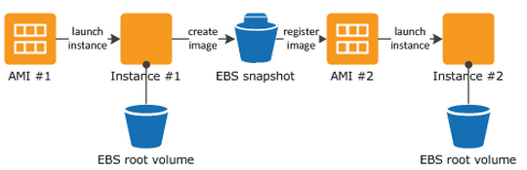To move an EC2 volume from one region to another, take a snapshot, create an AMI from that snapshot, [copy that AMI to another region](https://docs.aws.amazon.com/AWSEC2/latest/UserGuide/CopyingAMIs.html), and then use the copied AMI to launch a new EC2 instance in the new region.AWS does not **copy launch permissions, user-defined tags, or Amazon S3 bucket permissions.**

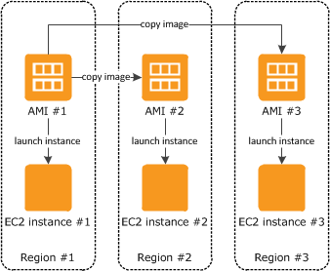

**Encryption:**The use of encryption at rest is default requirement for many industry compliance certifications.EBS volumes can be encrypted, but they are not encrypted by default.Existing EBS volumes cannot be encrypted.Snapshots of encrypted volumes are encrypted automatically .Volumes restored from encrypted snapshots are encrypted automatically.You can share snapshots (on AWS or publicly), but only if they are unencrypted.You can now encrypt root device volumes upon creation of the EC2 instance.

* + You can create an encrypted snapshot from an unencrypted snapshot: To encrypt an unencrypted root device volume, create a snapshot of it, encrypt that snapshot, create an AMI from that snapshot, and use that AMI to launch a new encrypted EC2 instance.
  + It is better to use KMS API instead to automatically encrypt the data before saving it to disk.
  + Amazon EBS encryption uses 256-bit Advanced Encryption Standard algorithms (AES-256)
* **Termination**:
  + The default action is for the root EBS volume to be deleted when the instance is terminated.
  + The default action for additional volumes is to be persisted.

When an instance is terminated, Amazon Elastic Compute Cloud (Amazon EC2) uses the value of the [DeleteOnTermination attribute](https://docs.aws.amazon.com/AWSEC2/latest/UserGuide/terminating-instances.html#preserving-volumes-on-termination) for each attached EBS volume to determine whether to preserve or delete the volume when the instance is terminated. By default, the DeleteOnTermination attribute for the root volume of an instance is set to true, but it is set to false for all other volume types.To preserve the root volume when an instance is terminated, change the DeleteOnTermination attribute for the root volume to false.

**You need to back up your mySQL database hosted on a Reserved EC2 instance. It is using EBS volumes that are configured in a RAID array. What steps will you take to minimize the time during which the database cannot be written to and to ensure a consistent backup?**

* ​1. Detach EBS volumes from the EC2 instanc2. Start EBS snapshot of volumes.3. Re-attach the EBS volumes.



* ​1. Stop all applications from writing to the RAID array.



2. Flush all caches to the disk.

3. Confirm that the associated EC2 instance is no longer writing to the RAID array by taking actions such as freezing the file system, unmounting the RAID array, or even shutting down the EC2 instance.

4. After taking steps to halt all disk-related activity to the RAID array, take a snapshot of each EBS volume in the array.

* ​1. Stop all I/O activity in the volumes.2. Create an image of the EC2 Instance.



]\]

3. Resume all I/O activity in the volume.

* ​1. Stop all I/O activity in the volumes.



2. Start EBS snapshot of volumes.

3. While the snapshot is in progress, resume all I/O activity.

Remember that since the instance is using a RAID configuration, the snapshot process is different. You should stop all I/O activity of the volumes before creating a snapshot. Hence, option 2 is correct:

1. Stop all applications from writing to the RAID array.
2. Flush all caches to the disk.
3. Confirm that the associated EC2 instance is no longer writing to the RAID array by taking actions such as freezing the file system, unmounting the RAID array, or even shutting down the EC2 instance.
4. After taking steps to halt all disk-related activity to the RAID array, take a snapshot of each EBS volume in the array.

When you take a snapshot of an attached Amazon EBS volume that is in use, the snapshot excludes data cached by applications or the operating system. For a single EBS volume, this is often not a problem. However, when cached data is excluded from snapshots of multiple EBS volumes in a RAID array, restoring the volumes from the snapshots can degrade the integrity of the array.

When creating snapshots of EBS volumes that are configured in a RAID array, it is critical that there is no data I/O to or from the volumes when the snapshots are created. RAID arrays introduce data interdependencies and a level of complexity not present in a single EBS volume configuration.

**A corporate and investment bank has recently decided to adopt a hybrid cloud architecture for their Trade Finance web application which uses an Oracle database with Oracle Real Application Clusters (RAC) configuration. Since Oracle RAC is not supported in RDS, they decided to launch their database in a large On-Demand EC2 instance instead, with multiple EBS Volumes attached. As a Solutions Architect, you are responsible to ensure the security, availability, scalability, and disaster recovery of the whole architecture.In this scenario, which of the following will enable you to take backups of your EBS volumes that are being used by the Oracle database?**

* ​EBS-backed EC2 instances.



* ​Use Disk Mirroring, which is also known as RAID 1, that replicates data to two or more disks/EBS Volumes.



* ​Launch the EBS Volumes to a Placement Group which will automatically back up your data.



* ​Create snapshots of the EBS Volumes.



Option 4 is correct. You can back up the data on your Amazon EBS volumes to Amazon S3 by taking point-in-time snapshots. Snapshots are *incremental* backups, which means that only the blocks on the device that have changed after your most recent snapshot are saved.

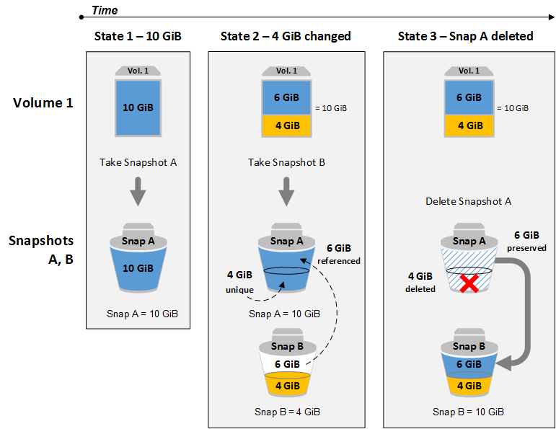

This minimizes the time required to create the snapshot and saves on storage costs by not duplicating data. When you delete a snapshot, only the data unique to that snapshot is removed. Each snapshot contains all of the information needed to restore your data (from the moment the snapshot was taken) to a new EBS volume.

Option 1 is incorrect since running an EBS-backed EC2 instance does not relate to your problem as you are already running a few of them in the first place.

Option 2 is incorrect. Disk mirroring is not an efficient and cost-optimized solution for your problem. You should use EBS snapshots instead.

* **Additional volumes:**
  + Additional volumes can be detached without stopping the instance.
  + You can add multiple volumes to an EC2 instance and then create your own RAID 5/RAID 10/RAID 0 configurations using those volumes.
  + You cannot attach an EBS volume to more than one EC2 instance at the same time.
* RAID configuration:**RAID 0 uses striping, i.e., data is split across all the drives.RAID 0 is a more suitable option for providing faster read and write operations.**This means RAID 0 offers no fault tolerance; if any of the constituent drives fails, the RAID unit fails.
  + RAID 1 offers redundancy through mirroring, i.e., data is written identically to two drives.
  + [The snapshot process for RAID 1 is different](https://aws.amazon.com/premiumsupport/knowledge-center/snapshot-ebs-raid-array/): Stop all I/O activity before creating a snapshot.
* Applications that run on an Amazon EC2 instance need credentials in order to access other AWS services. To provide credentials to the application in a secure way, use IAM roles. A role is an entity that has its own set of permissions, but that isn't a user or group. Roles also don't have their own permanent set of credentials the way IAM users do. In the case of Amazon EC2, IAM dynamically provides temporary credentials to the EC2 instance, and these credentials are automatically rotated for you. Boosting performance:
  + Ensure that your EC2 instances are types that can be optimized for use with EBS. This ensures that network traffic cannot contend with traffic between your instance and your EBS volumes.Schedule snapshots for periods of low use. This only applies to HDD based EBS volumes. When you create a snapshot of a Throughput Optimized HDD (st1) or Cold HDD (sc1) volume, performance may drop as far as the volume's baseline value while the snapshot is in progress.One of the easiest options is to drive more I/O throughput is by striping using RAID 0.
* **Amazon Data Lifecycle Manager:Amazon DLM provides a complete backup solution for EBS volumes at no additional cost.Automates the creation, retention, and deletion of EBS snapshots.**

**As part of the Business Continuity Plan of your company, your IT Director instructed you to set up an automated backup of all of the EBS Volumes for your EC2 instances as soon as possible.**

**What is the fastest and most cost-effective solution to automatically back up all of your EBS Volumes?**

* ​For an automated solution, create a scheduled job that calls the "create-snapshot" command via the AWS CLI to take a snapshot of production EBS volumes periodically.



* ​Set your Amazon Storage Gateway with EBS volumes as the data source and store the backups in your on-premises servers through the storage gateway.



* ​Use an EBS-cycle policy in Amazon S3 to automatically back up the EBS volumes.



* ​Use Amazon Data Lifecycle Manager (Amazon DLM) to automate the creation of EBS snapshots.



**Explanation**

You can use Amazon Data Lifecycle Manager (Amazon DLM) to automate the creation, retention, and deletion of snapshots taken to back up your Amazon EBS volumes. Automating snapshot management helps you to:

* -Protect valuable data by enforcing a regular backup schedule.
* -Retain backups as required by auditors or internal compliance.
* -Reduce storage costs by deleting outdated backups.

Combined with the monitoring features of Amazon CloudWatch Events and AWS CloudTrail, Amazon DLM provides a complete backup solution for EBS volumes at no additional cost. Hence, Option 5 is the correct answer as it is the fastest and cost-effective solution in providing an automated way of backing up your EBS volumes.

Option 1 is incorrect because even though this is a valid solution, you would still need additional time to create a scheduled job that calls the "create-snapshot" command. It would be better to use Amazon Data Lifecycle Manager (Amazon DLM) instead as this provides you the fastest solution which enables you to automate the creation, retention, and deletion of the EBS snapshots without having to write custom shell scripts or creating scheduled jobs.

**You work for a brokerage firm as an AWS Infrastructure Engineer who handles the stocks trading application. You host your database in an EC2 server with two EBS volumes for OS and data storage in ap-southeast-1a. Due to the fault tolerance requirements, there is a need to assess if the EBS volumes will be affected in the event of ap-southeast-1a availability zone outage.**

**Can EBS tolerate an Availability Zone failure each and every time?**

* ​No, all EBS volumes are stored and replicated in a single AZ only.



* ​Yes, EBS volume is fault-tolerant and has multiple copies across multiple AZ.



* ​Depends on how the EBS volume is set up.



* ​Depends on the AWS region where the EBS volume is created.



**Explanation**

Option 1 is correct because when you create an EBS volume in an Availability Zone, it is automatically replicated within that zone only to prevent data loss due to a failure of any single hardware component. After you create a volume, you can attach it to any EC2 instance in the same Availability Zone.

**Types**

* SSD-backed volumes:
  + SSD >> General purpose SSD (GP2): For most workloads (16,000 IOPS, $0.1)
  + General Purpose SSD with its ability to **support burst capacity would be the cost effective solution to be able to handle the occasional peak performance**.
  + [SSD >> Provisioned IOPS SSD (IO1)](https://docs.aws.amazon.com/AWSEC2/latest/UserGuide/EBSVolumeTypes.html#EBSVolumeTypes_piops): For databases (64,000 IOPS, $.125)
* HDD-backed volumes:
  + Magnetic >> Throughput Optimized HDD (ST1): For Big data, Data Warehouses, Log processing big data, DWH, logs (500 IOPS, $0.045)
  + Magnetic >> Cold HDD (SC1): Cheap, for file servers (250 IOPS, $0.025)

Magnetic >> EBS Magnetic: Extra cheap, for infrequently accessed workloads (40-200 IOPS) performance level and the better it performs when more performance is needed.

**You are setting up the required compute resources in your VPC for your application which have workloads that require high, sequential read and write access to very large data sets on local storage. Which of the following instance type is the most suitable one to use in this scenario?**

* ​

Storage Optimized Instances

**(Correct)**

* ​

Memory Optimized Instances

* ​

Compute Optimized Instances

* ​

General Purpose Instances

**(Incorrect)**

**Explanation**

Option 1 is the correct answer. Storage optimized instances are designed for workloads that require high, sequential read and write access to very large data sets on local storage. They are optimized to deliver tens of thousands of low-latency, random I/O operations per second (IOPS) to applications.

Option 2 is incorrect because Memory optimized instances are designed to deliver fast performance for workloads that process large data sets in memory, which is quite different from handling high read and write capacity on local storage.

Option 3 is incorrect because Compute optimized instances are ideal for compute-bound applications that benefit from high-performance processors, such as batch processing workloads and media transcoding.

Option 4 is incorrect because General purpose instances are the most basic type of instances. They provide a balance of compute, memory, and networking resources, and can be used for a variety of workloads. Since you are requiring higher read and write capacity, storage optimized instances should be selected instead.

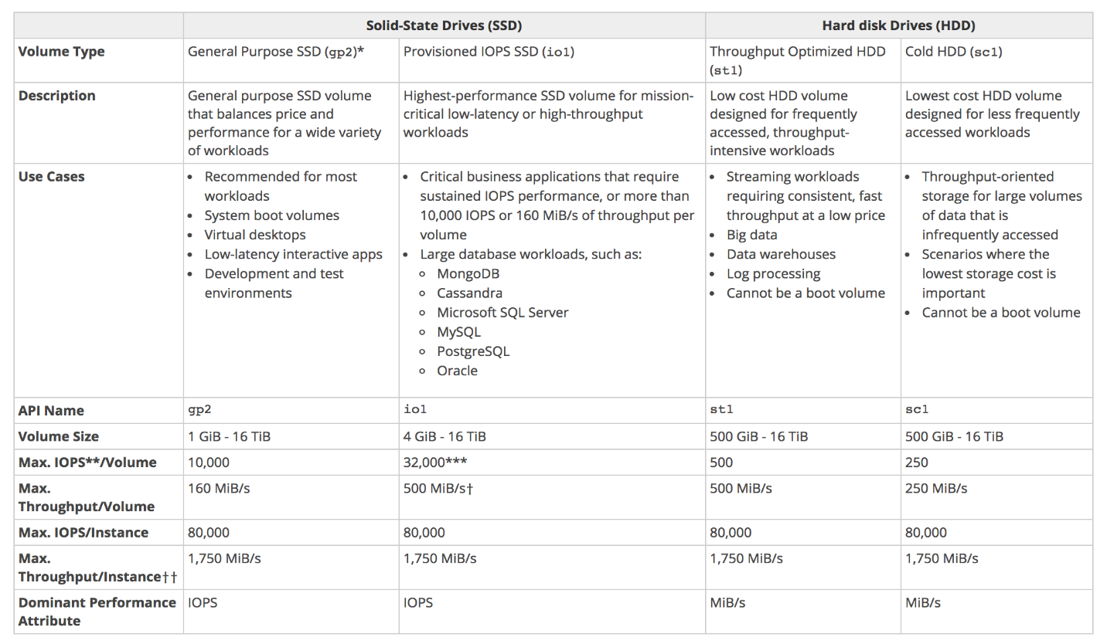

**A company is planning to launch an application which requires a data warehouse that will be used for their infrequently accessed data. You need to use an EBS Volume that can handle large, sequential I/O operations.**

**Which of the following is the most cost-effective storage type that you should use to meet the requirement?**

* ​EBS General Purpose SSD (gp2)



* ​Provisioned IOPS SSD (io1)



* ​Throughput Optimized HDD (st1)**(Incorrect)**



* ​Cold HDD (sc1)**(Correct)**



**Explanation**

Cold HDD volumes provide low-cost magnetic storage that defines performance in terms of throughput rather than IOPS. With a lower throughput limit than Throughput Optimized HDD, this is a good fit ideal for large, sequential cold-data workloads. If you require infrequent access to your data and are looking to save costs, Cold HDD provides inexpensive block storage. Take note that bootable Cold HDD volumes are not supported.

n the exam, always consider the difference between SSD and HDD as shown on the table below. This will allow you to easily eliminate specific EBS-types in the options which are not SSD or not HDD, depending on whether the question asks for a storage type which has ***small, random*** I/O operations or ***large, sequential*** I/O operations.

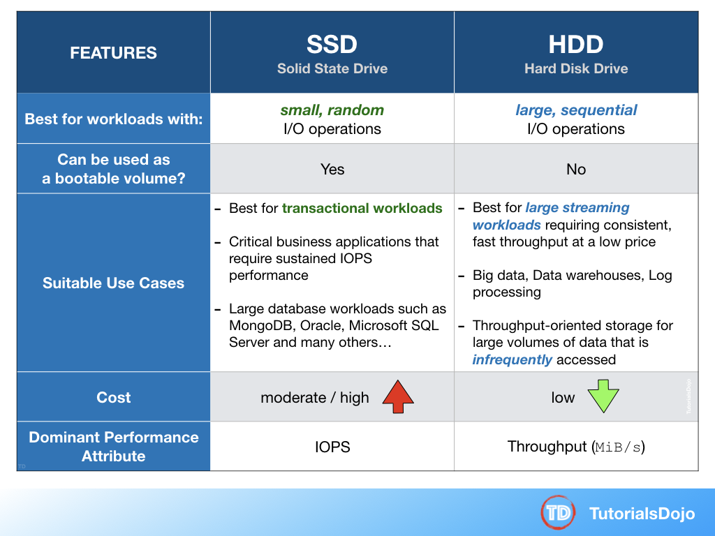

Option 1 is incorrect because a General purpose SSD volume costs more and it is

EBS volumes can be changed on the fly (including the size and storage type)

* Of all the EBS types, both current and of the previous generation, HDD based volumes will always be less expensive than SSD types.
* [I/O Characteristics and Monitoring](https://docs.aws.amazon.com/AWSEC2/latest/UserGuide/ebs-io-characteristics.html)
  + **SSD volumes deliver consistent performance whether an I/O operation is random or sequential.**
  + **HDD volumes deliver optimal performance only when I/O operations are large and sequential.**
* **persists and is independent of EC2 lifecycle**
* **multiple volumes can be attached** to a single EC2 instance
* can be **detached & attached to another EC2 instance in that same AZ only**
* **volumes are created in an specific AZ** and **CANNOT span across AZs**
* **snapshots CANNOT span across regions**
* for making volume available to different AZ, create a snapshot of the volume and restore it to a new volume in any AZ within the region
* for making the volume available to different Region, the snapshot of the volume can be copied to a different region and restored as a volume
* provides **high durability** and are **redundant in an AZ**, as the data is automatically replicated within that AZ to prevent data loss due to any single hardware component failure

**You have triggered the creation of a snapshot of your EBS volume attached to an Instance Store-backed EC2 Instance and is currently on-going. At this point, what are the things that the EBS volume can or cannot do?**

* ​The volume can be used as normal while the snapshot is in progress.



​The volume can be used in write-only mode while the snapshot is in progress.



* ​The volume can be used in read-only mode while the snapshot is in progress.



* ​The volume cannot be used until the snapshot completes.



**Explanation**

EBS snapshots occur asynchronously which makes option 1 the correct answer. This means that the point-in-time snapshot is created immediately, but the status of the snapshot is pending until the snapshot is complete (when all of the modified blocks have been transferred to Amazon S3), which can take several hours for large initial snapshots or subsequent snapshots where many blocks have changed. While it is completing, an in-progress snapshot is not affected by ongoing reads and writes to the volume hence, you can still use the volume.

**An application is hosted on an EC2 instance with multiple EBS Volumes attached and uses Amazon Neptune as its database. To improve data security, you encrypted all of the EBS volumes attached to the instance to protect the confidential data stored in the volumes.**

**Which of the following statements are true about encrypted Amazon Elastic Block Store volumes? (Choose 2)**

* ​

All data moving between the volume and the instance are encrypted.

**(Correct)**

* ​

Snapshots are automatically encrypted.

**(Correct)**

* ​

Snapshots are not automatically encrypted.

* ​

Only the data in the volume is encrypted and not all the data moving between the volume and the instance.

**(Incorrect)**

* ​

The volumes created from the encrypted snapshot are not encrypted.

**Explanation**

Amazon Elastic Block Store (Amazon EBS) provides block level storage volumes for use with EC2 instances. EBS volumes are highly available and reliable storage volumes that can be attached to any running instance that is in the same Availability Zone. EBS volumes that are attached to an EC2 instance are exposed as storage volumes that persist independently from the life of the instance.

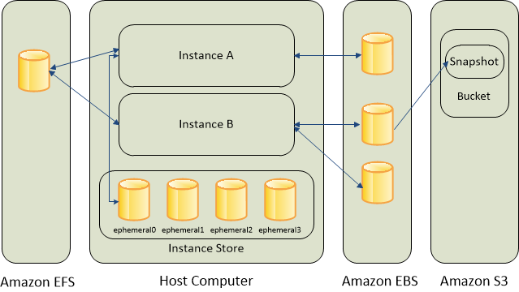

When you create an encrypted EBS volume and attach it to a supported instance type, the following types of data are encrypted:

   - Data at rest inside the volume

   - All data moving between the volume and the instance

   - All snapshots created from the volume

   - All volumes created from those snapshots

Encryption operations occur on the servers that host EC2 instances, ensuring the security of both data-at-rest and data-in-transit between an instance and its attached EBS storage. You can encrypt both the boot and data volumes of an EC2 instance.

Top of Form

**You have an On-Demand EC2 instance with an attached EBS volume. There is a scheduled job that creates a snapshot of this EBS volume every midnight at 12 AM when the instance is not used. One night, there has been a production incident where you need to perform a change on both the instance and on the EBS volume at the same time, when the snapshot is currently taking place.**

**Which of the following scenario is true when it comes to the usage of an EBS volume while the snapshot is in progress?**

* ​

The EBS volume can be used while the snapshot is in progress.

**(Correct)**

* ​

The EBS volume cannot be detached or attached to an EC2 instance until the snapshot completes

* ​

The EBS volume can be used in read-only mode while the snapshot is in progress.

* ​

The EBS volume cannot be used until the snapshot completes.

#### Explanation

Snapshots occur asynchronously; the point-in-time snapshot is created immediately, but the status of the snapshot is pending until the snapshot is complete (when all of the modified blocks have been transferred to Amazon S3), which can take several hours for large initial snapshots or subsequent snapshots where many blocks have changed.

While it is completing, an in-progress snapshot is not affected by ongoing reads and writes to the volume hence, you can still use the EBS volume normally.

When you create an EBS volume based on a snapshot, the new volume begins as an exact replica of the original volume that was used to create the snapshot. The replicated volume loads data lazily in the background so that you can begin using it immediately. If you access data that hasn't been loaded yet, the volume immediately downloads the requested data from Amazon S3, and then continues loading the rest of the volume's data in the background.

**References:**

<https://docs.aws.amazon.com/AWSEC2/latest/UserGuide/ebs-creating-snapshot.html>

<https://docs.aws.amazon.com/AWSEC2/latest/UserGuide/EBSSnapshots.html>

**Check out this Amazon EBS Cheat Sheet:**

<https://tutorialsdojo.com/aws-cheat-sheet-amazon-ebs/>

Bottom of Form

Top of Form

Question 50: **Correct**

**A health organization is using a large Dedicated EC2 instance with multiple EBS volumes to host its health records web application. The EBS volumes must be encrypted due to the confidentiality of the data that they are handling and also to comply with the HIPAA (Health Insurance Portability and Accountability Act) standard.**

**In EBS encryption, what service does AWS use to secure the volume's data at rest? (Choose 2)**

* ​

By using your own keys in AWS Key Management Service (KMS).

**(Correct)**

* ​

By using S3 Server-Side Encryption.

* ​

By using Amazon-managed keys in AWS Key Management Service (KMS).

**(Correct)**

* ​

By using S3 Client-Side Encryption.

* ​

By using a password stored in CloudHSM.

* ​

By using the SSL certificates provided by the AWS Certificate Manager (ACM).

#### Explanation

Amazon EBS encryption offers seamless encryption of EBS data volumes, boot volumes, and snapshots, eliminating the need to build and maintain a secure key management infrastructure. EBS encryption enables data at rest security by encrypting your data using Amazon-managed keys, or keys you create and manage using the AWS Key Management Service (KMS). The encryption occurs on the servers that host EC2 instances, providing encryption of data as it moves between EC2 instances and EBS storage. Hence, options 1 and 3 are the right answers.

Options 2 and 4 are incorrect as these relate only to S3.

Option 5 is incorrect as you only store keys in CloudHSM and not passwords.

Option 6 is incorrect as ACM only provides SSL certificates and not data encryption of EBS Volumes.

Bottom of Form

**EFS**

* Amazon Elastic File System (EFS) is a file storage service for EC2 instances.
* Easy to use, and provides a **simple interface for creating and configuring file systems.**
* Storage capacity is elastic, that is, it is growing and shrinking automatically.can scale up to petabytes.Supports the NFSv4 protocol.Can support thousands of concurrent NFS connections.Only pay for what you use (no pre-provisioning required)
* **Data is stored across multiple AZ's within a region.**Read after write consistency.
* 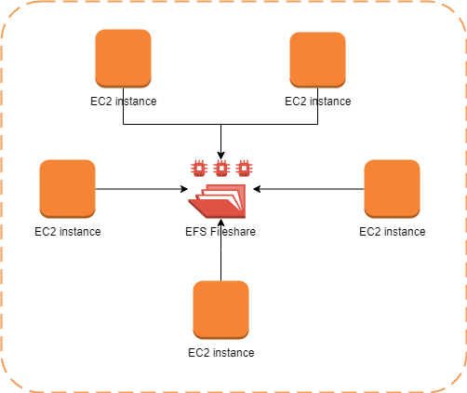

**A Solutions Architect is developing a solution for sharing files in an organization. The solution must allow multiple users to access the storage service at once from different virtual machines and scale automatically. It must also support file-level locking. Which storage service meets the requirements of this use case?**

* ​A. Amazon S3**(Incorrect)**



* ​B. Amazon EFS**(Correct)**



* C. Amazon EBS



* D. Cached Volumes



#### Explanation

Q. What is Amazon Elastic File System?

Amazon EFS is a fully-managed service that makes it easy to set up and scale file storage in the Amazon Cloud. With a few clicks in the AWS Management Console, you can create file systems that are accessible to Amazon EC2 instances via a file system interface (using standard operating system file I/O APIs) and supports full file system access semantics (such as strong consistency and file locking).Amazon EFS file systems can automatically scale from gigabytes to petabytes of data without needing to provision storage. Tens, hundreds, or even thousands of Amazon EC2 instances can access an Amazon EFS file system at the same time, and Amazon EFS provides consistent performance to each Amazon EC2 instance. Amazon EFS is designed to be highly durable and highly available. With Amazon EFS, there is no minimum fee or setup costs, and you pay only for the storage you use.

Q. What type of locking does Amazon EFS support?

Locking in Amazon EFS follows the NFSv4.1 protocol for advisory locking, and enables your applications to use both whole file and byte range locks.

Question 56: **Incorrect**

**A Solutions Architect needs a storage for a fleet of Linux web application servers. The solution should provide system interface and be able to support millions of files. Which AWS service should the Architect choose?**

* ​ Amazon S3
* ​B. Amazon EFS **(Correct)**
*  Amazon EBS
* D. Amazon ElastiCache

#### Explanation

Correct answer is **B** as EFS provides the ability to scale on demand, be shared across multiple instances and provide a system interface.

Amazon EFS is built to elastically scale on demand without disrupting applications, growing and shrinking automatically as you add and remove files, so your applications have the storage they need, when they need it. It is designed to provide massively parallel shared access to thousands of Amazon EC2 instances, enabling your applications to achieve high levels of aggregate throughput and IOPS that scale as a file system grows, with consistent low latencies. As a regional service, Amazon EFS is designed for high availability and durability storing data redundantly across multiple Availability Zones.

**When mounted on Amazon EC2 instances, an Amazon EFS file system provides a standard file system interface and file system access semantics**, allowing you to seamlessly integrate Amazon EFS with your existing applications and tools. Multiple Amazon EC2 instances can access an Amazon EFS file system at the same time, allowing Amazon EFS to provide a common data source for workloads and applications running on more than one Amazon EC2 instance.

Option A is wrong as S3 does not provide a system interface.Option C is wrong as EBS cannot be shared across multiple instances and have scaling limitations.Option D is wrong as ElastiCache is a caching solution.

**A data analytics company has been building its new generation big data and analytics platform on their AWS cloud infrastructure. They need a storage service that provides the scale and performance that their big data applications require such as high throughput to compute nodes coupled with read-after-write consistency and low-latency file operations. In addition, their data needs to be stored redundantly across multiple AZs and allows concurrent connections from multiple EC2 instances hosted on multiple AZs.**

**Which of the following AWS storage services will you use to meet this requirement?**

* ​

EFS

**(Correct)**

* ​

EBS

* ​

S3

**(Incorrect)**

* ​

Glacier

**Explanation**

In this question, you should take note of the two keywords/phrases: "file operation" and "allows concurrent connections from multiple EC2 instances". There are various AWS storage options that you can choose but whenever these criteria show up, always consider using EFS instead of using EBS Volumes which is mainly used as a "block" storage and can only have one connection to one EC2 instance at a time. Amazon EFS provides the scale and performance required for big data applications that require high throughput to compute nodes coupled with read-after-write consistency and low-latency file operations.

Amazon EFS is a fully-managed service that makes it easy to set up and scale file storage in the Amazon Cloud. With a few clicks in the AWS Management Console, you can create file systems that are accessible to Amazon EC2 instances via a file system interface (using standard operating system file I/O APIs) and supports full file system access semantics (such as strong consistency and file locking).

Amazon EFS file systems can automatically scale from gigabytes to petabytes of data without needing to provision storage. Tens, hundreds, or even thousands of Amazon EC2 instances can access an Amazon EFS file system at the same time, and Amazon EFS provides consistent performance to each Amazon EC2 instance. Amazon EFS is designed to be highly durable and highly available.

Option 2 is incorrect because EBS does not allow concurrent connections from multiple EC2 instances hosted on multiple AZs and it does not store data redundantly across multiple AZs by default, unlike EFS.

Option 3 is incorrect because although S3 can handle concurrent connections from multiple EC2 instances, it does not have the ability to provide low-latency file operations, which is required in this scenario.

Option 4 is incorrect because Glacier is an archiving storage solution and is not applicable in this scenario.

**A leading e-commerce company is in need of a storage solution that can be accessed by 1000 Linux servers in multiple availability zones. The service should be able to handle the rapidly changing data at scale while still maintaining high performance. It should also be highly durable and highly available whenever the servers will pull data from it, with little need for management.**

**As the Solutions Architect, which of the following services is the most cost-effective choice that you should use to meet the above requirement?**

* ​

S3

**(Incorrect)**

* ​

EFS

**(Correct)**

* ​

EBS

* ​

Storage Gateway

**Explanation**

Amazon Web Services (AWS) offers cloud storage services to support a wide range of storage workloads such as EFS, S3 and EBS. You have to understand when you should use Amazon EFS, Amazon S3 and Amazon Elastic Block Store (EBS) based on the specific workloads. In this scenario, the keywords are ***rapidly changing data*** and 1000 Linux servers.

Amazon EFS is a file storage service for use with Amazon EC2. Amazon EFS provides a file system interface, file system access semantics (such as strong consistency and file locking), and concurrently-accessible storage for **up to thousands of Amazon EC2 instances**. EFS provides the same level of high availability and high scalability like S3 however, this service is more suitable for scenarios where it is required to have a POSIX-compatible file system or if you are storing rapidly changing data.

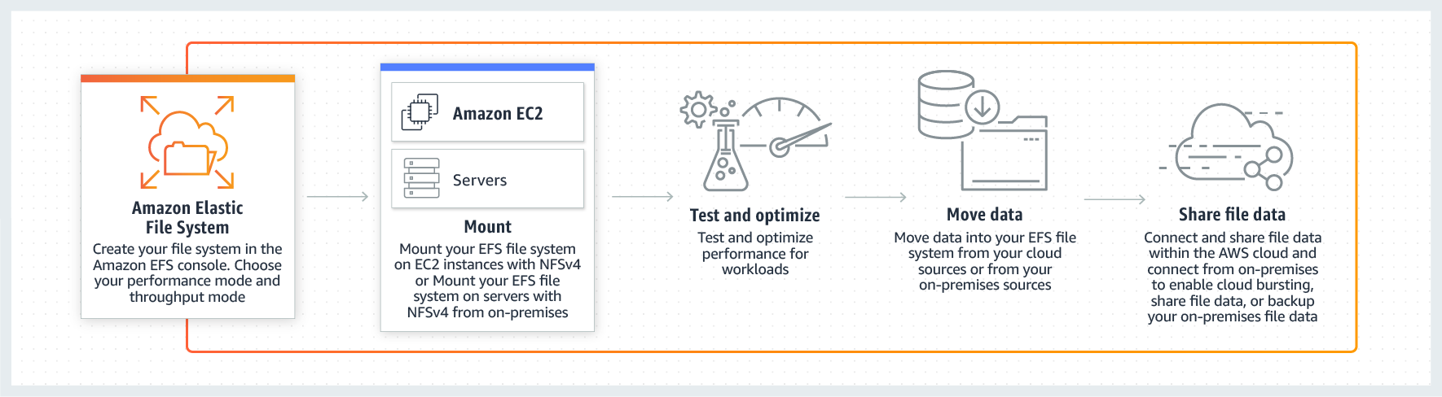

Data that must be updated very frequently might be better served by storage solutions that take into account read and write latencies, such as Amazon EBS volumes, Amazon RDS, Amazon DynamoDB, Amazon EFS, or relational databases running on Amazon EC2.

**You are working as a Solutions Architect for a start-up company that has a not-for-profit crowdfunding platform hosted in AWS. Their platform allows people around the globe to raise money for social enterprise projects including challenging circumstances like accidents and illnesses. Since the system handles financial transactions, you have to ensure that your cloud architecture is secure.**

**Which of the following AWS services encrypts data at rest by default? (Choose 2)**

* ​

AWS Storage Gateway

**(Correct)**

* ​

Amazon RDS

**(Incorrect)**

* ​

Amazon ECS

* ​

Amazon Glacier

**(Correct)**

* ​

AWS Lambda

**Explanation**

All data transferred between any type of gateway appliance and AWS storage is encrypted using SSL. By default, all data stored by AWS Storage Gateway in S3 is encrypted server-side with Amazon S3-Managed Encryption Keys (SSE-S3). Also, when using the file gateway, you can optionally configure each file share to have your objects encrypted with AWS KMS-Managed Keys using SSE-KMS. This is the reason why Option 1 is correct.

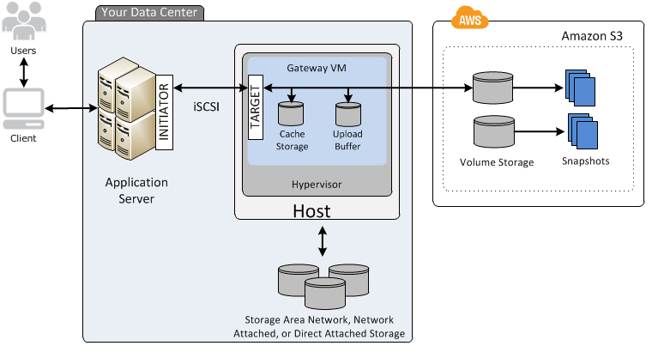

Data stored in Amazon Glacier is protected by default; only vault owners have access to the Amazon Glacier resources they create. Amazon Glacier encrypts your data at rest by default and supports secure data transit with SSL. This is the reason why Option 4 is correct.

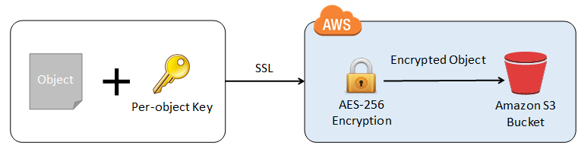

Options 2, 3 and 5 are incorrect because although Amazon RDS, ECS and Lambda all support encryption, you still have to enable and configure them first with tools like AWS KMS to encrypt the data at rest.

s

**Storage Gateway**

* AWS Storage Gateway is a service that connects an on-premises software appliance with cloud-based storage to provide seamless and secure integration between an organization's on-premises IT environment and AWS's storage infrastructure.At its heart it is a way of using AWS S3 managed storage to supplement on-premise storage.You can think of a file gateway as a file system mount on S3.It is a physical or virtual appliance that can be used to cache S3 locally.**Available for download as a virtual machine (VM) image that install on a host in the datacenter.**Supports either VMware ESXi or Microsoft Hyper-V.
  + It can also be used within a VPC in a similar way.All data transferred between any type of gateway appliance and AWS storage is encrypted using SSL.All data stored by AWS Storage Gateway in S3 is encrypted server-side with SSE-S3.
  + 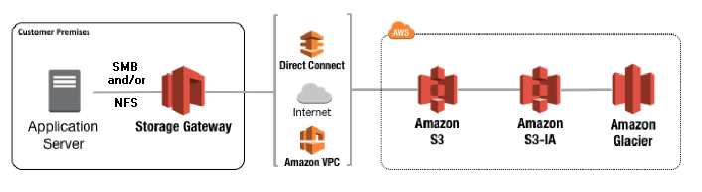

**Types**

* File Gateway (NFS & SMB):
  + Enables you to store and retrieve objects in Amazon S3 using file protocols, such as NFS.
  + Ownership, permissions, and timestamps are durably stored in S3 in the metadata.
  + Using File Gateway is the recommended way to use S3 with shared document pools.
* In this type, files are stored as objects in your S3 buckets, accessed through a Network File System(NFS) mount point. Once transferred to S3, objects can be managed just the same way as native S3 objects and the bucket policies such as versioning, lifecycle mgmnt, CRR can be directly applied.

You are working on a migration project from a large enterprise's on-premises location into AWS. One of the client's systems stores files on a local file system that is shared to the business's local Microsoft Windows 10 workstations. You need to migrate the data into AWS without outage and ensure the files can be accessed both using SMB and over HTTPS.What option should you suggest? AStorage Gateway volume gateway

* BStore the files directly on S3 using the S3 connector. CStorage Gateway file gateway
* DMigrate the application and server onto an EC2 instance and share the files using SMB.

**Your Answer: B**This solution is invalid — it doesn't offer access via SMB and, in this context, an S3 connector is invalid.

* **Correct Answer: C**Using a file gateway would mean files could be migrated onto the gateway, presented via SMB, and accessible directly from S3 as objects.

Volume Gateway (iSCSI):Provides block storage to your applications using the iSCSI block protocol.Data is asynchronously backed up as point-in-time snapshots and stored as Amazon EBS snapshots.Snapshots are incremental backups capture only changed blocks (and compressed) **Volume based Gateway**(iSCSI) – think of this as **virtual hard disk that sits on premise** and then you back them up to aws. Volume interface presents your application with disk volumes using the iSCSI block protocol. Data written to these volumes can be asynchronously backed up as point-in –time snapshots of your volumes, and stored in the cloud as Amazon **EBS** snapshots.

**A->Stored Volumes** – This lets you store your primary data locally while asynchronously backing up that data to AWS. Entire dataset is stored on site and is asynchronously backed up to S3.You can create storage volumes and mount them as iSCSI devices from your on-premises application servers. **Data written to your stored volumes is stored on your on-premises storage hardware**. This data is asynchronously backed up to Amazon S3 in the form of Amazon EBS snapshots. 1GB-16 TB in size for stored volumes.

* + **B->Cached Volumes**Here, complete copy of the data is not **kept on-prem**, it is stored in S3. Wherein only the primary data which is frequently accessed is kept on-premises. You can create storage volumes up to 32TiB in size and attach to them as iSCSI devices from your on-premises application servers. Your gateway stores data that your write to these volumes in Amazon S3 and retains recently read data in your on-premises storage gateway’s cache and upload buffer storage. 1GB-32TB in size for Cached Volumes. Entire dataset is stored on S3 and the most frequently accessed data is cached on site.

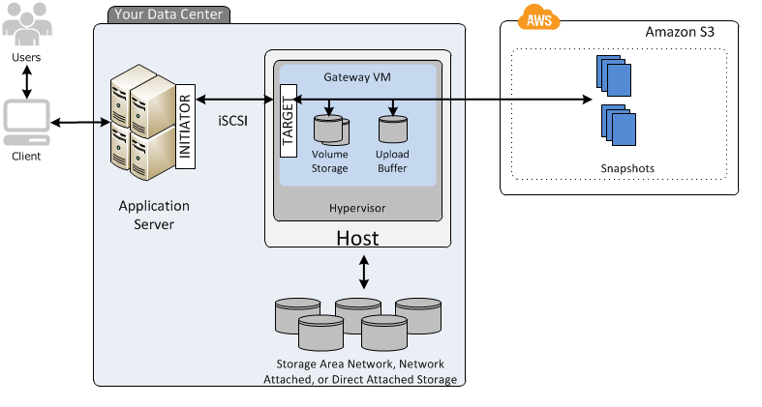

* Gateway Virtual Tape Library (VTL):A durable, cost-effective solution to archive tape data.

1. Stores data on virtual tape cartridges that are created on tape gateway.Supported by NetBackup, Backup Exec, Veeam. **Tape based Gateway**(VTL) – Used for backup primarily.
   * Tape gateway provides VTL interface that lets you leverage your existing tape-based backup application infrastructure to store data on virtual tape cartridges that you create on your tape gateway. Each tape gateway is preconfigured with a media changer and tape drives, which are available to your existing client backup applications as iSCSI devices

**Data transport**

**Snowball:-**Snowball is a petabyte-scale data transport solution.Uses secure appliances to transfer large amounts of data and out of AWS.Addresses challenges such as high network costs, long transfer times, and security concerns.Transferring data with Snowball can be as little as one-fifth the cost of high speed internet.Uses multiple layers of security including tamper-resistant enclosures, 256-bit encryption, and an industry-standard Trusted Platform Module (TPM) designed to ensure both security and full chain-of-custody of data.

* Once the data transfer job has been processed and verified, AWS performs a software erase.Comes in either a 50TB or 80TB size.Only has 72TB of usable capacity.
* [AWS Snowball Cheat Sheet](https://tutorialsdojo.com/aws-cheat-sheet-aws-snowball/)

**Snowball Edge**AWS Snowball Edge is a data transfer device with on-board storage and **compute capabilities**.Can be used to move large amounts of data into and out of AWS, as a temporary storage tier for large local datasets, and to support local workloads in remote or offline locations.Connects to existing applications and infrastructure.Can cluster together to form a local storage tier and process data on-premises, helping ensure your applications continue to run even when they are not able to access to cloud.Can transfer up to 100TB.

* + Only has 83TB of usable capacity.

**Snowmobile**AWS Snowmobile is an Exabyte-scale data transfer service.One can transfer up to 100PB per Snowmobile, a 45-foot long ruggedized shipping container.For video libraries, image repositories, or even a complete data center migration.

* [When to use Snowball](https://aws.amazon.com/snowball/faqs/#When_to_use_Snowball)

internet SCSI, is an IETF standard which maps SCSI blocks into Ethernet packets. Fundamentally, the iSCSI protocol is a method for transporting low latency SCSI blocks across IP networks.

iSCSI also allows you to build storage area networks over IP using something you already know and use everyday: Ethernet. In this way, iSCSI removes the limitations of direct attached storage, including the inability to share storage resources across servers and to expand capacity without shutting down applications. 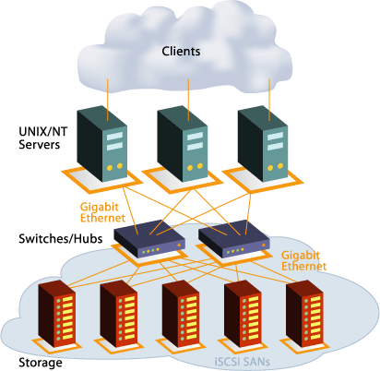

**Benefits of iSCSI SANs**

* **High Availability:** Multiple paths between servers and storage enable a constant connection, even if some lines go down.
* **Scalability:** The switched architecture of SANs enable IT managers to expand storage capacity without shutting down applications.
* **Maximize Storage Resource Investment:** SANs allow you to share disk and tape devices across heterogeneous platforms.

**What is iSCSI**

iSCSI is an acronym for Internet Small Computer System Interface. SCSI is defined as the means by which a computer can be connected to peripheral devices such as printers, CD disc drives, and, of course, storage devices. This includes commands, protocols, electrical, and optical interfaces.

**How Does iSCSI Work?**iSCSI encapsulates SCSI commands and places the data in packets for the TCP/IP layer.  Fibre Channel requires specific cable, but iSCSI protocols work over a standard Ethernet cable to transport data it over a business’s intranet. This standard encapsulation makes protocol routable

**How Can It Help Me?**The benefits of an iSCSI storage interface are quite significant. As mentioned earlier, data transmission occurs faster and easier, using the same infrastructure as the business network. Another great benefit of iSCSI service is the fact that it can also transport data across much longer distances than its Fibre Channel predecessor. This makes it especially useful for companies that have multiple locations. iSCSI also gives the storage device its own IP address to make it easy to access and allow for a large number of expansions to be implemented on it, allowing the device to be customized to your specific needs. Nfina’s [iSCSI SAN](https://www.nfinausa.com/products/storage-area-network/) and [iSCSI NAS](https://www.nfinausa.com/products/nfina-attached-storage/) products can help you reap the benefits of iSCSI for your business at the best cost.

The **Internet Small Computer System Interface**, or **iSCSI**, is an IP-based protocol for transmitting data and linking data storage facilities. iSCSI works for transmitting data over several types of networks, including [LAN](https://www.computerhope.com/jargon/l/lan.htm) (local area networks) and [WAN](https://www.computerhope.com/jargon/w/wan.htm) (wide area networks), as well as the Internet itself. iSCSI is also a SAN (Storage Area Network) protocol, which can allow companies to utilize data center storage arrays to consolidate their data. Doing so can make it look as if they are utilizing local hard disk storage versus a data center storage, due to the improved performance in data retrieval that a SAN provides.

RAID stands for Redundant Array of Inexpensive (Independent) Disks.

On most situations you will be using one of the following four levels of RAIDs.

* RAID 0
* RAID 1
* RAID 5
* RAID 10 (also known as RAID 1+0)  
  In all the diagrams mentioned below:
* A, B, C, D, E and F – represents blocks
* p1, p2, and p3 – represents parity

RAID LEVEL 0

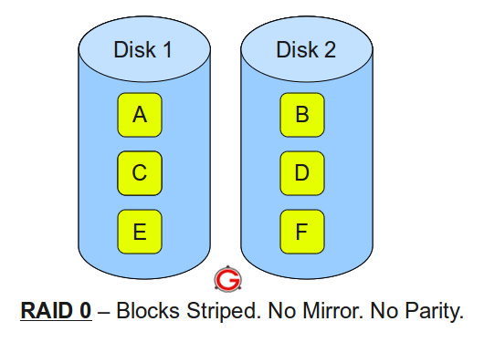  
Following are the key points to remember for RAID level 0.

* Minimum 2 disks.Excellent performance ( as blocks are striped ).
* No redundancy ( no mirror, no parity ).Don’t use this for any critical system.

RAID LEVEL 1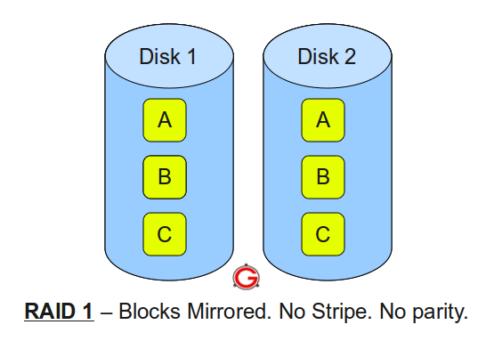

Following are the key points to remember for RAID level 1.

* Minimum 2 disks.
* Good performance ( no striping. no parity ).
* Excellent redundancy ( as blocks are mirrored ).

RAID LEVEL 5

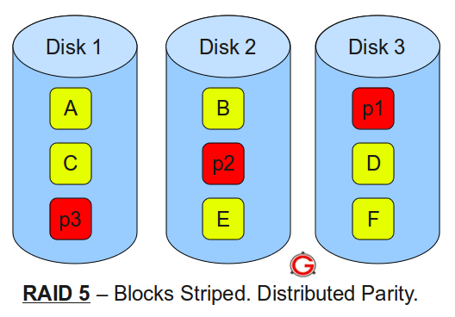  
Following are the key points to remember for RAID level 5.

* Minimum 3 disks.
* Good performance ( as blocks are striped ).
* Good redundancy ( distributed parity ).
* Best cost effective option providing both performance and redundancy. Use this for DB that is heavily read oriented. Write operations will be slow.

RAID LEVEL 10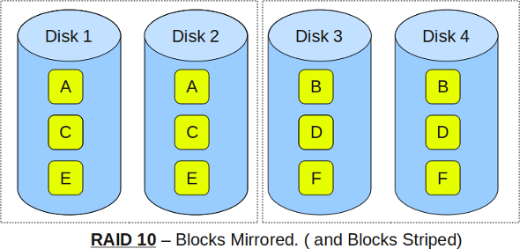

Following are the key points to remember for RAID level 10.

* Minimum 4 disks.
* This is also called as “stripe of mirrors”
* Excellent redundancy ( as blocks are mirrored )
* Excellent performance ( as blocks are striped )
* If you can afford the dollar, this is the BEST option for any mission critical applications (especially databases).

**Decoupling services**Decoupled architecture is a type of computing architecture that enables computing components or layers to execute independently while still interfacing with each other.

**SQS**Amazon Simple Queue Service (SQS) is a fully managed message queuing service that enables you to decouple and scale microservices, distributed systems, and serverless applications. offers a reliable, highly-scalable hosted queue for storing messages as they travel between applications or microservices. A queue is a temporary repository for messages that are awaiting processing.

* + The queue acts as a buffer between the producing and receiving components.
  + Any component of a distributed application can store messages in a fail-save queue.
  + The queue redundantly stores the messages across multiple Amazon SQS servers.
* In IT the term 'message' can be used in the common sense, or to describe a piece of data of Task in an asynchronous queueing system such as MQseries, RabbitMQ or SQS.
  + Messages can contain up to 256KB of text in any format (or 2GB with S3)
  + Messages can be retrieved using the AWS SQS API.SQS is pull based, not push based.
* You can set the message retention period to a value from 60 seconds to 14 days.
* **supports multiple readers and writers** interacting with the same queue as the same time
* holds message for 4 days, by default, and can be changed from 1 min – 14 days after which the message is deleted
* message needs to be **explicitly deleted** by the consumer once processed
* allows send, receive and delete **batching** which helps club up to 10 messages in a single batch while charging price for a single message
* Visibility timeout:The visibility timeout controls how long a message is invisible in the queue while it is being worked on by a processing instance.If the message is processed before the timeout, it becomes deleted. Otherwise, it becomes visible again. This can result in the same message being delivered twice.This interval should not be confused with how long the message can remain in the queue.Visibility timeout maximum is 12 hours.

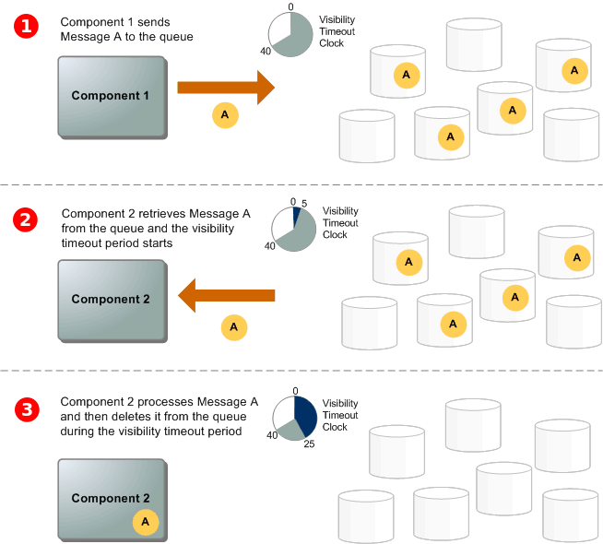

[Credit](https://docs.aws.amazon.com/AWSSimpleQueueService/latest/SQSDeveloperGuide/sqs-basic-architecture.html)

* Long polling:Won't return a response until a message arrives in the message queue, or it times out.Enable long polling by setting ReceiveMessageWaitTimeSeconds > 0 Helps reduce the cost of using SQS by eliminating the number of empty and false responses. Messages being sent twice in an SQS queue configured with long polling is quite unlikely.
* Poor timing of SQS processes can significantly impact the cost effectiveness of the solution:
  + DelaySeconds: When a new message is added to the SQS queue, it will be hidden from the consumer instances for a fixed period.
  + VisibilityTimeout: When a consumer instances receives a message, that message will be hidden from other consumer instances for a fixed period.
  + WaitTimeSeconds: When the consumer instance polls for new work, the SQS service will allow it to wait a certain time for one or more messages to be available before closing the connection.
* Priority queues:It is best to create separate SQS queues for each priority.
  + The SQS queues for with the highest priority will be polled first by consumers.

**You have an order processing system where you are printing high-quality pictures onto glass panels. The ordering system currently uses a custom application running on an EC2 instance to design the order, an SQS queue to hold the orders, and a fleet of EC2 instances inside an Auto Scaling group to control the printing machines. There is a growing issue with duplicate orders and the need to create an order flow with fixed steps and controls. How could you resolve this using AWS services?**

AAdjust the visibility timeout value on the SQS queue.

BChange the architecture to use a state machine.

CChange the standard SQS queue to a FIFO queue, ensuring once-only delivery.

DEnsure you are using a standard SQS queue, ensuring once-only delivery.

**our Answer: C**FIFO does add exactly-once processing, but this doesn't fix the situation where a message is read from the queue, the processing crashes or times out, and another EC2 instance starts the job again.

**Correct Answer: B**State machines are part of Step Functions, which would allow you to create an order flow with fixed steps and controls. It functions in much the same way as the legacy SWF (Simple Workflow Service), but Step Functions is serverless.

Question 12: **Incorrect**

**A financial company instructed you to automate the recurring tasks in your department such as patch management, infrastructure selection, and data synchronization to improve their current processes. You need to have a service which can coordinate multiple AWS services into serverless workflows.**

**Which of the following is the most cost-effective service to use in this scenario?**

* ​

SWF

**(Incorrect)**

* ​

AWS Lambda

* ​

AWS Step Functions

**(Correct)**

* ​

AWS Batch

**Explanation**

AWS Step Functions provides serverless orchestration for modern applications. Orchestration centrally manages a workflow by breaking it into multiple steps, adding flow logic, and tracking the inputs and outputs between the steps. As your applications execute, Step Functions maintains application state, tracking exactly which workflow step your application is in, and stores an event log of data that is passed between application components. That means that if networks fail or components hang, your application can pick up right where it left off.

Application development is faster and more intuitive with Step Functions, because you can define and manage the workflow of your application independently from its business logic. Making changes to one does not affect the other. You can easily update and modify workflows in one place, without having to struggle with managing, monitoring and maintaining multiple point-to-point integrations. Step Functions frees your functions and containers from excess code, so your applications are faster to write, more resilient, and easier to maintain.

**You have EC2 instances running on your VPC. You have both UAT and production EC2 instances running. You want to ensure that employees who are responsible for the UAT instances don’t have the access to work on the production instances to minimize security risks.  
  
Which of the following would be the best way to achieve this?**

* ​

Launch the UAT and production EC2 instances in separate VPC's connected by VPC peering.

* ​

Create an IAM policy with a condition which allows access to only EC2 instances that are used for production or development.

* ​

Launch the UAT and production instances in different Availability Zones and use Multi Factor Authentication.

* ​

Define the tags on the UAT and production servers and add a condition to the IAM policy which allows access to specific tags.

**(Correct)**

**Explanation**

For this scenario, the best way to achieve this solution is to use a combination of Tags and IAM policies. You can define the tags on the UAT and production EC2 instances and add a condition to the IAM policy which allows access to specific tags.

Tags enable you to categorize your AWS resources in different ways, for example, by purpose, owner, or environment. This is useful when you have many resources of the same type — you can quickly identify a specific resource based on the tags you've assigned to it.

By default, IAM users don't have permission to create or modify Amazon EC2 resources, or perform tasks using the Amazon EC2 API. (This means that they also can't do so using the Amazon EC2 console or CLI.) To allow IAM users to create or modify resources and perform tasks, you must create IAM policies that grant IAM users permission to use the specific resources and API actions they'll need, and then attach those policies to the IAM users or groups that require those permissions.

**Your customer is building an internal application that serves as a repository for images uploaded by a couple of users. Whenever a user uploads an image, it would be sent to Kinesis for processing before it is stored in an S3 bucket. Afterwards, if the upload was successful, the application will return a prompt telling the user that the upload is successful. The entire processing typically takes about 5 minutes to finish.**

**Which of the following options will allow you to asynchronously process the request to the application in the most cost-effective manner?**

* ​

Use a combination of Lambda and Step Functions to orchestrate service components and asynchronously process the requests.

**(Incorrect)**

* ​

Use a combination of SQS to queue the requests and then asynchronously process them using On-Demand EC2 Instances.

* ​

Create a Lambda function that will asynchronously process the requests.

**(Correct)**

* ​

Use a combination of SNS to buffer the requests and then asynchronously process them using On-Demand EC2 Instances.

**Explanation**

AWS Lambda supports synchronous and asynchronous invocation of a Lambda function. You can control the invocation type only when you invoke a Lambda function. When you use an AWS service as a trigger, the invocation type is predetermined for each service. You have no control over the invocation type that these event sources use when they invoke your Lambda function. Since the processing only takes 5 minutes, Lambda is also a cost-effective choice.

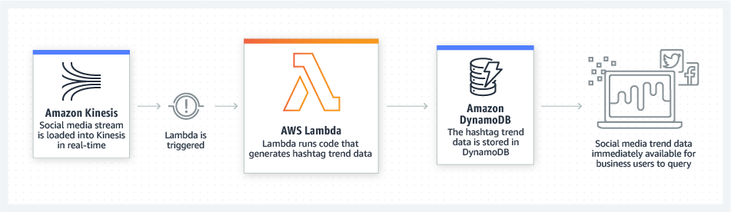

Option 1 is incorrect because the AWS Step Functions service lets you coordinate multiple AWS services into serverless workflows so you can build and update apps quickly. Although this can be a valid solution, it is not cost-effective since the application does not have a lot of components to orchestrate. Lambda functions can effectively meet the requirements in this scenario without using Step Functions. This service is not as cost-effective as Lambda.

Options 2 and 4 are incorrect as using On-Demand EC2 instances is not cost-effective. It is better to use a Lambda function instead.

**A company is using hundreds of AWS resources in multiple AWS regions. They require a way to uniquely identify all of their AWS resources that will allow them to specify a resource unambiguously across all of AWS, such as in IAM policies, Amazon Relational Database Service (Amazon RDS) tags, and API calls.**

**Which of the following is the most suitable option to use in this scenario?**

* ​

AWS Resource ID

* ​

AWS Service Namespaces

* ​

Amazon Resource Name

**(Correct)**

* ​

Tags

**(Incorrect)**

**Explanation**

Amazon Resource Names (ARNs) uniquely identify AWS resources. We require an ARN when you need to specify a resource unambiguously across all of AWS, such as in IAM policies, Amazon Relational Database Service (Amazon RDS) tags, and API calls.

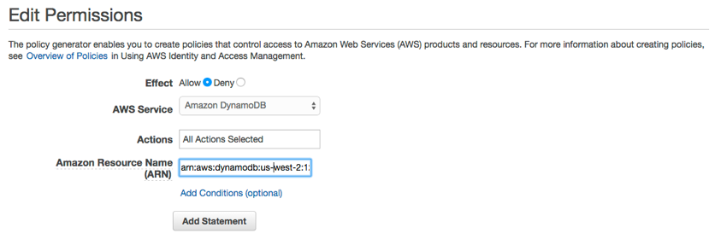

Option 1 is incorrect because an AWS Resource ID is primarily used to find your resources in the Amazon EC2 console only and not your entire VPC or AWS account.

Option 2 is incorrect because AWS Service Namespaces only helps you identify an AWS service and not a unique resource. For example, the namespace for Amazon S3 is **s3**, and the namespace for Amazon EC2 is **ec2**.

Option 4 is incorrect because although Tags can enable you to categorize your AWS resources by purpose, owner, or environment, it is still limited because you cannot tag all of your AWS resources. Take note that you cannot tag Egress-only internet gateway, VPC flow log, VPC endpoint, and many others. Amazon Resource Names (ARNs) uniquely identify all of your AWS resources which is a more suitable option for this scenario.

**References:**

**Your company has a two-tier environment in its on-premises data center which is composed of an application tier and database tier. You are instructed to migrate their environment to the AWS cloud, and to design the subnets in their VPC with the following requirements:**

**a) There is an application load balancer that would distribute the incoming traffic among the servers in the application tier.**

**b) The application tier and the database tier must not be accessible from the public Internet. The application tier should only accept traffic coming from the load balancer.**

**c) The database tier contains very sensitive data. It must not share the same subnet with other AWS resources and its custom route table with other instances in the environment.**

**d) The environment must be highly available and scalable to handle a surge of incoming traffic over the Internet.**

**How many subnets should you create to meet the above requirements?**

* ​

2

* ​

3

* ​

4

**(Incorrect)**

* ​

6

**(Correct)**

**Explanation**

The given scenario indicated 4 requirements that should be met in order to successfully migrate their two-tier environment from their on-premises data center to AWS Cloud. The first requirement means that you have to use an application load balancer (ALB) to distribute the incoming traffic to your application servers.

The second requirement specifies that both your application and database tier should not be accessible from the public Internet. This means that you could create a single private subnet for both of your application and database tier. However, the third requirement mentioned that the database tier should not share the same subnet with other AWS resources to protect its sensitive data. This means that you should provision one private subnet for your application tier and another private subnet for your database tier.

The last requirement alludes to the need for using at least two Availability Zones to achieve high availability. This means that you have to distribute your application servers to two AZs as well as your database which can be set up with a master-slave configuration to properly replicate the data between two zones.

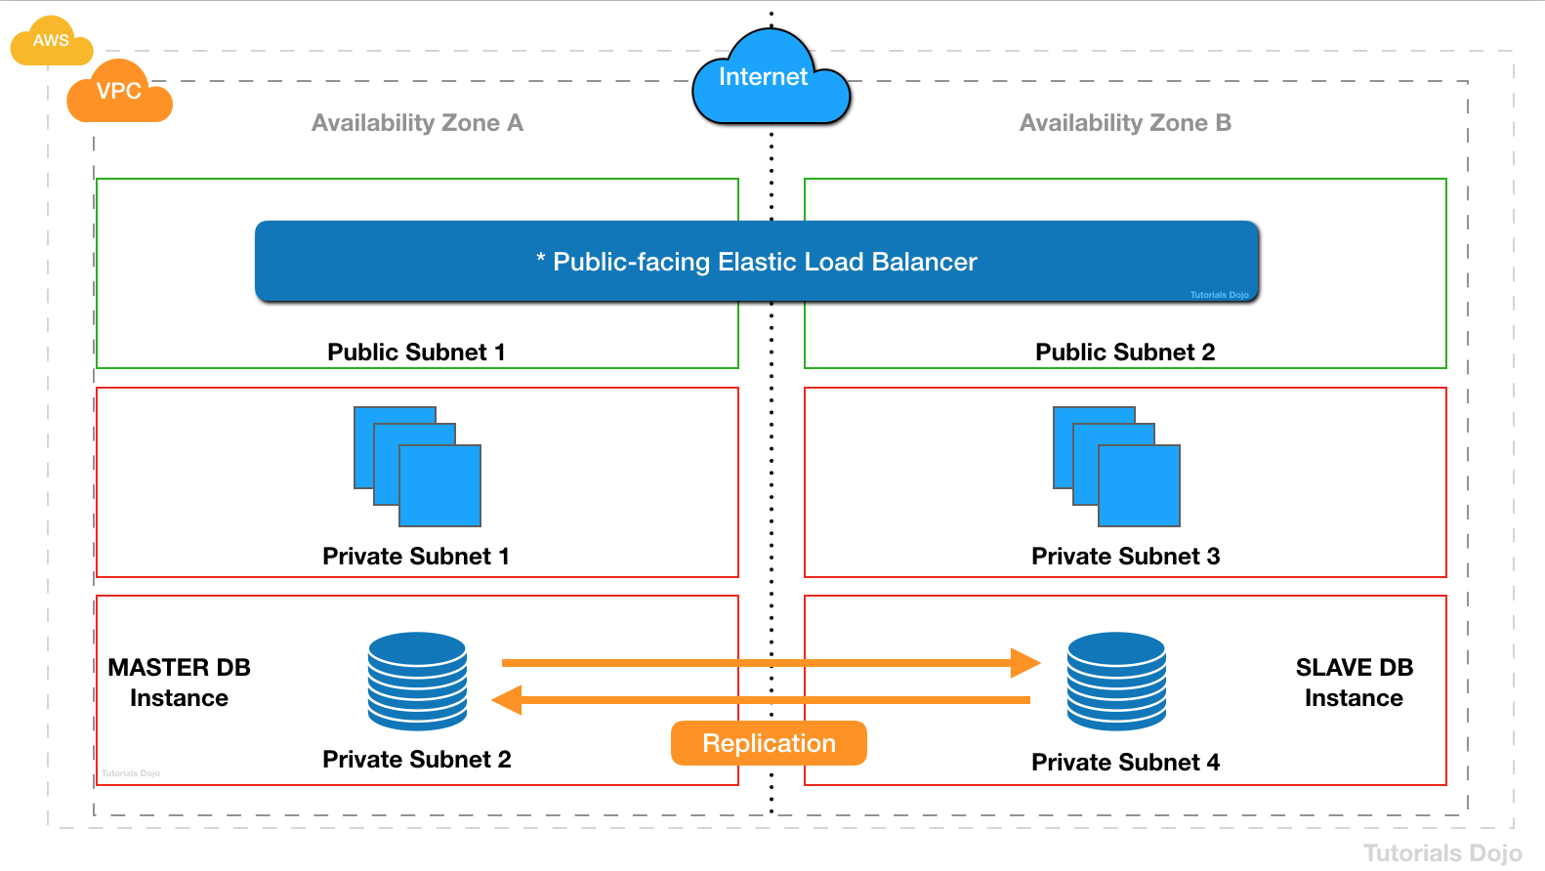

Since you have a public internet-facing load balancer that has a group of backend Amazon EC2 instances that are not deployed in a private subnet, you must create the corresponding public subnets in the **same** Availability Zones. This new public subnet is on top of the private subnet that is used by your private EC2 instances. Lastly, you should associate these public subnets to the internet-facing load balancer to complete the setup.

To summarize, we need to have one private subnet for the application tier and another one for the database tier. We then need to create another public subnet in the same Availability Zone where the private EC2 instances are hosted, in order to properly connect the public internet-facing load balancer to your instances. This means that we have to use a total of 3 subnets consisting of 2 private subnets and 1 public subnet.

Question 15: **Incorrect**

**You manage an application that uses EC2 instances and SQS to process requests from end users. Your application is working great, but your supervisor is concerned about the cost of the AWS resources it uses. Which of the following would not help address that concern? Choose the correct answer**

* A. Decrease the size of the SQS messages from 70 KB to 60 KB



* ​B. Switch from short polling to long polling**(Incorrect)**



* ​C. Increase the visibility timeout for messages in the SQS queue**Correct)**



* D. Use Auto Scaling to grow and shrink the number of EC2 instances based on the number of messages in the SQS queue



#### Explanation

Correct answer is **C**as increasing the visibility timeout does not impact cost, but just makes the message unavailable for other customers for processing.

Option A is wrong as reducing the size to 60KB would help reduce cost

Each 64 KB chunk of a payload is billed as 1 request

Option B is wrong as long polling only helps reduce the cost

Long polling helps reduce your cost of using Amazon SQS by reducing the number of empty responses (when there are no messages available to return in reply to a *ReceiveMessage* request sent to an Amazon SQS queue) and eliminating false empty responses (when messages are available in the queue but aren't included in the response):

Option D is wrong as EC2 instance can be scaled based on the SQS queue demand to cut cost.

**Types**

* Standard queues:Nearly an unlimited number of transactions per second, at-least-once processing, and the order is not preserved.SQS uses multiple hosts, and each host holds only portion of all the messages. When a consumer calls for a new message, it does not see all the hosts or all the messages. As such, messages are not necessarily delivered in the order in which they were generated.If an agent abandons a message or takes a break before finishing a message, it will be offered in the queue again. In order to ensure that no message is lost, a message will persist in the SQS queue until it is processed successfully.
* FIFO queues:
  + FIFO delivery, exactly-once processing, and the order is preserved.

**MQ**



* Amazon MQ supports industry-standard APIs and protocols so you can switch from any standards-based message broker to Amazon MQ without rewriting the messaging code in your applications.Using Amazon SQS requires you to do additional changes in the code.
  + **But if you are building brand new applications in the cloud, then it is highly recommended that you consider Amazon SQS and Amazon SNS.**

supports **delay queues** to make messages available after a certain delay, can you used to differentiate from priority queues

* supports **dead letter queues**, to redirect messages which failed to process after certain attempts instead of being processed repeatedly
* **Design Patterns**
  + **Job Observer Pattern**can help coordinate number of EC2 instances with number of job requests (Queue Size) automatically thus Improving cost effectiveness and performance
  + **Priority Queue Pattern** can be used to setup different queues with different handling either by delayed queues or low scaling capacity for handling messages in lower priority queues

**SWF**

* Amazon Simple Workflow Service (Amazon SWF) makes it easy to build applications that coordinate work across distributed components.
  + Used by [Amazon.com](http://amazon.com/) for orders, payments, warehousing, etc.Tasks represent invocations of various processing steps.For example, executable code, web service calls, human actions, and scripts.
* Concepts:
  + Actors: An application that can initiate a workflow.
  + Deciders: Control the flow of activity tasks in a workflow execution.
  + Activity workers: Carry out activity tasks.
  + Domains: Collections of related workflows.
* By default, each workflow execution can run for a maximum of 1 year in Amazon SWF.
* While there are a limited range of SDKs available for SWF, AWS provides an HTTP based API which allows you to interact using any language as long as you phrase the interactions in HTTP requests.
* helps define tasks which can be executed on AWS cloud or **on-premises**
* helps coordinating tasks across the application which involves managing intertask dependencies, scheduling, and concurrency in accordance with the logical flow of the application
* supports **built-in retries, timeouts and logging**
* supports **manual tasks**
* Characteristics
  + deliver exactly once
  + uses long polling, which reduces number of polls without results
  + Visibility of task state via API
  + Timers, signals, markers, child workflows
  + supports versioning
  + keeps workflow history for a user-specified time
* AWS SWF vs AWS SQS
  + task-oriented **vs** message-oriented
  + track of all tasks and events **vs** needs custom handling

**You are working for a startup as its AWS Chief Architect. You are currently assigned on a project that develops an online registration platform for events, which uses Simple Workflow for complete control of your orchestration logic. A decider ingests the customer name, address, contact number, and email address while the activity workers update the customer with the status of their online application status via email. Recently, you were having problems with your online registration platform which was solved by checking the decision task of your workflow.**

**In SWF, what is the purpose of a decision task?**

* ​It defines all the activities in the workflow.



* ​It tells the decider the state of the workflow execution.



* ​It tells the worker to perform a function.



* ​It represents a single task in the workflow.



**Explanation**

Amazon SWF issues decision tasks whenever a workflow execution has transitions such as an activity task completing or timing out. A decision task contains information on the inputs, outputs, and current state of previously initiated activity tasks. Your decider uses this data to decide the next steps, including any new activity tasks, and returns those to Amazon SWF. Amazon SWF in turn enacts these decisions, initiating new activity tasks where appropriate and monitoring them.

**You have a web-based order processing system which is currently using a queue in Amazon SQS. The support team noticed that there are a lot of cases where an order was processed twice. This issue has caused a lot of trouble in your processing and made your customers very unhappy. Your IT Manager has asked you to ensure that this issue does not happen again.  
  
What can you do to prevent this from happening again in the future?**

* ​

Alter the retention period in Amazon SQS.

* ​

Alter the visibility timeout of SQS.

* ​

Replace Amazon SQS and instead, use Amazon Simple Workflow service.

**(Correct)**

* ​

Change the message size in SQS.

**(Incorrect)**

**Explanation**

**Amazon SWF** provides useful guarantees around task assignment. It ensures that a task is never duplicated and is assigned only once. Thus, even though you may have multiple workers for a particular activity type (or a number of instances of a decider), Amazon SWF will give a specific task to only one worker (or one decider instance). Additionally, Amazon SWF keeps at most one decision task outstanding at a time for a workflow execution. Thus, you can run multiple decider instances without worrying about two instances operating on the same execution simultaneously. These facilities enable you to coordinate your workflow without worrying about duplicate, lost, or conflicting tasks.

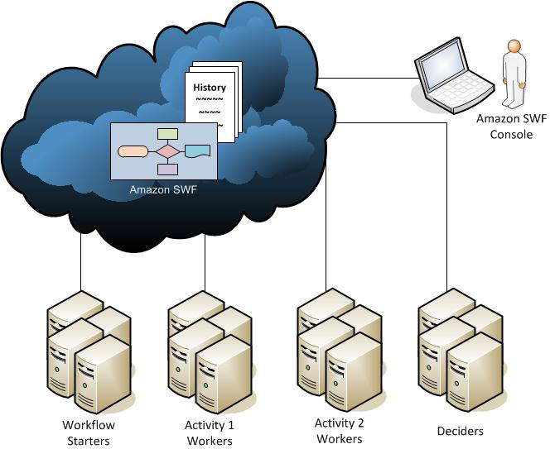

The main issue in this scenario is that the order management system produces duplicate orders at times. Since the company is using SQS, there is a possibility that a message can have a duplicate in case an EC2 instance failed to delete the already processed message. To prevent this issue from happening, you have to use Amazon Simple Workflow service instead of SQS. Therefore, the correct answer is Option 3.

Option 1 is incorrect because the retention period simply specifies if the Amazon SQS should delete the messages that have been in a queue for a certain period of time.

Option 2 is incorrect because, for standard queues, the visibility timeout isn't a guarantee against receiving a message twice. To avoid duplicate SQS messages, it is better to design your applications to be *idempotent* (they should not be affected adversely when processing the same message more than once).

Option 4 is incorrect because changing the message size in SQS is not related at all in this scenario.

**Compared to SQS**

* Similar to SQS, SWF manages queues of work, however unlike SQS it can have out-of-band parallel and sequential task to be completed by humans and non AWS services.
* With SWF, workflow executions can last up to 1 year.
  + SQS has retention period of up to 14 days.
* SWF presents a task-oriented API.
  + SQS presents a message-oriented API.
* SWF ensures that a task is assigned only once and is never duplicated.
  + With SQS you may handle duplicated messages and need to ensure that a message is processed only once (FIFO)
* SWF keeps track of all tasks and events in an application.
  + In SQS you need to implement your own application-level tracking, especially if your applic:-- ations uses multiple queues.

**SNS:--** Amazon Simple Notification Service (SNS) is a highly available, durable, secure, fully managed pub/sub messaging service that enables you to decouple microservices, distributed systems, and serverless applications.Makes it easy to set up, operate, and send notifications from the cloud.

* Provides developers with a highly scalable, flexible, and cost-effective capability to publish messages from an application and immediately deliver them to subscribers or other applications.
* Besides pushing cloud notifications directly to mobile devices, Amazon SNS can also deliver notifications by SMS, email, or any HTTP endpoint.Allows grouping multiple recipients using topics.
  + For example, using topics, you can group together iOS, Android, and SMS recipients.
  + When you create a topic on Amazon SNS, an ARN is created.

To prevent messages from being lost, all messages are stored redundantly across multiple AZs. In order for customers to have broad flexibility of delivery mechanisms, Amazon SNS supports notifications over multiple transport protocols. Customers can select one the following transports as part of the subscription requests:

“HTTP”, “HTTPS” – Subscribers specify a URL as part of the subscription registration; notifications will be delivered through an HTTP POST to the specified URL.

”Email”, “Email-JSON” – Messages are sent to registered addresses as email. Email-JSON sends notifications as a JSON object, while Email sends text-based email.

“SQS” – Users can specify an SQS standard queue as the endpoint; Amazon SNS will enqueue a notification message to the specified queue (which subscribers can then process using SQS APIs such as ReceiveMessage, DeleteMessage, etc.

“SMS” – Messages are sent to registered phone numbers as SMS text messages.

* Benefits:
  + Instantaneous, push-based delivery (no polling)Simple APIs and easy integration with applications.Flexible message delivery over multiple transport protocols.Inexpensive, pay-as-you-go model with no up-front costs.AWS Management Console offers the simplicity of a point-and-click interface.
* supports **Mobile Push Notifications** to push notifications directly to mobile devices with services like Amazon Device Messaging (ADM), Apple Push Notification Service (APNS), Google Cloud Messaging (GCM) etc. supported
* **order is not guaranteed** and **No recall** available
* **integrated with Lambda** to invoke functions on notifications
* **for Email notifications, use SNS or SES directly, SQS does not work**

**Compared to SQS**

* Both are messaging systems in AWS.
* SQS is pull-based, whereas SNS is push-based.
* Top of Form
* Amazon SQS is a reliable and highly-scalable managed message queue service for storing messages in transit between application components. FIFO queues complement the existing Amazon SQS standard queues, which offer high throughput, best-effort ordering, and at-least-once delivery. FIFO queues have essentially the same features as standard queues, but provide the added benefits of supporting ordering and **exactly-once processing**. **Additionally, message groups allow multiple separate ordered message streams within the same queue.**
* FIFO queues provide [exactly-once processing](https://docs.aws.amazon.com/AWSSimpleQueueService/latest/SQSDeveloperGuide/FIFO-queues.html#FIFO-queues-exactly-once-processing), which means that each message is delivered once and remains available until a consumer processes it and deletes it. Duplicates are not introduced into the queue.
* Option B is wrong as Kinesis does not support exactly once processing and can [deliver duplicates](https://docs.aws.amazon.com/streams/latest/dev/kinesis-record-processor-duplicates.html)
* Option C is wrong as SNS Amazon Simple Notification Service (SNS) can [deliver duplicates](https://aws.amazon.com/sns/faqs/).
* Although most of the time each message will be delivered to your application exactly once, **the distributed nature of Amazon SNS and transient network conditions could result in occasional, duplicate messages at the subscriber end**. Developers should design their applications such that processing a message more than once does not create any errors or inconsistencies.
* Option D is wrong as STS is not a messaging service. AWS Security Token Service (STS) is a web service that enables you to request temporary, limited-privilege credentials for AWS Identity and Access Management (IAM) users or for users that you authenticate (federated users)
* Bottom of Form
* Top of Form

## **SES**

* highly scalable and cost-effective email service
* uses **content filtering technologies** to scan outgoing emails to check standards and email content for spam and malware
* **supports full fledged emails to be sent as compared to SNS where only the message is sent in Email**
* ideal for **sending bulk emails** at scale
* **guarantees first hop**
* eliminates the need to support custom software or applications to do heavy lifting of email transport

## **EMR**

* is a web service that utilizes a hosted **Hadoop** framework running on the web-scale infrastructure of EC2 and S3
* launches all nodes for a given cluster in the **same Availability Zone**, which improves performance as it provides higher data access rate
* seamlessly supports Reserved, On-Demand and Spot Instances
* consists of Master Node for management and Slave nodes, which consists of Core nodes holding data and Task nodes for performing tasks only
* is fault tolerant for slave node failures and continues job execution if a slave node goes down
* does not automatically provision another node to take over failed slaves
* supports Persistent and Transient cluster types
  + Persistent which continue to run
  + Transient which terminates once the job steps are completed
* supports **EMRFS** which allows S3 to be used as a durable HA data storage

## **Data Pipeline**

* orchestration service that helps define **data-driven workflows** to automate and schedule regular data movement and data processing activities
* integrates with **on-premises and cloud-based** storage systems
* allows scheduling, **retry, and failure logic** for the workflows
* **VPC**
* Amazon Virtual Private Cloud (Amazon VPC) lets you provision a logically isolated section of the AWS where you can launch AWS resources in a virtual network that you define.
  + Think of VPC as a logical datacenter on AWS.You have complete control over your network environment, including selection of your IP address range, creation of subnets, and configuration of route tables and network gateways.For example, create a public-facing subnet (10.0.1.0/24) for web servers and private-facing subnet (10.0.2.0/24) for databases.Allows creation of a hardware VPN connection between private datacenters and Amazon VPC.
* Consists of gateways, route tables, ACLs, subnets, and security groups.
* Default VPC:User friendly, allowing to immediately deploy instances.
  + Your default VPC includes a subnet per AZ, an internet gateway (each default subnet is a public subnet), a route table with the route to the internet gateway, a default NACL that allows everything, and a default security group that also allows everything. Each EC2 instance created under a subnet of this VPC has both a private and public IP address.
  + If you do delete the default VPC, it will remove any network objects associated with it. But you can recover it now.
* Internet gateway (**IGW**) provides access to the Internet
* Virtual gateway (**VGW**) provides access to on-premises data center through **VPN** and **Direct Connect** connections
* VPC can have only one IGW and VGW
* **Route tables** determine where network traffic from subnet is directed
* Dedicated hosting tenancy:
  + Once a VPC is set to *Dedicated*, it can be changed back to *Default* via the CLI, SDK or API.Note that this will not change hosting settings for existing instances, only future ones.Existing instances can be changed via CLI, SDK or API but need to be in a stopped state to do so.
* Vulnerability scans:
  + Until recently customers were not permitted to conduct penetration testing without AWS engagement. However that has changed. There are still conditions though.
* How to communicate to the back-end services hosted on-premise:
  + You can do this by either using a site to site VPN or Direct Connect.
  + You must also make sure that your internal IP addresses do not overlap.
* You can create up to 5 VPCs in a single region.In Amazon VPC, an instance always retains its private IP address.

**Components**

* Inside a region, we have our VPC**. On the outside of the VPC, we have two ways to connecting to it: Internet Gateway and Virtual Private Gateway**. The traffic from an Internet gateway is routed to the appropriate subnet using the routes in the routing table. The rules of the network ACL associated with the subnet control which traffic is allowed to the subnet. The rules of the security group associated with an instance control which traffic is allowed to the instance.AWS has removed the Firewall appliance from the hub of the network and implemented the firewall functionality as stateful Security Groups, and stateless subnet NACLs.

**Subnets**

* A subnet is a range of IP addresses in your VPC.To protect the AWS resources in each subnet, you can use multiple layers of security, including security groups and ACL.
* **map to AZs** and do not span across AZs
* have a CIDR range that is a portion of the whole VPC.
* **CIDR ranges cannot overlap** between subnets within the VPC.
* AWS **reserves 5 IP addresses in each subnet – first 4 and last one**
* Each subnet is associated with a route table which define its behavior
  + **Public subnets** – inbound/outbound Internet connectivity via IGW
  + **Private subnets** – outbound Internet connectivity via an NAT or VGW
  + **Protected subnets** – no outbound connectivity and used for regulated workloads
* By default, instances in new subnets in a custom VPC can communicate with each other across AZs. In a custom VPC with new subnets in each AZ, there is a route that supports communication across all subnets/AZs. Plus a default SG with an allow rule 'All traffic, all protocols, all ports, from anything using this default SG'.

**Elastic IP**

* is a **static IP address** designed for dynamic cloud computing.
* is **associated with AWS account**, and not a particular instance
* can be **remapped** from one instance to an other instance
* is **charged for non usage**, if not linked for any instance or instance associated is in stopped state

**Classless Inter-Domain Routing (CIDR)**

* Some private IP address ranges include 10.0.0.0/8, 172.16.0.0/12, and 192.168.0.0/16
* The largest prefix Amazon allows is 16 (65,536 addresses), the smallest is 28 (16 addresses)The CIDR block must not overlap with any existing CIDR block that's associated with the VPC.You cannot increase or decrease the size of an existing CIDR block.
* You have a limit on the number of CIDR blocks you can associate with a VPC.
* The CIDR block must not be the same or larger than the CIDR range of a route.
* The first four IP addresses and the last IP address in each subnet CIDR block are not available.
* To translate an IP address with prefix (192.64.0.0/14):
  + Convert the prefix into the bitmask (14 bits from left is 11111111.11111100.00000000.00000000)
  + Then into the decimal subnet mask (255.252.0.0)
  + Then into the wildcard (remaining 0.3.255.255)
  + Finally, add the prefix to the IP address (the first available host is 192.64.0.1, the last 192.67.255.254)

**In your AWS VPC, you need to add a new subnet that will allow you to host a total of 20 EC2 instances.Which of the following IPv4 CIDR block can you use for this scenario?**

* ​172.0.0.0/27



* ​172.0.0.0/28



* 172.0.0.0/29
* ​172.0.0.0/30



To calculate the total number of IP addresses of a given CIDR Block, you simply need to follow the 2 easy steps below. Let's say you have a CIDR block **/27**:

1. Subtract **32** with the mask number :

(32 - 27) = **5**

2. Raise the number **2** to the power of the answer in Step #1 :

2^ **5** = (2 * 2 * 2 * 2 * 2)

  = **32**

The answer to Step #2 is the total number of IP addresses available in the given CIDR netmask. Don't forget that in AWS, the first 4 IP addresses and the last IP address in each subnet CIDR block are not available for you to use, and cannot be assigned to an instance. In addition, you can always associate a netmask of /27 which also has the same number of usable IP addresses (27) to help you with your exam.

**You have a requirement to make sure that an On-Demand EC2 instance can only be accessed from this IP address (110.238.98.71) via an SSH connection. Which configuration below will satisfy this requirement?**

* ​Security Group Inbound Rule: Protocol – TCP. Port Range – 22, Source 110.238.98.71/32



* ​Security Group Inbound Rule: Protocol – UDP, Port Range – 22, Source 110.238.98.71/32



* ​Security Group Inbound Rule: Protocol – TCP. Port Range – 22, Source 110.238.98.71/0



* ​Security Group Inbound Rule: Protocol – UDP, Port Range – 22, Source 110.238.98.71/0



**Explanation**

The SSH protocol uses TCP and port 22. Hence, Options 2 and 4 are incorrect as they are using UDP. Options 1 and 3 have one major difference and that is their CIDR block

 The requirement is to only allow the individual IP of the client and not the entire network. Therefore, the proper CIDR notation should be used. The **/32** denotes one IP address and the **/0** refers to the entire network. That is why Option 3 is incorrect as it allowed the entire network instead of a single IP.

**Route tables**

* A route table contains a set of rules (routes) that are used to determine where network traffic is directed.The route table entries enable instances in the subnet to communicate with other instances in the VPC (also in other subnets), and to communicate directly over the Internet.Every time we create a subnet, it will be automatically associated with the main route table.Thus, create a separate, custom route table for any public subnets.
* Each VPC has a Main Route table, and can have multiple custom route tables created
* Every route table contains a local route that enables communication within a VPC which cannot be modified or deleted
* Route priority is decided by matching the most specific route in the route table that matches the traffic
* The default route table also contains route to the IGW.

**IGW:**An internet gateway (IGW) is a horizontally scaled, redundant, and highly available VPC component that allows communication between instances in your VPC and the internet.Imposes no availability risks or bandwidth constraints on your network traffic.

* A subnet that's associated with a route table that has a route to an Internet gateway (IGW) is known as a public subnet**.You can only attach one internet gateway per VPC.**

**NACLA Network Access Control List (Network ACL)** is an optional layer of security for your VPC that acts as a firewall for controlling traffic in and out of one or more subnets.

* + Think of Homeland Security.Operate at the subnet level.
* NACLs have separate inbound and outbound rules, and each rule can either allow or deny traffic.For example, you can block a specific IP address.Stateless:Return traffic must be explicitly allowed by rules.Automatically apply to all instances in the subnets they're associated with.Therefore, an additional layer of defense if the security group rules are too permissive.The rules are evaluated in numerical order, from the lowest to the highest.
  + Amazon recommends that you use increments of 100 for each rule (and of 1 for IPv4 and IPv6)Rules are executed immediately when a matching allow/deny rule is found.
  + For example, if you allow port 80 in the rule "100" and disable it in the rule "200", the port will still be open. That's also why everything under the rule "*" is denied at the end.
* A *network access control list (ACL)* is an optional layer of security for your VPC that acts as a firewall for controlling traffic in and out of one or more subnets. You might set up network ACLs with rules similar to your security groups in order to add an additional layer of security to your VPC

**Your client is an insurance company that utilizes SAP HANA for their day-to-day ERP operations. Since you can’t migrate this database due to customer preferences, you need to integrate it with your current AWS workload in your VPC in which you are required to establish a site-to-site VPN connection.   What needs to be configured outside of the VPC for you to have a successful site-to-site VPN connection?**

* ​A dedicated NAT instance in a public subnet



* ​An Internet-routable IP address (static) of the customer gateway's external interface for the on-premises network



* ​The main route table in your VPC to route traffic through a NAT instance



* ​An EIP to the Virtual Private Gateway



**Explanation**

By default, instances that you launch into a virtual private cloud (VPC) can't communicate with your own network. You can enable access to your network from your VPC by attaching a virtual private gateway to the VPC, creating a custom route table, updating your security group rules, and creating an AWS managed VPN connection.

Although the term *VPN connection* is a general term, in the Amazon VPC documentation, a VPN connection refers to the connection between your VPC and your own network. AWS supports Internet Protocol security (IPsec) VPN connections.

A *customer gateway* is a physical device or software application on your side of the VPN connection.

To create a VPN connection, you must create a customer gateway resource in AWS, which provides information to AWS about your customer gateway device. Next, you have to set up an Internet-routable IP address (static) of the customer gateway's external interface.

The following diagram illustrates single VPN connections. The VPC has an attached virtual private gateway, and your remote network includes a customer gateway, which you must configure to enable the VPN connection. You set up the routing so that any traffic from the VPC bound for your network is routed to the virtual private gateway.

**You have set up a VPC with public subnet and an Internet gateway. You set up an EC2 instance with a public IP as well. However, you are still not able to connect to the instance via the Internet. You checked its associated security group and it seems okay.What should you do to ensure you can connect to the EC2 instance from the Internet?**

* ​Set an Elastic IP Address to the EC2 instance.



* ​et a Secondary Private IP Address to the EC2 instance.



* ​Check the main route table and ensure that the right route entry to the Internet Gateway (IGW) is configured.



* ​Check the CloudWatch logs as there must be some issue in the EC2 instance.



**Explanation**

The route table entries enable EC2 instances in the subnet to use IPv4 to communicate with other instances in the VPC, and to communicate directly over the Internet. A subnet that's associated with a route table that has a route to an Internet gateway is known as a public subnet.

If you could not connect to your EC2 instance even if there is already an Internet Gateway in your VPC and there is no issue in the security group, then you must check if the entries in the route table are properly configured.

**You are a Solutions Architect working for a large insurance company that deployed their production environment on a custom Virtual Private Cloud in AWS with a default configuration. The VPC consists of two private subnets and one public subnet. Inside the public subnet is a group of EC2 instances which are created by an Auto Scaling group and all of the instances are in the same Security Group. Your development team has created a new application which will be accessed by mobile devices via a custom port. This application has been deployed to the production environment and you need to open this port globally to the Internet.**

**Which of the following is the correct procedure to meet this requirement?**

* ​Open the custom port on the Security Group. Your EC2 instances will be able to use this port after 60 minutes.



* ​Open the custom port on the Network Access Control List of your VPC. Your EC2 instances will be able to use this port immediately.



* ​Open the custom port on the Security Group. Your EC2 instances will be able to use this port immediately.



* ​Open the custom port on the Network Access Control List of your VPC. Your EC2 instances will be able to use this port after a reboot.



**Explanation**

To allow the custom port, you have to change the Inbound Rules in your Security Group to allow traffic coming from the mobile devices. Security Groups usually control the list of ports that are allowed to be used by your EC2 instances and the NACLs control which network or list of IP addresses can connect to your whole VPC.

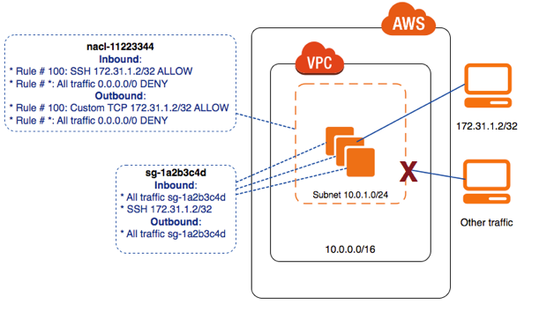

When you create a security group, it has no inbound rules. Therefore, no inbound traffic originating from another host to your instance is allowed until you add inbound rules to the security group. By default, a security group includes an outbound rule that allows all outbound traffic. You can remove the rule and add outbound rules that allow specific outbound traffic only. If your security group has no outbound rules, no outbound traffic originating from your instance is allowed.

* **new NACL:All traffic is blockby default &default NACL:All traffic is allowed by default.**
* Your VPC automatically comes with a default network ACL that allows everything.
* Each subnet in the VPC must be associated with a network ACL.If you don't explicitly associate a subnet with a NACL, the subnet is automatically associated with the default NACL.You can associate a NACL with multiple subnets.However, a subnet can only be associated with a single NACL at a time.When you associate a subnet with a new NACL, starting with the lowest numbered rule.
* **Correct answer is D as NACL can be used to deny access to the attacking IP address.**
* **Option A is wrong as Route table cannot help block traffic but just define routes for traffic.Option B is wrong as NAT is only for routing outgoing traffic and not incoming traffic.Option C is wrong as Security Groups cannot help block/deny access**

**ou have been asked to advise a junior colleague how to explicitly *deny* traffic from an EC2 instance to a specific remote internet FQDN. What advice would you give?**

AUse a security group attached to the instance, and explicitly *deny* traffic to the FQDN.

BUse a security group attached to the VPC, and explicitly *deny* traffic to the FQDN.

CUse a NACL on the subnet that the EC2 instance is on, and *deny* traffic from the EC2 instance to the FQDN.

DImplement a proxy service in the VPC, adjust route tables, and use the proxy server to *deny* access to the remote hostname.

**Your Answer: C**A NACL is incapable of blocking traffic to a hostname, even an FQDN.

**Correct Answer: D**This is the only valid option. AWS has no products capable of handling this type of denying traffic to an FQDN.

**Security groups**Security groups act as a firewall for associated Amazon EC2 instances:

* + Think of local law enforcement.Operate at the instance level.Support "allow" rules only.Evaluate all rules before deciding whether to allow traffic.stateful:Return traffic is automatically allowed, regardless of any rules.Changes to security groups take effect immediately.For a new security group:All inbound traffic is blocked by default.
  + All outbound traffic is allowed by default.For the default security group:All inbound traffic is allowed only for instances sharing this SG.All outbound traffic is allowed by default.
* By default, security groups do not have access to each other.

**You have one security group associated with 10 On-Demand EC2 instances. You then modified the security group to allow all inbound SSH traffic and then right after that, you created two new EC2 instances in the same security group.   When will the changes be applied to the EC2 instances?**

* ​Immediately to all 12 instances in the security group.



* ​Immediately to the new instances only.



* ​Immediately to the new instances, but not for the old ones which must be restarted before the changes take effect.



* ​The changes will apply to all 12 instances after an hour when the propagation is complete.



**Explanation**

A *security group* acts as a virtual firewall for your instance to control inbound and outbound traffic. When you launch an instance in a VPC, you can assign up to five security groups to the instance. Security groups act at the instance level, not the subnet level. Therefore, each instance in a subnet in your VPC could be assigned to a different set of security groups. If you don't specify a particular group at launch time, the instance is automatically assigned to the default security group for the VPC.

Option 1 is correct. When you add or remove rules, those changes are automatically applied to all instances to which you've assigned the security group. Since the first 10 instances are already assigned to the security group, you can SSH into them immediately after the change. After adding the two new instances to the security group, you should be able to SSH into them as well since the change was made beforehand.

* **EC2 instances:**Any number of EC2 instances can be within a security group.
  + You can assign up to five security groups to an instance.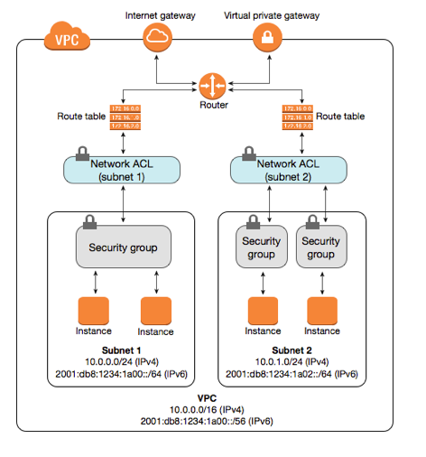

**Custom VPC**Create a new VPC (10.0.0.0/16). When you create a custom VPC, a default route table, a default ACL, and a default VPC security group are created. It won't create any subnets, nor it will create any gateways.

* Create two subnets under this VPC. Assign custom IP address ranges in each subnet: 10.0.1.0/24 for public and 10.0.2.0/24 for private. Select the AZ for each one (**Keep in mind: An AZ in one AWS account can be different from the same AZ in a different AWS account, since they are randomized).** By default, any user-created VPC subnet WILL NOT automatically assign public IPv4 addresses to instances, thus for the public one, turn on "Auto-assign IPv4".Create an internet gateway and attach it to the VPC.
* Configure route tables between subnets. Since the created subnets are associated with the main route table by default, create a new route table and add the 0.0.0.0/0 route to the internet gateway created earlier. Associate then the public subnet 10.0.1.0/24 with this table.Go over to the AWS resources, and create them under the corresponding subnets.
* Specify the appropriate security groups for your resources for them to communicate. For example, for SG 'A' to talk to a private SG 'B', create a new rule for SG 'B' and add SG 'A' as Source.[VPC with Public and Private Subnets (NAT)](https://docs.aws.amazon.com/vpc/latest/userguide/VPC_Scenario2.html)

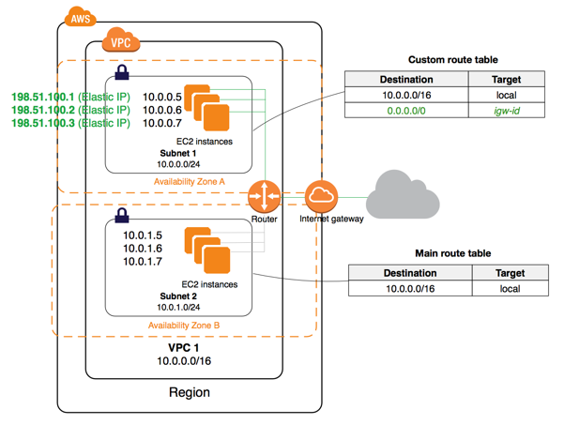

ELB is already in public subnet, the EC2 instances and RDS can be hosted in the private subnet with ELB pointing to Auto Scaled EC2 instances. Using private subnets would keep the instances secure.

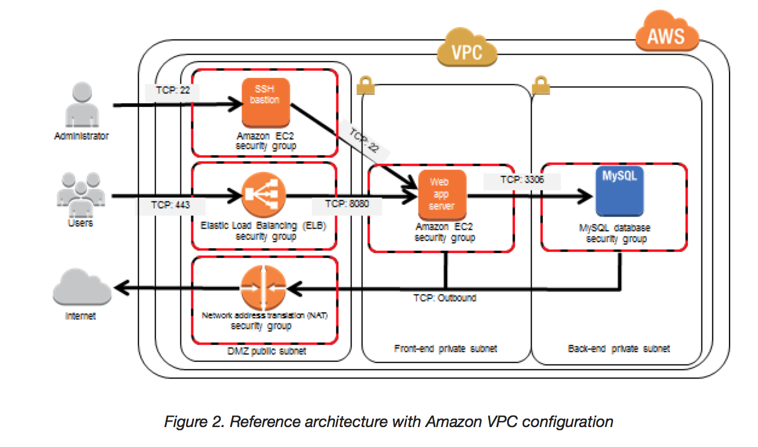

**VPC Peering**

* Connect one VPC with another via a direct network route using private IP addresses.
* Instances behave as they are on the same private network.You can peer VPCs with VPCs in another regions or even AWS accounts.You may peer a VPC to another VPC that's in your same account, or to any VPC in any other account.
* The following VPC peering connection configurations are not supported.
  + Overlapping CIDR Blocks
  + Transitive Peering: If both VPC A and VPC B are peered with VPC C, VPC A and VPC B cannot communicate with each other directly.
* Edge to Edge Routing Through a Gateway or Private ConnectionNo single point of failure and bandwidth bottlenecks
* **cannot span across region**
* supports inter-region VPC peering
* IP space or **CIDR blocks cannot overlap**
* **cannot be transitive**, one-to-one relationship between two VPC
* Only one between any two VPCs and have to be explicitly peered
* **Private DNS values cannot be resolved**Security groups from peered VPC can now be referred, however the VPC should be in the same region

The following VPC peering connection configurations are not supported.

1. Overlapping CIDR Blocks
2. Transitive Peering
3. Edge to Edge Routing Through a Gateway or Private Connection

**Overlapping CIDR Blocks**

You cannot create a VPC peering connection between VPCs with matching or overlapping IPv4 CIDR blocks.

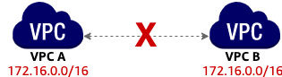

If the VPCs have multiple IPv4 CIDR blocks, you cannot create a VPC peering connection if any of the CIDR blocks overlap (regardless of whether you intend to use the VPC peering connection for communication between the non-overlapping CIDR blocks only).

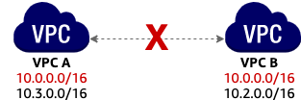

This limitation also applies to VPCs that have non-overlapping IPv6 CIDR blocks. Even if you intend to use the VPC peering connection for IPv6 communication only, you cannot create a VPC peering connection if the VPCs have matching or overlapping IPv4 CIDR blocks. Communication over IPv6 is not supported for an inter-region VPC peering connection.

**Transitive Peering**

You have a VPC peering connection between VPC A and VPC B (pcx-aaaabbbb), and between VPC A and VPC C (pcx-aaaacccc). There is no VPC peering connection between VPC B and VPC C. You cannot route packets directly from VPC B to VPC C through VPC A.

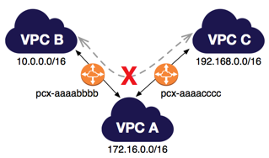

**Edge to Edge Routing Through a Gateway or Private Connection**

If either VPC in a peering relationship has one of the following connections, you cannot extend the peering relationship to that connection:

1. A VPN connection or an AWS Direct Connect connection to a corporate network
2. An internet connection through an internet gateway
3. An internet connection in a private subnet through a NAT device
4. A VPC endpoint to an AWS service; for example, an endpoint to Amazon S3.
5. (IPv6) A ClassicLink connection. You can enable IPv4 communication between a linked EC2-Classic instance and instances in a VPC on the other side of a VPC peering connection. However, IPv6 is not supported in EC2-Classic, so you cannot extend this connection for IPv6 communication.

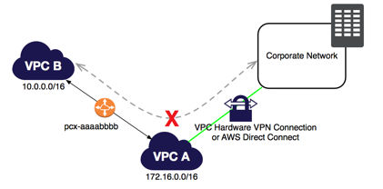

For example, if VPC A and VPC B are peered, and VPC A has any of these connections, then instances in VPC B cannot use the connection to access resources on the other side of the connection. Similarly, resources on the other side of a connection cannot use the connection to access VPC B.

You have three VPCs in the same region. You need to ensure all three VPCs have network connectivity to the other VPCs and can tolerate failure within AWS. How many VPC peers are needed?

AOne — connecting all the VPCs

BTwo — connecting VPC1 -> VPC2 and VPC2 -> VPC3

CThree — connecting VPC1<->2, 2<->3, 1<->3

DSix — connecting VPC1<->2, 2<->3, 1<->3, but with a redundant VPC peer for each

**Your Answer: D**

**Why is this incorrect?**

VPC peers are HA by design. T

**NAT**

* You can use a network address translation (NAT) gateway to enable instances in a private subnet to connect to the internet or other AWS services, **but prevent the internet from initiating a connection with those instances.**
  + For example, this can be used to do software updates in private subnets.

**NAT instances (outdated)**

* **A NAT instance is acting as a bridge between subnets and the internet gateway.**
* To set it up, create a NAT instance, and in the route table of the subnet where your EC2 instance is located, enter a route to this NAT instance to direct the internet traffic through this instance.A NAT instance is always behind the security group.
* Requirements:
  + Must be in a public subnet.The source/destination checks must be disabled.
* Limitations:The amount of traffic that this instance can support depends on its size.A massive bottleneck: A single VM, which can be easily overwhelmed. You can create HA using Autoscaling Groups, multiple subnets in different AZs, and a script to automate failover.
  + **When the instance is removed, the corresponding route is marked as "blackhole"**
  + You can use a NAT device to enable instances in a private subnet to connect to the Internet (for example, for software updates) or other AWS services, but prevent the Internet from initiating connections with the instances. A NAT device forwards traffic from the instances in the private subnet to the Internet or other AWS services, and then sends the response back to the instances. **When traffic goes to the Internet, the source IPv4 address is replaced with the NAT device’s address and similarly, when the response traffic goes to those instances, the NAT device translates the address back to those instances’ private IPv4 addresses**.

**NAT Gateway**

Redundant in the AZ and thus highly available.Starts at 5Gbps and scales currently to 45Gbps.There is no need to patch operation system.Automatically assigned a public IP address.Remember to update your route tables.Uses ephemeral ports 1024-65535.

* Not behind any security group.If you have resources in multiple AZs and they share one NAT gateway, in the event of that the NAT gateway's AZ is down, resources in the other AZs lose internet access.
  + **To create an AZ-independent architecture, create a NAT gateway in each AZ.**
* [AT Gateway](https://docs.aws.amazon.com/vpc/latest/userguide/vpc-nat-gateway.html) helps host the application in private subnets and still be able to access the external third-party services.

You are charged for creating and using a NAT gateway in your account. NAT gateway hourly usage and data processing rates apply. Amazon EC2 charges for data transfer also apply.

* Option A is wrong as Internet gateway cannot be moved to private subnet and the traffic from private subnets needs to the route through the Internet gateway via public subnet.
* Option B is wrong as a single instance would be able scalable.
* Option D is wrong as creating an Auto Scaling group of NAT instances, would cost more depending on the bandwidth provided the instances and number of instances required.

**Egress-Only Internet Gateway**The purpose of an "Egress-Only Internet Gateway" is to allow IPv6 based traffic within a VPC to access the Internet, whilst denying any Internet based resources the possibility of initiating a connection back into the VPC.

* An egress-only Internet gateway is for use with IPv6 traffic only.**To enable outbound-only Internet communication over IPv4, use a NAT gateway instead.**

**Bastion host:**

* A NAT gateway is used to provide internet traffic to EC2 instances in private subnets.
* A bastion is used to securely administer EC2 instances (SSH/RDP)
* Don't confuse Bastions and NATs, which allow outside traffic to reach an instance in a private subnet.
* A bastion host is a special computer on a network designed and configured to withstand attacks.Generally hosts a single application (e.g. proxy server)All other services are removed or limited to reduce the threat to the computer.Located either on the outside of the firewall or in a demilitarized zone (DMZ)Usually involves access from untrusted networks or computers.**The best way to implement a bastion host is to create a small EC2 instance which should only have a security group from a particular IP address for maximum security.**
  + **Small because this host will only act as a jump server to connect to other instances.**

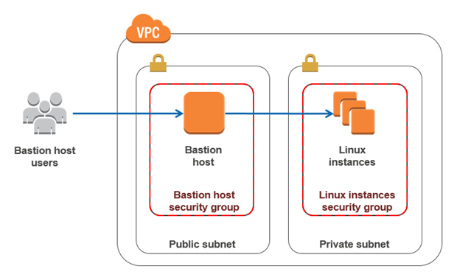

* ​D. Deploy a Bastion host with an Elastic IP address in the public subnet and restrict access to the bastion from only the corporate public IP addresses. Allow SSH access to EC2 instances from Bastion host.



**VPC Flow LogsVPC** Flow Logs enables you to capture information about the IP traffic.

* Logs are stored either using S3 or Amazon CloudWatch Logs.For this, create a log group in Amazon CloudWatch and an IAM role first.
* Can be created at three levels:VPC,SubnetNetwork Interface Level
* Limitations:You cannot enable flow logs for VPCs that are peered with your VPC unless the peer VPCs are under your account.After you've created a flow log, you cannot change its configuration.You cannot tag a flow log.Not all IP traffic is monitored:Traffic generated by EC2 instances when they contact the Amazon DNS server (unless its your own DNS server)
  + Traffic generated by a Windows instance for Amazon Windows license activation.
  + Traffic to and from 169.254.169.254 for instance metadata.**DHCP traffic as well as the traffic to the reserved IP address for the default VPC router.**
  + After you've created a flow log, you can view and retrieve its data in Amazon CloudWatch Logs.

Flow logs can help you with a number of tasks; for example, to troubleshoot why specific traffic is not reaching an instance, which in turn can help you diagnose overly restrictive security group rules. You can also use flow logs as a security tool to monitor the traffic that is reaching your instance

**You have been asked to suggest a solution that can monitor the flow of IP data to an EC2 instance. You need to be able to inspect the contents of the IP traffic. What solution should you suggest?**

AVPC Flow Logs BCloudTrail CA program such as Wireshark DCloudWatch Logs and agent

**Your Answer: A**VPC flow logs can only show IP traffic metadata — they cannot show traffic contents, which is part of the requirement.

**Correct Answer: C**Using an IP data sniffer such as Wireshark is the only solution from the ones offered to actually see the contents of IP data.

**One member of your DevOps team consulted you about a problem in connecting to one of the EC2 instances of your VPC over the Internet. Your environment is set up with four EC2 instances that all belong to a public non-default subnet. The EC2 instances also belong to the same security group. Everything works well as expected except for one of the EC2 instances which is not able to send nor receive traffic over the Internet.**

**What could be the possible reason for this issue?**

* ​The route table is not properly configured to allow traffic to and from the Internet through the Internet gateway.



* ​The EC2 instance is running in an Availability Zone that is not connected to an Internet gateway.



* ​The EC2 instance does not have a private IP address associated with it.



* ​The EC2 instance does not have a public IP address associated with it.



**(Correct)**

**Explanation**

In this scenario, there are 4 EC2 instances that belong to the same security group that should be able to connect to the Internet. The main route table is properly configured but there is a problem connecting to one instance. Since the other three instances are working fine, we can assume that the security group and the route table are correctly configured.

**You are a Solutions Architect working for a software development company. You are planning to launch a fleet of EBS-backed EC2 instances and want to automatically assign each instance witha static private IP address which does not change even if the instances are restarted.  
What should you do to accomplish this?**

* ​Launch the instances to a single Availability Zone.
* ​Launch the instances to multiple Availability Zones.
* ​Launch the instances in the Amazon Virtual Private Cloud (VPC).
* ​Launch the instances in a Placement Group.
* ​Launch the instances in EC2-Classic.

#### Explanation

In EC2-Classic, your EC2 instance receives a private IPv4 address from the EC2-Classic range each time it's started. In EC2-VPC on the other hand, your EC2 instance receives a static private IPv4 address from the address range of your default VPC. Hence, the correct answer is Option 3 and not Option 5.

|  |  |  |  |
| --- | --- | --- | --- |
| **Characteristic** | **EC2-Classic** | **Default VPC** | **Nondefault VPC** |
| Public IPv4 address (from Amazon's public IP address pool) | Your instance receives a public IPv4 address from the EC2-Classic public IPv4 address pool. | Your instance launched in a default subnet receives a public IPv4 address by default, unless you specify otherwise during launch, or you modify the subnet's public IPv4 address attribute. | Your instance doesn't receive a public IPv4 address by default, unless you specify otherwise during launch, or you modify the subnet's public IPv4 address attribute. |
| Private IPv4 address | Your instance receives a private IPv4 address from the EC2-Classic range each time it's started. | Your instance receives a static private IPv4 address from the address range of your default VPC. | Your instance receives a static private IPv4 address from the address range of your VPC. |
| Multiple private IPv4 addresses | We select a single private IP address for your instance; multiple IP addresses are not supported. | You can assign multiple private IPv4 addresses to your instance. | You can assign multiple private IPv4 addresses to your instance. |
| Elastic IP address (IPv4) | An Elastic IP is disassociated from your instance when you stop it. | An Elastic IP remains associated with your instance when you stop it. | An Elastic IP remains associated with your instance when you stop it. |

Options 1 and 2 are incorrect due to the fact that Availability Zones do not provide static private IP addresses to EC2 instances.

Option 4 is incorrect as a Placement Group is just a grouping of instances.

**VPC Endpoints**

* A VPC endpoint enables you to privately connect from your VPC to other AWS services without requiring an internet gateway, NAT device, VPN connection, or AWS Direct Connect connection and use  powered by PrivateLink**.In contrast to a NAT gateway, traffic does not leave the Amazon network.Instances in your VPC do not require public IP addresses**
* are horizontally scaled, redundant, and highly available VPC components that allow communication between instances in your VPC and services without imposing availability risks or bandwidth constraints on your network traffic.
* There are two types of VPC endpoints:
* Interface endpoints: A whole bunch of services are supported. is an elastic network interface with a private IP address that serves as an entry point for traffic destined to a supported service
* services supported API Gateway AWS CloudFormation, CloudWatch, CloudWatch Events, CloudWatch Logs AWS CodeBuild AWS CodeCommit AWS Config, EC2 API Elastic Load Balancing API, Elastic Container Registry, Elastic Container Service AWS Key Management Service, Kinesis Data Streams, SageMaker and, SageMaker Runtime, SageMaker Notebook Instance AWS Secrets Manager AWS Security Token Service AWS Service Catalog, SNS, SQS AWS Systems Manager
  + Gateway endpoints: S3 and DynamoDB are supported.

**A legacy application running on premises requires a solutions architect to be able to open a firewall to allow access to several Amazon S3 buckets. The Architect has a VPN connection to AWS in place.How should the Architect meet this requirement?**

#### Explanation

Correct answer is **B** as VPC S3 Endpoint can be used to access S3 via a proxy only.

**Endpoint connections cannot be extended out of a VPC. Resources on the other side of a VPN connection, VPC peering connection, AWS Direct Connect connection, or ClassicLink connection in your VPC cannot use the endpoint to communicate with resources in the endpoint service.**

**Since VPC endpoints are only accessible from Amazon EC2 instances inside a VPC, a local instance must proxy all remote requests before they can utilize a VPC endpoint connection.**

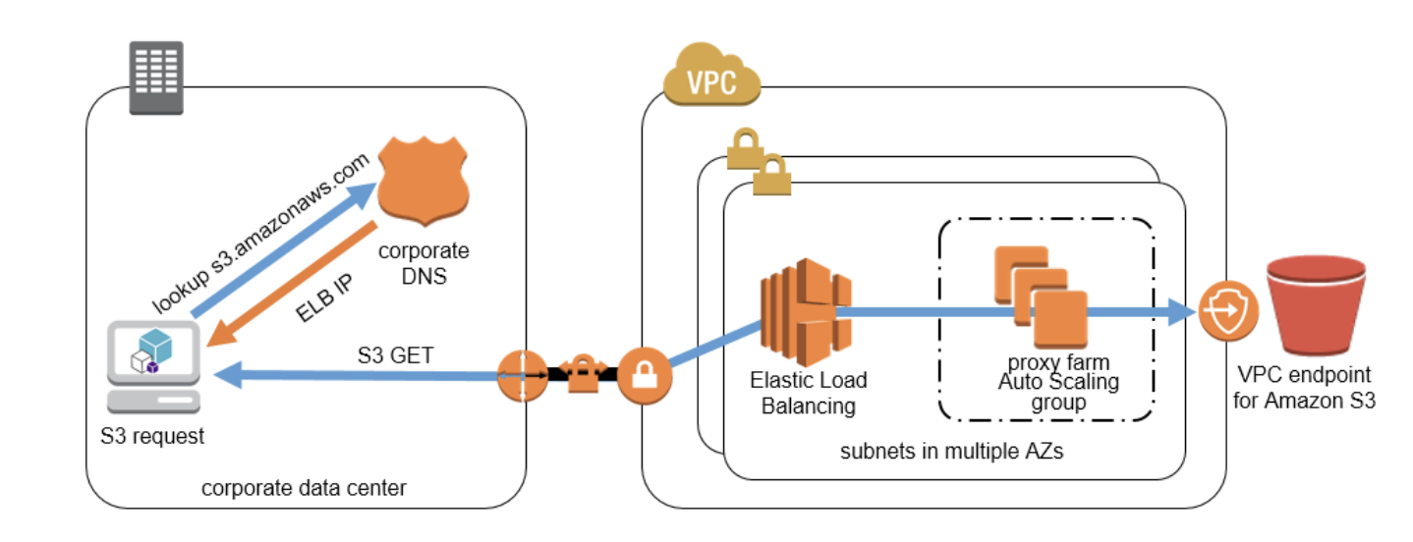

**The proxy farm proxies S3 traffic to the VPC endpoint. The proxy farm can use access control lists (ACLs) to provide additional control over VPC endpoint traffic. An ACL can specify which remote users or networks are authorized to leverage the solution, and can further restrict the VPC endpoints or destination domains that clients can access. Configure an Auto Scaling group to manage the proxy servers and automatically grow or shrink the number of required instances based on proxy server load.**

Correct answer is **C** as VPC Endpoint for DynamoDB helps route the traffic internally through AWS network with no exposure to the public internet.

VPC endpoints for DynamoDB can alleviate these challenges. A VPC endpoint for DynamoDB enables Amazon EC2 instances in your VPC to use their private IP addresses to access DynamoDB with no exposure to the public Internet. Your EC2 instances do not require public IP addresses, and you do not need an Internet gateway, a NAT device, or a virtual private gateway in your VPC. You use endpoint policies to control access to DynamoDB. Traffic between your VPC and the AWS service does not leave the Amazon network.

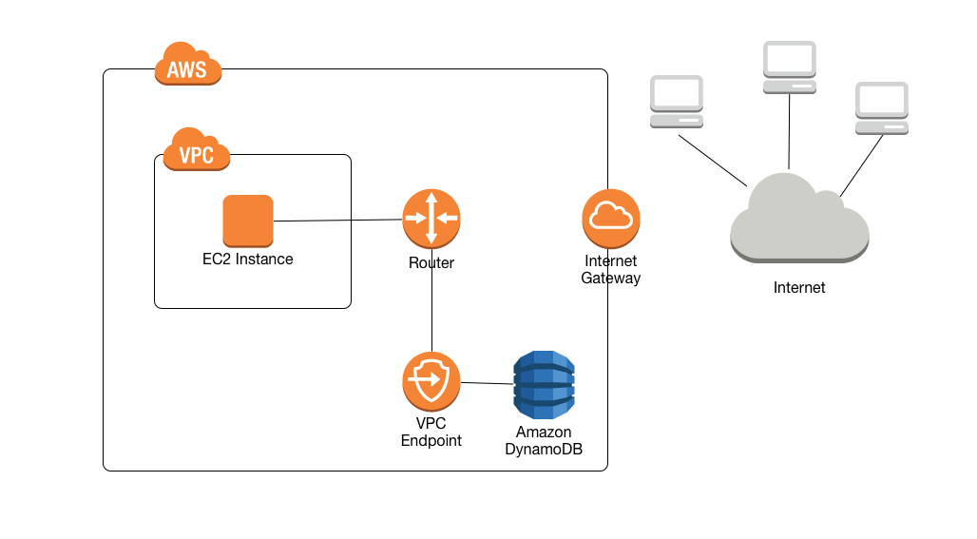  
Option A is wrong as VPC peering connection helps instances in different VPC interact with each other.  
Option B is wrong as NAT gateway helps instances in private subnet access Internet.  
Option D is wrong as Direct Connect helps dedicated high bandwidth connection between on-premises and AWS network..

**Your business operates in a very security-sensitive industry. You are looking at how to secure a small VPC. Your environment consists of a single S3 bucket and an EC2 instance running in an internet-connected VPC. Only the EC2 instance needs access to S3. What is the best way to lock down the environment, allowing the EC2 instance access to S3 but keeping the environment as secure as possible?**

ACreate an S3 VPC endpoint. Apply a policy restricting access to the S3 bucket from the VPC endpoint.

BCreate a new security group, denying all IPs except the EC2 instance, and associate it with the S3 bucket.

CCreate an S3 VPC endpoint. Apply a policy restricting access to the S3 bucket from the VPC endpoint, and remove the internet gateway. Set up a VPN connection to securely log in to the EC2 instance via SSH when needed.

DProvision a privately addressable S3 bucket in your VPC. Migrate the contents of the public bucket and update the application. Remove the internet gateway to isolate the VPC.

**Your Answer: A**

Leaving the internet gateway attached still leaves the VPC with internet access.

**Correct Answer: C**A VPC endpoint doesn't require an internet gateway. It allows access to S3, which is a public service from a VPC. Thi

**A Solutions Architect is developing a three-tier cryptocurrency web application for a FinTech startup. The Architect has been instructed to restrict access to the database tier to only accept traffic from the application-tier and deny traffic from other sources. The application-tier is composed of application servers hosted in an Auto Scaling group of EC2 instances.**

**Which of the following options is the MOST suitable solution to implement in this scenario?**

* ​Set up the security group of the database tier to allow database traffic from a specified list of application server IP addresses.
* ​Set up the security group of the database tier to allow database traffic from the security group of the application servers.
* ​Set up the Network ACL of the database subnet to deny all inbound non-database traffic from the subnet of the application-tier.
* ​Set up the Network ACL of the database subnet to allow inbound database traffic from the subnet of the application-tier.

**(Incorrect)**

**Explanation**

A *security group* acts as a virtual firewall for your instance to control inbound and outbound traffic. When you launch an instance in a VPC, you can assign up to five security groups to the instance. Security groups act at the instance level, not the subnet level. Therefore, each instance in a subnet in your VPC could be assigned to a different set of security groups. If you don't specify a particular group at launch time, the instance is automatically assigned to the default security group for the VPC.

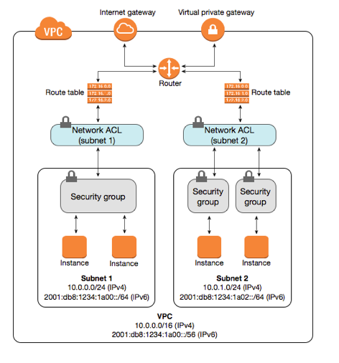

For each security group, you add *rules* that control the inbound traffic to instances, and a separate set of rules that control the outbound traffic. This section describes the basic things you need to know about security groups for your VPC and their rules.

You can add or remove rules for a security group which is also referred to as *authorizing* or *revoking* inbound or outbound access. A rule applies either to inbound traffic (ingress) or outbound traffic (egress). You can grant access to a specific CIDR range, or to another security group in your VPC or in a peer VPC (requires a VPC peering connection).

In the scenario, the servers of the application-tier are in an Auto Scaling group which means that the number of EC2 instances could grow or shrink over time. An Auto Scaling group could also cover one or more Availability Zones (AZ) which have their own subnets. Hence, the most suitable solution would be Option 2 since you can utilize the security group of the application-tier Auto Scaling group as the source for the security group rule in your database tier.

Option 1 is incorrect because the list of application server IP addresses will change over time since an Auto Scaling group can add or remove EC2 instances based on the configured scaling policy. This will create inconsistencies in your application because the newly launched instances, which are not included in the initial list of IP addresses, will not be able to access the database.

Option 3 is incorrect because denying all inbound non-database traffic from the application-tier subnet could affect the other EC2 instances of other applications, which are also hosted in the same subnet of the application-tier. For example, a large subnet with a CIDR block of /16 could be shared by several applications. Denying all inbound non-database traffic from the entire subnet will impact other applications which use this subnet.

Option 4 is incorrect because although this solution can work, the subnet of the application-tier could be shared by another tier or another set of EC2 instances other than the application-tier. This means that you would inadvertently be granting database access to unauthorized servers hosted in the same subnet other than the application-tier.

**You are working as a Solutions Architect for a major accounting firm, and they have a legacy general ledger accounting application that needs to be moved to AWS. However, the legacy application has a dependency on multicast networking. On this scenario, which of the following options should you consider to ensure the legacy application works in AWS?**

* ​

Provision Elastic Network Interfaces between the subnets.

* ​

Create all the subnets on another VPC and enable VPC peering.

**(Incorrect)**

* ​

Create a virtual overlay network running on the OS level of the instance.

**(Correct)**

* ​

All of the above.

**Explanation**

Multicast is a network capability that allows one-to-many distribution of data. With multicasting, one or more sources can transmit network packets to subscribers that typically reside within a multicast group. However, take note that Amazon VPC does not support multicast or broadcast networking.

You can use an overlay multicast in order to migrate the legacy application. An overlay multicast is a method of building IP level multicast across a network fabric supporting unicast IP routing, such as Amazon Virtual Private Cloud (Amazon VPC).

Option 1 is incorrect because just providing ENIs between the subnets would not resolve the dependency on multicast.

Option 2 is incorrect because VPC peering and multicast are not the same.

Option 3 is correct because overlay multicast is a method of building IP level multicast across a network fabric supporting unicast IP routing, such as Amazon Virtual Private Cloud (Amazon VPC).

Option 4 is incorrect because the only option that will work in this scenario is creating a virtual overlay network.

Question 28: **Incorrect**

**You are a Solutions Architect of a tech company. You are having an issue whenever you try to connect to your newly created EC2 instance using a Remote Desktop connection from your computer. Upon checking, you have verified that the instance has a public IP and the Internet gateway and route tables are in place.  
  
What else should you do for you to resolve this issue?**

* ​

You should adjust the security group to allow traffic from port 22

**(Incorrect)**

* ​

You should adjust the security group to allow traffic from port 3389

**(Correct)**

* ​

You should restart the EC2 instance since there might be some issue with the instance

* ​

You should create a new instance since there might be some issue with the instance

**Explanation**

Since you are using a Remote Desktop connection to access your EC2 instance, you have to ensure that the Remote Desktop Protocol is allowed in the security group. By default, the server listens on TCP port 3389 and UDP port 3389.

Option 1 is incorrect as the port 22 is used for SSH connections and not for RDP.

Options 3 and 4 are incorrect as the EC2 instance is newly created and hence, unlikely to cause the issue. You have to check the security group first if it allows the Remote Desktop Protocol (3389) before investigating if there is indeed an issue on the specific instance.

**Your IT Manager asks you to create a decoupled application whose process includes dependencies on EC2 instances and servers located in your company’s on-premises data center.  
  
Which of these options are you least likely to recommend as part of that process?**

* ​

SQS polling from an EC2 instance deployed with an IAM role

* ​

An SWF workflow

* ​

SQS polling from an EC2 instance using IAM user credentials

**(Correct)**

* ​

Establish a Direct Connect connection from your on-premises network and VPC

**(Incorrect)**

**Explanation**

For decoupled applications, it is best to use SWF and SQS which are both available in all options. Note that this question asks you for the option that you would **LEAST** likely to recommend.

If you notice the 3rd option, it uses IAM user credentials for the EC2 instances which is not the recommended way to do so. It should use an IAM role instead. Hence, the correct answer is option 3.

Options 1, 2 and 4 are the recommended steps to satisfy the given requirement. You have to establish first a Direct Connect connection from your data center to your VPC to allow the on-premises servers to connect to SQS. You can either use SWF or SQS to create a decoupled application and you have to use an IAM Role, not an IAM user credential, on the EC2 instance to allow polling to the SQS queue.

**You have designed and built a new AWS architecture. After deploying your application to an On-demand EC2 instance, you found that there is an issue in your application when connecting to port 443. After troubleshooting the issue, you added port 443 to the security group of the instance.How long will it take before the changes are applied to all of the resources in your VPC?**

* ​Roughly around 5-8 minutes in order for the security rules to propagate.
* ​Immediately after a reboot of the EC2 instances which belong to that security group.
* ​Immediately.
* ​It takes exactly one minute for the rules to apply to all availability zones within the AWS region.

**Explanation**

A *security group* acts as a virtual firewall for your instance to control inbound and outbound traffic. When you launch an instance in a VPC, you can assign up to five security groups to the instance. Security groups act at the instance level, not the subnet level. Therefore, each instance in a subnet in your VPC could be assigned to a different set of security groups. If you don't specify a particular group at launch time, the instance is automatically assigned to the default security group for the VPC.

Option 3 is the correct answer. Changes made in a security group are immediately implemented. There is no need to wait for some amount of time for propagation nor reboot any instances for your changes to take effect.

Options 1 and 4 are incorrect because the changes in your security group are implemented immediately and not after a minute or after a few minutes.

Option 2 is incorrect because there is no need to reboot your EC2 instance before the security group changes are fully applied. The change takes effect immediately.

**Site-to-site connection**

**VPN**

* Step 1: Create a Customer Gateway:A Customer Gateway is the anchor on on-premise side of that connection.Contains information about the third party site e.g. the external IP address and type of routing.It can be a physical or software appliance.
* Step 2: Create a Virtual Private Gateway (VGW):A Virtual Private Gateway (VPG) is the anchor on the AWS side of the VPN connection.Connects a specified VPC to the VPN.
* Step 3: Enable route propagation in your route table:
  + To enable instances in your VPC to reach your customer gateway.
* Step 4: Update your security group:To allow access to instances in your VPC from your network.Update your security group rules to enable inbound SSH, RDP, and ICMP access.
* Step 5: Get the VPN connection configuration and configure your customer gateway.

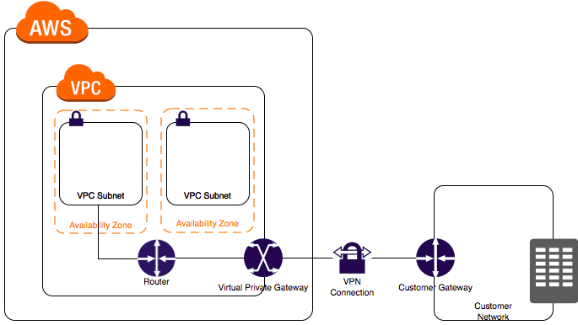

|  |
| --- |
| **A company is using a managed VPN connection to connect with their on-premises data center. They would like to monitor when the vpn goes down. How can they implement the monitoring?Using tunnel state cloud metrics** |
| **escription** |
| TunnelState | The state of the tunnel. 0 indicates DOWN and 1 indicates UP. |
| Amazon VPC offers you the flexibility to fully manage both sides of your Amazon VPC connectivity by creating a VPN connection between your remote network and a software VPN appliance running in your Amazon VPC network. This option is recommended if you must manage both ends of the VPN connection either for compliance purposes or for leveraging gateway devices that are not currently supported by Amazon VPC’s VPN solution.  https://docs.aws.amazon.com/whitepapers/latest/aws-vpc-connectivity-options/images/software-vpn.png  You can create an IPsec VPN connection between your VPC and your remote network. On the AWS side of the VPN connection, a *virtual private gateway* provides two VPN endpoints (tunnels) for automatic failover. You configure your *customer gateway* on the remote side of the VPN connection. If you have more than one remote network (for example, multiple branch offices), you can create multiple AWS managed VPN connections via your virtual private gateway to enable communication between these networks.  With AWS Site-to-Site VPN, you can connect to an Amazon VPC in the cloud the same way you connect to your branches. AWS Site-to-Site VPN establishes secure and private sessions with IP Security (IPSec) and Transport Layer Security (TLS) tunnels.  Hence, the correct answer is Option 2 since one of the main advantages of having a VPN connection is that you will be able to connect your Amazon VPC to other remote networks securely. |  |

**Direct Connect**

Direct Connect makes it easy to establish a dedicated network connection from your premises to AWS.AWS Direct Connect does not involve the Internet; instead, it uses dedicated, private network connections.

* Benefits:
  + Useful for high throughput workloads (i.e. lots of network traffic)
  + Or if you want to establish a stable and reliable network connection.
  + Provides a more consistent network experience than Internet-based applications.
* To connect to your on-premise servers via Direct Connect:
  + By default, there is no route connecting your VPC back to the on premise data center.
  + Edit the VPC subnet route table, adding a route back to the on-premise datacenter.
* Enable route propagation on your Virtual Private Gateway (VPG) provides Virtual Interfaces
  + **Private VIF** to access instances within an VPC via VGW
  + **Public VIF** to access non VPC services
* **requires time to setup** probably months, and should not be considered as an option if turnaround time is less
* **does not provide redundancy**, use either second direct connection or IPSec VPN connection
* Virtual Private Gateway is on the AWS side and Customer Gateway is on the Customer side
* **route propagation is enabled on VGW** and not on CGW

**You are reviewing an existing VPN between a data center and an AWS VPC. Your client has asked you to suggest any HA improvements; the system must be able to tolerate the failure of an AWS AZ and a customer internet connection or router. Currently, the system includes:**

* **One VPC**
* **One business location with two internet connections — each with a router**
* **One VPN connection using one virtual private gateway and two IPSec tunnels to one of the customer routers** Which option below is the most appropriate and correct?

A Add an additional virtual private gateway to the VPC.

B Move one of the IPSec tunnels to the other customer router.

C Add another VPN connection to the second CGW.

D Take no action — the system meets the HA requirements with no changes.

**Correct Answer: C**This will add an additional two IPSec tunnels between the VGW and the second CGW. This will tolerate the failure of one customer connection and one AWS AZ because the VGW is already HA across multiple AZs.

**Direct Connect vs VPN IPSec**

* Expensive to Setup and Takes time vs Cheap & Immediate
* Dedicated private connections vs Internet
* Reduced data transfer rate vs Internet data transfer cost
* Consistent performance vs Internet inherent variability
* Do not provide Redundancy vs Provides Redundancy

**Networking & Content Delivery**

**Routing**

**DNS**

* + Converts a hostname ([www.example.com](http://www.example.com/)) into a computer-friendly IP address (192.168.1.1)
* The **DNS recursor** is a server designed to receive queries from client machines.
  + Makes a series of requests until it reaches the **authoritative DNS nameserver.**
  + Cached either locally inside the querying computer or remotely in the DNS infrastructure.
  + Examples include Google DNS, OpenDNS, and providers like Comcast.
* **Root nameserver responds** to the resolver with the address of a TLD server (such as .com or .net)
* Top Level Domain (TLD) nameserver stores the information for its domains.
  + **The TLD server** responds with the IP address of the domain’s nameserver ([example.com](http://example.com/))
  + The top-level domain (TLD) names (e.g. .com) are controlled by the Internet Assigned Numbers Authority (IANA) in a root zone database, which is essentially a database of all available TLD names.The database can be viewed under <https://www.iana.org/domains/root/db>
* **Authoritative nameserver** is a server that actually holds, and is responsible for, DNS resource records.This is the server at the bottom of the DNS lookup chain.
  + Can satisfy queries from its own data without needing to query another source.
  + **But requires an additional nameserver for serving queries for a subdomain (**[**blog.cloudflare.com**](http://blog.cloudflare.com/)**)**
* A registrar is an authority that can assign domain names under one or multiple TLDs.
  + This domains are registered with InterNIC, a service of ICANN, which enforces uniqueness of domain names across the Internet.
  + Each domain name becomes registered in a central database known as the WhoIS database.
  + For example, Amazon, [GoDaddy.com](http://godaddy.com/)

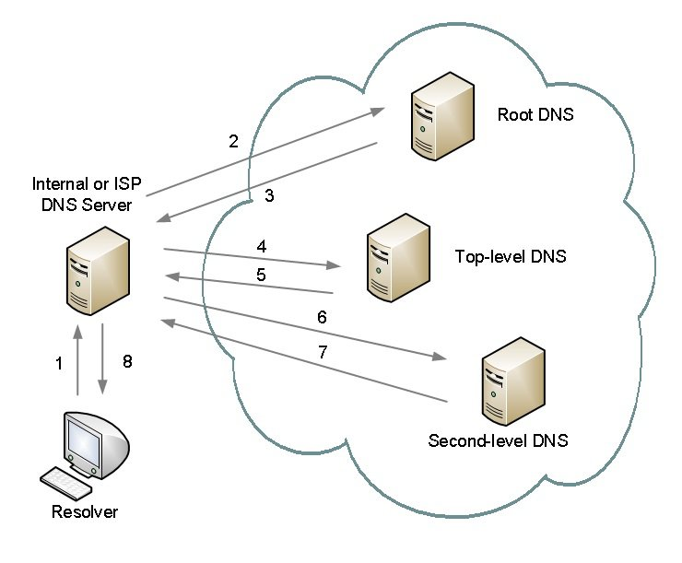

**Records**

* T**he State of Authority Record (SOA**) stores information about:
  + The name of the server that supplied the data for the zone.
  + The administrator of the zone.
  + The current version of the data file.
  + The default number of seconds for the TTL file on resource records.
  + When any record in the zone is updated, the SOA record serial number is incremented.
* The Name Server (NS) record is used for recursively resolving the required domain name.
  + Used to redirect the resolver to the DNS server hosting the next level domain.
* The record A specifies IP address (IPv4) for given host.
* The record AAAA (also quad-A record) specifies IPv6 address for given host.
* The Canonical Name (CNAME) record maps a name to another name.
  + Use a CNAME record if you want to alias one name to another name, and you don’t need other records (such as MX records for emails) for the same name.
  + Can be used to map two domain names to the same IP address.
  + Should only be used when there are no other records on that name.
* The ALIAS record maps a name to another name, but can coexist with other records on that name.
  + Use an ALIAS record if you’re trying to alias the root domain (apex zone), or if you need other records for the same name.
  + Given the choice, always choose an ALIAS record over a CNAME.
  + ALIAS records have special functions that are not present in other DNS servers. Their main function is to provide special functionality and integration into AWS services.
  + ALIAS records can also point to AWS resources that are hosted in other accounts.
* The MX record is used for emails.
* The PTR record is used to lookup the domain name of an IP address (also called reversed A record)
* The duration that the DNS record is cached (on Resolving Server or user PC) is TTL in seconds.
  + The default is 48 hours, that is, a DNS change may need 48 hours to fully propagate.

**Route 53**

* Route 53 is Amazon's DNS Service.Route 53 is named so because the DNS port is 53.Buy domain names directly with AWS.Can take up to 3 days to register.There is a default limit of 50 domain names. However, this limit can be increased by contacting the AWS support.
* **Health checks:You can set health checks on individual record sets.If a record set fails a health check, it will be removed until it passes the check.You can also set up SNS notifications to be notified about any failed health checks.**

**You are setting up the cloud architecture for an international money transfer service to be deployed in AWS which will have thousands of users around the globe. The service should be available 24/7 to avoid any business disruption and should be resilient enough to handle the outage of an entire AWS region. To meet this requirement, you have deployed your AWS resources to multiple AWS Regions. You need to use Route 53 and configure it to set all of your resources to be available all the time as much as possible. When a resource becomes unavailable, your Route 53 should detect that it's unhealthy and stop including it when responding to queries.   Which of the following is the most fault tolerant routing configuration that you should use in this scenario?**

* ​Configure an Active-Active Failover with Weighted routing policy.
* ​Configure an Active-Passive Failover with Weighted Records.
* ​Configure an Active-Active Failover with One Primary and One Secondary Resource.
* ​Configure an Active-Passive Failover with Multiple Primary and Secondary Resources.

**Explanation**

You can use Route 53 health checking to configure active-active and active-passive failover configurations. You configure active-active failover using any routing policy (or combination of routing policies) other than failover, and you configure active-passive failover using the failover routing policy.

**Active-Active Failover**

Use this failover configuration when you want all of your resources to be available the majority of the time. When a resource becomes unavailable, Route 53 can detect that it's unhealthy and stop including it when responding to queries.

In active-active failover, all the records that have the same name, the same type (such as A or AAAA), and the same routing policy (such as weighted or latency) are active unless Route 53 considers them unhealthy. Route 53 can respond to a DNS query using any healthy record.

**Active-Passive Failover**

Use an active-passive failover configuration when you want a primary resource or group of resources to be available the majority of the time and you want a secondary resource or group of resources to be on standby in case all the primary resources become unavailable. When responding to queries, Route 53 includes only the healthy primary resources. If all the primary resources are unhealthy, Route 53 begins to include only the healthy secondary resources in response to DNS queries.

Options 2 and 4 are incorrect because an Active-Passive Failover is mainly used when you want a primary resource or group of resources to be available most of the time and you want a secondary resource or group of resources to be on standby in case all the primary resources become unavailable. In this scenario, all of your resources should be available all the time as much as possible which is why you have to use an Active-Active Failover instead.

Option 3 is incorrect because you cannot set up an Active-Active Failover with One Primary and One Secondary Resource. Remember that an Active-Active Failover uses all available resources all the time without a primary nor a secondary resource.

**You are an IT Consultant for an advertising company that is currently working on a proof of concept project that automatically provides SEO analytics for their clients. Your company has a VPC in AWS that operates in dual-stack mode in which IPv4 and IPv6 communication is allowed. You deployed the application to an Auto Scaling group of EC2 instances with an Application Load Balancer in front that evenly distributes the incoming traffic. You are ready to go live but you need to point your domain name (tutorialsdojo.com) to the Application Load Balancer.  In Route 53, which record types will you use to point the DNS name of the Application Load Balancer? (Choose 2)**

* ​Non-Alias with a type "A" record set



* ​Alias with a type "AAAA" record set



* ​Alias with a type "CNAME" record set



* ​Alias with a type "A" record set**)**



* ​Alias with a type of “MX” record set



**Explanation**

Options 2 and 4 are correct. To route domain traffic to an ELB load balancer, use Amazon Route 53 to create an alias record that points to your load balancer. An alias record is a Route 53 extension to DNS. It's similar to a CNAME record, but you can create an alias record both for the root domain, such as tutorialsdojo.com, and for subdomains, such as portal.tutorialsdojo.com. (You can create CNAME records only for subdomains.) To enable IPv6 resolution, you would need to create a second resource record, tutorialsdojo.com ALIAS AAAA -> myelb.us-west-2.elb.amazonnaws.com, this is assuming your Elastic Load Balancer has IPv6 support.

Option 1 is incorrect because you only use Non-Alias with a type “A” record set for IP addresses.

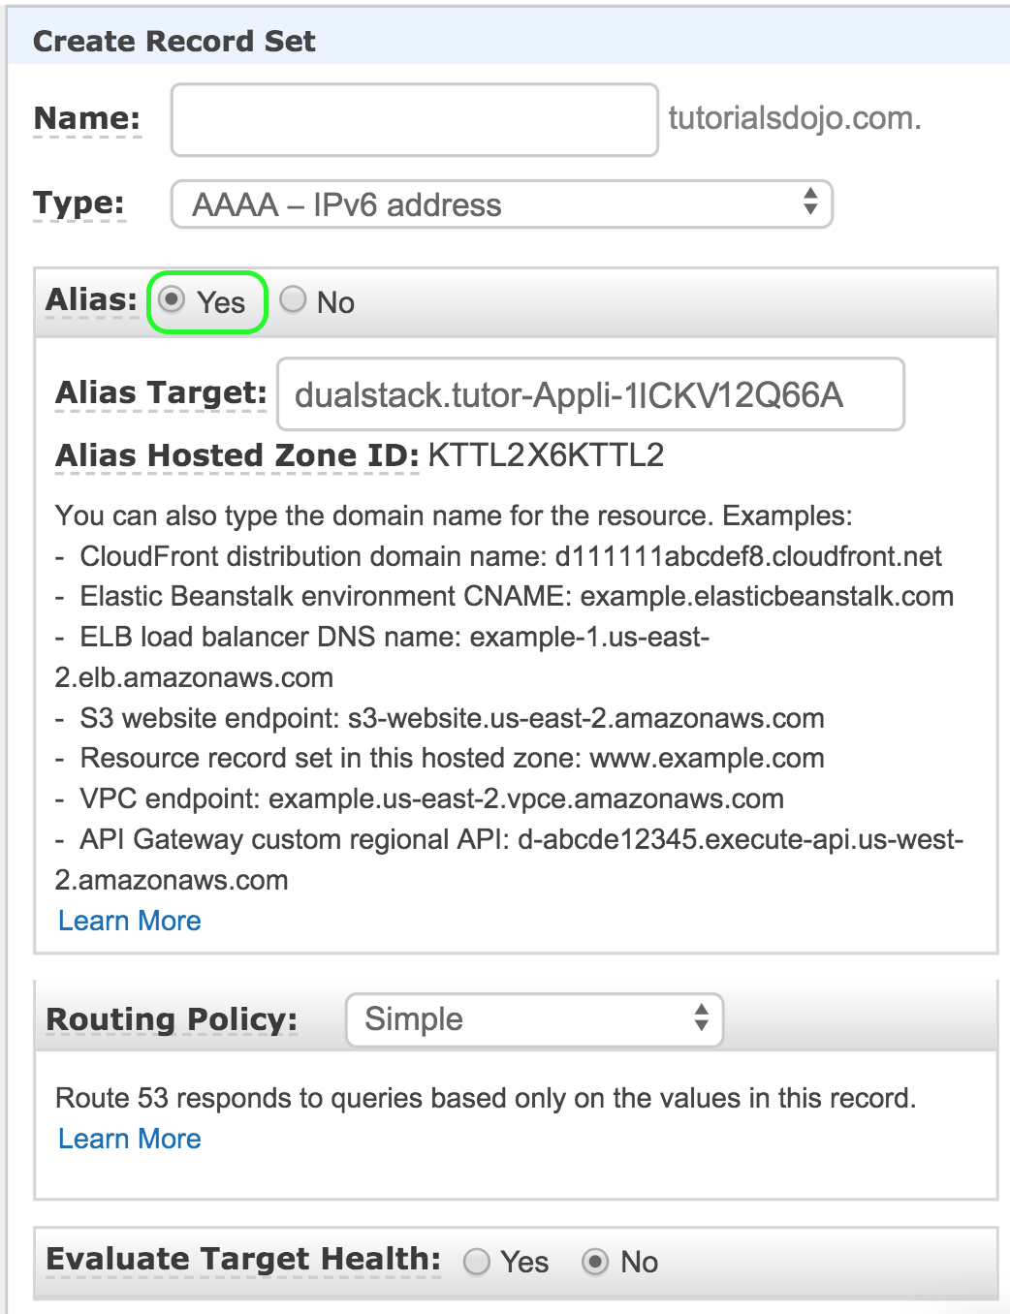

Option 3 is incorrect because you can't create a CNAME record at the zone apex. For example, if you register the DNS name tutorialsdojo.com, the zone apex is tutorialsdojo.com.

Option 5 is incorrect because an MX record is primarily used for mail servers. It includes a priority number and a domain name, for example: 10 mailserver.tutorialsdojo.com.

**You have a cryptocurrency exchange portal which is hosted in an Auto Scaling group of EC2 instances behind an Application Load Balancer, and are deployed across multiple AWS regions. Your users can be found all around the globe, but the majority are from Japan and Sweden. Because of the compliance requirements in these two locations, you want your Japanese users to connect to the servers in the ap-northeast-1 Asia Pacific (Tokyo) region, while your Swedish users should be connected to the servers in the eu-west-1 EU (Ireland) region.**

**Which of the following services would allow you to easily fulfill this requirement?**

* ​Use Route 53 Geolocation Routing policy.



* ​Set up an Application Load Balancers that will automatically route the traffic to the proper AWS region.



* ​Set up a new CloudFront web distribution with the geo-restriction feature enabled.



* ​Use Route 53 Weighted Routing policy.



**Explanation**

Geolocation routing lets you choose the resources that serve your traffic based on the geographic location of your users, meaning the location that DNS queries originate from. For example, you might want all queries from Europe to be routed to an ELB load balancer in the Frankfurt region.

When you use geolocation routing, you can localize your content and present some or all of your website in the language of your users. You can also use geolocation routing to restrict distribution of content to only the locations in which you have distribution rights. Another possible use is for balancing load across endpoints in a predictable, easy-to-manage way, so that each user location is consistently routed to the same endpoint.

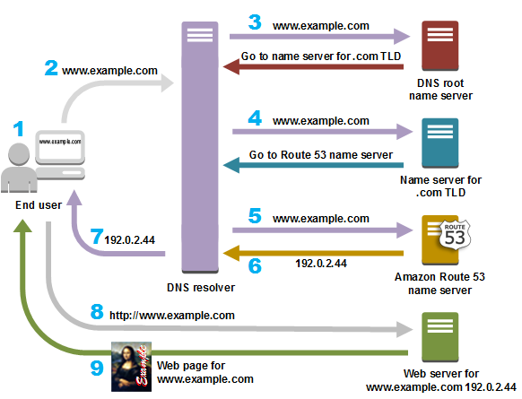

Option 2 is incorrect because Elastic Load Balancers distribute traffic among EC2 instances across multiple Availability Zones but not across AWS regions.

Option 3 is incorrect because the CloudFront geo-restriction feature is primarily used to prevent users in specific geographic locations from accessing content that you're distributing through a CloudFront web distribution. It does not let you choose the resources that serve your traffic based on the geographic location of your users, unlike the Geolocation routing policy in Route 53.

Option 4 is incorrect because the Route 53 Weighted Routing policy is not a suitable solution to meet the requirements of this scenario. It just lets you associate multiple resources with a single domain name (tutorialsdojo.com) or subdomain name (forums.tutorialsdojo.com) and choose how much traffic is routed to each resource. You have to use a Geolocation routing policy instead.

* Failover configurations:
  + Use **active-active failover configuration** when you want all of resources to be available the majority of the time. You configure active-active failover using **any routing policy**.
  + Use **active-passive failover configuration** when you want a secondary resource or group of resources to be on standby in case all the primary resources become unavailable. You configure active-passive failover using the **failover routing policy**.
* Route 53 has a security feature that prevents internal DNS from being read by external sources.The work around is to create a EC2 hosted DNS instance that does zone transfers from the internal DNS, and allows itself to be queried by external servers.
* Prerequisites for [routing traffic to a website that is hosted in an Amazon S3 Bucket](https://docs.aws.amazon.com/Route53/latest/DeveloperGuide/RoutingToS3Bucket.html):
  + An S3 bucket that is configured to host a static website.The bucket must have the same name as your domain or subdomain.A registered domain name.Route 53 as the DNS service for the domain.
* 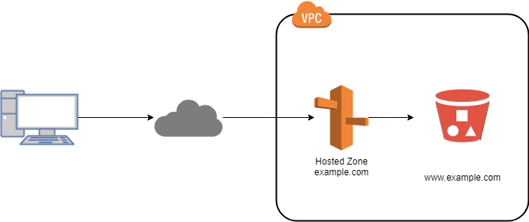 A: A: URL to IPv4
* AAAA: URL to IPv6
* CNAME: URL to URL
* ALIAS: URL to AWS resource

Route 53 can use:

* Public domain names you own
* Private domain names that can be resolved by your instances in your VPCs

**Routing policies**

* **Simple routing:**One record with multiple IP addresses.If multiple values are specified, Route 53 returns them in random order.For example, the user can be redirected to Ohio and the next time to Sydney (after TTL expires)Cannot be associated with health check
* **Weighted routing:**Allows you to split your traffic based on different weights assigned.
  + For example, you can set 10% of traffic to go to US-EAST-1 and 90% to EU-WEST-1.
* **Latency-based routing**:Routes traffic based on the lowest network latency for the end user.To use it, create a latency RRset for the AWS resource in each region it is hosted.
  + Use VPN clients (such as NordVPN) to test the service.**Latency based routing will approximate geographic balance only when all routes and traffic evenly supported which is rarely the case due to infrastructure and day night variations**.
* **Failover routing:**Used when you want to create an active/passive setup.example, when your primary server is in US-EAST-1 and secondary in EU-WEST-1.Route 53 will monitor the health of the primary server using a health check.[Configuring DNS Failover](https://docs.aws.amazon.com/Route53/latest/DeveloperGuide/dns-failover.html)
* **Geolocation routing:**Routes traffic based on the geolocation of the end user (national boundaries)For example, route all queries from Europe to a fleet of EC2 instances in EU-WEST-1. These servers may have the local language of European customers and all price are displayed in Euros.Not to be confused with latency-based routing.
* **Geoproximity routing (traffic flow only):**Routes traffic based on the geolocation of the end user and resource (latitude & longitude)You can also specify to route more traffic or less to a given resource by specifying a value (bias)A bias expands or shrinks the size of the geographic region from which traffic is routed.

To use it, you must use Route 53 traffic flow.

* **Multivalue Answer routing**:Lets configure Route 53 to return multiple IP addresses in response to DNS queries.Compared to simple routing, allows health checks and returns only values for healthy resources. The choice of which to use is left to the requesting service effectively creating a form or randomization

Route53 has advanced features such as:

* Load balancing (through DNS - also called client load balancing)
* Health checks (although limited…)
* Routing policy: simple, failover, geolocation, geoproximity, latency, weighted

Prefer Alias over CNAME for AWS resources (for performance reasons)

* 53 is the port of DNS
* Create and Manage Public DNS records
* You can purchase domain names via Route 53
* You can transfer a domain name to Route 53
* Each zone has it's own virtual DNS servers
* Access is controlled via IAM
* Activation can take up to 24 hours
* Route 53 has a SLA
* Route 53 uses a anycast network
* Route 53 is limited to 500 hosted zones and 10,000 resources per hosted zone
* Route 53 CAN import zone files
* Route 53 DOES NOT provide website hosting
* Record Types
  + A, AAAA ,CNAME ,MX,NAPTR,NS,PTR,SOA,SPF,SRV,TXT,ALIAS
* **Route 53 supports wild card entries for all record types**
* Record types do NOT have a default TTL - you must specify when configuring
* You can use an Alias record type to map a sub domain (test.domain.com) to an ELB, CloudFront or S3
* Changes to a resource record is transactional. All or nothing
* DNS Changes should propagate within 60 seconds to AWS networks around the world.
* **CloudTrail can monitor Route 53 changes**
* DNSSEC is NOT supported by Route 53 right now
* Route 53 DOES support IPv6
* **Zone Apex** can point to an ELB, CloudFront, Elastic Beanstalk, and S3 via the Alias record type

Supports **multi-region and backup architectures for High availability. ELB , limited to region, does not support multi region HA architecture**supports private Intranet facing DNS servic

**internal resource record sets only work for requests originating from within the VPC** and currently cannot extend to on-premise

Global propagation of any changes made to the DN records within ~ 1min

**Route 53 to create an**[**alias resource record set**](http://docs.aws.amazon.com/Route53/latest/DeveloperGuide/resource-record-sets-choosing-alias-non-alias.html)**that points to ELB, S3, CloudFront. An alias resource record set is a Route 53 extension to DNS. It’s similar to a CNAME resource record set, but supports both for root domain – zone apex  e.g. example.com, and for subdomains for e.g. www.example.com.**

**CNAME resource record sets can be created only for subdomains and cannot be mapped to the zone apex record**

Route 53 **Split-view (Split-horizon)** DNS enables you to access an internal version of your website using the same domain name that is used publicly

Weighted, Latency and Geolocation can be used for Active-Active while Failover routing can be used for Active-Passive multi region architecture

**A client is hosting their company website on a cluster of web servers that are behind a public-facing load balancer. The client also uses Amazon Route 53 to manage their public DNS.**

**How should the client configure the DNS zone apex record to point to the load balancer?**

* ​Create an A record pointing to the IP address of the load balancer.
* ​Create a CNAME record pointing to the load balancer DNS name.
* ​Create an alias for CNAME record to the load balancer DNS name.
* ​Create an A record aliased to the load balancer DNS name.

**(Correct)**

**Explanation**

Route 53's DNS implementation connects user requests to infrastructure running inside (and outside) of Amazon Web Services (AWS). For example, if you have multiple web servers running on EC2 instances behind an Elastic Load Balancing load balancer, Route 53 will route all traffic addressed to your website (e.g. www.tutorialsdojo.com) to the load balancer DNS name (e.g. elbtutorialsdojo123.elb.amazonaws.com).

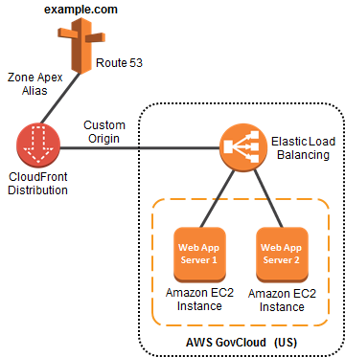

Additionally, Route 53 supports the alias resource record set, which lets you map your **zone apex (**e.g. tutorialsdojo.com) DNS name to your load balancer DNS name. IP addresses associated with Elastic Load Balancing can change at any time due to scaling or software updates. Route 53 responds to each request for an Alias resource record set with one IP address for the load balancer.

Option 1 is incorrect. You should be using an Alias record pointing to the DNS name of the load balancer since the IP address of the load balancer can change at any time.

Option 2 and 3 are incorrect because CNAME records cannot be created for your **zone** apex. You should create an alias record at the top node of a DNS namespace which is also known as the *zone apex*. For example, if you register the DNS name tutorialsdojo.com, the zone apex is tutorialsdojo.com. You can't create a CNAME record directly for tutorialsdojo.com, but you can create an alias record for tutorialsdojo.com that routes traffic to **www**.tutorialsdojo.com.

**Management & Governance**

**Monitoring**

**1)CloudWatch**Amazon CloudWatch is a monitoring service for AWS resources and applications.

* + CloudWatch can monitor most of the AWS.
* Dashboards:Creates dashboards to see what is happing in the AWS environment.
  + Can be global or regional.
* **Alarms:Set alarms to notify you when particular thresholds have been hit.**
* **Events:Helps you to respond to state changes in AWS resources.**
* **Logs:Helps you to aggregate, monitor and store logs.**
* **Available metrics:CPU Utilization Network Utilization Disk Reads**
* **Custom metrics:** using CloudWatch Monitoring Scripts (shell, Perl, etc.)
  + You can also install CloudWatch Agent to collect more system-level metrics (Linux and Windows)Custom metrics include Memory utilization, Disk swap utilization, Disk space utilization, Page file utilization, Log collection.
  + [Monitoring Memory and Disk Metrics for Amazon EC2 Linux Instances](https://docs.aws.amazon.com/AWSEC2/latest/UserGuide/mon-scripts.html#using_put_script)
  + [CloudWatch Agent vs SSM Agent vs Custom Daemon Scripts](https://tutorialsdojo.com/aws-cheat-sheet-cloudwatch-agent-vs-ssm-agent-vs-custom-daemon-scripts/)???????
* Watching compute instances:
  + Host level checks metrics include CPU, network, disk and status check.
  + Standard monitoring = 5 minutes (default)
  + Detailed monitoring = 1 minute (additional costs may apply)
  + Allows creating performance alarms that trigger notifications.
* You need to prepare a custom metric using CloudWatch Monitoring Scripts which is written in Perl. You can also install CloudWatch Agent to collect more system-level metrics from Amazon EC2 instances. Here's the list of custom metrics that you can set up:
* - Memory utilization  
  - Disk swap utilization  
  - Disk space utilization  
  - Page file utilization  
  - Log collection
* Take note that there is a multi-platform CloudWatch agent which can be installed on both Linux and Windows-based instances. You can use a single agent to collect both system metrics and log files from Amazon EC2 instances and on-premises servers. This agent supports both Windows Server and Linux and enables you to select the metrics to be collected, including sub-resource metrics such as per-CPU core. It is recommended that you use the new agent instead of the older monitoring scripts to collect metrics and logs.

**An online cryptocurrency exchange platform is hosted in AWS which uses ECS Cluster and RDS in Multi-AZ Deployments configuration. The application is heavily using the RDS instance to process complex read and write database operations. To maintain the reliability, availability, and performance of your systems, you have to closely monitor how the different processes or threads on a DB instance use the CPU, including the percentage of the CPU bandwidth and total memory consumed by each process.**

**Which of the following is the most suitable solution to properly monitor your database?**

* ​Use Amazon CloudWatch to monitor the CPU Utilization of your database.



* ​Create a script that collects and publishes custom metrics to CloudWatch, which tracks the real-time CPU Utilization of the RDS instance, and then set up a custom CloudWatch dashboard to view the metrics.



* ​Enable Enhanced Monitoring in RDS.



* ​Check the CPU% and MEM% metrics which are readily available in the Amazon RDS console that shows the percentage of the CPU bandwidth and total memory consumed by each database process of your RDS instance.



**Explanation**

Amazon RDS provides metrics in real time for the operating system (OS) that your DB instance runs on. You can view the metrics for your DB instance using the console, or consume the Enhanced Monitoring JSON output from CloudWatch Logs in a monitoring system of your choice. By default, Enhanced Monitoring metrics are stored in the CloudWatch Logs for 30 days. To modify the amount of time the metrics are stored in the CloudWatch Logs, change the retention for the RDSOSMetrics log group in the CloudWatch console.

Take note that there are certain differences between CloudWatch and Enhanced Monitoring Metrics.  CloudWatch gathers metrics about CPU utilization from the hypervisor for a DB instance, and Enhanced Monitoring gathers its metrics from an agent on the instance. As a result, you might find differences between the measurements, because the hypervisor layer performs a small amount of work. Hence, Option 3 is the correct answer in this specific scenario.

The differences can be greater if your DB instances use smaller instance classes, because then there are likely more virtual machines (VMs) that are managed by the hypervisor layer on a single physical instance. Enhanced Monitoring metrics are useful when you want to see how different processes or threads on a DB instance use the CPU.

* Compared to AWS CloudTrail:CloudTrail monitors AWS Management Console actions and API calls.CloudTrail records users who called AWS services, their IP addresses, and timestamps.
  + CloudWatch is used for monitoring performance, while CloudTrail is used for auditing.
  + CloudWatch will only cover the activities of the regional services.
* **does not aggregate data across regions**
* **stores the log data indefinitely**, and the retention can be changed for each log group at any time
* **alarm history is stored for only 14 days**
* can be used an **alternative to S3 to store logs** with the ability to configure Alarms and generate metrics, however logs **cannot be made public**
* **Alarms exist only in the created region and the Alarm actions must reside in the same region as well**
  + Using Amazon CloudWatch alarm actions, [you can create alarms](https://docs.aws.amazon.com/AmazonCloudWatch/latest/monitoring/UsingAlarmActions.html) that automatically stop, terminate, reboot, or recover your EC2 instances.
* AWS can see the instance, but not inside the instance to what it is doing.

|  |  |  |
| --- | --- | --- |
| Memory utilization, disk swap utilization, disk space utilization, page file utilization, log collection |  | [Linux and Windows Server instances] [Collect Metrics and Logs from Amazon EC2 Instances and On-Premises Servers with the CloudWatch Agent](http://docs.aws.amazon.com/AmazonCloudWatch/latest/monitoring/Install-CloudWatch-Agent.html)  [Migration from previous CloudWatch Logs agent on Windows Server instances] [Migrate Windows Server Instance Log Collection to the CloudWatch Agent](http://docs.aws.amazon.com/systems-manager/latest/userguide/monitoring-cloudwatch-agent.html#monitoring-cloudwatch-agent-migrate) |

**Kinesis**

Streaming data is data that is generated continuously by many data sources, which typically send in the data records simultaneously, and in small sizes (order of KB)

* + For example, purchases of an online store, stock prices and game data.
* Amazon Kinesis is a platform on AWS to send your streaming data to.

**The AWS Kinesis Platform offers four services: Kinesis Video Streams (which can capture, process, and store live media data), Kinesis Data Streams (which can capture, process, and store real-time data), Kinesis Data Firehose (which can load real-time data streams into data storage), and Kinesis Data Analytics (which can analyze real-time data with SQL).**  **Types**

* **Kinesis Data Streams:**
  + A massively scalable and durable real-time data streaming service. KDS can continuously capture gigabytes of data per second from hundreds of thousands of sources such as website clickstreams, database event streams, financial transactions, social media feeds, IT logs, and location-tracking events. The data collected is available in milliseconds to enable real-time analytics use cases such as real-time dashboards, real-time anomaly detection, dynamic pricing, and more.**.Data is stored in shards that are then processed by consumers (EC2 instances)** provides ordering of records, as well as the ability to read and/or replay records in the same order to multiple Kinesis applications Data encryption can be supported either using client side encryption before pushing the data to data streams or server side encryption.
  + Per shard, allows 5 transactions per second for reads, up to a maximum total data read rate of 2 MB per second and up to 1000 records per second for writes, up to a maximum total data write rate of 1 MB per second (including partition keys)
  + Persistently stores streaming data for 24 hours and up to 7 days.
  + The data capacity of your stream is the sum of the capacities of its shards.

**Producer & Consumers**

* API PutRecord and PutRecords are **synchronous**, while KPL producer supports synchronous or **asynchronous** use cases
* KCL uses a unique DynamoDB table to keep track of the application’s state, so if Kinesis Data Streams application receives provisioned-throughput exceptions, increase the provisioned throughput for the DynamoDB table

**A company’s website receives 50,000 requests each second, and the company wants to use multiple applications to analyze the navigation patterns of the users on their website so that the experience can be personalized. What can a Solutions Architect use to collect page clicks for the website and process them sequentially for each user?**

* A. Amazon Kinesis Stream**(Correct)**
* ​B. Amazon SQS standard queue
* ​C. Amazon SQS FIFO queue**(Incorrect)**
* ​D. AWS CloudTrail trail

Correct answer is **A**as Kinesis streams provides ability to consume massive data and process sequentially.

**A Solutions Architect designed a real-time data analytics system based on Kinesis Data Stream and Lambda. A week after the system has been deployed, the users noticed that it performed slowly as the data rate increases. The Architect identified that the performance of the Kinesis Data Streams is causing this problem.**

**Which of the following should the Architect do to improve performance?**

* ​Increase the number of shards of the Kinesis stream by using the UpdateShardCount command.​

Replace the data stream with Amazon Kinesis Data Firehose instead.

* ​Improve the performance of the stream by decreasing the number of its shards using the MergeShard command.
* ​Implement Step Scaling to the Kinesis Data Stream.

**Explanation**

Amazon Kinesis Data Streams supports *resharding*, which lets you adjust the number of shards in your stream to adapt to changes in the rate of data flow through the stream. Resharding is considered an advanced operation.

There are two types of resharding operations: shard split and shard merge. In a shard split, you divide a single shard into two shards. In a shard merge, you combine two shards into a single shard. Resharding is always *pairwise* in the sense that you cannot split into more than two shards in a single operation, and you cannot merge more than two shards in a single operation. The shard or pair of shards that the resharding operation acts on are referred to as *parent* shards. The shard or pair of shards that result from the resharding operation are referred to as *child*shards.

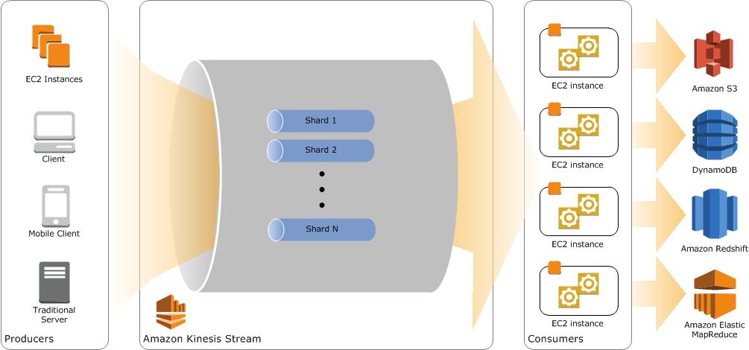

Splitting increases the number of shards in your stream and therefore increases the data capacity of the stream. Because you are charged on a per-shard basis, splitting increases the cost of your stream. Similarly, merging reduces the number of shards in your stream and therefore decreases the data capacity—and cost—of the stream.

If your data rate increases, you can also increase the number of shards allocated to your stream to maintain the application performance. You can reshard your stream using the **UpdateShardCount** API. The throughput of an Amazon Kinesis data stream is designed to scale without limits via increasing the number of shards within a data stream. Hence, the correct answer is Option 1.

Option 2 is incorrect because the throughput of Kinesis Firehose is not exceptionally higher than Kinesis Data Streams. In fact, the throughput of an Amazon Kinesis data stream is designed to scale **without** limits via increasing the number of shards within a data stream.

Option 3 is incorrect because merging the shards will effectively decrease the performance of the stream rather than improve it.

Option 4 is incorrect because there is no Step Scaling feature for Kinesis Data Streams. This is only applicable for EC2.

**You have a data analytics application that updates a real-time, foreign exchange dashboard and another separate application that archives data to Amazon Redshift. Both applications are configured to consume data from the same stream concurrently and independently by using Amazon Kinesis Data Streams. However, you noticed that there are a lot of occurrences where a shard iterator expires unexpectedly. Upon checking, you found out that the DynamoDB table used by Kinesis does not have enough capacity to store the lease data.**

**Which of the following is the most suitable solution to rectify this issue?**

* ​Increase the write capacity assigned to the shard table.
* ​Upgrade the storage capacity of the DynamoDB table.
* ​Enable In-Memory Acceleration with DynamoDB Accelerator (DAX).
* ​Use Amazon Kinesis Data Analytics to properly support the data analytics application instead of Kinesis Data Stream.

**Explanation**

A new shard iterator is returned by every **GetRecords** request (as NextShardIterator), which you then use in the next **GetRecords** request (as ShardIterator). Typically, this shard iterator does not expire before you use it. However, you may find that shard iterators expire because you have not called **GetRecords** for more than 5 minutes, or because you've performed a restart of your consumer application.

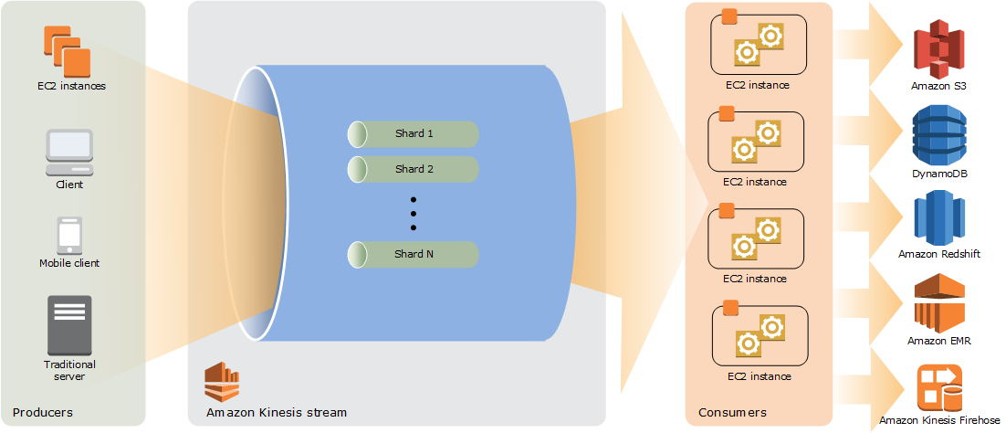

If the shard iterator expires immediately before you can use it, this might indicate that the DynamoDB table used by Kinesis does not have enough capacity to store the lease data. This situation is more likely to happen if you have a large number of shards. To solve this problem, increase the write capacity assigned to the shard table. Hence, Option 1 is correct.

Option 2 is incorrect because DynamoDB is a fully managed service which automatically scales its storage, without setting it up manually. The scenario refers to the **write capacity** of the shard table when it says that the DynamoDB table used by Kinesis does not have enough *capacity* to store the lease data.

Option 3 is incorrect because the DAX feature is primarily used for read performance improvement of your DynamoDB table from *milliseconds* response time to *microseconds*. It does not have any relationship with Amazon Kinesis Data Stream in this scenario.

Option 4 is incorrect because although Amazon Kinesis Data Analytics can support a data analytics application, it is still not a suitable solution for this issue. You simply need to increase the write capacity assigned to the shard table in order to rectify the problem which is why switching to Amazon Kinesis Data Analytics is not necessary.

Q: How does Amazon Kinesis Data Streams differ from Amazon SQS?

Amazon Kinesis Data Streams enables real-time processing of streaming big data. It provides ordering of records, as well as the ability to read and/or replay records in the same order to multiple Amazon Kinesis Applications. The Amazon Kinesis Client Library (KCL) delivers all records for a given partition key to the same record processor, making it easier to build multiple applications reading from the same Amazon Kinesis data stream (for example, to perform counting, aggregation, and filtering).

Option B is wrong as SQS standard queue does not guarantee order.

Option C is wrong as SQS FIFO, although provides order, the message cannot be consumed at a high rate. FIFO queues support up to 300 messages per second and 3000 with batching.

Option D is wrong as CloudTrail is for governance and auditing.

* **Kinesis Data Firehose:**The easiest way to reliably load streaming data into data lakes, data stores and analytics tools.
  + A fully managed service that automatically scales to match the throughput.
  + Can capture, transform, and load streaming data into S3, Redshift, Elasticsearch, and Splunk.

* + Can also batch, compress, transform, and encrypt the data before loading it.
  + With Kinesis Data Firehose, you don't need to write applications or manage resources. You configure your data producers to send data to Kinesis Data Firehose, and it automatically delivers the data to the destination that you specified. **You can also configure Kinesis Data Firehose to transform your data before delivering it.** 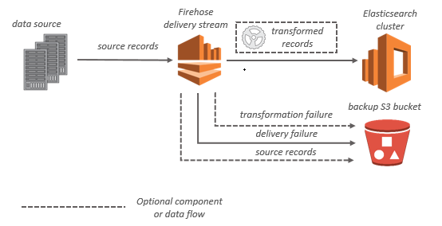
* is **NOT real time** (**min. 60 secs**) as it buffers incoming streaming data to a certain size or for a certain period of time before delivering it
* supports multiple producers as datasource, which include Kinesis data stream, Kinesis Agent, or the Kinesis Data Firehose API using the AWS SDK, CloudWatch Logs, CloudWatch Events, or AWS IoT
* supports out of box data transformation as well as custom transformation using Lambda function to transform incoming source data and deliver the transformed data to destinations
* supports interface VPC endpoint to keep traffic between the Amazon VPC and Kinesis Data Firehose from leaving the Amazon network.
* **Kinesis Data Analytics:**Enables you to build queries and sophisticated streaming applications with SQL or Java.Can use Data Streams or Data Firehose as an underlying streaming service.
* Kinesis Video Streams:
  + Makes it easy to securely stream video from connected devices to AWS.
* [Amazon Kinesis Cheat Sheet](https://tutorialsdojo.com/aws-cheat-sheet-amazon-kinesis/)

**You are working for a multinational telecommunications company. Your IT Manager is willing to consolidate their log streams including the access, application, and security logs in one single system. Once consolidated, the company wants to analyze these logs in real-time based on heuristics. There will be some time in the future where the company will need to validate heuristics, which requires going back to data samples extracted from the last 12 hours.**

**What is the best approach to meet this requirement?**

* ​First, set up an Auto Scaling group of EC2 servers then store the logs on Amazon S3 then finally, use EMR to apply heuristics on the logs.
* ​First, send all of the log events to Amazon Kinesis then afterwards, develop a client process to apply heuristics on the logs.
* ​First, configure Amazon Cloud Trail to receive custom logs and then use EMR to apply heuristics on the logs.
* ​First, send all the log events to Amazon SQS then set up an Auto Scaling group of EC2 servers to consume the logs and finally, apply the heuristics.

**Explanation**

In this scenario, you need a service that can collect, process, and analyze data in real-time hence, the right service to use here is Amazon Kinesis.

Amazon Kinesis makes it easy to collect, process, and analyze real-time, streaming data so you can get timely insights and react quickly to new information. Amazon Kinesis offers key capabilities to cost-effectively process streaming data at any scale, along with the flexibility to choose the tools that best suit the requirements of your application.

With Amazon Kinesis, you can ingest real-time data such as video, audio, application logs, website clickstreams, and IoT telemetry data for machine learning, analytics, and other applications. Amazon Kinesis enables you to process and analyze data as it arrives and respond instantly instead of having to wait until all your data is collected before the processing can begin.

**CloudTrail**AWS CloudTrail is a service that enables governance, compliance, operational auditing, and risk auditing of your AWS account.An event in CloudTrail is the record of an activity in an AWS account.

* + This activity can be an action taken by a user, role, or service that is monitorable by CloudTrail.Provides a history of both API and non-API account activity made through the AWS Management Console, AWS SDKs, command line tools, and other AWS services.
* A trail can be applied to all regions (default) or a single region.
  + Pass --is-multi-region-train when using CLI.
* Events are delivered to any trail that includes global services.
  + Pass --include-global-service-events when using CLI.
* [About Global Service Events](https://docs.aws.amazon.com/awscloudtrail/latest/userguide/cloudtrail-concepts.html#cloudtrail-concepts-global-service-events)
* can be **enabled per-region basis**, a region can include global services (like IAM, STS etc), is applicable to all the **supported services within that region**
* log files from different regions can be sent to the **same S3 bucket**
* can be integrated with SNS to notify logs availability, CloudWatch logs log group for notifications when specific API events occur
* call history enables **security analysis, resource change tracking, trouble shooting and compliance auditing**
* [Logging IAM and AWS STS API Calls with AWS CloudTrail](https://docs.aws.amazon.com/IAM/latest/UserGuide/cloudtrail-integration.html)
* By default, the log files delivered by CloudTrail to your bucket are encrypted by
* To determine whether a log file was modified, deleted, or unchanged after CloudTrail delivered it, you can use CloudTrail log file integrity validation. This feature is built using industry standard algorithms: SHA-256 for hashing and SHA-256 with RSA for digital signing. This makes it computationally infeasible to modify, delete or forge CloudTrail log files without detection. You can use the AWS CLI to validate the files in the location where CloudTrail delivered them.

CloudTrail provides event history of your AWS account activity, including actions taken through the AWS Management Console, AWS SDKs, command line tools, API calls, and other AWS services. This event history simplifies security analysis, resource change tracking, and troubleshooting.

**A Solutions Architect is working for a company which has multiple VPCs in various AWS regions. The Architect is assigned to set up a logging system which will track all of the changes made to their AWS resources in all regions, including the configurations made in IAM, CloudFront, AWS WAF, and Route 53. In order to pass the compliance requirements, the solution must ensure the security, integrity, and durability of the log data. It should also provide an event history of all API calls made in AWS Management Console and AWS CLI.**

**Which of the following solutions is the best fit for this scenario?**

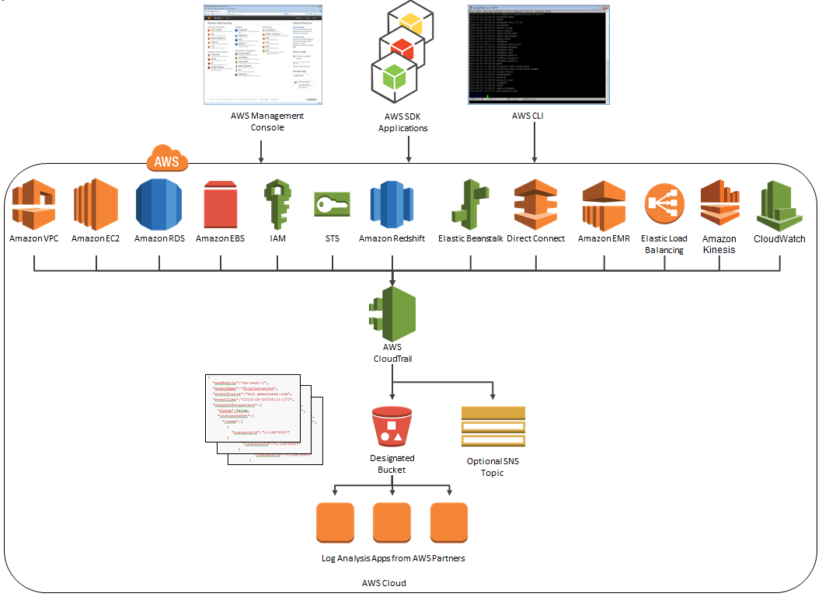

* ​Set up a new CloudTrail trail in a new S3 bucket using the AWS CLI and also pass both the --is-multi-region-trail and --include-global-service-events parameters then encrypt log files using KMS encryption. Apply Multi Factor Authentication (MFA) Delete on the S3 bucket and ensure that only authorized users can access the logs by configuring the bucket policies.



* ​Set up a new CloudWatch trail in a new S3 bucket using the AWS CLI and also pass both the --is-multi-region-trail and --include-global-service-events parameters then encrypt log files using KMS encryption. Apply Multi Factor Authentication (MFA) Delete on the S3 bucket and ensure that only authorized users can access the logs by configuring the bucket policies.



* ​Set up a new CloudWatch trail in a new S3 bucket using the CloudTrail console and also pass the --is-multi-region-trail parameter then encrypt log files using KMS encryption. Apply Multi Factor Authentication (MFA) Delete on the S3 bucket and ensure that only authorized users can access the logs by configuring the bucket policies.



* ​Set up a new CloudTrail trail in a new S3 bucket using the AWS CLI and also pass both the --is-multi-region-trail and --no-include-global-service-events parameters then encrypt log files using KMS encryption. Apply Multi Factor Authentication (MFA) Delete on the S3 bucket and ensure that only authorized users can access the logs by configuring the bucket policies.



**Explanation**

An event in CloudTrail is the record of an activity in an AWS account. This activity can be an action taken by a user, role, or service that is monitorable by CloudTrail. CloudTrail events provide a history of both API and non-API account activity made through the AWS Management Console, AWS SDKs, command line tools, and other AWS services. There are two types of events that can be logged in CloudTrail: management events and data events. By default, trails log management events, but not data events.

**You are working as a Solutions Architect for a leading technology company where you are instructed to troubleshoot the operational issues of your cloud architecture by logging the AWS API call history of your AWS resources. You need to quickly identify the most recent changes made to resources in your environment, including creation, modification, and deletion of AWS resources. One of the requirements is that the generated log files should be encrypted to avoid any security issues.**

**Which of the following is the most suitable approach to implement the encryption?**

* ​Use CloudTrail and configure the destination Amazon Glacier archive to use Server-Side Encryption (SSE).
* ​Use CloudTrail and configure the destination S3 bucket to use Server-Side Encryption (SSE).

**(Incorrect)**

* ​Use CloudTrail and ensure that the Server-Side Encryption (SSE) option is enabled for the trail in the CloudTrail console.
* ​Use CloudTrail with its default settings

**(Correct)**

**Explanation**

By default, CloudTrail event log files are encrypted using Amazon S3 server-side encryption (SSE). You can also choose to encrypt your log files with an AWS Key Management Service (AWS KMS) key. You can store your log files in your bucket for as long as you want. You can also define Amazon S3 lifecycle rules to archive or delete log files automatically. If you want notifications about log file delivery and validation, you can set up Amazon SNS notifications.

 Option 1 is incorrect because CloudTrail stores the log files to S3 and not in Glacier. Take note that by default, CloudTrail event log files are already encrypted using Amazon S3 server-side encryption (SSE).

Option 2 is incorrect because CloudTrail event log files are already encrypted using the Amazon S3 server-side encryption (SSE) which is why you do not have to do this anymore.

Option 3 is incorrect because there is no available Server-Side Encryption (SSE) option in the CloudTrail console.

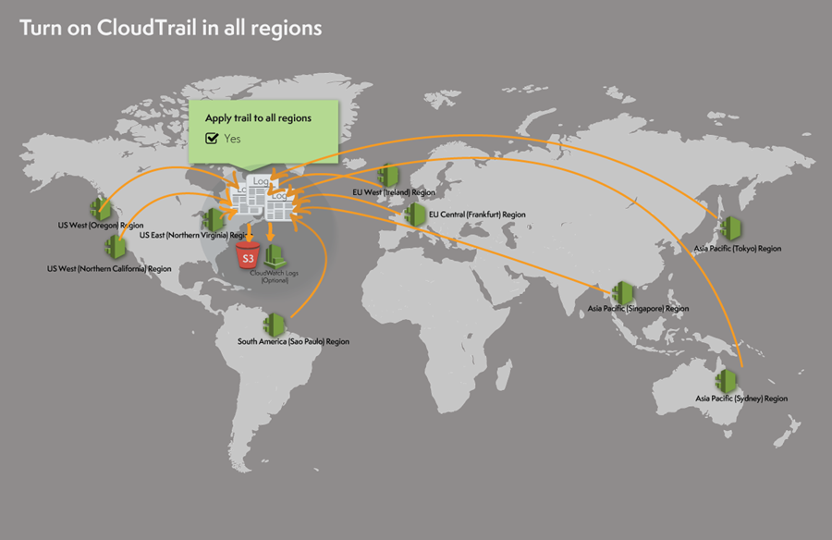

A trail can be applied to all regions or a single region. As a best practice, create a trail that applies to all regions in the AWS partition in which you are working. This is the default setting when you create a trail in the CloudTrail console.

For most services, events are recorded in the region where the action occurred. For global services such as AWS Identity and Access Management (IAM), AWS STS, Amazon CloudFront, and Route 53, events are delivered to any trail that includes global services, and are logged as occurring in US East (N. Virginia) Region.

In this scenario, the company requires a secure and durable logging solution that will track all of the activities of all AWS resources on all regions. CloudWatch can be used for this case with multi-region trail enabled. However, CloudWatch will only cover the activities of the regional services (EC2, S3, RDS etc.) and not for global services such as IAM, CloudFront, AWS WAF, and Route 53.

Option 1 is correct because it provides security, integrity, and durability to your log data and in addition, it has the -include-global-service-events parameter enabled which will also include activity from global services such as IAM, Route 53, AWS WAF, and CloudFront.

**Automation**

**CloudFormation**

* CloudFormation is a way of completely scripting using templates to create complex environments easily.
* Templatesections:*AWSTemplateFormatVersion*, *Description*, *Metadata*, *Parameters*, *Mappings*, *Conditions*, *Transform*, *Resources*, and *Outputs*.
* The formats JSON and YAML can be used to create CloudFormation templates.
* There is no additional charge for AWS CloudFormation.
  + You only pay for the AWS resources that are created.
* gives developers and systems administrators an easy way to create and manage a collection of related AWS resources
* Resources can be updated, deleted and modified in a **orderly, controlled and predictable fashion**, in effect applying **version control** to the AWS **infrastructure as code** done for software code
* CloudFormation **Template is an architectural diagram**, in JSON format, and **Stack is the end result of that diagram**, which is actually provisioned
* template can be used to set up the resources consistently and repeatedly over and over across multiple regions and consists of
  + List of AWS **resources** and their configuration values
  + An optional **template file format version number**
  + An optional list of **template parameters** (input values supplied at stack creation time)
  + An optional list of **output values** like public IP address using the Fn::GetAtt function
  + An optional list of **data tables** used to lookup static configuration values *for e.g., AMI names per AZ*
* **supports Chef & Puppet Integration** to deploy and configure right down the the application layer
* supports **Bootstrap scripts** to install packages, files and services on the EC2 instances by simple describing them in the CF template
* **automatic rollback on error** feature is enabled, by default, which will cause all the AWS resources that CF created successfully for a stack up to the point where an error occurred to be deleted
* provides a ***WaitCondition*** resource to block the creation of other resources until a completion signal is received from an external source
* allows **DeletionPolicy** attribute to be defined for resources in the **template**
  + **retain to preserve resources like S3 even after stack deletion**
  + **snapshot to backup resources like RDS after stack deletion**
* **DependsOn** attribute to specify that the creation of a specific resource follows another
* **Service role** is an IAM role that allows AWS CloudFormation to make calls to resources in a stack on the user’s behalf
* support **Nested stacks** that can separate out reusable, common components and create dedicated templates to mix and match different templates but use nested stacks to create a single, unified stack

**A new DevOps engineer has created a CloudFormation template for a web application and she raised a pull-request in GIT for you to check and review. After checking the template, you immediately told her that the template will not work.**

**Which of the following is the reason why this CloudFormation template will fail to deploy the stack?**

1. **{ "AWSTemplateFormatVersion":"2010-09-09",**
2. **"Parameters":{**
3. **"VPCId":{**
4. **"Type":"String",**
5. **"Description":"tutorialsdojo"**
6. **},**
7. **"SubnetId":{**
8. **"Type":"String",**
9. **"Description":"subnet-b46032ec"**
10. **}**
11. **},**
12. **"Outputs":{**
13. **"InstanceId":{**
14. **"Value":{**
15. **"Ref":"TutorialsDojoInstance"**
16. **}, "Description":"Instance Id"**
17. **}**
18. **}**
19. **}**

* ​

The value of the AWSTemplateFormatVersion is incorrect. It should be 2017-06-06.

* ​

The Resources section is missing.

**(Correct)**

* ​

An invalid section named Parameters is present. This will cause the CloudFormation stack to fail.

* ​

The Conditions section is missing.

**(Incorrect)**

#### Explanation

In CloudFormation, a template is a JSON or a YAML-formatted text file that describes your AWS infrastructure. Templates include several major sections. The Resources section is the only required section. Some sections in a template can be in any order. However, as you build your template, it might be helpful to use the logical ordering of the following list, as values in one section might refer to values from a previous section. Take note that all of the sections here are optional, except for Resources, which is the only one required.

* -Format Version
* -Description
* -Metadata
* -Parameters
* -Mappings
* -Conditions
* -Transform
* -Resources (required)
* -Outputs
* **OpsWorks**Automates deployment, configurations and operational tasks for distributed applications.Using Chef, customize stacks or use pre-built layer templates on Chef scripts called cookbooks. is a **configuration management service** that helps to configure and operate applications in a cloud enterprise by using **Chef**
* helps **deploy and monitor applications in stacks with multiple layers**
* supports preconfigured layers for Applications, Databases, Load Balancers, Caching
* OpsWorks Stacks features is a set of lifecycle events – Setup, Configure, Deploy, Undeploy, and Shutdown – which automatically runs specified set of recipes at the appropriate time on each instance
* Layers depend on **Chef recipes** to handle tasks such as installing packages on instances, deploying apps, running scripts, and so on
* OpsWorks Stacks **runs the recipes for each layer**, even if the instance belongs to multiple layers
* supports **Auto Healing** and Auto Scaling to monitor instance health, and provision new instances

**Elastic Beanstalk**

**An online shopping platform has been deployed to AWS using Elastic Beanstalk. They simply uploaded their Node.js application, and Elastic Beanstalk automatically handles the details of capacity provisioning, load balancing, scaling, and application health monitoring. Since the entire deployment process is automated, the DevOps team is not sure where to get the application log files of their shopping platform.**

**In Elastic Beanstalk, where does it store the application files and server log files?**

* ​

Application files are stored in S3. The server log files can only be stored in the attached EBS volumes of the EC2 instances, which were launched by AWS Elastic Beanstalk.

* ​

Application files are stored in S3. The server log files can be stored directly in Glacier or in CloudWatch Logs.

* ​

Application files are stored in S3. The server log files can be optionally stored in CloudTrail or in CloudWatch Logs.

* ​

Application files are stored in S3. The server log files can also optionally be stored in S3 or in CloudWatch Logs.

**(Correct)**

**Explanation**

Option 4 is correct. AWS Elastic Beanstalk stores your application files and optionally, server log files in Amazon S3. If you are using the AWS Management Console, the AWS Toolkit for Visual Studio, or AWS Toolkit for Eclipse, an Amazon S3 bucket will be created in your account and the files you upload will be automatically copied from your local client to Amazon S3. Optionally, you may configure Elastic Beanstalk to copy your server log files every hour to Amazon S3. You do this by editing the environment configuration settings.

With CloudWatch Logs, you can monitor and archive your Elastic Beanstalk application, system, and custom log files from Amazon EC2 instances of your environments. You can also configure alarms that make it easier for you to react to specific log stream events that your metric filters extract. The CloudWatch Logs agent installed on each Amazon EC2 instance in your environment publishes metric data points to the CloudWatch service for each log group you configure. Each log group applies its own filter patterns to determine what log stream events to send to CloudWatch as data points. Log streams that belong to the same log group share the same retention, monitoring, and access control settings. You can configure Elastic Beanstalk to automatically stream logs to the CloudWatch service.

Option 1 is incorrect because the server log files can also be stored in either S3 or CloudWatch Logs, and not only on the EBS volumes of the EC2 instances which are launched by AWS Elastic Beanstalk.

Option 2 is incorrect because the server log files can optionally be stored in either S3 or CloudWatch Logs, but not directly to Glacier. You can create a lifecycle policy to the S3 bucket to store the server logs and archive it in Glacier, but there is no direct way of storing the server logs to Glacier using Elastic Beanstalk unless you do it programmatically.

Option 3 is incorrect because the server log files can optionally be stored in either S3 or CloudWatch Logs, but not directly to CloudTrail as this service is primarily used for auditing API calls.

Quickly deploy and manage applications without worrying about infrastructure.

* Simply upload your application, and Elastic Beanstalk will automatically handle the capacity provisioning, load balancing, scaling, and health monitoring.
* Aimed at developers who don't know CloudFormation and want to get their stuff into AWS.
* **CloudFormation supports** ElasticBeanstalk
* provisions resources to support
  + a web application that handles HTTP(S) requests or
  + a web application that handles background-processing (worker) tasks
* supports Out Of the Box
  + Apache Tomcat for Java applications
  + Apache HTTP Server for PHP applications
  + Apache HTTP server for Python applications
  + Nginx or Apache HTTP Server for Node.js applications
  + Passenger for Ruby applications
  + MicroSoft IIS 7.5 for .Net applications
  + Single and Multi Container Docker
* supports custom AMI to be used
* is designed to **support multiple running environments** such as one for Dev, QA, Pre-Prod and Production.
* **supports versioning** and stores and tracks application versions over time allowing easy rollback to prior version
* can provision RDS DB instance and connectivity information is exposed to the application by environment variables, but is NOT recommended for production setup as the RDS **is tied up with the Elastic Beanstalk lifecycle** and if deleted, the RDS instance would be deleted as well

**Organization**

**Resource groups**A resource group is a collection of AWS resources that are all in the same AWS region, and that match criteria provided in a query.

* With Resource Groups, you can:View and manage large numbers of related resources.
  + Create a custom console that organizes and consolidates information.Perform bulk actions on resources at one time.
* Two types of queries supported: tag-based and AWS CloudFormation stack-based.

**Organizations**

* AWS Organizations is an account management service which allows you manage multiple accounts centrally.
* Features:
  + Hierarchical-based control over groups of IAM users and roles, within multiple accounts.
  + Grouping all of your AWS accounts into Organizational Units (OUs)
* AWS Organizations offers policy-based management for multiple AWS accounts
* Organizations allows creation of groups of accounts and then apply policies to those groups
* Organizations enables you to centrally manage policies across multiple accounts, without requiring custom scripts and manual processes
  + AWS accounts that are members of an Organization benefit from consolidated billing.

**You are working as a Solutions Architect in a global investment bank which requires corporate IT governance and cost oversight of all of their AWS resources across their divisions around the world. Their corporate divisions want to maintain administrative control of the discrete AWS resources they consume and ensure that those resources are separate from other divisions.**

**Which of the following options will support the autonomy of each corporate division while enabling the corporate IT to maintain governance and cost oversight? (Choose 2)**

* ​

Use AWS Trusted Advisor

* ​

Enable IAM cross-account access for all corporate IT administrators in each child account.

**(Correct)**

* ​

Create separate VPCs for each division within the corporate IT AWS account.

**(Incorrect)**

* ​

Use AWS Consolidated Billing by creating AWS Organizations to link the divisions’ accounts to a parent corporate account.

**(Correct)**

* ​

Create separate Availability Zones for each division within the corporate IT AWS account.

**Explanation**

In this scenario, Options 2 and 4 are the correct choices. The combined use of IAM and Consolidated Billing will support the autonomy of each corporate division while enabling corporate IT to maintain governance and cost oversight.

You can use an IAM role to delegate access to resources that are in different AWS accounts that you own. You share resources in one account with users in a different account. By setting up cross-account access in this way, you don't need to create individual IAM users in each account. In addition, users don't have to sign out of one account and sign into another in order to access resources that are in different AWS accounts.

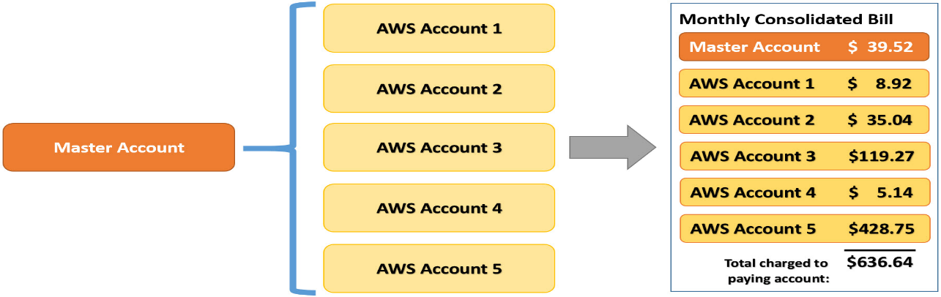

You can use the consolidated billing feature in AWS Organizations to consolidate payment for multiple AWS accounts or multiple AISPL accounts. With consolidated billing, you can see a combined view of AWS charges incurred by all of your accounts. You can also get a cost report for each member account that is associated with your master account. Consolidated billing is offered at no additional charge. AWS and AISPL accounts can't be consolidated together.

Option 1 is incorrect. Trusted Advisor is an online tool that provides you real-time guidance to help you provision your resources following AWS best practices. It only provides you alerts on areas where you do not adhere to best practices and tells you how to improve them. It does not assist in maintaining governance over your AWS accounts.

Option 3 is incorrect because creating separate VPCs would not separate the divisions from each other since they will still be operating under the same account and therefore contribute to the same billing each month.

Option 5 is incorrect because you do not need to create Availability Zones. They are already provided for you by AWS right from the start, and not all services support multiple AZ deployments. In addition, having separate Availability Zones in your VPC does not meet the requirement of supporting the autonomy of each corporate division.

**Support**

* Business Level Premium Support:
  + General guidance: < 24 hours
  + System impaired: < 12 hours
  + Production system impaired: < 4 hours
  + Production system down: < 1 hour

Q: What level of architecture support is provided by Support

**Developer: Building Blocks**Guidance on how to use all AWS products, features, and services together. Includes guidance on best practices and generalized architectural advice.

**Business: Use Case Guidance**Guidance on what AWS products, features, and services to use to best support your specific use cases. Includes guidance on optimizing AWS products and configuration to meet your specific needs.

**Enterprise: Application Architecture**Consultative partnership supporting specific use cases and applications. Includes design reviews and architectural guidance. Enterprise-level customers support team includes a designated Technical Account Manager, and access to an AWS Solutions Architect.

**Billing and cost management**

* **Consolidated Billing:**
  + A single bill is issued containing the charges for all AWS accounts.
  + Account charges can be still tracked individually.
  + Multiple standalone accounts are combined and may reduce your overall bill.
* AWS Budgets gives you the ability to set custom budgets that alert you when your costs or usage exceed.
  + Can be tracked at the monthly, quarterly, or yearly level.
* Cost Explorer helps you visualize and manage your AWS costs and usages over time.
  + Offers a set of reports you can view data with for up to the last 13 months.
  + Can forecast how much you're likely to spend for the next three months.
  + Can get recommendations for what Reserved Instances to purchase.
* Paying account with multiple linked accounts
* Paying account is independent and should be only used for billing purpose
* Paying account cannot access resources of other accounts unless given exclusively access through Cross Account roles
* All linked accounts are independent and soft limit of 20
* One bill per AWS account
* provides **Volume pricing discount** for usage across the accounts
* allows **unused Reserved Instances** to be applied across the group
* Free tier is not applicable across the accounts

**You founded a tech startup that provides online training and software development courses to various students across the globe. Your team has developed an online portal in AWS where the students can log into and access the courses they are subscribed to.**

**Since you are in the early phases of the startup and the funding is still hard to come by, which service can help you manage the budgets for all your AWS resources?**

* ​Cost Explorer



* ​Cost Allocation Tags



* ​AWS Budgets



* ​Payment History



**Explanion**

AWS Budgets gives you the ability to set custom budgets that alert you when your costs or usage exceed (or are forecasted to exceed) your budgeted amount.

Budgets can be tracked at the monthly, quarterly, or yearly level, and you can customize the start and end dates. You can further refine your budget to track costs associated with multiple dimensions, such as AWS service, linked account, tag, and others. Budget alerts can be sent via email and/or Amazon Simple Notification Service (SNS) topic.

You can also use AWS Budgets to set a custom reservation utilization target and receive alerts when your utilization drops below the threshold you define. RI utilization alerts support Amazon EC2, Amazon RDS, Amazon Redshift, and Amazon ElastiCache reservations.

Budgets can be created and tracked from the AWS Budgets dashboard or via the Budgets API.

Option 1 is incorrect because the Cost Explorer only helps you visualize and manage your AWS costs and usages over time. It offers a set of reports you can view data with for up to the last 13 months, forecast how much you're likely to spend for the next three months, and get recommendations for what Reserved Instances to purchase. You use Cost Explorer to identify areas that need further inquiry and see trends to understand your costs.

Option 2 is incorrect because Cost Allocation Tags only eases the organization of your resource costs on your cost allocation report, to make it easier for you to categorize and track your AWS costs.

Option 4 is incorrect because the payment history option only provides a location where you can view the monthly invoices you receive from AWS. If your account isn't past due, the Payment History page shows only previous invoices and payment status.

**Tags & Resource Groups**

* are **metadata**, specified as **key/value pairs** with the AWS resources
* are for **labelling** purposes and **helps managing, organizing resources**
* can be **inherited** when created resources created from Auto Scaling, Cloud Formation, Elastic Beanstalk etc
* can be used for
  + **Cost allocation** to categorize and track the AWS costs
  + **Conditional Access Control policy** to define permission to allow or deny access on resources based on tags
* Resource Group is a collection of resources that share one or more tags

**AWS hosts a variety of public datasets such as satellite imagery, geospatial, or genomic data that you want to use for your web application hosted in Amazon EC2.**

**If you use these datasets, how much will it cost you?**

* ​

A one-time charge of $10.

* ​

$10 per month for each dataset.

* ​

$10 per month for all datasets.

* ​

No charge.

**(Correct)**

**Explanation**

AWS hosts a variety of public datasets that anyone can access for **free**.

Previously, large datasets such as satellite imagery or genomic data have required hours or days to locate, download, customize, and analyze. When data is made publicly available on AWS, anyone can analyze any volume of data without needing to download or store it themselves.

**Disaster recovery (DR)**

* RTO refers to the length of time it takes to restore business operations.
* RPO refers to the amount of time between backups.
* Disaster recovery plans:
  + Backup and Restore: Backs up your data and applications from anywhere to the AWS cloud.
  + Pilot Light: A small part of your infrastructure is always running simultaneously syncing mutable data (as databases or documents), while other parts of your infrastructure are switched off and used only during testing.
  + Warm Standby: A scaled-down version of a fully functional environment is always running in the cloud. It further decreases the recovery time because some services are always running.
  + Multi-Site: A multi-site solution runs on AWS as well as on your existing on-site infrastructure in an active-active configuration.
  + ***Recovery Time Objective***(RTO): is the maximum interval of time, that your application goes offline.

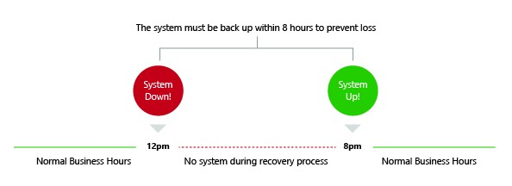

1. ***Recovery Point Objective (RPO)***: is the maximum time, in which your data might be lost from an application due to the disaster. RPO describes only the interval of time and doesn’t address the amount or quality of the data lost.
2. 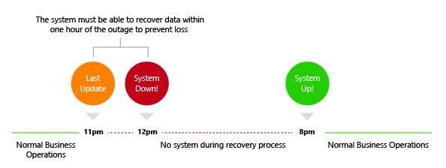If we need lower the values of RTO and RPO, then the cost of running the application will be higher.Depending on these metrics, AWS offers 4 basic techniques for back-up and disaster recovery.
3. ***Back-up and Recovery***In this technique, data is backed up to the tape and sent off-site regularly. Amazon S3 is the destination for data backup. For long term data storage, we use Amazon Glacier, which has the same durability as Amazon S3, but the difference is that the cost is lower compared to S3With Amazon S3, restoring a process is pretty fast compared to Amazon Glacier. As the retrieval time is more in Amazon Glacier, it is used to store old backup files.

AWS Storage Gateway will copy the backup to Amazon S3 by taking the snapshot of the data. The following figure shows data backup options to Amazon S3, from either on-site infrastructure or from AWS.

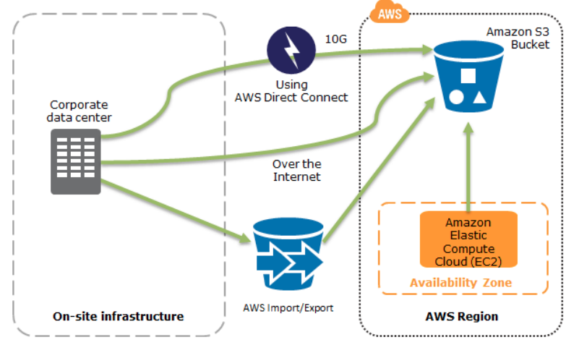

If a disaster occurs, we need to recover the data very quickly and reliably. The following diagram shows how to quickly restore a system from Amazon S3 backups to Amazon EC2.

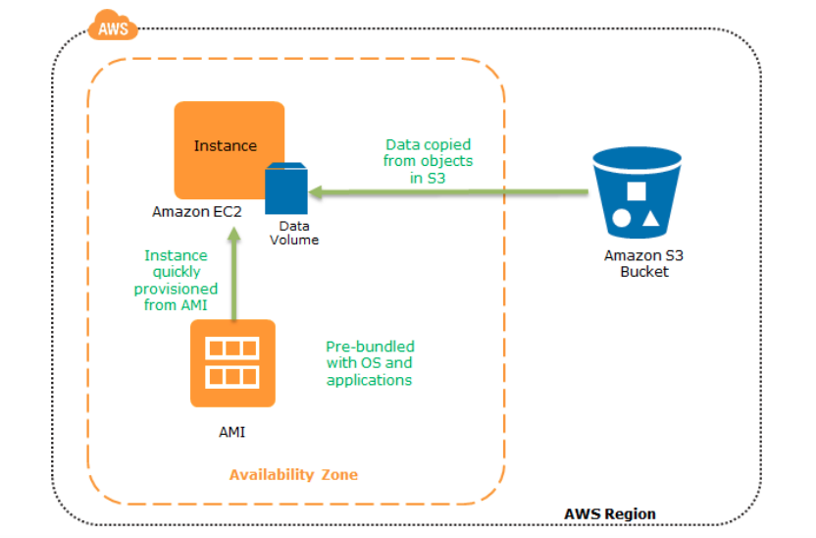This technique is simple and cost-effective, however RPO will be huge and there will be a downtime before restoration.

2.**Pilot Light**In recovery time is less compared to the backup-and-recovery method. Here the core piece of the system such as a database is already running and up to date in AWS.

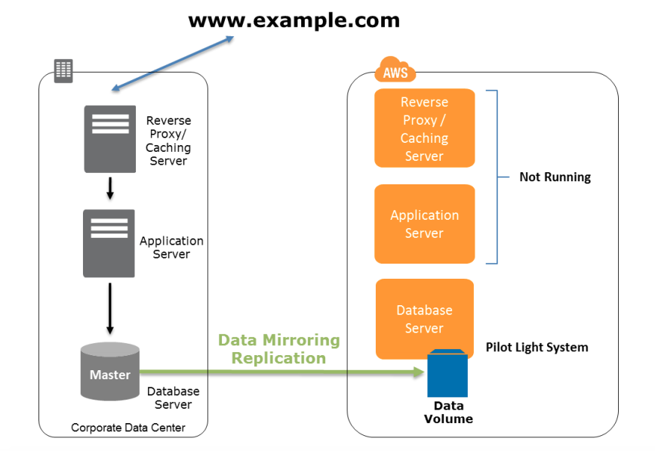

The database is always activated for data replication and for the other layers, server images are created and updated periodically.In Pilot Light, the RTO and RPO are low and it just takes a few minutes for recovery. Amazon Cloud Formation can be used to automate the provisioning of these services.

The instances are created by the backed up AMI. We can configure load balancing and auto-scaling, so that when the traffic goes high the service will scale up automatically. The DNS needs to update in parallel.

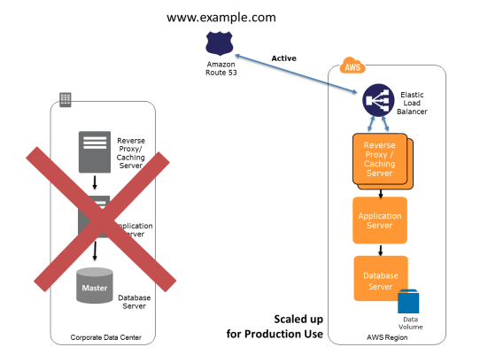

3.**Warm Standby**:extended version of Pilot Light. It reduces the recovery time further, because in warm standby part of the service is always running. the recovery time is reduced to almost zero by always running a scaled down version of a fully functional environment. At the time of recovery point, if the system fails, the standby infrastructure will be scaled up with the level of the production environment, DNS records are updated and it routes all the traffic to a new AWS environment. So this approach reduces RTO and RPO but the cost will be high due to the fact that an alternate system is running 24/7.The following figure shows the preparation phase for a warm standby solution, in which an on-site solution and an AWS solution run side-by-side.

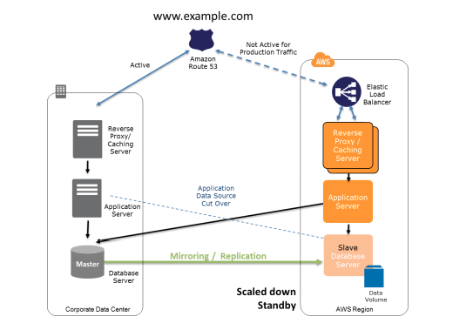

In case of failure of the production system :

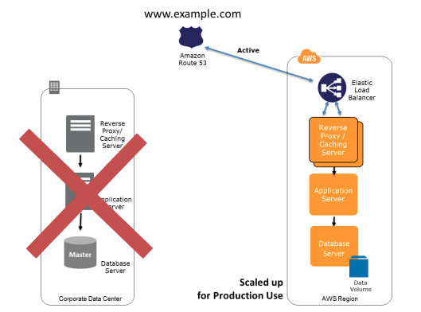

4.**Hot Standby (Multi-Site)**the application runs in AWS as well as on the existing infrastructure also. Here the DNS service supports weighted routing. The traffic will go to the standby infrastructure as well as the existing infrastructure.If a disaster occurs on the existing system, the whole traffic is routed to the new AWS environment. By using auto-scaling, the capacity of services rapidly increases to handle the full production load. Here you can achieve zero RTO and RPO but the cost would be high.

The following figure shows how you can use the weighted routing policy of the Amazon Route 53 DNS to route a portion of your traffic to the AWS site. The application on AWS might access data sources on the on-site production system. Data is replicated or mirrored to the AWS infrastructure.

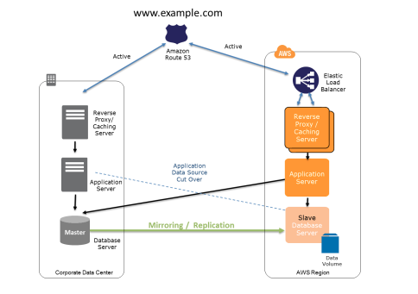

The following figure shows the change in traffic routing in the event of an on-site disaster. Traffic is cut over to the AWS infrastructure by updating DNS, and all traffic and supporting data queries are supported by the AWS infrastructure.

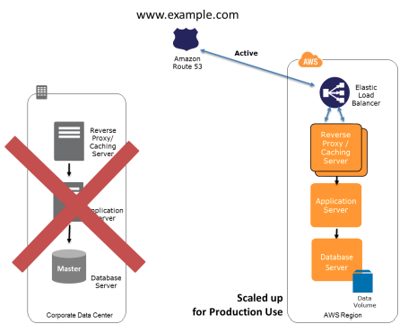

## **AWS Services Region, AZ, Subnet VPC limitations**

* Services like IAM (user, role, group, SSL certificate), Route 53, STS are Global and available across regions
* All other AWS services are limited to Region or within Region and do not exclusively copy data across regions unless configured
* AMI are limited to region and need to be copied over to other region
* EBS volumes are limited to the Availability Zone, and can be migrated by creating snapshots and copying them to another region
* Reserved instances  (can be migrated to other Availability Zone now) cannot be migrated to another region
* RDS instances are limited to the region and can be recreated in a different region by either using snapshots or promoting a Read Replica
  + Cluster Placement groups are limited to single Availability Zones
  + Spread Placement groups can span across multiple Availability Zones
* S3 data is replicated within the region and can be move to another region using cross region replication
* DynamoDB maintains data within the region can be replicated to another region using DynamoDB cross region replication (using DynamoDB streams) or Data Pipeline using EMR (old method)
* Redshift Cluster span within an Availability Zone only, and can be created in other AZ using snapshots

**Athena**

* Amazon Athena is an interactive query service to analyze data in Amazon S3 using standard SQL.Athena is serverless, so there is no infrastructure to manage.
* Works with a number of data formats including JSON, Apache Parquet, and Apache ORC amongst others. Amazon Athena uses Presto with ANSI SQL support and works with a variety of standard data formats, including CSV, JSON, ORC, Avro, and Parquet

**obal infrastructure**

* An availability zone (AZ) is one or more discrete data centers.
  + Each with redundant power, networking and connectivity, housed in separate facilities.
* Each region is a distinct location designed to provide high availability to a specific geography.
  + Each region comprises at least two AZs.
* Edge locations are endpoints for AWS that are used for caching content (CloudFront).
  + The number of edge locations >> the number of AZs >> the number of regions.

**AWS Shield**

[AWS Shield](https://aws.amazon.com/shield/) is a managed DDoS protection service that is available in two tiers: Standard and Advanced. AWS Shield Standard applies always-on detection and inline mitigation techniques, such as deterministic packet filtering and priority-based traffic shaping, to minimize application downtime and latency. AWS Shield Standard is included automatically and transparently to your Elastic Load Balancing load balancers, Amazon CloudFront distributions, and Amazon Route 53 resources at no additional cost. When you use these services that include AWS Shield Standard, you receive comprehensive availability protection against all known infrastructure layer attacks. Customers who have the technical expertise to manage their own monitoring and mitigation of application layer attacks can use AWS Shield together with [AWS WAF](https://aws.amazon.com/waf/) rules to create a comprehensive DDoS attack mitigation strategy.

AWS Shield Advanced provides enhanced DDoS attack detection and monitoring for application-layer traffic to your Elastic Load Balancing load balancers, CloudFront distributions, Amazon Route 53 hosted zones and resources attached to an Elastic IP address, such Amazon EC2 instances. AWS Shield Advanced uses additional techniques to provide granular detection of DDoS attacks, such as resource-specific traffic monitoring to detect HTTP floods or DNS query floods. AWS Shield Advanced includes 24x7 access to the [AWS DDoS Response Team (DRT)](http://docs.aws.amazon.com/waf/latest/developerguide/ddos-overview.html#ddos-drt), support experts who apply manual mitigations for more complex and sophisticated DDoS attacks, directly create or update AWS WAF rules, and can recommend improvements to your AWS architectures. AWS WAF is included at no additional cost for resources that you protect with AWS Shield Advanced.

* AWS Shield is a managed Distributed Denial of Service (DDoS) protection service.
* Operates on layer 3 and 4 of the ISO network model.
* AWS Shield Advanced:
  + Provides additional detection and mitigation against large and sophisticated DDoS attacks, near real-time visibility into attacks, and integration with AWS WAF, a web application firewall.
  + Gives you 24x7 access to the AWS DDoS Response Team (DRT)

AWS WAF

[AWS WAF](https://aws.amazon.com/waf/) is a web application firewall that helps protect web applications from common web exploits that could affect application availability, compromise security, or consume excessive resources. You can use AWS WAF to define customizable web security rules that control which traffic accesses your web applications. If you use AWS Shield Advanced, you can use AWS WAF at no extra cost for those protected resources and can engage the DRT to create WAF rules.

* AWS WAF rules use conditions to target specific requests and trigger an action, allowing you to identify and block common DDoS request patterns and effectively mitigate a DDoS attack.  These include size constraint conditions to block a web request based on the length of its query string or request body, and geographic match conditions to implement geo restriction (also known as *geoblocking*) on requests that originate from specific countries. Web Application Firewall is a firewall that helps protect web applications from common web exploits.
* The following conditions are supported: Cross-site scripting, Geo, IP, Size, SQL injection, and String and regex match conditions. is a web application firewall that helps monitor the HTTP/HTTPS and allows controlling access to the content.
* helps protect web applications from attacks by allowing rules configuration that allow, block, or monitor (count) web requests based on defined conditions. These conditions include IP addresses, HTTP headers, HTTP body, URI strings, SQL injection and cross-site scripting.
* helps define Web ACLs, which is a combination of Rules, which is a combinations of Conditions and Action to block or allow
* integrated with CloudFront, Application Load Balancer (ALB), API Gateway services commonly used to deliver content and applications
* supports custom origins outside of AWS, when integrated with CloudFront

## **AWS GuardDuty**

## offers threat detection that enables continuous monitoring and protect the AWS accounts and workloads.

## analyzes continuous streams of meta-data generated from AWS account and network activity found in AWS CloudTrail Events, VPC Flow Logs, and DNS Logs.integrated threat intelligence such as known malicious IP addresses, anomaly detection, and machine learning to identify threats more accurately.

operates completely independently from the resources so there is no risk of performance or availability impacts to the workloads

## **AWS Inspector**

* is an automated security assessment service that helps test the network accessibility of EC2 instances and the security state of the applications running on the instances.
* helps automate security vulnerability assessments throughout the development and deployment pipeline or against static production systems

**Security, Identity, & Compliance**

* + Security and Compliance is a shared responsibility between AWS and the customer.
* Security and Compliance is a shared responsibility between AWS and the customer. This shared model can help relieve customer’s operational burden as AWS operates, manages and controls the components from the host operating system and virtualization layer down to the physical security of the facilities in which the service operates. The customer assumes responsibility and management of the guest operating system (including updates and security patches), other associated application software as well as the configuration of the AWS provided security group firewall.
* Customers should carefully consider the services they choose as their responsibilities vary depending on the services used, the integration of those services into their IT environment, and applicable laws and regulations. The nature of this shared responsibility also provides the flexibility and customer control that permits the deployment. As shown in the chart below, this differentiation of responsibility is commonly referred to as Security “of” the Cloud versus Security “in” the Cloud.
* Option 1 is incorrect since providing you customer data would be a breach in security protocols and data privacy laws.
* Option 3 is incorrect because it is your responsibility to set up the security tools AWS has provided you to secure your instances in your cloud environment.
* Option 4 is incorrect since it is your responsibility to delegate user access to your cloud environment.
* Refer to this diagram for a better understanding of the shared responsibility model.
* 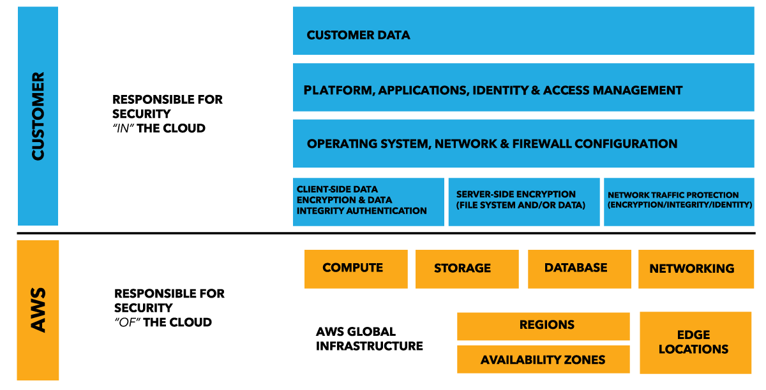

**You are designing a social media website for a startup company and the founders want to know the ways to mitigate distributed denial-of-service (DDoS) attacks to their website.**

**Which of the following are not viable mitigation techniques? (Choose 2)**

* ​Use Dedicated EC2 instances to ensure that each instance has the maximum performance possible.



* ​Add multiple elastic network interfaces (ENIs) to each EC2 instance to increase the network bandwidth.



* ​Use an Amazon CloudFront service for distributing both static and dynamic content.



* ​Use an Application Load Balancer with Auto Scaling groups for your EC2 instances then restrict direct Internet traffic to your Amazon RDS database by deploying to a private subnet.



* ​Use AWS Shield and AWS WAF.



**Explanation**

Take note that the question asks about the viable mitigation techniques to avoid Distributed Denial of Service (DDoS) attack.A Denial of Service (DoS) attack is an attack that can make your website or application unavailable to end users. To achieve this, attackers use a variety of techniques that consume network or other resources, disrupting access for legitimate end users.

To protect your system from SoS attack, you can do the following:

1. Use an Amazon CloudFront service for distributing both static and dynamic content.
2. Use an Application Load Balancer with Auto Scaling groups for your EC2 instances then restrict direct Internet traffic to your Amazon RDS database by deploying to a private subnet.
3. Setup alerts in Amazon CloudWatch to look for high **Network In** and CPU utilization metrics.

Services that are available within AWS Regions, like Elastic Load Balancing and Amazon Elastic Compute Cloud (EC2), allow you to build Distributed Denial of Service resiliency and scale to handle unexpected volumes of traffic within a given region. Services that are available in AWS edge locations, like Amazon CloudFront, AWS WAF, Amazon Route53, and Amazon API Gateway, allow you to take advantage of a global network of edge locations that can provide your application with greater fault tolerance and increased scale for managing larger volumes of traffic.

**IAM**

* IAM is universal and is not region-specific at this time.
* Identity access management (IAM) offers the following features:
  + Centralized control of the AWS account , Shared access to the account
  + Fine-grained access control to AWS resources,Identity federations (Facebook, Linkedin, etc.)Multi-factor authentication Provides temporary access for users/devices and services when necessary.Allows to set up own password rotation policy.
* The "root account" is simply the account created with the AWS account.
* Owner:The Owner refers to the identity and email address used to create the AWS account.
  + Comes into play especially when setting or locking down access to various objects.
* **Users:**
  + End users such as employees of an organization. New users have no permissions by default.
  + To access the AWS Management Console, new users use the account and password combination.To access the AWS programmatically, they use the access key & secret access key combination.
  + Credentials can be viewed only once, thus save them in a secure location.
  + Set up multi-factor authentication (MFA) to the root account (easy with Google Authenticator)
* **Groups:**Groups are collections of users.Each user inherits the permissions of the group.
* **Policies:**A policy is a JSON document that provides formal statement of one or more permissions.For example, allow user to access of all AWS services except the IAM service (power user)Configure users and policy documents only once, as these are applied globally. helps define Policies,
  + in JSON format
  + all permissions are implicitly denied by default
  + most restrictive policy wins

**Roles:**Give permissions to AWS services to use other AWS services.

* + needs Trust policy to define who and Permission policy to define what the user or service can access
* One of the best practices in Amazon IAM is to *grant least privilege*.
* When you create IAM policies, follow the standard security advice of granting *least privilege*—that is, granting only the permissions required to perform a task. Determine what users need to do and then craft policies for them that let the users perform *only* those tasks. Therefore, option 1 is the correct answer.
* Start with a minimum set of permissions and grant additional permissions as necessary.
* Defining the right set of permissions requires some understanding of the user's objectives. Determine what is required for the specific task, what actions a particular service supports, and what permissions are required in order to perform those actions.
  + used with Security Token Service (STS), a lightweight web service that provides temporary, **limited privilege credentials for IAM users or for authenticated federated users**

**You are the Solutions Architect for your company's AWS account of approximately 300 IAM users. They have a new company policy that will change the access of 100 of the IAM users to have a particular sort of access to Amazon S3 buckets.What will you do to avoid the time-consuming task of applying the policy at the individual user?**

* ​Create a new IAM group and then add the users that require access to the S3 bucket. Afterwards, apply the policy to IAM group.



* ​Create a new policy and apply it to multiple IAM users using a shell script.



* ​Create a new S3 bucket access policy with unlimited access for each IAM user.



* ​Create a new IAM role and add each user to the IAM role.



**Explanation**

In this scenario, the best option is to group the set of users in an IAM Group and then apply a policy with the required access to the Amazon S3 bucket. This will enable you to easily add, remove, and manage the users instead of manually adding a policy to each and every 100 IAM users.

Option 2 is incorrect because you need a new IAM Group for this scenario and not assign a policy to each user via a shell script. This method can save you time but afterwards, it will be difficult to manage all 100 users that are not contained in an IAM Group.

Option 3 is incorrect because you need a new IAM Group and the method is also time-consuming.

Option 4 is incorrect because you need to use an IAM Group and not an IAM role.

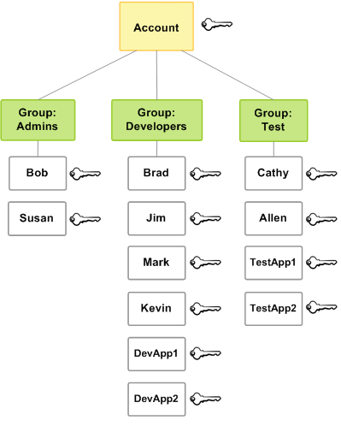

**You work for an Intelligence Agency as its Principal Consultant developing a missile tracking application, which is hosted on both development and production AWS accounts. Alice, the Intelligence agency’s Junior Developer, only has access to the development account. She has received security clearance to access the agency’s production account but the access is only temporary and only write access to EC2 and S3 is allowed.Which of the following allows you to issue short-lived access tokens that acts as temporary security credentials to allow access to your AWS resources?**

* ​Use AWS Cognito to issue JSON Web Tokens (JWT)



* ​Use AWS STS



* ​Use AWS SSO



* ​All of the above.



**Explanation**

AWS Security Token Service (AWS STS) is the service that you can use to create and provide trusted users with temporary security credentials that can control access to your AWS resources. Temporary security credentials work almost identically to the long-term access key credentials that your IAM users can use.

In this diagram, IAM user Alice in the Dev account (the role-assuming account) needs to access the Prod account (the role-owning account). Here’s how it works:

1. Alice in the Dev account assumes an IAM role (WriteAccess) in the Prod account by calling AssumeRole.
2. STS returns a set of temporary security credentials.
3. Alice uses the temporary security credentials to access services and resources in the Prod account. Alice could, for example, make calls to Amazon S3 and Amazon EC2, which are granted by the WriteAccess role.

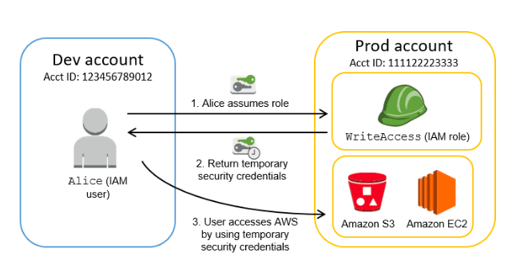

* + IAM role scenarios
    - Service access *for e.g. EC2 to access S3 or DynamoDB*
    - Cross Account access for users
      * with user within the same account
      * with user within an AWS account owned the same owner
      * with user from a Third Party AWS account with External ID for enhanced security
    - Identity Providers & Federation
      * Web Identity Federation, where the user can be authenticated using external authentication Identity providers like Amazon, Google or any OpenId IdP using AssumeRoleWithWebIdentity
      * Identity Provider using SAML 2.0, where the user can be authenticated using on premises Active Directory, Open Ldap or any SAML 2.0 compliant IdP using AssumeRoleWithSAML
      * For other Identity Providers, use Identity Broker to authenticate and provide temporary Credentials using AssumeRole (recommended) or GetFederationToken
* **IAM Best Practices**
  + Do not use Root account for anything other than billing
  + Create Individual IAM users
  + Use groups to assign permissions to IAM users
  + Grant least privilege
  + Use IAM roles for applications on EC2
  + Delegate using roles instead of sharing credentials
  + Rotate credentials regularly
  + Use Policy conditions for increased granularity
  + Use CloudTrail to keep a history of activity
  + Enforce a strong IAM password policy for IAM users
  + Remove all unused users and credentials

**You have been asked to perform a security review for a client. They have a fleet of EC2 instances created by an Auto Scaling group and SQS queue to process jobs stored in DynamoDB. Currently, they retrieve access keys from an S3 bucket to gain access to other AWS resources. Recently, the bucket was exploited and the keys were leaked. The business has asked for a best-practice alternative solution for this architecture.What should you suggest?**

* AConfigure an S3 bucket policy only allowing access to the Auto Scaling group instances.
* BAdd access keys to the Auto Scaling group configuration for delivery via the instance metadata.
* CCreate a new launch template, IAM role, and instance profile.
* DRemove the access keys from the S3 bucket.
* ELeave the access keys stored in S3.
* **Your Answer: A**This isn't a viable technical solution. A bucket policy can only reference identities — it cannot allow access for an Auto Scaling group.
* **Correct Answer: C**An IAM role and instance profile can be used to deliver temporary credentials to EC2 instances securely. By configuring this in the launch template, it can be applied to all EC2 instances created by the Auto Scaling group.
* **Correct Answer: D**This resolves the immediate issue causing the credential leak.
* **Tips:**
  + Enact a strong password policy: user passwords must be changed every 45 days, with each password containing a combination of capital letters, lower case letters, numbers, and special symbols.
  + If you create an individual user for each staff member, there will be no way to keep their active directory credentials synched when they change their password. You should either create a federation proxy or identity provider and then use AWS security token service to create temporary tokens. You will then need to create the appropriate IAM role for which the users will assume when accessing AWS resources.
* An IAM role is similar to a user, in that it is an AWS identity with permission policies that determine what the identity can and cannot do in AWS. However, instead of being uniquely associated with one person, a role is intended to be assumable by anyone who needs it. Also, a role does not have any credentials (password or access keys) associated with it. Instead, if a user is assigned to a role, access keys are created dynamically and provided to the user.
* Option A is wrong as MFA is to enable two factor authentication
* Option C is wrong as storing credentials is not recommended
* Option D is wrong as IAM user cannot be assigned to EC2 instance

**You recently created a brand new IAM User with a default setting using AWS CLI. This is intended to be used to send API requests to your S3, DynamoDB, Lambda, and other AWS resources of your cloud infrastructure.**

**Which of the following must be done to allow the user to make API calls to your AWS resources?**

* ​

Do nothing as the IAM User is already capable of sending API calls to your AWS resources.

* ​

Enable Multi-Factor Authentication for the user.

* ​

Assign an IAM Policy to the user to allow it to send API calls.

**(Incorrect)**

* ​

Create a set of Access Keys for the user and attach the necessary permissions.

**(Correct)**

**Explanation**

You can choose the credentials that are right for your IAM user. When you use the AWS Management Console to create a user, you must choose to at least include a console password or access keys. By default, a brand new IAM user created using the AWS CLI or AWS API has no credentials of any kind. You must create the type of credentials for an IAM user based on the needs of your user.

Access keys are long-term credentials for an IAM user or the AWS account root user. You can use access keys to sign programmatic requests to the AWS CLI or AWS API (directly or using the AWS SDK). Users need their own access keys to make programmatic calls to AWS from the AWS Command Line Interface (AWS CLI), Tools for Windows PowerShell, the AWS SDKs, or direct HTTP calls using the APIs for individual AWS services.

To fill this need, you can create, modify, view, or rotate access keys (access key IDs and secret access keys) for IAM users. When you create an access key, IAM returns the access key ID and secret access key. You should save these in a secure location and give them to the user.

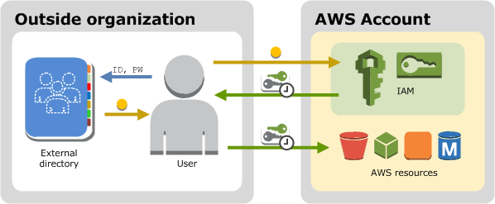

Option 1 is incorrect because by default, a brand new IAM user created using the AWS CLI or AWS API has no credentials of any kind. Take note that in the scenario, you created the new IAM user using the AWS CLI and not via the AWS Management Console, where you must choose to at least include a console password or access keys when creating a new IAM user.

Option 2 is incorrect because enabling Multi-Factor Authentication for the IAM user will still not provide the required Access Keys needed to send API calls to your AWS resources. You have to grant the IAM user with Access Keys to meet the requirement.

Option 3 is incorrect because adding a new IAM policy to the new user will not grant the needed Access Keys needed to make API calls to the AWS resources.

**STS**

* AWS Security Token Service (AWS STS) is the service that you can use to create and provide trusted users with temporary security credentials that can control access to your AWS resources.

**A tech company that you are working for has undertaken a Total Cost Of Ownership (TCO) analysis evaluating the use of Amazon S3 versus acquiring more storage hardware. The result was that all 1200 employees would be granted access to use Amazon S3 for storage of their personal documents.   Which of the following will you need to consider so you can set up a solution that incorporates single sign-on feature from your corporate AD or LDAP directory and also restricts access for each individual user to a designated user folder in an S3 bucket? (Choose 2)**

* ​Use 3rd party Single Sign-On solutions such as Atlassian Crowd, OKTA, OneLogin and many others.



* ​Set up a Federation proxy or an Identity provider, and use AWS Security Token Service to generate temporary tokens.



* ​Use a resource tag on each folder in the S3 bucket.



* ​Configure an IAM role and an IAM Policy to access the bucket.



* ​Setup up a matching IAM user for each 1200 users in your corporate directory that needs access to a folder in the S3 bucket.



**Explanation**

The question refers to one of the common scenarios for temporary credentials in AWS. Temporary credentials are useful in scenarios that involve identity federation, delegation, cross-account access, and IAM roles. In this example, it is called **enterprise identity federation** considering that you also need to set up a single sign-on (SSO) capability.

The correct answers are:

- Setup a Federation proxy or an Identity provider

- Setup an AWS Security Token Service to generate temporary tokens (Option 2)

- Configure an IAM role (Option 4)

In an enterprise identity federation, you can authenticate users in your organization's network, and then provide those users access to AWS without creating new AWS identities for them and requiring them to sign in with a separate user name and password. This is known as the *single sign-on* (SSO) approach to temporary access. AWS STS supports open standards like Security Assertion Markup Language (SAML) 2.0, with which you can use Microsoft AD FS to leverage your Microsoft Active Directory. You can also use SAML 2.0 to manage your own solution for federating user identities.

**You recently created a brand new IAM User with a default setting using AWS CLI. This is intended to be used to send API requests to your S3, DynamoDB, Lambda, and other AWS resources of your cloud infrastructure.**

**Which of the following must be done to allow the user to make API calls to your AWS resources?**

* ​

Do nothing as the IAM User is already capable of sending API calls to your AWS resources.

* ​

Enable Multi-Factor Authentication for the user.

* ​

Assign an IAM Policy to the user to allow it to send API calls.

**(Incorrect)**

* ​

Create a set of Access Keys for the user and attach the necessary permissions.

**(Correct)**

**Explanation**

You can choose the credentials that are right for your IAM user. When you use the AWS Management Console to create a user, you must choose to at least include a console password or access keys. By default, a brand new IAM user created using the AWS CLI or AWS API has no credentials of any kind. You must create the type of credentials for an IAM user based on the needs of your user.

Access keys are long-term credentials for an IAM user or the AWS account root user. You can use access keys to sign programmatic requests to the AWS CLI or AWS API (directly or using the AWS SDK). Users need their own access keys to make programmatic calls to AWS from the AWS Command Line Interface (AWS CLI), Tools for Windows PowerShell, the AWS SDKs, or direct HTTP calls using the APIs for individual AWS services.

To fill this need, you can create, modify, view, or rotate access keys (access key IDs and secret access keys) for IAM users. When you create an access key, IAM returns the access key ID and secret access key. You should save these in a secure location and give them to the user.



Option 1 is incorrect because by default, a brand new IAM user created using the AWS CLI or AWS API has no credentials of any kind. Take note that in the scenario, you created the new IAM user using the AWS CLI and not via the AWS Management Console, where you must choose to at least include a console password or access keys when creating a new IAM user.

Option 2 is incorrect because enabling Multi-Factor Authentication for the IAM user will still not provide the required Access Keys needed to send API calls to your AWS resources. You have to grant the IAM user with Access Keys to meet the requirement.

Option 3 is incorrect because adding a new IAM policy to the new user will not grant the needed Access Keys needed to make API calls to the AWS resources.

**Cognito**

**A San Francisco-based tech startup is building a cross-platform mobile app that can notify the user with upcoming astronomical events such as eclipses, blue moon, novae or a meteor shower. Your mobile app authenticates with the Identity Provider (IdP) using the provider's SDK and Amazon Cognito. Once the end user is authenticated with the IdP, the OAuth or OpenID Connect token returned from the IdP is passed by your app to Amazon Cognito.**

**Which of the following is returned for the user to provide a set of temporary, limited-privilege AWS credentials?**

* ​Cognito SDK



* ​Cognito Key Pair



* ​Cognito ID



* Cognito API

**Explanation**

You can use Amazon Cognito to deliver temporary, limited-privilege credentials to your application so that your users can access AWS resources. Amazon Cognito identity pools support both authenticated and unauthenticated identities. You can retrieve a unique Amazon Cognito identifier (identity ID) for your end user immediately if you're allowing unauthenticated users or after you've set the login tokens in the credentials provider if you're authenticating users.

That is why the correct answer for this question is Option 3: Cognito ID.

Option 1 is incorrect because Cognito SDK is not the unique Amazon Cognito identifier but a software development kit that is available in various programming languages.

Option 2 is incorrect because Cognito Key Pair is not the unique Amazon Cognito identifier but a cryptography key.

Option 4 is incorrect because the Cognito API is not the unique Amazon Cognito identifier and is primarily used as an Application Programming Interface.

* **Web Identity Federation:**Web Identity Federation lets you give your users access to AWS resources after they have successfully authenticated with a web-based identity provides such as Amazon, Facebook, or Google.It does not utilize Active Directory.
* You can use Amazon Cognito to deliver temporary, limited-privilege credentials to your application so that your users can access AWS resources.
* Following successful authentication, the user receives an authentication code from the Web ID provider, which they can trade for temporary AWS security credentials.
* **Amazon Cognito provides WIF with the following features**:
  + Sign-up and sign-in to your apps.
  + Enables access for guest users.
  + Acts as an identity broker between application and Web ID providers.
  + Providers temporary credentials that map to an IAM role allowing access to the required resources.
  + No need for the application to embed or store AWS credentials.
  + Gives seamless experience across all mobile devices.
  + Tracks the association between user identity and the various devices they sign-in from.
  + Uses Push Synchronization to push updates and to synchronize user data across devices.
  + Uses SNS to send notifications whenever data stored in the cloud changes.
* **Cognito User Pools:**
  + Take care of user registration, authentication and account recovery.
  + User pools are user directories used to manage sign-up and sign-ins.
  + Authentication generates a JSON Web Token (JWT)
  + You can retrieve a unique Amazon Cognito ID for your end user immediately.
* **Cognito Identity Pools:**
  + Take care of granting rights to AWS resources (authorization)
  + Enable temporary AWS credentials to access AWS services like S3 or DynamoDB.

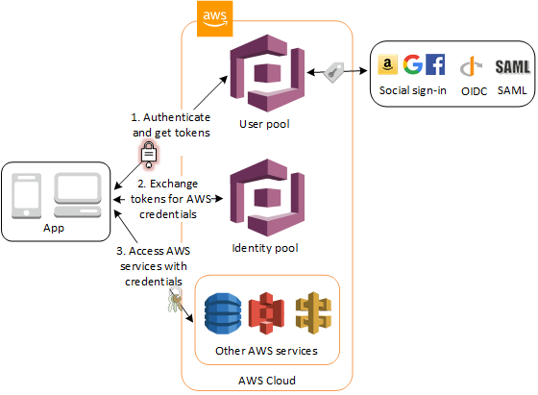

**As part of securing an API layer built on Amazon API Gateway, a Solutions Architect has to authorize users who are currently authenticated by an existing identity provider. The users must be denied access for a period of one hour after these unsuccessful attempts. How can the authentication be implemented?**

**Correct answer is B as Lambda authorizer can help authroize the user and deny access for a period of one hour after an unsuccessful attempt.A Lambda authorizer (formerly known as a custom authorizer) is an API Gateway feature that uses a Lambda function to control access to your API.A Lambda authorizer is useful if you want to implement a custom authorization scheme that uses a bearer token authentication strategy such as OAuth or SAML, or that uses request parameters to determine the caller's identity.**When a client makes a request to one of your API's methods, API Gateway calls your Lambda authorizer, which takes the caller's identity as input and returns an IAM policy as output.

**There are two types of Lambda authorizers:**

**A token-based Lambda authorizer (also called a TOKEN authorizer) receives the caller's identity in a bearer token, such as a JSON Web Token (JWT) or an OAuth token.**

**A request parameter-based Lambda authorizer (also called a REQUEST authorizer) receives the caller's identity in a combination of headers, query string parameters,**[**stageVariables**](https://docs.aws.amazon.com/apigateway/latest/developerguide/api-gateway-mapping-template-reference.html#stagevariables-template-reference)**, and**[**$context**](https://docs.aws.amazon.com/apigateway/latest/developerguide/api-gateway-mapping-template-reference.html#context-variable-reference)**variables.**

**For WebSocket APIs, only request parameter-based authorizers are supported.**

The two main components of Amazon Cognito are user pools and identity pools. Identity pools provide AWS credentials to grant your users access to other AWS services. To enable users in your user pool to access AWS resources, you can configure an identity pool to exchange user pool tokens for AWS credentials.

**SAML**

* **In an enterprise identity federation, you can authenticate users in your organization's network, and then provide those users access to AWS without creating new AWS identities for them and requiring them to sign in with a separate user name and password.**
* SAML (Security Assertion Markup Language 2.0) gives your federated users single sign-on (SSO) access to the AWS Management Console.
* An open standard that many identity providers (IdPs) use, for example, Microsoft Active Directory.
* **This feature enables federated single sign-on (SSO), so users can log into the AWS Management Console or call the AWS APIs without you having to create an IAM user for everyone.**
  + With SAML-enabled single sign-on, the portal first verifies the user's identity in your organization, then generates a SAML authentication response. After the client posts the SAML assertion, AWS sends the sign-in URL as a redirect, and the client browser is redirected to the console.

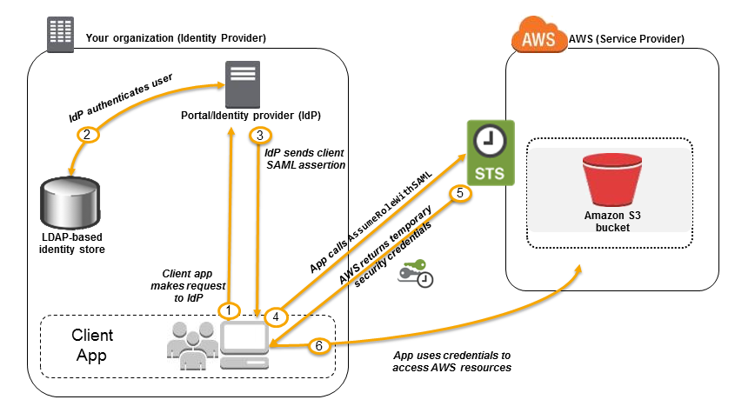

SAML 2.0 based federation can also be used to grant access to the federated users to the AWS Management console. This requires the use of the AWS SSO endpoint instead of directly calling the *AssumeRoleWithSAML*API. The endpoint calls the API for the user and returns a URL that automatically redirects the user’s browser to the AWS Management Console.

1. User browses to the organization’s portal and selects the option to go to the AWS Management Console.
2. Portal performs the function of the identity provider (IdP) that handles the exchange of trust between the organization and AWS.
3. Portal verifies the user’s identity in the organization.

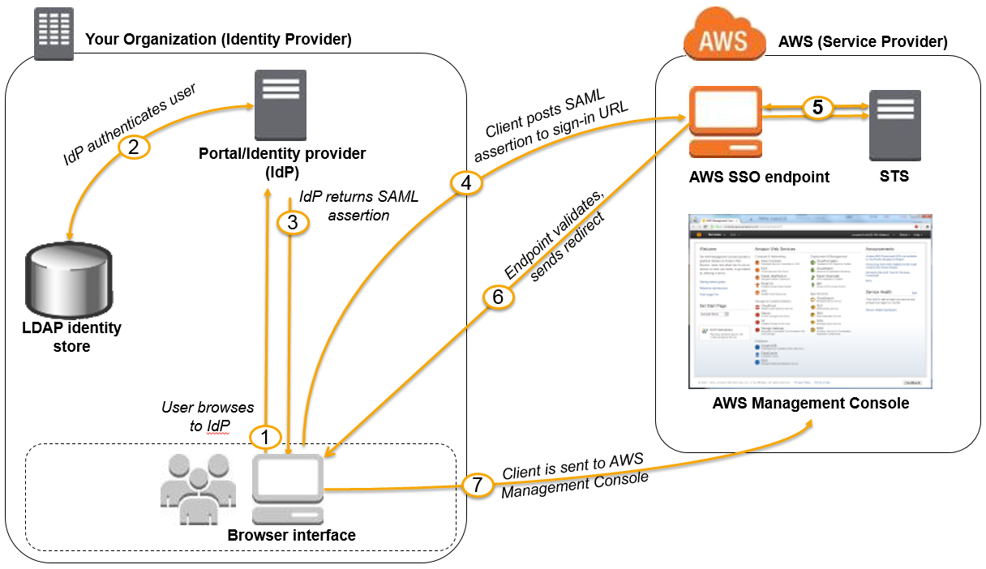

1. Portal generates a SAML authentication response that includes assertions that identify the user and include attributes about the user.
2. Portal sends this response to the client browser.
3. Client browser is redirected to the AWS SSO endpoint and posts the SAML assertion.
4. AWS SSO endpoint handles the call for the *AssumeRoleWithSAML*API action on the user’s behalf and requests temporary security credentials from STS and creates a console sign-in URL that uses those credentials.
5. AWS sends the sign-in URL back to the client as a redirect.
6. Client browser is redirected to the AWS Management Console. If the SAML authentication response includes attributes that map to multiple IAM roles, the user is first prompted to select the role to use for access to the console.

Custom Identity broker Federation

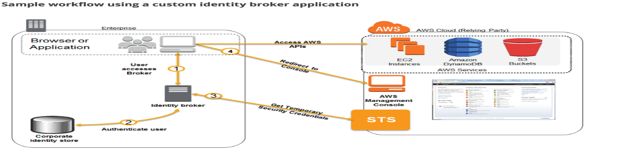

* If the Organization doesn’t support SAML compatible IdP, a Custom Identity Broker can be used to provide the access
* Custom Identity Broker should perform the following steps
  + Verify that the user is authenticated by the local identity system.
  + Call the AWS Security Token Service (AWS STS) ***AssumeRole***(recommended) or ***GetFederationToken*** (by default, has a expiration period of 36 hours) APIs to obtain temporary security credentials for the user.
  + Temporary credentials limit the permissions a user has to the AWS resource
  + Call an AWS federation endpoint and supply the temporary security credentials to get a sign-in token.
  + Construct a URL for the console that includes the token.
  + URL that the federation endpoint provides is valid for 15 minutes after it is created.
  + Give the URL to the user or invoke the URL on the user’s behalf.

**You launch an Amazon EC2 instance without an assigned AWS identity and Access Management (IAM) role. Later, you decide that the instance should be running with an IAM role. Which action must you take in order to have a running Amazon EC2 instance with an IAM role assigned to it?**

* ​ Create an image of the instance, and register the image with an IAM role assigned and an Amazon EBS volume mapping.



* ​Assign the IAM role to the running instance**(Correct)**



* C. Create an image of the instance, add a new IAM role with the same permissions as the desired IAM role, and deregister the image with the new role assigned.



* D. Create an image of the instance, and use this image to launch a new instance with the desired IAM role assigned**(Incorrect)**



#### ExplanationCorrect answer is ****B****as IAM Role can be attached to an EC2 instance when it is launched or if it is in running or in stopped state.

**A Solutions Architect is designing a web application that is running on an Amazon EC2 instance. The application store data in DynamoDB. The Architect needs to secure access to the DynamoDB table. What combination of steps does AWS recommend to achieve secure authorization? (Select TWO)**

* ​A. Store an access key on the Amazon EC2 instance with rights to the DynamoDB table.



* ​B. Attach an IAM user to the Amazon EC2 instance.



* C. Create an IAM role with permissions to write to the DynamoDB table**(Correct)**



* ​D. Attach an IAM role to the Amazon EC2 instance.**(Correct)**



* ​E. Attach an IAM policy to the Amazon EC2 instance.



#### Explanation

Applications that run on an Amazon EC2 instance need credentials in order to access other AWS services. To provide credentials to the application in a secure way, use IAM roles. A role is an entity that has its own set of permissions, but that isn't a user or group. Roles also don't have their own permanent set of credentials the way IAM users do. In the case of Amazon EC2, IAM dynamically provides temporary credentials to the EC2 instance, and these credentials are automatically rotated for you.

When you launch an EC2 instance, you can specify a role for the instance as a launch parameter. Applications that run on the EC2 instance can use the role's credentials when they access AWS resources. The role's permissions determine what the application is allowed to do

**Data protection**

## **CloudHSM**

* provides **secure cryptographic key storage** to customers by making hardware security modules (HSMs) available in the AWS cloud
* **single tenant, dedicated physical device** to securely generate, store, and manage cryptographic keys used for data encryption
* are**inside the VPC** (not EC2-classic) & isolated from the rest of the network
* can use VPC peering to connect to CloudHSM from multiple VPCs
* integrated with Amazon Redshift and Amazon RDS for Oracle
* EBS volume encryption, S3 object encryption and key management can be done with CloudHSM but requires custom application scripting
* is **NOT fault tolerant** and would need to build a cluster as if one fails all the keys are lost
* **expensive,**prefer AWS Key Management Service (KMS) if cost is a criteria

**A news company is planning to use a Hardware Security Module (CloudHSM) in AWS for secure key storage of their web applications. You have launched the CloudHSM cluster but after just a few hours, a support staff mistakenly attempted to log in as the administrator three times using an invalid password in the Hardware Security Module. This has caused the HSM to be zeroized, which means that the encryption keys on it have been wiped. Unfortunately, you did not have a copy of the keys stored anywhere else.**

**How can you obtain a new copy of the keys that you have stored on Hardware Security Module?**

* ​

Restore a snapshot of the Hardware Security Module.

* ​

Contact AWS Support and they will provide you a copy of the keys.

* ​

The keys are lost permanently if you did not have a copy.

**(Correct)**

* ​

Use the Amazon CLI to get a copy of the keys.

**Explanation**

Attempting to log in as the administrator more than twice with the wrong password zeroizes your HSM appliance. When an HSM is zeroized, all keys, certificates, and other data on the HSM is destroyed. You can use your cluster's security group to prevent an unauthenticated user from zeroizing your HSM.

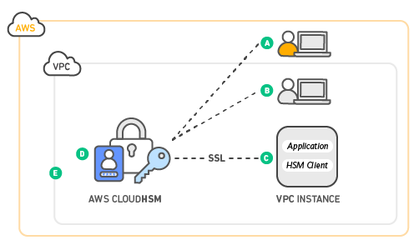

Amazon does not have access to your keys nor to the credentials of your Hardware Security Module (HSM) and therefore has no way to recover your keys if you lose your credentials. Amazon strongly recommends that you use two or more HSMs in separate Availability Zones in any production CloudHSM Cluster to avoid loss of cryptographic keys.

Refer to the CloudHSM FAQs for reference:

**Q: Could I lose my keys if a single HSM instance fails?**

Yes. It is possible to lose keys that were created since the most recent daily backup if the CloudHSM cluster that you are using fails and you are not using two or more HSMs. Amazon strongly recommends that you use two or more HSMs, in separate Availability Zones, in any production CloudHSM Cluster to avoid loss of cryptographic keys.

**Q: Can Amazon recover my keys if I lose my credentials to my HSM?**

No. Amazon does not have access to your keys or credentials and therefore has no way to recover your keys if you lose your credentials.

## **KMS**

* AWS Key Management Service (KMS) makes it easy for you to create and manage keys and control the use of encryption across a wide range of AWS services and in your applications.
* Create, import, disable and re-enable keys and define key management roles in IAM.
* AWS KMS is also integrated with AWS CloudTrail to provide encryption key usage logs to help meet your auditing, regulatory and compliance needs.
* You can configure your application to use the KMS API to encrypt all data before saving it to disk.

AWS KMS is integrated with AWS CloudTrail, a service that provides a record of actions performed by a user, role, or an AWS service in AWS KMS. CloudTrail captures all API calls for AWS KMS as events, including calls from the AWS KMS console and from code calls to the AWS KMS APIs. If you create a trail, you can enable continuous delivery of CloudTrail events to an Amazon S3 bucket, including events for AWS KMS. If you don't configure a trail, you can still view the most recent events in the CloudTrail console in ***Event history***. Using the information collected by CloudTrail, you can determine the request that was made to AWS KMS, the IP address from which the request was made, who made the request, when it was made, and additional details

**You are working as a Solutions Architect for a government project in which they are building an online portal to allow people to pay their taxes and claim their tax refunds online. Due to the confidentiality of data, the security policy requires that the application hosted in EC2 encrypts the data first before writing it to the disk for storage.   In this scenario, which service would you use to meet this requirement?**

* ​Security Token Service



* ​EBS encryption



* ​Elastic File System (EFS)



* ​AWS KMS API



**Explanation**

. The master keys that you create in AWS KMS are protected by FIPS 140-2 validated cryptographic modules. AWS KMS is integrated with most other AWS services that encrypt your data with encryption keys that you manage. AWS KMS is also integrated with AWS CloudTrail to provide encryption key usage logs to help meet your auditing, regulatory and compliance needs.

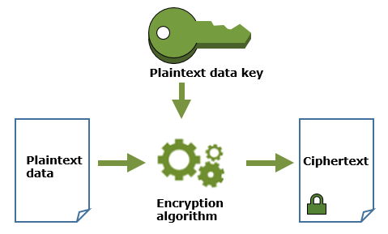

The scenario mentions that you have to encrypt the data **before** writing it to disk for storage. What this means is that you will have to temporarily store the data in **memory** and not persist it on the disk, then encrypt it on the fly before finally storing it. The end result would be an encrypted data in your disk EBS Volume, and the EBS Encryption would be the secondary layer of protection/encryption for your sensitive data.You can configure your application to use the KMS API to encrypt all data before saving it to disk. Hence, Option 4 is the correct answer.

**A media company has an Amazon ECS Cluster, which uses the Fargate launch type, to host its news website. The database credentials should be supplied using environment variables, to comply with strict security compliance. As the Solutions Architect, you have to ensure that the credentials are secure and that they cannot be viewed in plaintext on the cluster itself.Which of the following is the most suitable solution in this scenario that you can implement with minimal effort?**

* ​In the ECS task definition file of the ECS Cluster, store the database credentials using Docker Secrets to centrally manage these sensitive data and securely transmit it to only those containers that need access to it. Secrets are encrypted during transit and at rest. A given secret is only accessible to those services which have been granted explicit access to it via IAM Role, and only while those service tasks are running.



* ​Store the database credentials in the ECS task definition file of the ECS Cluster and encrypt it with KMS. Store the task definition JSON file in a private S3 bucket and ensure that HTTPS is enabled on the bucket to encrypt the data in-flight. Create an IAM role to the ECS task definition script that allows access to the specific S3 bucket and then pass the --cli-input-json parameter when calling the ECS register-task-definition. Reference the task definition JSON file in the S3 bucket which contains the database credentials.



* ​Use the AWS Secrets Manager to store the database credentials and then encrypt them using AWS KMS. Create a resource-based policy for your Amazon ECS task execution role and reference it with your task definition which allows access to both KMS and AWS Secrets Manager. Within your container definition, specify secrets with the name of the environment variable to set in the container and the full ARN of the Secrets Manager secret which contains the sensitive data, to present to the container.



* ​Use the AWS Systems Manager Parameter Store to keep the database credentials and then encrypt them using AWS KMS. Create an IAM Role for your Amazon ECS task execution role and reference it with your task definition, which allows access to both KMS and the Parameter Store. Within your container definition, specify secrets with the name of the environment variable to set in the container and the full ARN of the Systems Manager Parameter Store parameter containing the sensitive data to present to the container.**Explanation**



Amazon ECS enables you to inject sensitive data into your containers by storing your sensitive data in either AWS Secrets Manager secrets or AWS Systems Manager Parameter Store parameters and then referencing them in your container definition. This feature is supported by tasks using both the EC2 and Fargate launch types.

- To inject sensitive data into your containers as environment variables, use the secrets container definition parameter.

- To reference sensitive information in the log configuration of a container, use the secretOptions container definition parameter.

 Within your container definition, specify secrets with the name of the environment variable to set in the container and the full ARN of either the Secrets Manager secret or Systems Manager Parameter Store parameter containing the sensitive data to present to the container. The parameter that you reference can be from a different Region than the container using it, but must be from within the same account. Hence, Option 4 is the correct answer.

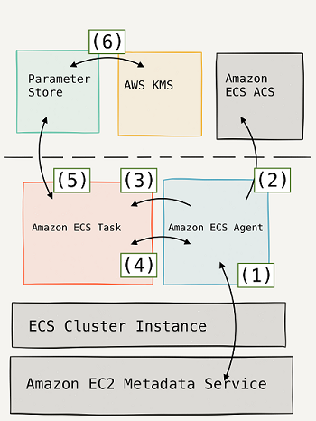

**Directory Service**

* AWS Directory Service provides multiple ways to use Amazon Cloud Directory and Microsoft Active Directory (AD) with other AWS services.
* Directories store information about users, groups, and devices.
  + Administrators use them to manage access to information and resources.
* Using a corporate Active Directory, it is best to use AWS Directory Service AD Connector:
  + It is a directory gateway with which you can redirect directory requests to your on-premises Microsoft Active Directory.
  + AWS Directory Service Simple AD just provides a subset of the features offered by AWS Managed Microsoft AD, including the ability to manage user accounts and group memberships, create and apply group policies, securely connect to Amazon EC2 instances, and provide Kerberos-based single sign-on (SSO).
* gives applications in AWS access to Active Directory services
* different from SAML + AD, where the access is granted to AWS services through Temporary Credentials
* Simple AD
  + least expensive but does not support Microsoft AD advance features
  + provides a Samba 4 Microsoft Active Directory compatible standalone directory service on AWS
  + No single point of Authentication or Authorization, as a separate copy is maintained
  + trust relationships cannot be setup between Simple AD and other Active Directory domains
  + Don’t use it, if the requirement is to leverage access and control through centralized authentication service
* AD Connector
  + acts just as an hosted proxy service for instances in AWS to connect to on-premises Active Directory
  + enables consistent enforcement of existing security policies, such as password expiration, password history, and account lockouts, whether users are accessing resources on-premises or in the AWS cloud
  + needs VPN connectivity (or Direct Connect)
  + integrates with existing RADIUS-based MFA solutions to enabled multi-factor authentication
  + does not cache data which might lead to latency
* Read-only Domain Controllers (RODCs)
  + works out as a Read-only Active Directory
  + holds a copy of the Active Directory Domain Service (AD DS) database and respond to authentication requests
  + they cannot be written to and are typically deployed in locations where physical security cannot be guaranteed
  + helps maintain a single point to authentication & authorization controls, however needs to be synced
* Writable Domain Controllers
  + are expensive to setup
  + operate in a multi-master model; changes can be made on any writable server in the forest, and those changes are replicated to servers throughout the entire forest

**A company is preparing to give AWS Management Console access to developers. Company policy mandates identity federation and role-based access control. Roles are currently assigned using groups in the corporate Active Directory. What combination of the following will give developers access to the AWS console? Choose 2 answers**

* ​A. AWS Directory Service AD Connector**(Correct)**



* ​B. AWS Directory Service Simple AD



* ​C. AWS Identity and Access Management groups



* ​D. AWS Identity and Access Management roles**(Correct)**



* ​E. AWS Identity and Access Management users**(Incorrect)**



#### Explanation

Correct answers are **A & D** as [AD connector](http://docs.aws.amazon.com/directoryservice/latest/admin-guide/directory_ad_connector.html) is required to connect to on-premises Active Directory and IAM Role can be used for Identity Provider and Federation.

**AD Connector is a directory gateway with which you can redirect directory requests to your on-premises Microsoft Active Directory without caching any information in the cloud**Your end users and IT administrators can use their existing corporate credentials to log on to AWS applications such as Amazon WorkSpaces, Amazon WorkDocs, or Amazon WorkMail.

Considering that the company is using a corporate Active Directory, it is best to use AWS Directory Service AD Connector for easier integration. In addition, since the roles are already assigned using groups in the corporate Active Directory, it would be better to also use IAM Roles. Take note that you can assign an IAM Role to the users or groups from your Active Directory once it is integrated with your VPC via the AWS Directory Service AD Connector.

You can manage AWS resources like Amazon EC2 instances or Amazon S3 buckets through IAM role-based access to the AWS Management Console.

Option B is wrong as Simple AD is a standalone AD setup and does not allow connection to the on-premises AD.Option C & E are wrong as users and groups do not work.

Amazon Macie is a security service that uses machine learning to automatically discover, classify, and protect sensitive data in AWS.

**API Gateway**

* Amazon API Gateway is a fully managed service that makes it easy for developers to publish, maintain, monitor, and secure APIs at any scale.
* You can create an API that acts as a "front door" for applications to access data, business logic, or functionality from your back-end services, such as applications running on EC2 instances, code running on Lambda, or any web application.

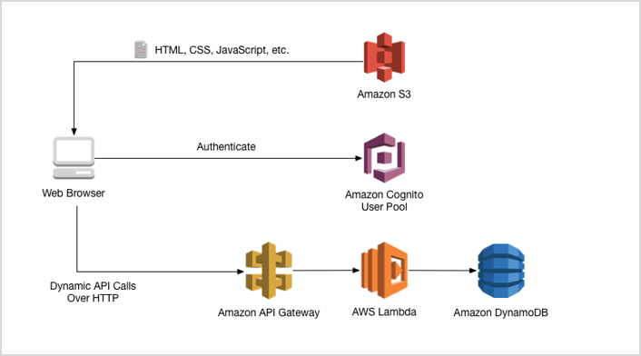

* Features:
  + Expose HTTP endpoints to define a RESTful API.
  + Serverlessly connect to services like Lambda and DynamoDB.
  + Send each API endpoint to a different target.
  + Track and control usage by API keys.Throttle requests to prevent attacks.
  + Connect to CloudWatch to log all requests for monitoring.
  + Maintain multiple versions of your API.
  + API Gateway is low cost and scales automatically.
* How to configure API Gateway:
  + Define an API (container)
  + Define resources and nested resources (URL paths)
  + For each resource, select supported HTTP methods, set security, choose the target (e.g. Lambda), and set request and response transformations.
* How to deploy API Gateway:
  + Deploy API to a stage: Uses the API Gateway domain by default, but you can use a custom domain.Now supports AWS Certificate Manager: free SSL/TLS certificates.
* Request throttling:Throttling limits can be set for standard rates and bursts (for a few seconds)
  + Any request over the limit will receive a 429 HTTP response.
* [Throttling and Caching](https://aws.amazon.com/api-gateway/faqs/#Throttling_and_Caching)
* You can enable API caching to cache your endpoint's responses.
  + With caching, you can reduce the number of calls and improve performance.
  + API Gateway caches responses for a specific TTL period, in seconds.
* Same Origin Policy:
  + Under the policy, the web browser permits scripts contained in a first web page to access data in a second web page, but only if both web pages have the same origin (domain name)
  + This is done to prevent Cross-Site Scripting (XSS) attacks.
  + Enforced by web browsers, but ignored by tools such as Postman and curl.
* If you're using JS/AJAX that uses multiple domains with API Gateway, ensure that you have enabled CORS on API Gateway.
  + Cross-Origin Resource Sharing (CORS) is a mechanism that allows restricted resources (e.g. fonts) on a web page to be requested from another domain outside the domain from which the first resource was served.
  + The way that server at the other end (not the client side) can relax SOP.
  + CORS is enforced by the client.
* tage variables are name-value pairs that you can define as configuration attributes associated with a deployment stage of an API. They act like environment variables and can be used in your API setup and mapping templates.
* For example, you can define a stage variable in a stage configuration, and then set its value as the URL string of an HTTP integration for a method in your API. Later, you can reference the URL string using the associated stage variable name from the API setup. This way, you can use the same API setup with a different endpoint at each stage by resetting the stage variable value to the corresponding URLs. You can also access stage variables in the mapping templates, or pass configuration parameters to your AWS Lambda or HTTP backend.
* Billing:
  + You pay only for the API calls you receive and the amount of data transferred out.
* You can use AWS X-Ray to trace and analyze user requests as they travel through your Amazon API Gateway APIs to the underlying services.
  + X-Ray gives you an end-to-end view of an entire request, so you can analyze latencies in your APIs and their backend services.

**A cryptocurrency trading platform is using an API built in AWS Lambda and API Gateway. Due to the recent news and rumors about the upcoming price surge of Bitcoin, Ethereum and other cryptocurrencies, it is expected that the trading platform would have a significant increase in site visitors and new users in the coming days ahead.In this scenario, how can you protect the backend systems of the platform from traffic spikes?**

* ​Switch from using AWS Lambda and API Gateway to a more scalable and highly available architecture using EC2 instances, ELB, and Auto Scaling.



* ​Enable throttling limits and result caching in API Gateway.



* ​Use CloudFront in front of the API Gateway to act as a cache.



* ​Move the Lambda function in a VPC.



**Explanation**

Amazon API Gateway provides throttling at multiple levels including global and by service call. Throttling limits can be set for standard rates and bursts. For example, API owners can set a rate limit of 1,000 requests per second for a specific method in their REST APIs, and also configure Amazon API Gateway to handle a burst of 2,000 requests per second for a few seconds. Amazon API Gateway tracks the number of requests per second. Any request over the limit will receive a 429 HTTP response. The client SDKs generated by Amazon API Gateway retry calls automatically when met with this response. Hence, Option 2 is the correct answer.

You can add caching to API calls by provisioning an Amazon API Gateway cache and specifying its size in gigabytes. The cache is provisioned for a specific stage of your APIs. This improves performance and reduces the traffic sent to your back end. Cache settings allow you to control the way the cache key is built and the time-to-live (TTL) of the data stored for each method. Amazon API Gateway also exposes management APIs that help you invalidate the cache for each stage.

**You have just launched a new API Gateway service which uses AWS Lambda as a serverless computing service. In what type of protocol will your API endpoint be exposed?**

* ​

HTTP/2

* ​

HTTPS

**(Correct)**

* ​

HTTP

* ​

WebSocket

**Explanation**

All of the APIs created with Amazon API Gateway expose **HTTPS** endpoints only. Amazon API Gateway does not support unencrypted (HTTP) endpoints. By default, Amazon API Gateway assigns an internal domain to the API that automatically uses the Amazon API Gateway certificate. When configuring your APIs to run under a custom domain name, you can provide your own certificate for the domain.

**Lambda**

* AWS Lambda lets you run code without provisioning or managing servers = serverless.
  + Takes care of provisioning and managing the servers that you use to run the code.
* Can be run in response to triggers, to HTTP requests using API Gateway, or API calls using AWS SDKs.API-Gateway Events, S3 Events and DynamoDB Events are all valid triggers for Lambda functions.Can trigger other Lambda functions.
  + Can do things globally, for example, back up S3 buckets to other S3 buckets.
  + For example, Amazon Alexa is directly speaking to Lambda.
* Lambda scales out automatically:
  + Each time a Lambda function is triggered, an isolated instance of that function is invoked.
  + Multiple triggers result in multiple concurrent invocations, one for each time it is triggered.
  + There are limits, but these can be adjusted on request.

*Each Lambda function has an IAM role (execution role) associated with it. You specify the IAM role when you create your Lambda function. Permissions you grant to this role determine what AWS Lambda can do when it assumes the role. There are two types of permissions that you grant to the IAM role:*

* *If your Lambda function code accesses other AWS resources, such as reading an object from an S3 bucket or writing logs to CloudWatch Logs, you need to grant permissions for relevant Amazon S3 and CloudWatch actions to the role.*
* *If the event source is poll-based (Amazon Kinesis Data Streams, DynamoDB, Amazon SQS), AWS Lambda polls these resources on your behalf. AWS Lambda needs permissions to poll either the stream or queue to read new records. To enable this, you need to grant AWS Lambda permissions to access the new records. In turn, AWS Lambda will invoke any Lambda function subscribed to this event source to process the event.*

**Explanation**

If you're using the AWS Lambda compute platform, you must choose one of the following deployment configuration types to specify how traffic is shifted from the original AWS Lambda function version to the new AWS Lambda function version:

* **-Canary**: Traffic is shifted in two increments. You can choose from predefined canary options that specify the percentage of traffic shifted to your updated Lambda function version in the first increment and the interval, in minutes, before the remaining traffic is shifted in the second increment.
* **-Linear**: Traffic is shifted in equal increments with an equal number of minutes between each increment. You can choose from predefined linear options that specify the percentage of traffic shifted in each increment and the number of minutes between each increment.
* **-All-at-once**: All traffic is shifted from the original Lambda function to the updated Lambda function version at once.
* Billing:
  + Counts a request each time it starts executing in response to an event.
  + Calculates duration from the time (in 100ms units) code begins executing until it returns or otherwise terminates.Depends on the amount of memory (in MB) you allocate to your function.Free tier includes 1M free requests per month and 400,000 GB-s of compute time per month.
* AWS X-Ray allows you to debug complex Lambda architectures.
  + AWS X-Ray helps developers analyze and debug production, distributed applications, such as those built using a microservices & serverless architectures.
  + The first time you create or update Lambda functions that use environment variables in a region, a default service key is created for you automatically within AWS KMS. This key is used to encrypt environment variables. However, if you wish to use encryption helpers and use KMS to encrypt environment variables after your Lambda function is created, you must create your own AWS KMS key and choose it instead of the default key. The default key will give errors when chosen. Creating your own key gives you more flexibility, including the ability to create, rotate, disable, and define access controls, and to audit the encryption keys used to protect your data.
* **Encryption of environment variables:**
  + AWS Lambda encrypts environment variables using the AWS Key Management Service.
  + By default, the sensitive information is still visible when accessing the Lambda console.
  + To prevent anyone from seeing these credentials in plain text, **use encryption helpers.**
  + Creating your own key gives you more flexibility, including the ability to create, rotate, disable, and define access controls, and to audit the encryption keys used to protect your data.
  + [Environment Variable Encryption](https://docs.aws.amazon.com/lambda/latest/dg/env_variables.html#env_encrypt)

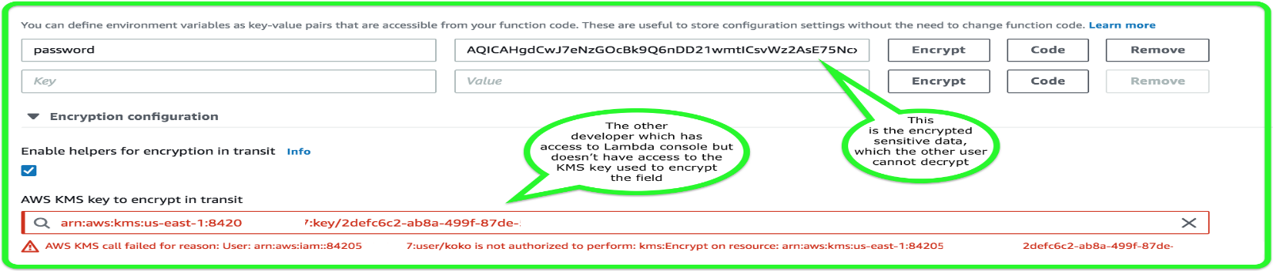

* **Deployment configuration types with AWS CodeDeploy:**
  + Allows you to shift traffic from one Lambda function to another.
  + Canary: Traffic is shifted in two increments.
  + Linear: Traffic is shifted in equal increments with an equal number of minutes in-between.
  + All-at-once: All traffic is shifted at once.
  + [What Is CodeDeploy?](https://docs.aws.amazon.com/codedeploy/latest/userguide/welcome.html#blue-green-lambda-compute-type)[Invoking AWS Lambda Functions](https://docs.aws.amazon.com/lambda/latest/dg/lambda-invocation.html)
  + AWS Lambda supports synchronous and asynchronous invocation of a Lambda function.
* AWS Lambda enables functions that can run up to 15 minutes.Lambda needs to have a role associated with it that provide credentials with rights to other services.
* Lambda like EC2 and ECS supports hyper-threading on one or more virtual CPUs.

**You are working as a Cloud Consultant for a government agency with a mandate of improving traffic planning, maintenance of roadways and preventing accidents. There is a need to manage traffic infrastructure in real time, alert traffic engineers and emergency response teams when problems are detected, and automatically change traffic signals to get emergency personnel to accident scenes faster by using sensors and smart devices.   Which AWS service will allow the developers of the agency to connect the said devices to your cloud-based applications?**

* ​CloudFormation



* ​Elastic Beanstalk



* ​AWS IoT Core



* ​Container service



**Explanation**

AWS IoT Core is a managed cloud service that lets connected devices easily and securely interact with cloud applications and other devices. AWS IoT Core provides secure communication and data processing across different kinds of connected devices and locations so you can easily build IoT applications.

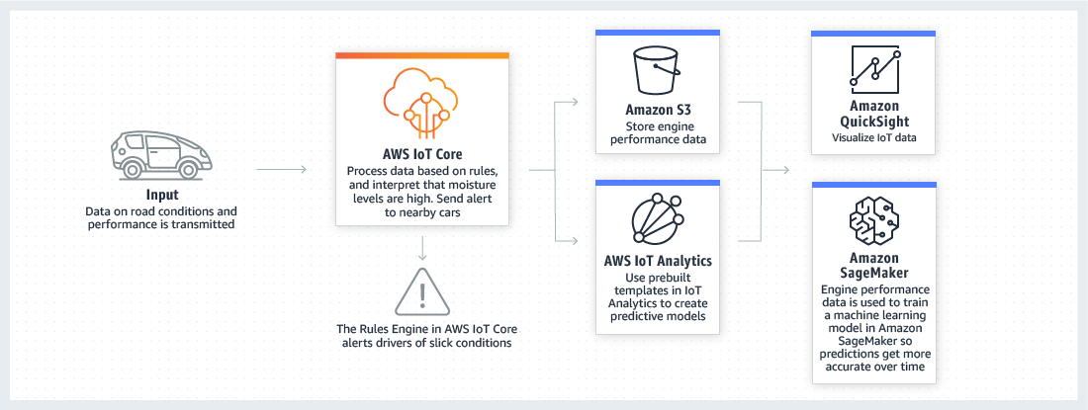

**Your company has recently deployed a new web application which uses a serverless-based architecture in AWS. Your manager instructed you to implement CloudWatch metrics to monitor your systems more effectively. You know that Lambda automatically monitors functions on your behalf and reports metrics through Amazon CloudWatch.**

**In this scenario, what types of data do these metrics monitor? (Choose 2)**

* ​ReservedConcurrentExecutions



* ​Invocations



* ​DeadLetterErrors



IteratorSize

* ​ApproximateAgeOfOldestMessage



**Explanation**

AWS Lambda automatically monitors functions on your behalf, reporting metrics through Amazon CloudWatch. These metrics include total invocation requests, latency, and error rates. The throttles, Dead Letter Queues errors and Iterator age for stream-based invocations are also monitored.

You can monitor metrics for Lambda and view logs by using the Lambda console, the CloudWatch console, the AWS CLI, or the CloudWatch API

**You have a VPC that has a CIDR block of 10.31.0.0/27 which is connected to your on-premises data center. There was a requirement to create a Lambda function that will process massive amounts of cryptocurrency transactions every minute and then store the results to EFS. After you set up the serverless architecture and connected Lambda function to your VPC, you noticed that there is an increase in invocation errors with EC2 error types such as EC2ThrottledException on certain times of the day.**

**Which of the following are the possible causes of this issue? (Choose 2)**

* ​



You only specified one subnet in your Lambda function configuration. That single subnet runs out of available IP addresses and there is no other subnet or Availability Zone which can handle the peak load.

**(Correct)**

* ​



Your VPC does not have a NAT gateway.

* ​



Your VPC does not have sufficient subnet ENIs or subnet IPs.

**(Correct)**

* ​



The associated security group of your function does not allow outbound connections.

* ​



The attached IAM execution role of your function does not have the necessary permissions to access the resources of your VPC.

**Explanation**

You can configure a function to connect to a virtual private cloud (VPC) in your account. Use Amazon Virtual Private Cloud (Amazon VPC) to create a private network for resources such as databases, cache instances, or internal services. Connect your function to the VPC to access private resources during execution.

AWS Lambda runs your function code securely within a VPC by default. However, to enable your Lambda function to access resources inside your private VPC, you must provide additional VPC-specific configuration information that includes VPC subnet IDs and security group IDs. AWS Lambda uses this information to set up elastic network interfaces (ENIs) that enable your function to connect securely to other resources within your private VPC.

Lambda functions cannot connect directly to a VPC with dedicated instance tenancy. To connect to resources in a dedicated VPC, peer it to a second VPC with default tenancy.

Your Lambda function automatically scales based on the number of events it processes. If your Lambda function accesses a VPC, you must make sure that your VPC has sufficient ENI capacity to support the scale requirements of your Lambda function. It is also recommended that you specify at least one subnet in each Availability Zone in your Lambda function configuration.

By specifying subnets in each of the Availability Zones, your Lambda function can run in another Availability Zone if one goes down or runs out of IP addresses. If your VPC does not have sufficient ENIs or subnet IPs, your Lambda function will not scale as requests increase, and you will see an increase in invocation errors with EC2 error types like EC2ThrottledException. For asynchronous invocation, if you see an increase in errors without corresponding CloudWatch Logs, invoke the Lambda function synchronously in the console to get the error responses. Hence, the correct answers for this scenario are Options 1 and 3.

**Your IT Director instructed you to ensure that all of the AWS resources in your VPC don’t go beyond their respective service limits. You should prepare a system that provides you real-time guidance in provisioning your resources that adheres to the AWS best practices.**

**Which of the following is the MOST appropriate service to use to satisfy this task?**

* ​

AWS Cost Explorer

* ​

AWS Budgets

**(Incorrect)**

* ​

AWS Trusted Advisor

**(Correct)**

* ​

AWS Inspector

**Explanation**

**AWS Trusted Advisor** is an online tool that provides you real-time guidance to help you provision your resources following AWS best practices. It inspects your AWS environment and makes recommendations for saving money, improving system performance and reliability, or closing security gaps.

Whether establishing new workflows, developing applications, or as part of ongoing improvement, take advantage of the recommendations provided by Trusted Advisor on a regular basis to help keep your solutions provisioned optimally.

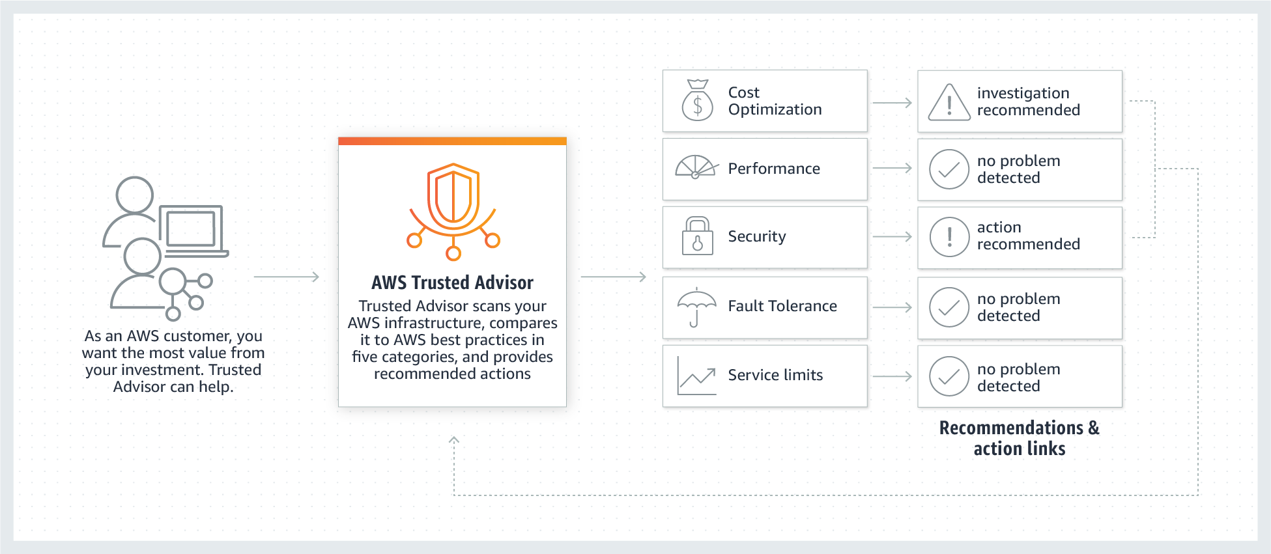

Trusted Advisor includes an ever-expanding list of checks in the following five categories:

**Cost Optimization**– recommendations that can potentially save you money by highlighting unused resources and opportunities to reduce your bill.

**Security** – identification of security settings that could make your AWS solution less secure.

**Fault Tolerance** – recommendations that help increase the resiliency of your AWS solution by highlighting redundancy shortfalls, current service limits, and over-utilized resources.

**Performance** – recommendations that can help to improve the speed and responsiveness of your applications.

**Service Limits** – recommendations that will tell you when service usage is more than 80% of the service limit.

Hence, the correct answer in this scenario is Option 3.

Option 1 is incorrect because this is just a tool that enables you to view and analyze your costs and usage. You can explore your usage and costs using the main graph, the Cost Explorer cost and usage reports, or the Cost Explorer RI reports. It has an easy-to-use interface that lets you visualize, understand, and manage your AWS costs and usage over time.

Option 2 is incorrect because it simply gives you the ability to set custom budgets that alert you when your costs or usage exceed (or are forecasted to exceed) your budgeted amount. You can also use AWS Budgets to set reservation utilization or coverage targets and receive alerts when your utilization drops below the threshold you define.

Option 4 is incorrect because it is just an automated security assessment service that helps improve the security and compliance of applications deployed on AWS. Amazon Inspector automatically assesses applications for exposure, vulnerabilities, and deviations from best practices.

**You are a working as a Solutions Architect for a fast-growing startup which just started operations during the past 3 months. They currently have an on-premises Active Directory and 10 computers. To save costs in procuring physical workstations, they decided to deploy virtual desktops for their new employees in a virtual private cloud in AWS. The new cloud infrastructure should leverage on the existing security controls in AWS but can still communicate with their on-premises network.**

**Which set of AWS services will you use to meet these requirements?**

* ​

AWS Directory Services, VPN connection, and ClassicLink

* ​

AWS Directory Services, VPN connection, and Amazon Workspaces

**(Correct)**

* ​

AWS Directory Services, VPN connection, and AWS Identity and Access Management

**(Incorrect)**

* ​

AWS Directory Services, VPN connection, and Amazon S3

**Explanation**

For this scenario, the best choice is Option 2: AWS Directory Services, VPN connection, and Amazon Workspaces. First, you need a VPN connection to connect the VPC and your on-premises network. Second, you need AWS Directory Services to integrate with your on-premises Active Directory and lastly, you need to use Amazon Workspace to create the needed virtual desktops in your VPC.

**You are working for a data analytics startup that collects clickstream data and stores them in an S3 bucket. You need to launch an AWS Lambda function to trigger your ETL jobs to run as soon as new data becomes available in Amazon S3.**

**Which of the following services can you use as an extract, transform, and load (ETL) service in this scenario?**

* ​

S3 Select

* ​

Redshift Spectrum

* ​

AWS Step Functions

**(Incorrect)**

* ​

AWS Glue

**(Correct)**

**Explanation**

AWS Glue is a fully managed extract, transform, and load (ETL) service that makes it easy for customers to prepare and load their data for analytics. You can create and run an ETL job with a few clicks in the AWS Management Console. You simply point AWS Glue to your data stored on AWS, and AWS Glue discovers your data and stores the associated metadata (e.g. table definition and schema) in the AWS Glue Data Catalog. Once cataloged, your data is immediately searchable, queryable, and available for ETL. AWS Glue generates the code to execute your data transformations and data loading processes.

**A Solutions Architect is migrating several Windows-based applications to AWS that require a scalable file system storage for high-performance computing (HPC). The storage service must have full support for the SMB protocol and Windows NTFS, Active Directory (AD) integration, and Distributed File System (DFS).**

**Which of the following is the MOST suitable storage service that the Architect should use to fulfill this scenario?**

* ​

Amazon FSx for Windows File Server

**(Correct)**

* ​

Amazon S3 Glacier Deep Archive

* ​

AWS DataSync

* ​

Amazon FSx for Lustre

**Explanation**

**Amazon FSx** provides fully managed third-party file systems. Amazon FSx provides you with the native compatibility of third-party file systems with feature sets for workloads such as Windows-based storage, high-performance computing (HPC), machine learning, and electronic design automation (EDA). You don’t have to worry about managing file servers and storage, as Amazon FSx automates the time-consuming administration tasks such as hardware provisioning, software configuration, patching, and backups. Amazon FSx integrates the file systems with cloud-native AWS services, making them even more useful for a broader set of workloads.

Amazon FSx provides you with two file systems to choose from: Amazon FSx for Windows File Server for Windows-based applications and Amazon FSx for Lustre for compute-intensive workloads.

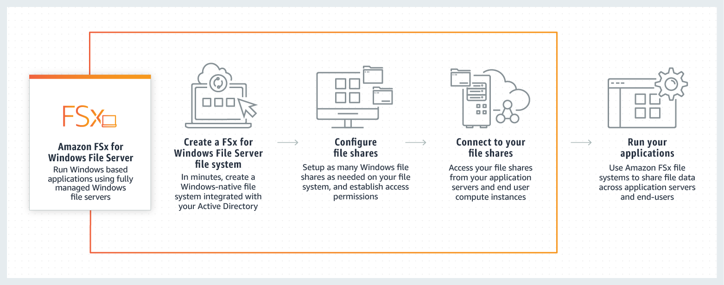

For Windows-based applications, Amazon FSx provides fully managed Windows file servers with features and performance optimized for "lift-and-shift" business-critical application workloads including home directories (user shares), media workflows, and ERP applications. It is accessible from Windows and Linux instances via the SMB protocol. If you have Linux-based applications, Amazon EFS is a cloud-native fully managed file system that provides simple, scalable, elastic file storage accessible from Linux instances via the NFS protocol.

For compute-intensive and fast processing workloads, like high-performance computing (HPC), machine learning, EDA, and media processing, Amazon FSx for Lustre, provides a file system that’s optimized for performance, with input and output stored on Amazon S3.

Hence, the correct answer is Option 1: ***Amazon FSx for Windows File Server****.*

Option 2 is incorrect because the Amazon S3 Glacier Deep Archive service is primarily used as a secure, durable, and extremely low-cost cloud storage for data archiving and long-term backup.

Option 3 is incorrect because the AWS DataSync service simply provides a fast way to move large amounts of data online between on-premises storage and Amazon S3 or Amazon Elastic File System (Amazon EFS).

Option 4 is incorrect because the Amazon FSx for Lustre service doesn't support the Windows-based applications as well as Windows servers.

**An online trading platform with thousands of clients across the globe is hosted in AWS. To reduce latency, you have to direct user traffic to the nearest application endpoint to the client. The traffic should be routed to the closest edge location via an Anycast static IP address. AWS Shield should also be integrated into the solution for DDoS protection.**

**Which of the following is the MOST suitable service that the Solutions Architect should use to satisfy the above requirements?**

* ​

AWS Global Accelerator

**(Correct)**

* ​

Amazon CloudFront

**(Incorrect)**

* ​

AWS WAF

* ​

AWS PrivateLink

**Explanation**

**AWS Global Accelerator** is a service that improves the availability and performance of your applications with local or global users. It provides static IP addresses that act as a fixed entry point to your application endpoints in a single or multiple AWS Regions, such as your Application Load Balancers, Network Load Balancers or Amazon EC2 instances.

AWS Global Accelerator uses the AWS global network to optimize the path from your users to your applications, improving the performance of your TCP and UDP traffic. AWS Global Accelerator continually monitors the health of your application endpoints and will detect an unhealthy endpoint and redirect traffic to healthy endpoints in less than 1 minute.

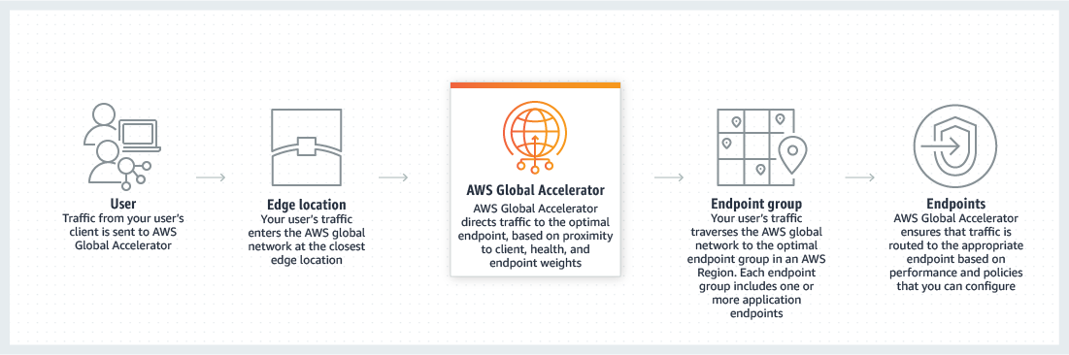

Many applications, such as gaming, media, mobile applications, and financial applications, need very low latency for a great user experience. To improve the user experience, AWS Global Accelerator directs user traffic to the nearest application endpoint to the client, thus reducing internet latency and jitter. It routes the traffic to the closest edge location via Anycast, then by routing it to the closest regional endpoint over the AWS global network. AWS Global Accelerator quickly reacts to changes in network performance to improve your users’ application performance.

AWS Global Accelerator and Amazon CloudFront are separate services that use the AWS global network and its edge locations around the world. CloudFront improves performance for both cacheable content (such as images and videos) and dynamic content (such as API acceleration and dynamic site delivery). Global Accelerator improves performance for a wide range of applications over TCP or UDP by proxying packets at the edge to applications running in one or more AWS Regions. Global Accelerator is a good fit for non-HTTP use cases, such as gaming (UDP), IoT (MQTT), or Voice over IP, as well as for HTTP use cases that specifically require static IP addresses or deterministic, fast regional failover. Both services integrate with AWS Shield for DDoS protection.

Hence, the correct answer is Option 1: AWS Global Accelerator.

Option 2 is incorrect because although the Amazon CloudFront service uses edge locations, it doesn't have the capability to route the traffic to the closest edge location via an Anycast static IP address.

Option 3 is incorrect because the AWS WAF service is just a web application firewall that helps protect your web applications or APIs against common web exploits that may affect availability, compromise security, or consume excessive resources

Option 4 is incorrect because the AWS PrivateLink service simply provides private connectivity between VPCs, AWS services, and on-premises applications, securely on the Amazon network. It doesn't route traffic to the closest edge location via an Anycast static IP address.